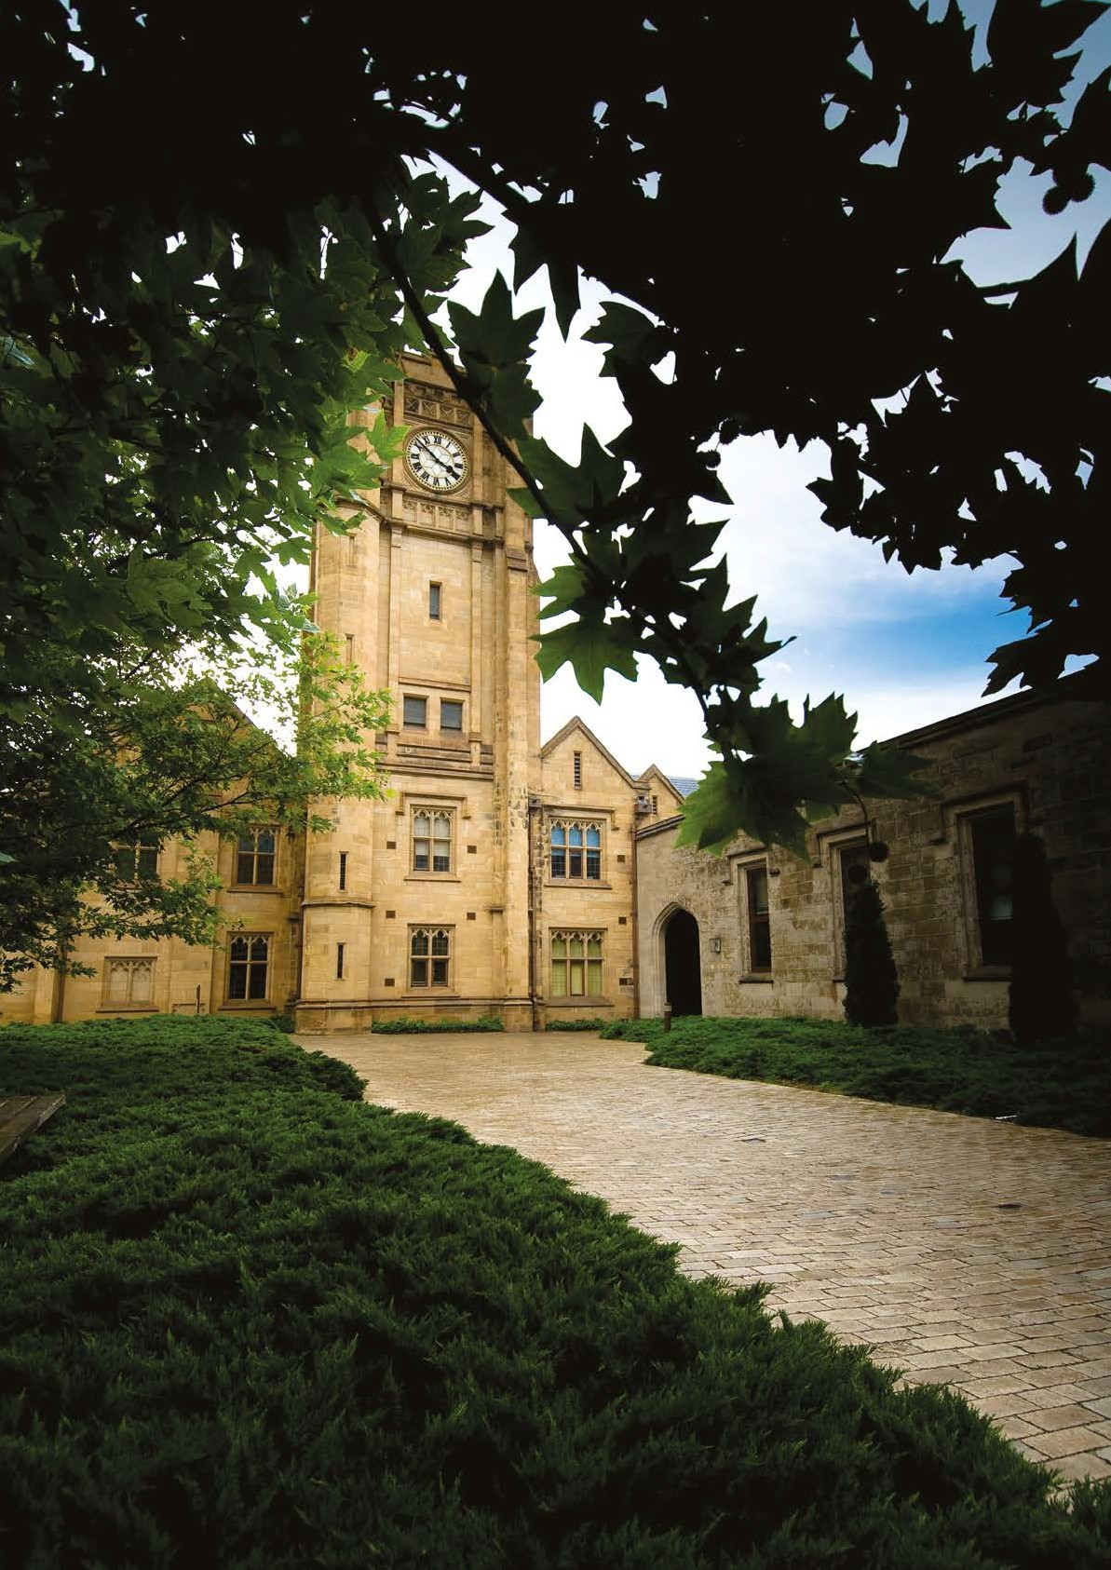
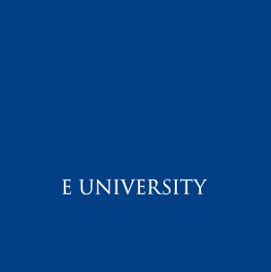
Appointment of
Teaching Specialist (Academic Support)
Arts Teaching Innovation, Faculty of Arts
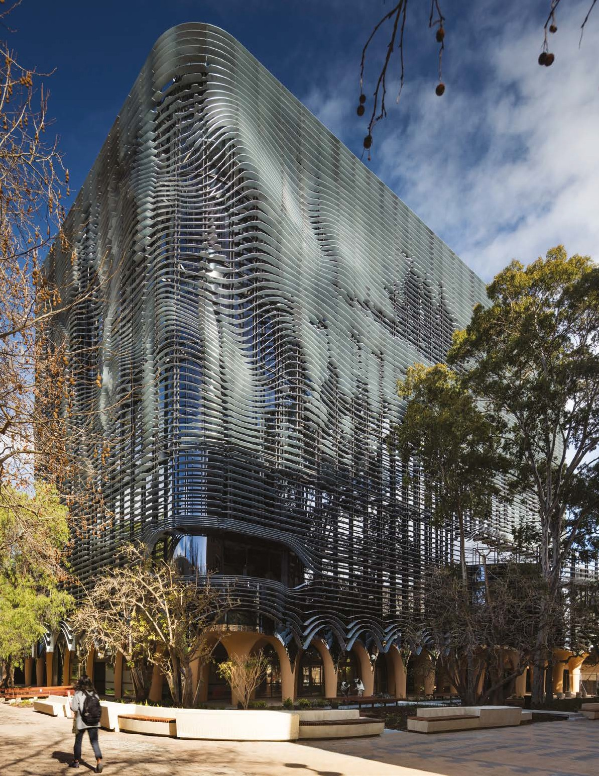
Contents
- Faculty of Arts
- Position Description & Selection Criteria
- The University of Melbourne
- University of Melbourne’s Strategic Plan 2020 – 2030
- People & Benefits
- Living & Working in Melbourne
- Further Information
- How to Apply & Contact Information

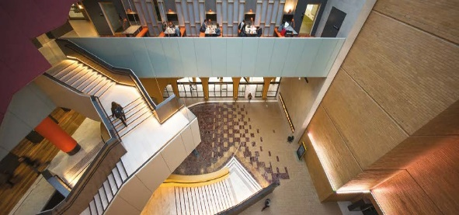
Arts West Atrium. Photo: John Gollings
The Faculty of Arts
The Faculty of Arts at the University of Melbourne is widely recognised as Australia’s leading centre for the study of the Humanities and Social Sciences
__
The Faculty of Arts at the University of Melbourne brings together leading scholars across 40 disciplines of study in the Humanities and Social Sciences. Our academic staff are of international standing and committed to excellence in teaching and research.
The Faculty is home to the University’s first degree, the Bachelor of Arts, which is one of the most sought-after degrees in Australia, consistently attracting outstanding students from around the country and internationally. Our teaching programs encourage critical inquiry, creativity, global perspectives and the questioning of ideas. In 2016, the Faculty opened Arts West – an award-winning building in the heart of the historic campus and a new home for the Bachelor of Arts. Arts West supports active and informal learning through object-based learning laboratories and purpose-built teaching spaces which has transformed teaching and learning in the Humanities and Social Sciences, setting a new benchmark in the Asia region.
Our Graduate School of Humanities and Social Sciences offers 19 professionally oriented Masters programs, including Arts and Cultural Management, Applied Linguistics, Global Media Communication, International Relations and Public Policy and Management. The Graduate School also houses our outstanding PhD program.
Over its 150-year history, the Faculty has produced leaders in a wide range of fields, including government, business, creative industries and media, community and not-for- profit organisations. The Faculty maintains strong strategic relationships with leading international universities through joint teaching collaborations, research projects and student exchange programs. Partnerships with government, not-for-profit and private organisations facilitate work integrated learning opportunities for our students and research collaboration with our researchers. The Faculty has an active and vibrant outreach program, promoting lifelong learning in the Humanities and Social Sciences.
Our community includes over 450 academic and professional staff, 10,000 students across undergraduate, graduate coursework and research higher degree programs, and a strong and active alumni population of over 70,000 worldwide.
The Faculty actively seeks to welcome and value the unique contributions of people from all backgrounds and is committed to diversity and inclusion practices to achieve our vision. Our Faculty has gender parity across all levels and supports its staff through initiatives such as the Faculty of Arts Conference Childcare Support Scheme, the Faculty’s mentoring program and the Divisional Indigenous Development Plan (DIDP).
Alongside the Graduate School of Humanities and Social Sciences, the Faculty consists of five interdisciplinary Schools:
Asia Institute – the University’s key centre for study in Asian languages and cultures, with programs including Arabic, Chinese, Indonesian and Japanese languages, alongside Asian, Islamic and Contemporary Chinese Studies.
School of Culture and Communication – with programs in Art History, Arts and Cultural Management, Indigenous Studies, Creative Writing, English and Theatre Studies, Media and Communications, Publishing and Editing, Journalism, and Screen and Cultural Studies.
School of Historical and Philosophical Studies – encompassing History, History and Philosophy of Science, Philosophy, Jewish and Hebrew Studies, Conservation and Classics and Archaeology.
School of Languages and Linguistics – includes French, German, Italian, Russian and Spanish languages, alongside European studies, Latin American studies and Linguistics, Applied Linguistics and English as a Second Language.
School of Social and Political Sciences – with programs in Anthropology and Development Studies, Criminology, Political Science, and Sociology and Social Policy.
FACULTY OF ARTS STRATEGY
Under the leadership of Professor Russell Goulbourne, we have launched a Faculty of Arts Strategy focusing on:
- Transformative learning
- Research that makes a difference
- Partnerships that add value
- Support for all staff
Mission
The Faculty of Arts is committed to benefiting the peoples, cultures and economies of Melbourne, Australia, the region and the world.
We do this across our distinctively broad range of Humanities and Social Sciences disciplines by creating, transforming and sharing knowledge that deepens and enriches understanding of what it means to be human and by developing graduates whose skills, values and empathy enable them to shape better, fairer and more sustainable societies.
Values and Behaviours
We are committed to benefiting the peoples, cultures and economies of Melbourne, Australia, the Region and the World. We expect all our staff to commit to our values of:
- Rigour and integrity, generosity and humility, intellectual freedom and critical independence
- Diversity and inclusion, trust and mutual respect, social justice and civic responsibility
- Courage and creativity, openness and transparency, environmental sustainability.

Vision
Building on our achievements to date, by 2025 the Faculty of Arts will be:
- the leading faculty of our kind in the Asia-Pacific region and one of the most compelling in the world, known above all for the difference we make locally, nationally, regionally and globally
- home to a dynamic, diverse and inclusive community of staff and students who are committed to achieving our full potential by working together and with our partners in a spirit of courageous generosity
- transformed by recognising and engaging the ways of knowing held by Aboriginal and Torres Strait Islander peoples, on whose land we work

Acknowledgment of Country
The Faculty of Arts acknowledge the Elders, and descendants of the Wurundjeri people who have been and are the Custodians of these lands. We acknowledge that the land on which we meet was the place of age-old ceremonies, of celebration, initiation and renewal, and that the local Aboriginal peoples have had and continue to have a unique role in the life of these lands.
Position Description & Selection Criteria
__
POSITION NO. 0046271
Classification Level B
Salary $110,236 - $130,900 p.a.
Superannuation 17%
Working Hours 1 FTE Full-time
Basis of Employment Fixed term – 12 months
Other Benefits Click here

Position Summary
The Arts Teaching Innovation Team in the Faculty of Arts at the University of Melbourne is an established specialist team of teaching and learning practitioners who bring pedagogical expertise and support to undergraduate and graduate teaching within the Faculty and across its five schools. It combines staff in the areas of Work Integrated Learning, Object Based Learning and Curriculum Design and Development. It is an academic unit led by a Head of Program and overseen by the Associate Dean Education and Students.
The Faculty of Arts ensures that its graduates achieve the University of Melbourne’s desired graduate attributes and in particular the expectation that they are critical, creative thinkers with strong reasoning skills, can apply knowledge, information and research skills to complex problems in a range of contexts and are effective oral and written communicators. In this way we prepare our students to be global citizens. Increasingly this means that our curriculum and pedagogies are designed to meet the global aspirations of our students.
In order to achieve these expectations the Faculty of Arts is appointing a Teaching Specialist to support the development of pedagogical skills among academic staff and devise teaching methodologies so as to ensure that all students acquire the desired graduate attributes, and are well prepared for employment in global workplaces. The successful applicant will work closely with academic staff to improve curriculum offerings by providing advice on curriculum design and innovative pedagogical methods.
As a Teaching Specialist (Academic Support) you will identify the learning needs of students from diverse cultural and linguistic backgrounds, assist staff with curriculum design and advice and undertake direct tutoring and teaching in the Arts Discovery subject. You will be expected to contribute to teaching excellence within disciplines by fostering best practice in curriculum development, preparation and conduct of lectures and tutorials and related assessment, as well as offering one-to-one and group consultations and workshops with students.
Working under the direction of the Head of Program, Arts Teaching Innovation, in the portfolio of the Associate Dean Education and Students in the Faculty, and in collaboration with curriculum designers and work integrated learning staff, the Teaching Specialist will play a significant role in supporting curriculum development design, delivery and evaluation.
The Teaching Specialist will contribute to teaching excellence within and across disciplines in the humanities and social sciences including supporting the coordination of subjects, preparation and conduct of lectures and seminars and related assessment, and consultations with students. The appointee will also be expected to contribute to the production of publications relating to teaching pedagogies in the humanities and social sciences.
The successful applicant will be a committed and engaging educator, with a familiarity with the challenges and opportunities of teaching a diverse cohort of students at the undergraduate and graduate level across a diverse range of humanities and social sciences disciplines. They will have an appreciation of broad discipline subject areas and the capacity to undertake individual and collaborative projects congruent with the direction of the discipline/s. The Teaching Specialist may be deployed to discipline clusters and/or pedagogical groupings based on the successful applicants’ level, nature of teaching expertise and background.

Key Responsibilities
TEACHING AND LEARNING
Under the supervision of the Associate Dean Education and Students and in conjunction with the relevant subject and course co-ordinator/s:
- Contribute to the design, development, implementation and evaluation of exemplary learning and teaching resources which enhance the engagement experiences of a diverse cohort of students.
- Design and deliver group project work sessions in the first-year Arts Discovery subject and other tutorial, seminars and specialist learning workshops.
- Advise on the internationalisation of the curriculum in line with pedagogical imperatives in the humanities and social sciences.
- Contribute to the development of learning and teaching grants in relation to improvement of learning experiences of students.
- Liaise with central Infrastructure Services (IT), Learning Environments, the Faculty’s Academic Support Office and other relevant Units in relation to learning and teaching where necessary.

RESEARCH
- Actively research and implement new teaching methods designed to support the learning outcomes for students new to the University of Melbourne’s pedagogical practices including in class contributions, collaborative, project based and blended and online learning methodologies.
- Undertake research on pedagogies in the humanities, social sciences and languages disciplines.
- Contribute to the production of publications relating to teaching pedagogies in the humanities and social sciences.

SERVICE TO THE DISCIPLINE
- Contribution of professional expertise to the Faculty and broader teaching and learning community.
- Contribute to workshops and other staff development activities to build capacity in innovative active learning and teaching practices in the humanities and social sciences.

SERVICE TO THE FACULTY
- Attend meetings and undertake administrative activities in relation to the position where required.

Selection Criteria
ESSENTIAL
- A PhD or equivalent qualification in a relevant area of educational design and/or pedagogy.
- Demonstrated understanding of at least one or more broad discipline areas in the humanities or social sciences.
- Ability to initiate, develop and make recommendations in relation to learning design in curriculum development, delivery and assessment, with a particular emphasis on active learning pedagogies.
- Demonstrated experience of teaching diverse group of students including a sophisticated understanding of the learning needs of students from culturally and linguistically diverse backgrounds.
- Capacity to contribute to the production of publications relating to teaching pedagogies in the humanities and social sciences.
- Proven record of mentoring and supporting students.
- Excellent written and verbal communication and interpersonal skills with the ability to work independently and as a member of a team.
- High-level organisational skills including the ability to prioritise workload and work well under pressure to plan, implement, execute and evaluate new initiatives, working independently and collaboratively as part of a team.
- Ability to liaise and work effectively with a range of people across all levels of the organisation.
- Demonstrated professional and collegial behaviour of a very high standard (encompassing commitment to the Faculty’s Values and Behaviours outlined on page 2).

DESIRABLE
- Familiarity with the University of Melbourne’s systems, policies and procedures and a willingness to undertake specific University training in technologies and procedures relevant to teaching practice;
- Commitment to continual improvement and professional development as an educator

SPECIAL REQUIREMENTS
- Operational requirements of the Faculty may influence approval of annual leave.
- Out-of-hours work (including evenings and weekends) may be required, especially in supporting after hours events or teaching.
- Employment in this position is conditional upon completion of the University’s “fit and proper” checks where required and receipt of a valid Working with Children Check prior to commencement.
Equal Opportunity, Diversity & Inclusion
The University is an equal opportunity employer and is committed to providing a workplace free from all forms of unlawful discrimination, harassment, bullying, vilification and victimisation. The University makes decisions on employment, promotion and reward on the basis of merit. This commitment is set out in the University’s Strategy and policies that address diversity and inclusion, equal employment opportunity, discrimination, sexual harassment, bullying and appropriate workplace behaviour. All staff are required to comply with all University policies.
The University values diversity because we recognise that the differences in our people’s age, race, ethnicity, culture, gender, nationality, sexual orientation, physical ability and background bring richness to our work environment. Consequently, the Diversity and Inclusion Strategy 2030 sets out the strategic aims to advance and embed the principles of diversity and inclusion across all activities at the University to create enduring and widespread cultural change.
Occupational Health & Safety (OHS)
All staff are required to take reasonable care for their own health and safety and that of other personnel who may be affected by their conduct.
OHS responsibilities applicable to positions are published here.
These include general staff responsibilities and those additional responsibilities that apply for Managers and Supervisors and other Personnel.

The University of Melbourne
__
Established in 1853, the University of Melbourne is a public-spirited institution with an outstanding reputation for excellence in research, learning and teaching, and engagement.
Ranked number 31 in the latest Times Higher Education World University Rankings*, Melbourne competes on an international stage with the best institutions globally and has an international outlook and reach to match.
With a rich history stretching over 160 years, the University of Melbourne also occupies a special place in the heart of the city. Since its founding in 1853, the University has been a public-spirited institution committed to making distinctive contributions to intellectual, cultural, social and economic life in the region and beyond. These values underpin the University’s entire academic mission and shape operating practices, preparing engaged graduates and steering research that advances the world.
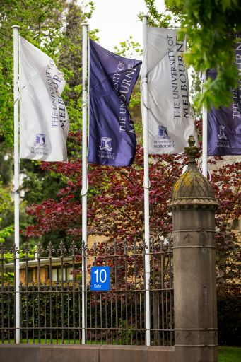
With a wide range of disciplines, the University of Melbourne currently educates over 50,000+ students from over 130 countries. The University comprises ten Academic Divisions providing learning that stimulates, challenges and fulfils the potential of excellent students from around the world, leading to personal development, meaningful careers and profound contributions to society.
The alumni network is significant and truly international, with representation from 160 countries. This international community includes former Prime Ministers, Governors General, and Nobel Laureates, and is a testament to the world-class education the University of Melbourne delivers.
*Times Higher Education World University Rankings 2021
THE MELBOURNE MODEL
Building on long-standing traditions of leadership and innovation in teaching and embracing international developments in curriculum design, the University introduced the Melbourne Model in 2008. The distinctive educational model offers degrees in three broad cycles. At Bachelor level, students select from one of six broad degrees (offering a total of 87 major fields of study) and a limited number of specialist offerings. These programs lay the intellectual foundations for future employment or further study. Most professional qualifications are subsequently offered at Masters level, where students can choose from a variety of professional or specialist graduate programs offering intensive graduate-level experiences that promote deep professional learning. At Doctoral level, students work alongside and are nurtured by international research leaders in a broad range of fields.
The Melbourne Model’s curriculum combines academic breadth with disciplinary depth to strategically reposition the University in an increasingly globalised higher education framework. The University prepares its students to enter a world marked by rapid change where graduates must possess the applicable knowledge, and flexible and adaptable skills, to succeed.

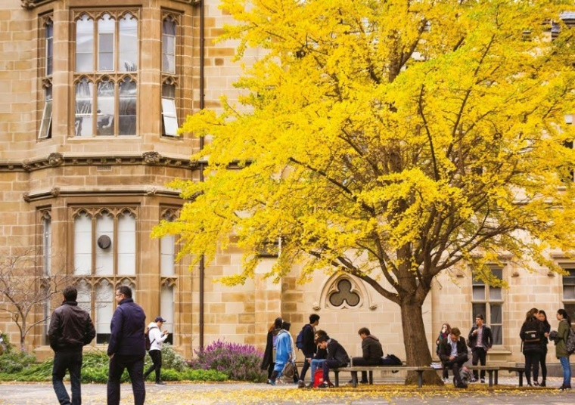
The University of Melbourne’s Strategic Plan 2020 – 2030
__
Advancing Melbourne
The University’s strategic direction is grounded in its purpose. While its expression may change, our purpose is enduring: to benefit society through the transformative impact of education and research. Together, the vision and purpose inform the focus and scale of our aspirations for the coming decade.
Advancing Melbourne reflects the University’s commitment to its people, its place, and its partners. Our aspiration for 2030 is to be known as a world-leading and globally connected Australian university, with our students at the heart of everything we do.
- We will offer students a distinctive and outstanding education and experience, preparing them for success as leaders, change agents and global citizens.
- We will be recognised locally and globally for our leadership on matters of national and global importance, through outstanding research and scholarship and a commitment to collaboration.
- We will be empowered by our sense of place and connections with communities. We will take opportunities to advance both the University and the City of Melbourne in close collaboration and synergy.
- We will deliver this through building a brilliant, diverse and vibrant University community, with strong connections to those we serve.
The means for achieving these goals include the development of the University of Melbourne’s academic and professional staff and the capabilities needed to support a modern, world class university. Those means require a commitment to ongoing financial sustainability and an ambitious infrastructure program which will reshape the campus and our contribution to the communities we engage with. This strategy, and the priorities proposed, is centred around five intersecting themes; place, community, education, discovery and global.

People and Benefits
__
The University is committed to providing an intellectually stimulating and personally rewarding workplace which attracts people who are the best in their professional, academic and teaching fields
Outstanding academic staff are at the heart of the University’s teaching, research and engagement endeavours. The University is proud of its many staff that have been recognised through prestigious national and international awards and through membership of Australia’s learned academics. Among the many scholars of international renown at the University is the winner of the Nobel Prize – Professor Peter Doherty (Physiology and Medicine) and many other public intellectuals and scientific leaders.
The Benefits
The University offers staff more than just a job – it offers them an opportunity to be part of a dynamic world class organisation which provides its staff with exceptional benefits and support at every stage of their life and career.
- Working in a culturally inclusive environment
- Engaging in an active and vibrant campus life
- A focus on health and wellbeing
- Outstanding staff benefits in addition to competitive salary packages
Staff benefits on offer at the University include the opportunity to salary package everything from childcare and additional superannuation to subscriptions to the Melbourne Theatre Company. Benefits can be tailored to best suit individual needs and circumstances, including generous relocation support.
The University also offers a family friendly environment for individuals that need increased flexibility, providing generous leave and working conditions. The University has been recognised as an employer of choice for women and is one of 40 organisations to participate in the Science in Australia Gender Equity (SAGE) pilot program of Athena SWAN in Australia.
Living and Working in Melbourne
__
Geography
Melbourne is the capital city of Victoria and the second largest city in Australia. It is set around the shores of Port Phillip Bay and sits beside the Yarra River, around five kilometres from the bay.
Melbourne is home 4.5 million people and a metropolitan area of 9990.5 km2. The Economist Intelligence Unit has rated Melbourne one of the world’s most liveable city for six consecutive years, based on its education, entertainment, health care, research and development, tourism and sport.
The City of Melbourne municipality, in which the University’s main Parkville campus is based, covers 37.7 km2 and has a population of more than 143 000 people. It includes the city centre and a number of attractive inner suburbs with thriving communities and businesses.
The City of Melbourne is home to residents from 180 countries who speak more than 233 languages and dialects and follow 116 religious faiths. The Wurundjeri, Boonwurrung, Taungurong, Dja Dja Wurrung and the Wathaurung people of the Kulin Nation are the Traditional Owners of the land now known by its European name of Melbourne.
The City of Melbourne is recognised as Australia’s cultural capital with a number of world-class galleries and museums, internationally renowned food and wine regions, and an impressive year-round calendar of events catering for all tastes.
Further Information
General Information about the University of Melbourne is available at its website www.unimelb.edu.au

About the University of Melbourne
about.unimelb.edu.au

The University of Melbourne’s Strategic Plan 2020-2030: Advancing Melbourne
https://about.unimelb.edu.au/strategy/advancing-melbourne

Annual Reports
http://annualreport.about.unimelb.edu.au

Faculty of Arts
arts.unimelb.edu.au

Research
University of Melbourne research strategy and implementation
research.unimelb.edu.au

Teaching
Teaching and Learning at the University of Melbourne
provost.unimelb.edu.au

Careers
https://about.unimelb.edu.au/careers

How to apply
Please submit your application via the University of Melbourne’s Careers page
The Faculty of Arts is committed to equity, diversity and inclusion and strongly encourages people with diverse experiences to apply. This includes First Nations people, culturally and linguistically diverse people, Deaf and hard of hearing people, people with a disability, LGBTIQ+, and neurodiverse people. If you have any accessibility requirements for the application or interview, please contact us. We are dedicated to ensuring barrier free and inclusive practices to recruit the most talented candidates. A position description is available in alternate formats if required, including USB, Large Print and Plain English.

ENQUIRIES
Contact for enquiries only, please do not send our application to this contact
NAME Dr Elizabeth Lakey
TELEPHONE 8344 9476
EMAIL elizabeth.lakey@unimelb.edu.au

