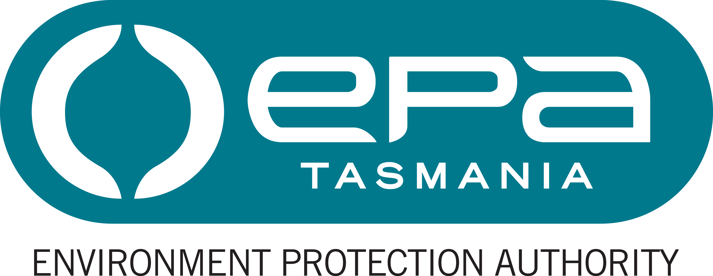
Environment Protection Authority

Section Manager, Northern Regulation

Statement of Duties

Position Number: 707614
Branch/Section: Industrial Regulation / Northern Industrial Regulation
Award/Agreement: Tasmanian State Service Award
Classification: General Stream, Band 7
Position Status: Fixed Term
Full Time Equivalent (FTE): 1.0 FTE (or part time hours, by negotiation)
Ordinary hours per week: 36.75 hours (or part time hours, by negotiation)
Location: Launceston or Devonport
Reports to: Manager, Industrial Regulation

Position Purpose
Manage the human, physical, financial and information resources of the Northern Industrial Regulation Section of the Industrial Regulation Branch to ensure that the activities that are regulated by the Section are assessed and managed in accordance with the requirements of the Environmental Management and Pollution Control Act 1994 and Government policy.
Provide a significant contribution to the overall business planning, development of procedures, effective management and future directions of the Industrial Regulation Branch.

Major Duties
- Manage the human, physical, financial and information resources of the Section to ensure the highest priority regulatory and policy development programs are delivered on time and within budget. Provide leadership, direction and mentoring to staff of the Section as appropriate.
- Provide strategic policy advice and authoritative professional advice to senior management, the Director, Environmental Regulation, Director, Environment Protection Authority and Board of the Environment Protection Authority on best practice environmental management and regulatory issues that impact on corporate objectives and Government policy.
- Exercise professional judgement in the implementation and management of the statutory system for the regulation of environmentally significant matters and activities for which the Section has responsibility.
- Ensure that the environmental regulation is carried out efficiently and effectively and in accordance with Government policy. Interpret policies, regulations and guidelines to provide advice to staff and senior management that is consistent with the policies and strategies of the Division.
- As an active participant and member of the Operations Management Team contribute to policy development, operational management, strategic planning and future directions.
- Represent the EPA, the Department and Government in a range of committees and forums at a State and National level and at the Resource Management and Planning Appeal Tribunal.
- Undertake emergency management activities including training and, commensurate with that training and relevant experience, participate in response to incidents, particularly for matters for which the EPA is the lead agency or otherwise responsible for contributing relevant staff resources.

Responsibility, Decision Making and Direction
The occupant of the position is responsible for:
- efficient and effective program or service delivery including budget management, optimising use of resources and maintaining and/or modifying policy, administrative processes and research projects. This includes planning future activities, negotiating for appropriate resources and determining measures for accountability;
- managing the performance and development of staff;
- the development of strategy, policy or program implementation especially with regard to new developments; with responsibility shared with relevant specialists and executive management for; and
- ensuring a safe working environment by complying with relevant Work Health and Safety (WHS) legislation, codes of practice and policies, procedures and guidelines issued under the EPA’s WHS Management System, and for promoting the principles of managing diversity.
The decision making and direction received in relation to the role are that:
- the occupant operates with considerable autonomy and is required to provide leadership regarding the design, development and operation of function and/or program activities;
- guidance and instruction may on occasion be received on the implementation of highly technically complex modification that provide solutions consistent with policy, regulatory and/or technological requirements and developments; and
- the occupant defines core program and service delivery issues to develop options and recommendations for operational change and/or new research projects.

Knowledge, Skills and Experience (Selection Criteria)
(in relation to the Major Duties)
- High level knowledge, expertise and extensive experience in the scientific and regulatory aspects of environmental management.
- High level knowledge, expertise and extensive experience in developing and implementing strategic plans and work plans.
- Highly developed management skills and expertise to lead an operational unit. An understanding of contemporary management practices and demonstrated experience and the ability to mentor and role-model less qualified or less experienced staff.
- The ability to communicate and provide authoritative advice on complex matters to non-specialists, high level liaison, presentation and conflict resolution skills and the capacity to represent the EPA.
- Highly developed conceptual and reasoning skills to research, investigate, analyse, evaluate and integrate relevant solutions from related disciplines or fields in the area of activity. Flexibility, creativity and innovation associated with research, investigative, analytical and appraisal skills.
- Demonstrated capacity to plan, organise, schedule and deliver, own outputs and those of a team, within set timeframes to achieve results particularly in a changing environment; project management experience with a knowledge and understanding of contemporary project management practices.

Position Requirements
Desirable Qualifications and Requirements
- A degree in Science or Engineering or an equivalent qualification from a recognised tertiary institution.
- A current driver’s licence.
- Several years relevant post qualification experience.

The EPA’s Role
The Environment Protection Authority is Tasmania’s principal environmental regulator. The EPA administers the Environmental Management and Pollution Control Act 1994 and is an integral part of Tasmania's Resource Management and Planning System.​
The EPA’s purpose is to regulate developments and activities that may impact on environmental quality and to promote best practice, sustainable environmental management. Its goals are clean air, clean water, clean land, acceptable noise levels and sustainable use of resources.
The EPA comprises a Board and Director, supported by staff. Both the Board and the Director exercise powers at arm's length from State Government and have independent statutory powers under the Act.
Under Tasmania’s emergency management arrangements, the EPA is the management authority (lead agency) for various aspects of emergencies including marine pollution spills. Emergency prevention, preparedness and response activities are core business of this agency and potentially may involve all staff in some way.
The EPA website at epa.tas.gov.au provides more information.

Working Environment
Employees work within an environment that supports safe work practices, diversity and equity with employment opportunities and ongoing learning and development. We are committed to valuing and respecting each other as colleagues and peers. We value the diverse backgrounds, skills and contributions of all employees and treat each other and our customers with respect. We do not tolerate discrimination, harassment or bullying in the workplace.
The Environment Protection Authority has a culture of zero tolerance towards violence, including any form of family violence. We will take an active role to support employees and their families by providing a workplace environment that promotes their safety and provides the flexibility to support employees to live free from violence.
There is a strong emphasis on building leadership capacity throughout the EPA.
The expected behaviours and performance of the EPA’s employees and managers are enshrined in the State Service Act 2000 through the State Service Principles and Code of Conduct. These can be located at www.dpac.tas.gov.au/divisions/ssmo.

