**Senior Dietitian**

Role Description

|  |  |  |  |
| --- | --- | --- | --- |
| **DIVISION / MATER MINISTRY** | Mater Health | | |
| **LOCATION** | Newstead and South Brisbane | | |
| **REPORTING RELATIONSHIPS** | Reports to: Team Leader Dietetics | | |
| **LEVEL OF ACCOUNTABILITY** | Team Member | | |
| **SALARY** | HP4 | | |
| **EMPLOYMENT STATUS** | Enterprise Agreement - HP | | |
| **TRAVEL REQUIREMENTS** | ☐ Yes | ☐ No | ☒ If required |
| ☐ Frequently | ☒ Infrequently |  |
| **EMPLOYMENT CONDITIONS** | ☒ Vaccination Category 1A | | |
| **DATE CREATED** | February 2023 | | |

**POSITION SUMMARY**

The purpose of this role is to:

* Deliver high level evidence based Nutrition and Dietetic clinical services of a complex and varied nature within the Department of Dietetics and Foodservices and as a member of multidisciplinary teams across Mater Health.
* Be responsible for the service delivery across one or more clinical areas to ensure clinical standards are maintained and quality and service improvement initiatives are delivered.
* Contribute to the professional development of staff within the Dietetics and Foodservices department, including the provision of professional mentoring and supervision for less experienced clinicians.

**ORGANISATIONAL OVERVIEW**

Mater is Queensland’s largest and most innovative not-for-profit healthcare service, providing care for almost 700,000 patients a year across a network of 11 hospitals. We are a leader in healthcare, education and research — and that’s because we employ exceptional people.

Delivering quality, compassionate care, in line with Mater’s Mission and Values, we are an employer of choice, committed to enabling our people with the supports they need to deliver a world-class service for our patients. They are at the heart of what we do, and we recognise they are what differentiates the Mater experience within our community.

**MISSION, VISION, AND VALUES**

We are our Mission. For more than a century, we have existed to respond to unmet community need; to provide compassionate care to those who need it most. Our Mission, Vision and Values are our constant guide to make appropriate decisions for a sustainable, socially relevant service that is genuinely committed to the delivery of a healthy community for everyone.

All Mater team members are required to adhere to relevant professional standards and the Mater behavioural standards, including those that support the Mater Mission, Vision, and Values, and promote an ethical environment in accordance with the Code of Conduct. In doing so, it is expected team members will hold both themselves and others to account for these standards, with a focus on maintaining the quality and safety of services in which we provide across the state.

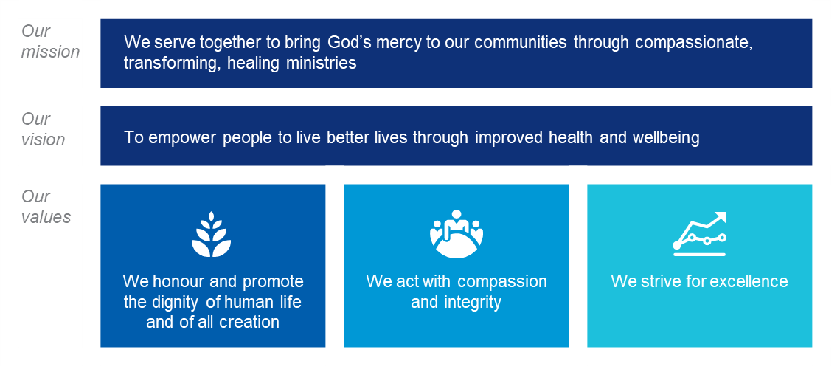

**ORGANISATIONAL ALIGNMENT**

The Mater Capability Framework consists of six core capability groups, which encompass the individual capabilities and behaviours essential to driving performance excellence across our organisation: Personal Attributes, Build Relationships, Results Focused, Mission Drivers, Business Enablers, and Leadership and People Management. Each Mater team member is accountable for consistently performing, promoting and developing the capabilities and behaviours within the Capability Framework - as individuals and as a team.

***Position’s required proficiency of Mater’s Capability Framework:***

Foundation

Proficient

Skilled

Expert

**Our six core capability groups**

**Leading self -**

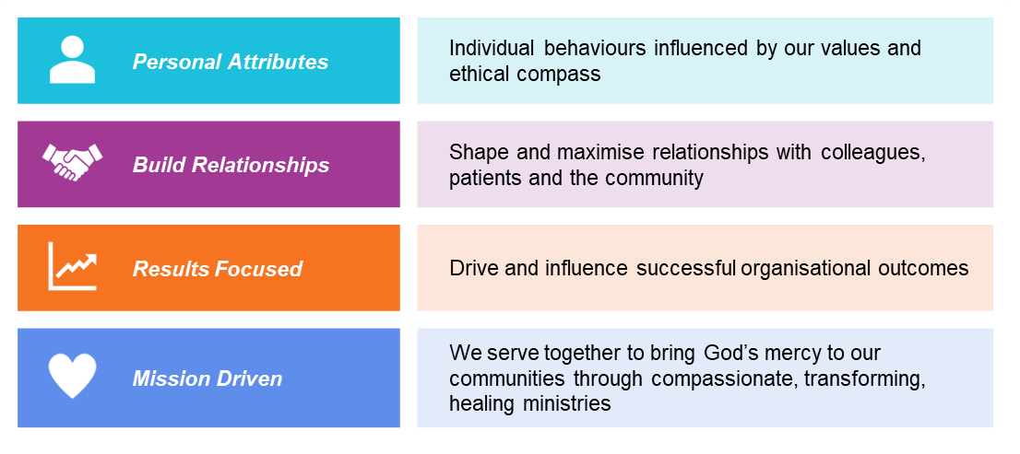

**Leading others -**

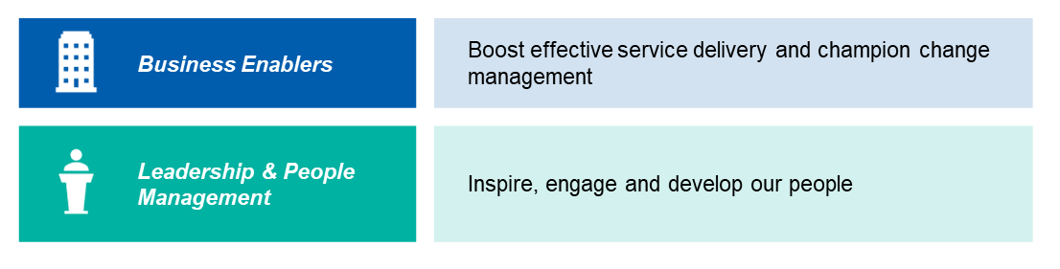

**KEY PERFORMANCE REQUIREMENTS**

Mater requires every Mater Person to understand and deliver on a series of accountabilities that are linked to the Mater strategy, described in the table below. Each Mater Person is held accountable for their own behaviour, performance and development, and for contribution to the strategic objectives and priorities. In addition, Mater managers and leaders are accountable to different extents for clinical outcomes, service and operational outcomes, financial outcomes, compliance and risk, interprofessional leadership and management of performance and accountability. This role is responsible for fulfilling the following accountabilities.

***Position-specific responsibilities***

**Clinical outcomes**

* Manage an allocated clinical workload to deliver high level Nutrition and Dietetic services to patients across Mater Group and across the continuum of care, within a multidisciplinary team environment, in accordance with professional and ethical standards
* Undertake high level Nutrition and Dietetic duties within the work unit, applying independent professional judgement to a complex caseload and adapting routine clinical practice based on valid and reliable evidence, with infrequent need for direct clinical practice supervision.
* Initiate and actively contribute to clinical research activities and/or translating research in to practice and have demonstrable outcomes.
* Apply high level communication skills with patients, colleagues and other stakeholders.

**Service and operational outcomes**

* Identify and contribute to the development of evidence based clinical practice, procedures, protocols and education materials at a local and state-wide level to improve the delivery of Nutrition and Dietetic services and support the continuum of care and the provision of a multi-disciplinary health service.

**Interprofessional leadership**

* Represent Mater on relevant local and state-wide networks, committees and professional groups as appropriate and requested by manager.
* Provide clinical advice and direction to a team of Dietitians delivering evidence based clinical services across clinical areas within the stream structure including monitoring and reporting on clinical practices, outcomes and activities that may lead to the identification and implementation of service improvement initiatives that enhance the delivery of Dietetic services and patient outcomes, under the direction of manager.
* Provide clinical education and supervision including lectures/ tutorials and assessment of students, and clinical practice supervision and performance development plans to less experienced practitioners, to ensure the maintenance of professional clinical standards for Nutrition and Dietetics.

**Performance and accountability**

* Provide general clinical advice regarding the operational processes and evidence based service delivery standards of the work team/s to senior managers and other relevant stakeholders.
* Develop clinical practice knowledge and expertise through actively engaging in professional development activities and participating in local professional development, and local/ state-wide/ national workshops or conferences and participating in the DAA APD program and Mater performance appraisal and development plans.
* Possess a broad understanding of the continuum of care and the organisational provision of multidisciplinary health services and contribute to the development of policies, procedures and plans for the work team that are consistent with the achievement of Dietetic service delivery objectives.

**KEY RELATIONSHIPS**

|  |  |
| --- | --- |
| **Internal** | **External** |
| * Reports to Team Leader Dietetics * Works closely with Senior Dietitians | * Universities and professional colleges * Professional bodies * Government, non-government and statutory agencies * Internal and external auditors * Represent the organisation in appropriate external forums and groups as appropriate * Other key external stakeholders and bodies as appropriate |

**SELECTION CRITERIA**

|  |  |
| --- | --- |
| **Qualifications** | |
| The successful applicant must possess tertiary qualifications in Nutrition and Dietetics and have Accredited Practising Dietitian (APD) status (or Provisional APD status as appropriate). | |
| **Skills, knowledge and experience** | |
| * Demonstrated high level of knowledge, expertise and skill in one or more areas of Nutrition and Dietetics. * Demonstrated ability to provide clinical services of a complex nature, where established principles, procedures and methods require some expansion, adaptation or modification. | * Demonstrated ability to initiate, plan and evaluate evidence based service improvement initiatives and /or research activities and provide clinical supervision and performance development to less experienced dietetic staff within your team. * Demonstrated ability to provide advice to professional supervisors, managers and other senior clinicians regarding evidence based service delivery and improvement opportunities. |

**THE POSITION WITHIN OUR ORGANISATIONAL STRUCTURE**

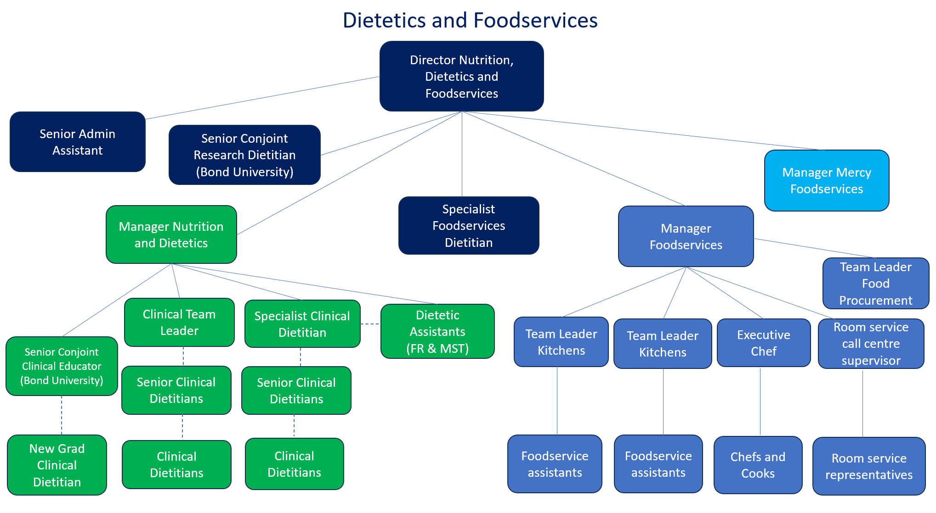

**WHY WORK FOR US?**

We offer salary packaging, career progression, flexible working hours and leading training and skills development.

As an equal opportunity employer, we value diversity and are committed to fostering a workplace that is respectful, welcoming and inclusive; where people are supported to draw strengths from their identity, culture and community. We value the integral dignity of each person and we encourage all applications.