Position Number: XXXXX
Position Title: HR Consultant
Date Written: March 2018
Faculty / Division: Human Resources
School / Unit: HR Business Partnering
Position Level: Level 7/8

ORGANISATIONAL ENVIRONMENT

UNSW is currently implementing a ten year strategy to 2025 and our ambition for the next decade is nothing less than to establish UNSW as Australia’s global university. We aspire to this in the belief that a great university, which is a global leader in discovery, innovation, impact, education and thought leadership, can make an enormous difference to the lives of people in Australia and around the world.
Following extensive consultation in 2015, we identified three strategic priority areas. Firstly, a drive for academic excellence in research and education. Universities are often classified as ‘research intensive’ or ‘teaching intensive’. UNSW is proud to be an exemplar of both. We are amongst a limited group of universities worldwide capable of delivering research excellence alongside the highest quality education on a large scale. Secondly, a passion for social engagement, which improves lives through advancing equality, diversity, open debate and economic progress. Thirdly, a commitment to achieving global impact through sharing our capability in research and education in the highest quality partnerships with institutions in both developed and emerging societies. We regard the interplay of academic excellence, social engagement and global impact as the hallmarks of a great forward-looking 21st century university.
To achieve this ambition we are attracting the very best academic and professional staff to play leadership roles in our organisation.

UNSW BEHAVIOURS

UNSW BEHAVIOURS
UNSW recognises the role of employees in driving a high performance culture. The behavioural expectations for UNSW are below.
Please refer to the UNSW Behavioural Indicators for the expectations of your career level (intermediate)

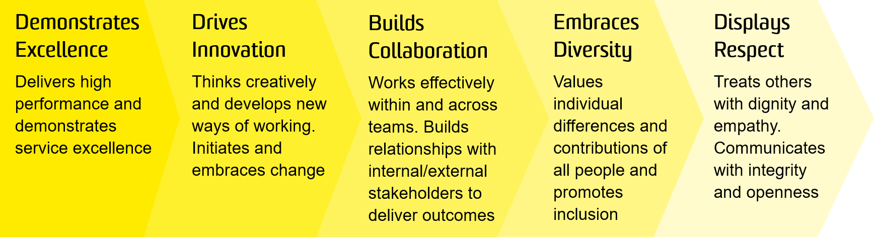

OVERVIEW OF RELEVANT AREA AND POSITION SUMMARY

The Human Resources (HR) function of UNSW exists to deliver strategic and operational HR support to all staff within UNSW. This includes the development and implementation of policies, frameworks and tools to support all aspects of the employee lifecycle including recruitment, on-boarding, organisational development, health and safety and career planning.
The People & Culture (P&C) team is responsible for providing operational support and advice regarding people and HR activities along with general employee support. The HR Consultant is a member of the HR Business Partnering team within the P&C portfolio, which is responsible for the delivery of strategic and operational HR support for all our employees. The team lead the way in providing advice and support to Leaders around all aspects of the employee lifecycle. The HRBP team support all employees across UNSW faculties and divisions, partner with the HR centres of expertise in ensuring all UNSW employees are supported in delivering the 2025 strategy. The HR Consultant reports to a HR Business Partner.

RESPONSIBILITIES
As the HR Consultant, your key responsibilities are to:

Level 7

- Work with the HR Business Partner to support the education and development of staff and manager capability in HR matters.
- Support the HR Business Partner in managing workplace change processes, staff complaints, performance management or other complex issues as required.
- Work collaboratively with the HR Business Partner and clients to develop, apply and implement creative/innovative HR solutions to help clients achieve their business objectives.
- Effectively assist Leaders with remuneration initiatives including job analysis, position evaluation and reclassification processes.
- Collaborate across the HR function to deliver a One HR service;
- Responsible for managing the operational HR service delivery to the client group and ensuring clients needs are met
- Provide expert HR advice and assistance to clients on HR policy and procedures in line with Enterprise Agreements and coordinate the provision of advice from specialist HR teams. Ensure that a high degree of sensitivity and confidentiality is maintained at all times.
- Accurate and timely completion of a broad range of HR administration related to the staff life cycle (entry through to exit) including offers of employment, fixed term contract reviews, variations, and terminations, including associated matters such as visa and relocation
- Actively contribute to the continuous improvement of HR processes, procedures and policy and participate in HR projects in collaboration with other HR staff and clients.
- Provide effective HR reporting and analysis as required.

Level 8 (in addition to Level 7 above)

- Effectively manage HR initiatives within the client group, such as, people initiatives related to the 2025 UNSW Strategy, performance development processes, equity and diversity programs and annual leave management.
- Liaise with UNSW Strategy Office to influence delivery of change at the faculty level with the work stream initiatives.
- Participate in the design and overall implementation of various change initiatives within the respective faculty.
- Act with a higher degree of independence in providing HR advice and assistance to clients and also in managing complex issues such as workforce planning, workplace change, staff complaints performance management with minimal direction.
- Support the HR Manager in the review, development and implementation of innovative and creative HR strategies and programs to build capability either within the client group or on an organisational level.
- Proactively partner with clients to provide effective HR solutions that are aligned to the business priorities of the portfolio and enable clients to achieve business objectives.
- Cooperate with all health and safety policies and procedures of the university and take all reasonable care to ensure that your actions or omissions do not impact on the health and safety of yourself or others.

SELECTION CRITERIA

Level 7

- A relevant Degree with extensive HR experience or an equivalent level of knowledge gained through any other combination of education, training and experience.
- Experience in interpreting legislation and Industrial Agreements together with policy and procedure to provide effective HR advice and solutions for client groups.
- Outstanding written and verbal communication skills with strong attention to detail and ability to prioritise and control workload with a positive sense of initiative.
- A strong customer service focus, a flexible and adaptable attitude and an ability to build effective relationships with managers and staff at all levels in the resolution of HR issues.
- Ability to contribute to the development and implementation of HR initiatives to meet the needs of the organisation.
- Effective computer literacy with excellent skills in Microsoft Office applications
- Knowledge of health and safety responsibilities and commitment to attending relevant health and safety training.

Level 8

- Proven ability to influence senior management and stakeholders as appropriate to ensure successful outcomes.
- Strong business acumen and a demonstrated capability to identify and deliver high level HR support required in the achievement of business objectives.
- Ability to manage more complex HR issues with minimal direction.
- Ability to apply judgement, creativity and flexibility to generate new and innovative ideas and approaches and to solve complex problems.
- Well-developed project management skills.

It is not the intention of the position description to limit the scope or accountabilities of the position but to highlight the most important aspects of the position. The aspects mentioned above may be altered in accordance with the changing requirements of the role.

