

|  |
| --- |
| **Position Description** |

|  |  |
| --- | --- |
| **Lecturer, Computer Science and IT** | |
|  |  |
| **Position No:** | NEW |
| **Business Unit:** | Provost |
|  |  |
| **School:** | School of Computing, Engineering and Mathematical Sciences |
| **Department:**  **Classification Level:** | Computer Science and IT  Level B Teaching & Research |
| **Employment Type:** | Full-Time, Continuing |
| **Campus Location:** | Melbourne (Bundoora) |
| **Other Benefits:** | <http://www.latrobe.edu.au/jobs/working/benefits> |

Further information about:

La Trobe University - <http://www.latrobe.edu.au/about>

**Position Context/Purpose**

This position is located at the Bundoora Campus in the Department of Computer Science and Information Technology (CSIT), part of the School of Computing, Engineering and Mathematical Sciences in Melbourne (Bundoora) campus. The school has three departments: Computer Science and Information Technology, Engineering, and Mathematical and Physical Sciences on both the Melbourne (Bundoora) and Bendigo campuses. The school hosts four Research Centres: The Centre for Technology Infusion (CTI), the CISCO Latrobe Centre for Artificial Intelligence and Internet of Things, the Centre for Materials and Surface Science, and ACAMI (Australian Centre for AI in Medical Innovation). The school has a reputation for innovative course design, the maintenance of a supportive student-centred learning environment and an outstanding research profile. The school offers a range of general and specialist undergraduate and postgraduate courses that are rigorous, attuned to emerging trends and taught by staff at the forefront of their fields.

The Department of Computer Science and Information Technology undertakes a wide range of teaching and research programs in the area of internet of things, data sciences, computational intelligence, software engineering, cybersecurity and mobile and wireless networks and offers a range of undergraduate and postgraduate courses that are rigorous and attuned to meeting the needs of students in ensuring their readiness to work in changing environments.

The Department is committed to the development and exploration of new and innovative teaching and research programs which drives opportunities for multidisciplinary collaboration across the School/College and the University. Coursework programs in the department are accredited by the Australian Computer Society. The Computer Science discipline is also ranked highly across QS and Time Higher Education international subject ranking. Over the years, the Department has produced a comparatively large number of PhD graduates. Graduates of the Department are now in the faculties of universities world-wide as well as holding key positions in industry globally.

*The Department is seeking a Level B staff member with proven teaching competencies in AI, Data and Cloud Technologies, and Programming Languages. Given the School's expanding research strength in AI for health and medical innovation, we aim to appoint a candidate with research expertise in AI applications for the medical and health sectors.*

La Trobe is a participant in the Athena SWAN Charter to enhance gender equality in Science, Technology, Engineering, and Mathematics disciplines. As such, we especially encourage female applicants to apply.

**Duties at this level will include:**

* Develop, coordinate and teach a high-quality learning experience that engages students through the conduct of tutorials, practical classes, demonstrations, workshops, student field excursions, clinical sessions and/or studio sessions.
* Demonstrate a scholarly approach to learning and teaching and contribute to disciplinary teaching pedagogy and research.
* Participate in innovative course level curriculum design, development and review.
* Conduct and publish, or otherwise disseminate high quality and/or high impact research as a member of a team or independently and produce conference/seminar papers and publications from that research.
* Contribute to a robust and ambitious research culture by participating in writing up research findings for publication and dissemination.
* Co-supervise or, where appropriate supervise Higher Degree by Research (HDR) postgraduate students as required.
* With mentoring support, obtain necessary research funding from external funding sources.
* Undertake other duties and administrative functions commensurate with the classification and scope of the position as required by the Head of Department or Dean.

**Essential Criteria**

**Skills and knowledge required for the position**

* PhD or equivalent accreditation and standing recognised by the University/profession as appropriate for the relevant discipline areas.
* Demonstrated competence in teaching and curriculum development.
* Evidence of high quality and/or high impact research conducted and published in the areas of Artificial Intelligence, Big data and Cloud technologies, and the Application of AI in multi-disciplinary areas, relative to opportunity.
* Demonstrated ability to supervise, or co-supervise, honours and postgraduate students.
* Sound analytical skills with an ability to communicate complex information clearly both verbally and in writing.
* High level organisational skills with the ability to set priorities, meet deadlines, initiate and follow-up actions, all with minimal or no supervision.
* High level verbal and written communication skills, including the ability to interact effectively with people from a diverse range of backgrounds.
* Demonstrated ability to work collaboratively and productively with staff and students from a diverse range of backgrounds.
* Experience in the preparation of research proposal submissions to external funding bodies and evidence of success in securing research funding.
* Demonstrated competencies to teach in the areas of AI, Data and Cloud Technologies, and Programming languages.

**Capabilities required to be successful in the position**

* Ability to demonstrate self-awareness, see things from another person’s perspective and actively seek out and act on feedback to improve knowledge, skills and behaviour.
* Ability to work collaboratively, recognise the value of diversity and model accountability, connectedness, innovation and care.
* Ability to cultivate and create space for creativity, continuously reviewing and identifying improvements to local work practices.
* Ability to build a culture of continuous improvement, implementing ideas generated by team members.

**Essential Compliance Requirements**

To hold this La Trobe University position the occupant must:

* hold, or be willing to undertake and pass, a Victorian Working With Children Check; AND
* take personal accountability to comply with all University policies, procedures and legislative or regulatory obligations; including but not limited to TEQSA and the Higher Education Threshold Standards.

**Other Information**

The position description is indicative of the initial expectation of the role and subject to changes to University goals and priorities, activities or focus of the job.

**Position Flexibility**

We offer flexible work arrangements that can assist you in balancing your work and other responsibilities.

**Why La Trobe:**

* Develop your career at an innovative, global university where you’ll collaborate with community and industry to create impact.
* Enjoy working on our inspiring and stunning campuses – the perfect hub for industry, students and academics
* Help transform the lives of students, partners and communities now and in the future

This is more than just a job. Working at La Trobe offers opportunities to demonstrate excellence and transform lives.

Here, you’ll join exceptional people, partners and communities, who power our operations with ambition and purpose.

Our success can be attributed to its strong sense of community. We have a long-standing commitment to diversity, inclusion and social justice; we are committed to providing a workplace where all staff feel valued, respected and supported to achieve their full potential. We strive to build a workplace where all employees of diverse backgrounds, abilities, experiences, sexuality, gender, religion and age are welcome, valued, respected and one that is representative of our community. We demonstrate our cultural qualities by holding ourselves accountable and creating a culture of trust and innovation while genuinely caring for one another.

**La Trobe’s Cultural Qualities:**

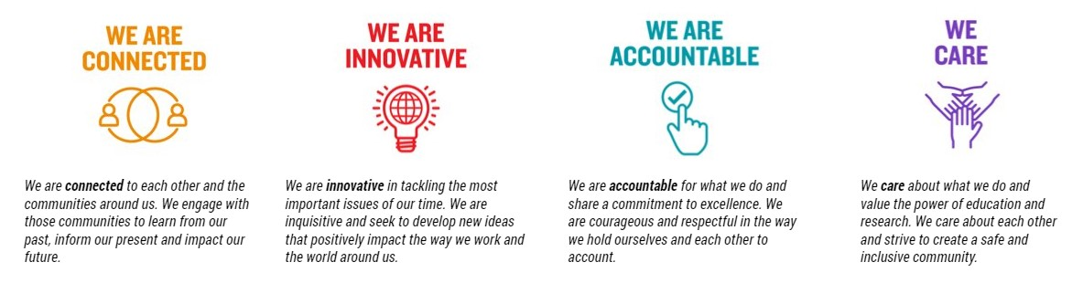

For Human Resource Use Only

Initials: Date: