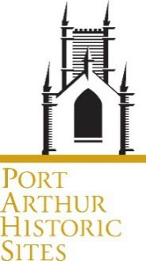 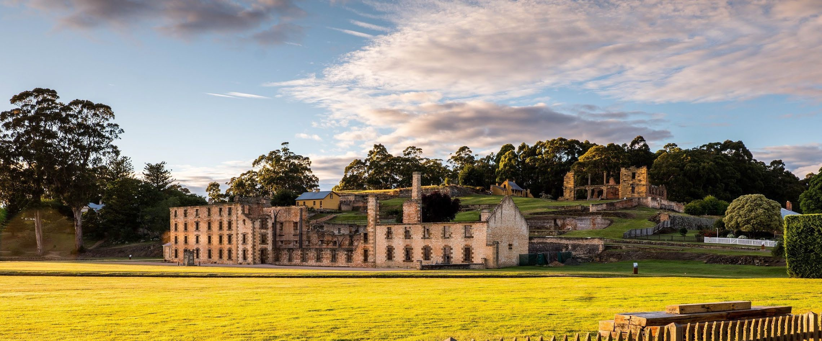

Position Description

|  |  |
| --- | --- |
| **Award** | Port Arthur Historic Site Management Authority Award |
| **Classification** | General Stream Band 3 |
| **Position Title** | **Painter** |
| **Employment Status** | Permanent Full Time |
| **Hours of work per week** |  |
| **Division** | Conservation and Infrastructure |
| **Position Reports to** | Works Co-ordinator |
| **Location** | Port Arthur (Head Office) and Hobart, Tasmania  Flexible work arrangements will be considered, if appropriate and possible. |

*It is strongly recommended when applying for positions with the Port Arthur Historic Site Management Authority (PAHSMA) that the Position Description is read in conjunction with the Information for Applicants document.*

# Position Overview

Perform a wide range of high quality, specialised painting tasks that support maintenance, improvement, new works, development and conservation at PAHSMA. Apply heritage conservation principles and practices that enhance the conservation of heritage values at our PAHSMA sites and ensure our significant heritage is properly managed and protected for future generations to enjoy.

**Key Deliverables (Statement of Duties)**

Using qualified and specialised trade skills, work under general instruction and exercise independent judgement and initiative to provide high quality work, resolve issues and satisfy client and stakeholder requirements.

* Working co-operatively and professionally, perform high quality surface preparation, painting work and finishing to maintain and conserve our natural and cultural landscapes and historic buildings and structures**.**
* Using good judgement and expertise apply traditional trade practices, materials and techniques for conservation, repair, and restoration to ensure PAHSMA’s heritage values are maintained.
* Safely operate and maintain tools, equipment and plant associated with programmed trade works, keep workspaces and tools clean. Advise the supervisor promptly of any potential hazard in the workplace
* Provide clear instruction, guidance, feedback, coaching and on-the job training to new, less qualified or experienced team members and work placement students and assist other staff in the C&I team.
* Assist in the completion of semi-skilled trade work and undertake a variety of tasks for the Building & Works Supervisor and/or the Works Manager.
* Liaise regularly and constructively with other team members, as well as internal and external stakeholders in a professional manner that supports information sharing and increases work efficiency and quality.
* Contribute to building and maintaining a positive, collaborative, open, respectful, supportive and high performance workplace culture across the C&I team.
* Other duties as required and directed from time to time.

*Duties should be reviewed and updated periodically to reflect changes in the role and to align with priorities*.

**Capabilities & Attributes (Selection Criteria)**

* Demonstrated trade knowledge and experience with relevant painting practices, materials and techniques.
* Understanding of contemporary heritage repair, conservation principles and practices.
* Working knowledge of workplace health and safety practices and proven ability to safely use and maintain relevant tools, plant and equipment.
* Good communication and team skills and the ability to work well independently and with diverse people and groups and to maintain a commitment to good client service.
* Sound organisational skills and the ability to plan and prioritise your work and complete tasks to a high standard in a timely and accurate manner.

## Vaccinations/Health Surveillance

The following is recommended for this position:

* Tetanus vaccination
* Audiometric testing at commencement of employment and thereafter at least every two years.

## Qualifications and Requirements:

Essential:

* Certificate III in a relevant trade or equivalent
* Construction Industry White Card
* Current Driver’s Licence

### Working in our team

The work we do is important for managing, maintaining and conserving PAHSMA’s heritage. No two days are the same, so we are flexible and adaptable. We are outcome focussed and have a diverse range of skills in our team.

Teamwork, resilience and good communication and collaboration are key to our success. We are agile and adopt a can do approach. We support each other by stepping up and sharing the load. We work collaboratively with other work areas to achieve our goals. We acknowledge how people achieve as well as what they achieve.

Respect is a key value for us. We strive to be a high performing innovative workplace. Creative problem solving skills are an asset in our team. We encourage collaboration and constructive feedback. We keep each other updated on issues and progress. Every job in our team is connected to other jobs and teams. We value diversity and inclusion and the different perspectives people bring to our team. We are all accountable and responsible for the team and to the team.

### Assessing candidates

The position overview and deliverables, capabilities and attributes outline the key skills, knowledge, experience, behaviours and attitudes required to successfully fulfil the responsibilities, duties and expectations of the position.

They also provide a measure against which candidates will be evaluated throughout the selection and appointment process and enable PAHSMA to assess the overall and comparative suitability of candidates.

# Working at PAHSMA

### About Us

[Port Arthur Historic Site Management Authority (PAHSMA)](https://www.bing.com/ck/a?!&&p=0c40fe3cd6df51b3JmltdHM9MTY5NTE2ODAwMCZpZ3VpZD0xMWIyYWY0Yi03NWFlLTZhMTgtMTVkZi1iZDhlNzQ0NDZiOGUmaW5zaWQ9NTIyNQ&ptn=3&hsh=3&fclid=11b2af4b-75ae-6a18-15df-bd8e74446b8e&psq=port%2Barthur%2Bhistoric%2Bsite&u=a1aHR0cHM6Ly9wb3J0YXJ0aHVyLm9yZy5hdS8&ntb=1) is responsible for the conservation and development of visitor experiences at three of the eleven sites which make up the UNESCO Australian Convict Sites World Heritage Property inscribed in 2010.

The [Port Arthur Historic Sites](https://portarthur.org.au/) are important places of outstanding heritage value at local, state national and international level. They form part of the Australian Convict Sites World Heritage Property and are major Tasmanian tourist attractions, which receive visitors from all walks of life and all parts of the world.

Our three sites are located in southern Tasmania

* + Port Arthur Historic Site
  + Coal Mines Historic Site, Saltwater River
  + Cascades Female Factory, Hobart

The sites tell unique aspects of the global story of forced migration of convicts by the British Empire. They help Australians and international visitors to understand the history of Australia – from the ongoing custodianship of the Palawa people before, during and after invasion, through the colonial period and convictism to the terrible events of 1996 that occurred at Port Arthur.

Our sites are important places for our communities to talk about and understand our complex history and build a better understanding for the future. They are places of history, learning and conversation – and they belong to the people of lutruwita/Tasmania, Australia and the world.

We are known as experts in conserving our heritage and convict history – and we share this deep knowledge with visitors and the world.

Read our [2023-28 Strategic Plan](https://portarthur.org.au/wp-content/uploads/2023/09/PAHSMA_Strategic-Plan_2023.pdf) to find out more.

### Our Expectations

PAHSMA People must meet high standards of behaviour and conduct and align with the organisation’s requirements and expectations, including but not limited to those outlined in this PD.

PAHSMA does not tolerate discrimination, harassment, sexual harassment, bullying or victimisation in the workplace or toward colleagues anywhere at any time. We have a culture of zero tolerance towards violence, including any form of family violence. We will take an active role to support employees and their families by providing a workplace environment that promotes their safety and provides the flexibility to support employees to live free from violence.

PAHSMA expects everyone to:

* understand and comply with all policies, procedures, standards and reasonable directions including in relation to the *Port Arthur Historic Site Management Authority Award*, the *Port Arthur Historic Site Management Authority Act 1987*, and our Emergency Management Plan;
* take reasonable care to protect the safety, health and welfare of self and others in the workplace including by adhering to occupational health and safety legislation and requirements including but not limited to: exercise reasonable care in the performance of duties; comply with all Work Health & Safety (WHS) policies, procedures and requirements; report and document all accidents/incidents; and, be aware of procedures in the Emergency Management Plan;
* model a high standard of ethical and respectful behaviours and attitudes consistent with PAHSMA Values and Tasmanian State Services Principles and Code of Conduct, PAHSMA policies and expected professional standards; and contribute towards a positive and result focussed workplace culture and visitor experience;
* support diversity and inclusion and uphold the principles of fair and equitable access to employment, promotion, personal development, and training;
* participate actively and constructively in performance management and professional development activities; and be agile, resilient and willing to take on new activities as needs, jobs and workplaces evolve.
* ensure the Sites are presented to the highest standard, to support the protection of the heritage fabric of the sites against vandalism or damage.

**Our Values**

|  |
| --- |
| **Unity**  We work as one to achieve PAHSMA’s Vision and Purpose |
| **People Matter**  We acknowledge and show respect to our people – past, present and future |
| **Accountability**  We hold ourselves, and each other, accountable for our actions and behaviours |
| **Passion & Pride**  We are committed to being world class |

*Port Arthur Historic Site Management Authority recognises the deep history and culture of lutruwita/Tasmania.*

*We acknowledge the Palawa people, the traditional owners of the Land upon which we work. We acknowledge and pay our respects to all Aboriginal Communities – all of whom have survived invasion and dispossession and continue to maintain their identity and culture.*

|  |  |  |  |
| --- | --- | --- | --- |
| **Endorsed by Head of People & Culture** | | **Approval by CEO** | |
|  | |  | |
| **Date:** |  | **Date** |  |

|  |  |  |  |
| --- | --- | --- | --- |
| **Version Control** | | | |
| **Position Number/s** | **Date of original version** | **Version Number** | **Date of this version** |
|  |  |  |  |

|  |  |
| --- | --- |
| **General inquiries** | Email [recruitment@portarthur.org.au](mailto:recruitment@portarthur.org.au) or visit portarthur.org.au |