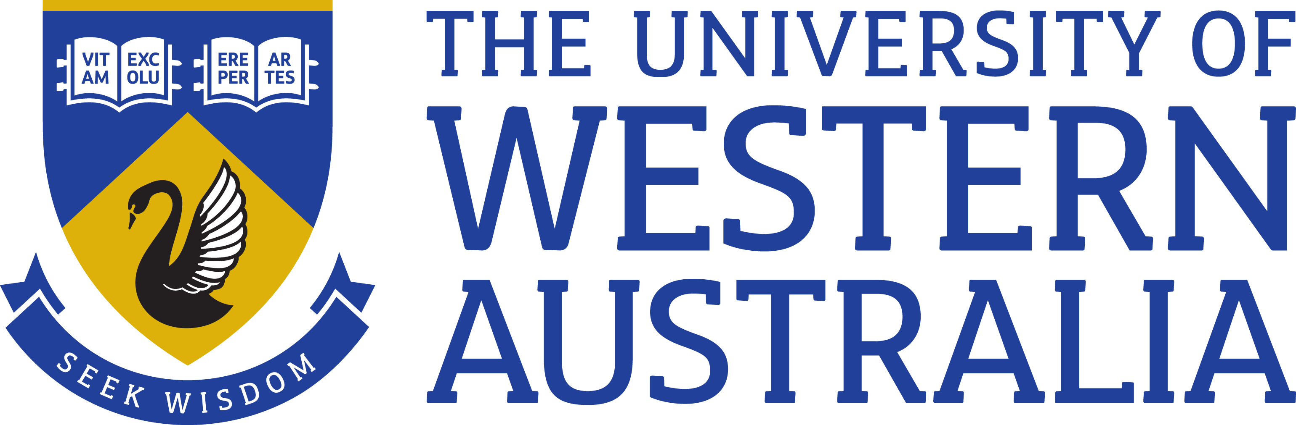

Position Title: Senior Manager, Development
Position Classification: Level 10 Grade 1
Position Number: 313357
Faculty/Office: Community & Engagement
School/Division: Development and Alumni Relations
Centre/Section: Central Unit
Supervisor Title: Associate Director, Development
Supervisor Position Number: 307846
Your work area
Development and Alumni Relations [DAR] oversees the University’s alumni engagement and philanthropic strategy. The function works collaboratively across the University to ensure the advancement strategy is built into outreach efforts across campus. The core responsibility of the development team is to build on the University’s community relations and secure philanthropic support for the University.
DAR works with a broad range of individual and corporate stakeholders whose investment as ambassadors, advocates, volunteers and donors are key to the University’s long term future, inclusive of:
- Alumni including graduates, staff and former students and staff
- Donors
- Corporate and business entities
- Foundations and Trusts
- Community organisations
- Government
- Friends and Volunteers
Reporting Structure

Reports to: Associate Director, Development

Direct Reports: Faculty Development Officers in SDCs (9)

Your role
The Senior Manager, Development plays a major role in the leadership, operations and delivery of successful fundraising outcomes for the University.
The Senior Manager, Development oversees the team of Faculty Development officers located within the Faculty Service Delivery Centres, in addition to building external relationships with major prospective donors and supporters maximising the University’s philanthropic income for academic priorities.
Key responsibilities
Provide leadership and strategic direction to the Faculty Development Officers whose primary focus is solicitation and cultivation of gifts that are in line with the University’s key fundraising priorities
Work with the University’s faculties, schools and centres to provide best practice development leadership and support for their fundraising activities ensuring they enhance the overall University development program
Actively engage in working to establish and strengthen existing relationships with the University’s senior alumni, major donors and corporate supporters, to develop and execute strategies to secure six and seven figure gifts
Provide policy and program advice to the Chief Advancement Officer, Associate Director and other members of the senior executive in support of the University’s development program
Ensure that prospects capable of major gifts are cultivated and solicited in an appropriate and strategic manner
Build solid relationships and work collaboratively with key functional areas within the Community and Engagement portfolio and beyond including Business Development and Research Enterprise
Achieve the position’s performance outcomes as agreed with the Associate Director, Development
Other duties as required
Your specific work capabilities (selection criteria)
Relevant tertiary qualification or demonstrated equivalent competency
Extensive management and leadership experience at an appropriate level
Extensive experience in major gift fundraising with proven success in securing substantial gifts as well as development program management such as annual giving programs, bequests or sponsorships
High level skills in influencing, negotiating, motivating and communicating across a large, complex organisation with the ability to build and manage relationships at a senior level
Demonstrated ability to provide high level, effective leadership, motivation and direction to significant teams of staff
Demonstrated ability to determine long term planning and key strategic direction and excellent conceptual and analytical skills
Professional skills and knowledge of advancement in higher education and an understanding of major international and national advancement trends
Special Requirements (selection criteria)
As part of managing major prospects this role may include regular Interstate and Overseas Travel
Compliance
Workplace Health and Safety
All supervising staff are required to undertake effective measures to ensure compliance with the Occupational Safety and Health Act 1984 and related University requirements (including Safety, Health and Wellbeing Objectives and Targets).
All staff must comply with requirements of the Occupational Safety and Health Act and all reasonable directives given in relation to health and safety at work, to ensure compliance with University and Legislative health and safety requirements. Details of the safety obligations can be accessed at http://www.safety.uwa.edu.au
Equity and Diversity
All staff members are required to comply with the University’s Code of Ethics and Code of Conduct and Equity and Diversity principles Details of the University policies on these can be accessed at http://www.hr.uwa.edu.au/publications/code_of_ethics, http://www.equity.uwa.edu.au

