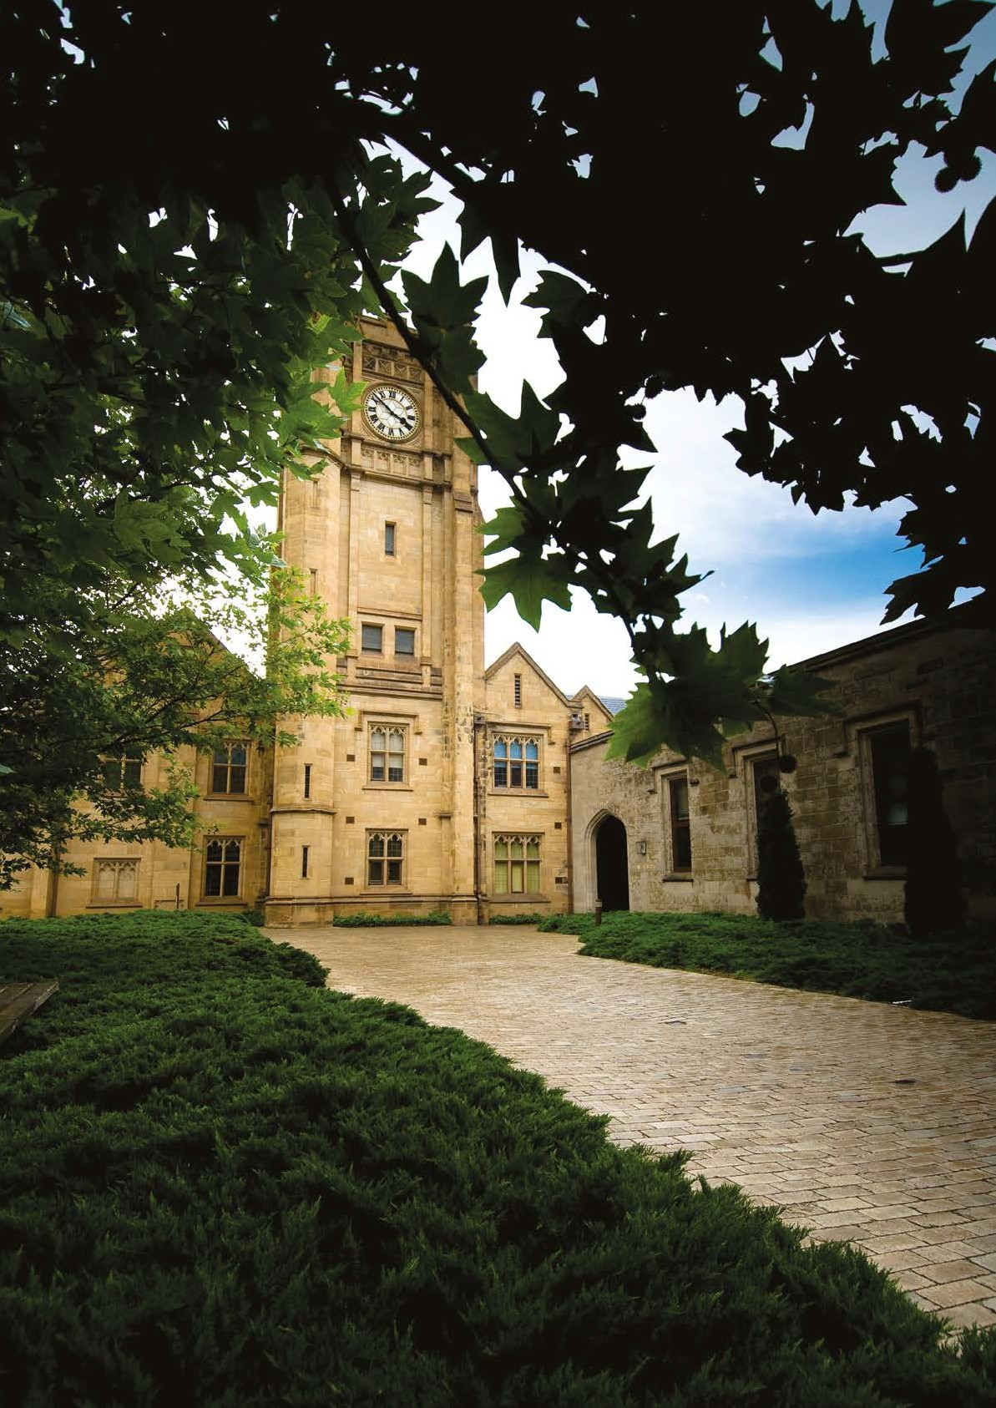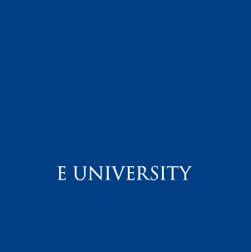

**Appointment of**

**Student Wellbeing Officer**

**Faculty of Arts,**

**Academic Support Office**

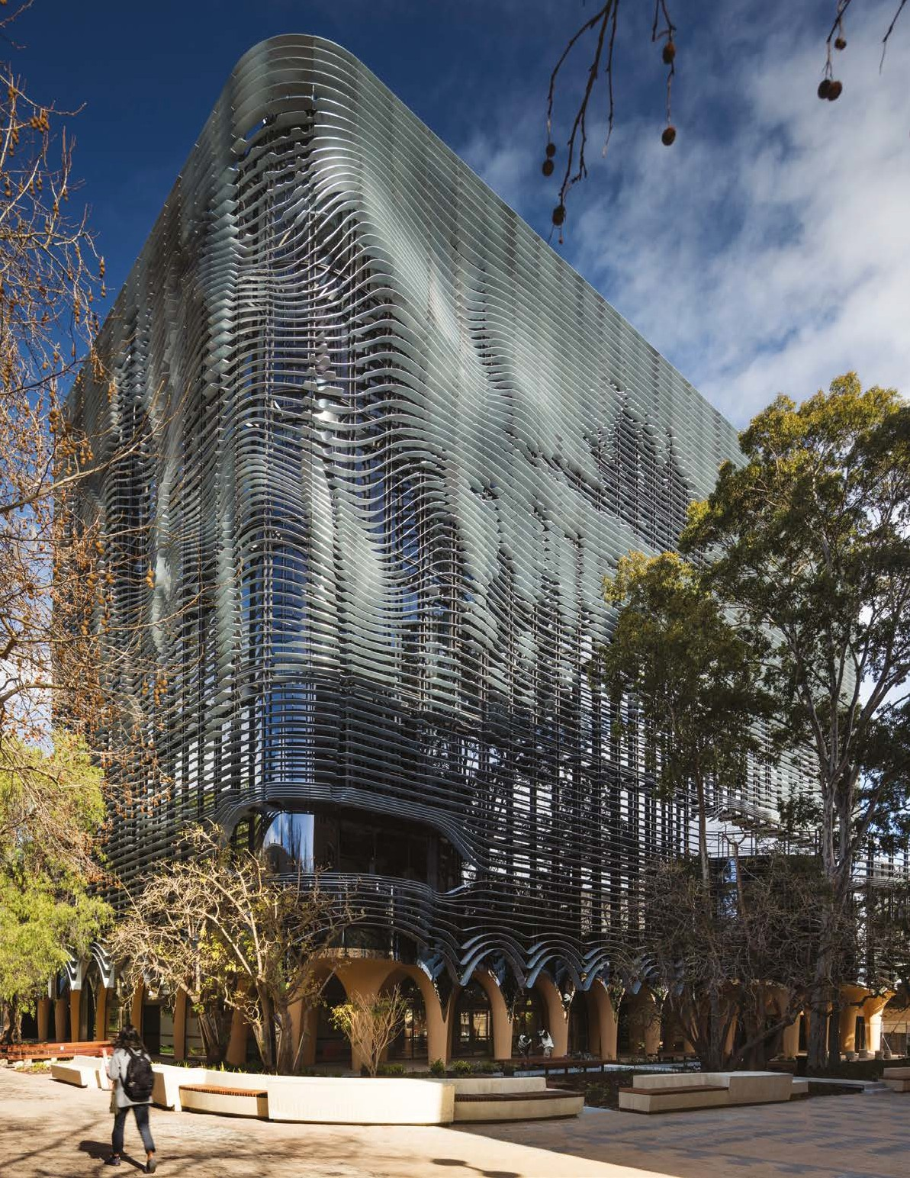

**Contents**

1. **The University of Melbourne**
2. **The Melbourne Vision**
3. **Faculty of Arts**
4. **Position Description & Selection Criteria**
5. **People & Benefits**
6. **Living & Working in Melbourne**
7. **Further Information**
8. **How to Apply &**

**Contact Information**

**The University of Melbourne**

**Consistently ranked as Australia’s best university, Melbourne enjoys an outstanding reputation as one of the world’s leading comprehensive research-intensive universities.**

**__**

Ranked number 32 in the latest Times Higher Education World University Rankings*, Melbourne competes on an international stage with the best institutions globally and has an international outlook and reach to match.

With a rich history stretching over 160 years, the University of Melbourne also occupies a special place in the heart of the city. Since its founding in 1853, the University has been a public-spirited institution committed to making distinctive contributions to intellectual, cultural, social and economic life in the region and beyond. These values underpin the University’s entire academic mission and shape operating practices, preparing engaged graduates and steering research that advances the world.

With a wide range of disciplines, the University of Melbourne currently educates over 50,000+ students from over 130 countries. The University comprises ten Academic Divisions providing learning that stimulates, challenges and fulfils the potential of excellent students from around the world, leading to personal development, meaningful careers and profound contributions to society.

The alumni network is significant and truly international, with representation from 160 countries. This international community includes former Prime Ministers, Governors General, and Nobel Laureates, and is a testament to the world-class education the University of Melbourne delivers.

The University employs over 8,000+ staff including many renowned researchers and industry leaders who are internationally recognised. Some of our scholars and high- achieving staff include Nobel Prize Laureate Professor Peter Doherty, who co-discovered how the immune system recognises virus infected cells; internationally recognised chemist, Professor Andrew Holmes, President of the Australian Academy of Science, who received the 2012 Royal Medal for his ground-breaking research in polymer chemistry; and Paediatric neurologist, Professor Ingrid Scheffer, who received the 2012 Asia-Pacific L’Oréal-UNESCO Women in Science award for her pioneering research into the causes of epilepsy.

The University of Melbourne operates an annual budget exceeding $2 billion, with income from research grants, student fees, government grants, commercial operations, executive education, investment and philanthropy. The increased demand for teaching programs, and the University’s focus on sustainability and resilience, have allowed savings to be reinvested into strategic teaching and research-related initiatives.

**\*Times Higher Education World University Rankings 2019**

10. Recognised as a leader in embedding sustainability in all aspects of the University’s operations, teaching and learning, research and engagement

7. Providing opportunities for students from all cultures and all backgrounds to participate successfully in the educational, cultural and social life of the University

9. Deeply connected with business, government and community, to engage with partners to leverage research and teaching strengths

8. Fully engaged in the life, culture and aspirations of Melbourne and the regions we serve

5. Known for research and impact, underpinned by a comprehensive and world-leading discipline base

6. Achieving student satisfaction and graduate outcomes comparable to the best universities in the world

2. Consistently ranked among the top 40 universities globally

1. The Australian University of choice for the most talented students and scholars worldwide

3. Known for its service to the nation, recognising the responsibilities that follow national higher education leadership

4. Renowned for delivering learning and teaching programs that transform talented students thoughtful and accomplished graduates

**The Melbourne Vision**

The University of Melbourne is committed to being one of the finest universities in the world, contributing to society in ways that enrich and transform our lives. We will know we have been successful in our aspirations if, by 2020, the University of Melbourne is:



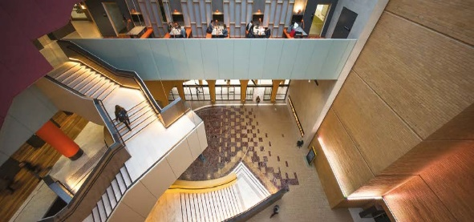

*Arts West Atrium. Photo: John Gollings*

**The Faculty of Arts**

**The Faculty of Arts at the University of Melbourne is widely recognised as Australia’s premier Arts Faculty**

**__**

The Faculty of Arts promotes a workplace that actively seeks to welcome and value the unique contributions of all people including those with diverse backgrounds. Our Faculty has gender parity across all levels and supports its staff through initiatives such as the Faculty of Arts Conference Childcare Support Scheme and the Indigenous Development Plan (DIDP).

Arts at Melbourne is home to the University’s first degree, the Bachelor of Arts. The Faculty brings together leading local and international scholars, and industry partners, across 40 disciplines of study in the humanities, social sciences and languages. Our academic staff are of international standing and committed to excellence in teaching and research. The Faculty currently hosts two ARC Centres of Excellence and a series of research centres, units and networks.

Our Bachelor of Arts is one of the most sought-after degrees in Australia, consistently attracting outstanding students from around the country, and internationally. Our teaching programs encourage critical inquiry, creativity, global perspectives and the questioning of ideas. In 2016, the Faculty opened Arts West – an award-winning building in the heart of the historic campus and a new home for the Bachelor of Arts. Arts West supports active and informal learning through object-based learning laboratories and purpose-built teaching spaces which has transformed teaching and learning in the humanities and social sciences, setting a new benchmark in the Asia region.

Our Graduate School of Humanities and Social Sciences offers 19 professionally oriented Masters programs such as Arts and Cultural Management, Applied Linguistics, Global Media Communication, International Relations and Public Policy and Management. The Graduate School also houses our outstanding PhD program.

Over its 150-year history, the Faculty has produced leaders in a wide range of fields, including government, business, creative industries and media, community and not-for- profit organisations. The Faculty maintains strong strategic relationships with leading international universities through joint teaching collaborations, research projects and student exchange programs. Partnerships with government, not-for-profit and private organisations facilitate work integrated learning opportunities for our students and research collaboration with our researchers. The Faculty has an active and vibrant outreach program, promoting lifelong learning in the humanities, languages and social sciences.

Our community includes over 450 academic and professional staff, 10,000 students across undergraduate, graduate coursework and research higher degree programs, and a strong and active alumni population of over 70,000 worldwide.

Alongside the Graduate School of Humanities and Social Sciences, the Faculty consists of five interdisciplinary Schools:

**Asia Institute –** the University’s key centre for study in Asian languages and cultures, with programs including Arabic, Chinese, Indonesian and Japanese languages, alongside Asian, Islamic and Contemporary Chinese Studies.

**School of Culture and Communication** **–** with programs in Art History, Arts and Cultural Management, Indigenous Studies, Creative Writing, English and Theatre Studies, Media and Communications, Publishing and Editing, Journalism, and Screen and Cultural Studies.

**School of Historical and Philosophical Studies –** encompassing History, History and Philosophy of Science, Philosophy, Jewish and Hebrew Studies, Conservation and Classics and Archaeology.

**School of Languages and Linguistics –** includes French, German, Italian, Russian and Spanish languages, alongside European studies, Latin American studies and Linguistics, Applied Linguistics and English as a Second Language.

**School of Social and Political Sciences –** with programs in Anthropology and Development Studies, Criminology, Political Science, and Sociology and Social Policy.

**Values and Behaviours**

We are committed to benefiting the peoples, cultures and economies of Melbourne, Australia, the Region and the World. We expect all our staff to commit to our values of:

Rigour and Integrity, Generosity and Humility, Intellectual Freedom and Critical Independence

Diversity and Inclusion, Trust and Mutual Respect, Social Justice and Civic Responsibility

Courage and Creativity, Openness and Transparency, Environmental Sustainability

**Position Description & Selection Criteria**

**__**

**Position No.** 0056525

**Classification** UOM 6

**Salary** $89,182 - $96,536 p.a

**Superannuation** Employer contribution of 17%

**Working Hours**  Full Time

**Basis of Employment** Fixed Term - 3 years

**Other Benefits** [Click here](http://about.unimelb.edu.au/careers/working/benefits)

**Position Summary**

Located in the Faculty of Arts, the Academic Support Office (ASO) supports the development, delivery and quality assurance of teaching and learning activities. The ASO manages essential functions in the following key areas: selection, scholarships, undergraduate, graduate coursework and graduate research programs, student enrichment, experiential learning and eTeaching.

The role sits within the ASO, reports to the Manager, Student Wellbeing and contributes to the provision of wellbeing support to a broad range of students including assisting in the management of complex student cases. The Student Wellbeing Officer also has responsibility for a diverse range of tasks in the delivery of the Academic Integrity process.

The incumbent will maintain a high level of awareness of university policies and procedures, issues and activities relevant to the area of responsibility and will be required to contribute to the development of strategies and systems that will enhance student wellbeing.

Due to Australian immigration regulations, we will prefer applicants with Australian work rights. We welcome applications from Aboriginal and Torres Strait Islander people, people from different cultural backgrounds and people with disabilities.

**Key Responsibilities**

* Contribute to the coordination, administration and delivery of all aspects of the academic integrity process across undergraduate, graduate and research higher degree cohorts.
* Prepare complex student cases for review by the Director, BA and Director, Graduate School, ensure communication of outcomes and follow up actions.
* Undertake outreach and provide support to Arts students to encourage engagement and success in their studies
* Be a point of contact for academic staff seeking to refer students to support services.
* Contribute to the effective communication and collaborative working relationships with Faculty Academic Support staff, academic staff and students.
* Undertake ongoing review of processes, keep abreast of best practice across the sector resulting in continuous improvement and enhanced delivery
* Contribute to the development and implementation of processes that enhance support to our complex cohort of Arts students
* Work collaboratively within and across functional areas to ensure broader Faculty goals and objectives are being met.
* Comply with quality assurance, in line with requirements under the University’s risk management framework including OH&S, legislation, statutes, regulations and policies.

**Selection Criteria**

**ESSENTIAL**

* Completion of a relevant tertiary qualification and significant relevant experience, or a combination of relevant work experience and/or education/training.
* Excellent interpersonal and verbal communication skills with the ability to effectively build and enhance relationships with internal and external stakeholders.
* Strong organisational, attention to detail and project management skills to ensure the effective prioritisation, management and completion of tasks within agreed deadlines.
* Demonstrated ability to exercise independent and informed judgement in problem-solving.
* Demonstrated use of initiative and responsiveness in managing tasks and ensuring organizational objectives are achieved.
* Ability to exercise sensitivity, discretion, and confidentiality in interactions with students and academic and professional staff at all levels.
* Ability to work independently and proactively under broad direction, and within the framework of Faculty/University guidelines and procedures.
* Demonstrated professional and collegial behaviour of a very high standard (encompassing commitment to the Faculty’s Values and Behaviours outlined on page 2).

**DESIRABLE**

* Experience working in the tertiary or government sector.
* Previous experience with RESOLVE Case Management System.
* Intermediate level Microsoft Office skills.
* Student-facing support experience.

**OTHER JOB-RELATED INFORMATION**

* Some out of hours work assisting with events such as Open Day.

**Equal Opportunity, Diversity & Inclusion**

The University is an equal opportunity employer and is committed to providing a workplace free from all forms of unlawful discrimination, harassment, bullying, vilification and victimisation. The University makes decisions on employment, promotion and reward on the basis of merit.

The University is committed to all aspects of equal opportunity, diversity and inclusion in the workplace and to providing all staff, students, contractors, honorary appointees, volunteers and visitors with a safe, respectful and rewarding environment free from all forms of unlawful discrimination, harassment, vilification and victimisation. This commitment is set out in the University’s People Strategy 2015-2020 and policies that address diversity and inclusion, equal employment opportunity, discrimination, sexual harassment, bullying and appropriate workplace behaviour. All staff are required to comply with all University policies.

The University values diversity because we recognise that the differences in our people’s age, race, ethnicity, culture, gender, nationality, sexual orientation, physical ability and background bring richness to our work environment. Consequently, the People Strategy sets out the strategic aim to drive diversity and inclusion across the University to create an environment where the compounding benefits of a diverse workforce are recognised as vital in our continuous desire to strive for excellence and reach the targets of Growing Esteem.

**Occupational Health & Safety (OHS)**

All staff are required to take reasonable care for their own health and safety and that of other personnel who may be affected by their conduct.

OHS responsibilities applicable to positions are published at:

<http://safety.unimelb.edu.au/people/community/responsibilities-of-personnel>

These include general staff responsibilities and those additional responsibilities that apply for Managers and Supervisors and other Personnel.

**Budget Unit**

[arts.unimelb.edu.au](http://arts.unimelb.edu.au/)

The Faculty of Arts is at the forefront of teaching and research in the languages, humanities and social sciences fields in Australia and in many cases internationally. Founded in 1853, it is one of Australia’s oldest and largest faculties with approximately 450+ staff and 10,000+ students across undergraduate and graduate programs – engaged in over 900 subjects in more than 40 areas of study. Over 600 international students from more than 50 different countries representing five continents are currently studying towards degrees offered in the Faculty.

The Faculty of Arts maintains strong connections with leading international universities through research collaborations and student exchange programs, and nurtures relationships with government, not-for- profit and private organisations through student internship placements, research projects and community engagement.

As well as housing the Graduate School of Humanities and Social Sciences, the Faculty of Arts also comprises five academic schools:

* Asia Institute
* School of Culture & Communication
* School of Historical & Philosophical Studies
* School of Languages & Linguistics
* School of Social & Political Sciences

Our students and staff are supported by business units within the Faculty including:

* The Office of the Dean & Faculty Executive Director
* The Academic Support Office
* The Strategy, Planning & Resources Unit
* The External Relations Unit
* The Research Office
* The Human Resource Office

**The University of Melbourne**

Established in 1853, the University of Melbourne is a leading international university with a tradition of excel­lence in teaching and research. The main campus in Parkville is recognised as the hub of Australia’s premier knowledge precinct comprising eight hospitals, many leading research institutes and a wide-range of knowledge-based industries. With outstanding performance in international rankings, the University is at the forefront of higher education in the Asia-Pacific region and the world.

The University employs people of outstanding calibre and offers a unique environment where staff are valued and rewarded.

Further information about working at The University of Melbourne is available at <http://about.unimelb.edu.au/careers>.

**Growing Esteem, The Melbourne Curriculum and research at Melbourne: Ensuring Excellence and Impact to 2025**

Growing Esteem describes Melbourne's strategy to achieve its aspiration to be a public-spirited and internationally - engaged institution, highly regarded for making distinctive contributions to society in research and research training, learning and teaching, and engagement. <http://about.unimelb.edu.au/strategy-and-leadership>

The University is at the forefront of Australia's changing higher education system and offers a distinctive model of education known collectively as the Melbourne Curriculum. The new educational model, designed for an outstanding experience for all students, is based on six broad undergraduate programs followed by a graduate professional degree, research higher degree or entry directly into employment. The emphasis on academic breadth as well as disciplinary depth in the new degrees ensures that graduates will have the capacity to succeed in a world where knowledge boundaries are shifting and reforming to create new frontiers and challenges. In moving to the new model, the University is also aligning itself with the best of emerging European and Asian practice and well-established North American traditions.

The University’s global aspirations seek to make significant contributions to major social, economic and environmental challenges. Accordingly, the University’s research strategy Research at Melbourne: Ensuring Excellence and Impact to 2025 aspires to a significant advancement in the excellence and impact of its research outputs. <http://research.unimelb.edu.au/our-research/research-at-melbourne>

The strategy recognises that as a public-spirited, research-intensive institution of the future, the University must strive to make a tangible impact in Australia and the world, working across disciplinary and sectoral boundaries and building deeper and more substantive engagement with industry, collaborators and partners. While cultivating the fundamental enabling disciplines through investigator-driven research, the University has adopted three grand challenges aspiring to solve some of the most difficult problems facing our world in the next century. These Grand Challenges include:

* Understanding our place and purpose – The place and purpose grand challenge centres on understanding all aspects of our national identity, with a focus on Australia’s ‘place’ in the Asia-Pacific region and the world, and on our ‘purpose’ or mission to improve all dimensions of the human condition through our research.
* Fostering health and wellbeing – The health and wellbeing grand challenge focuses on building the scale and breadth of our capabilities in population and global health; on harnessing our contribution to the ‘convergence revolution’ of biomedical and health research, bringing together the life sciences, engineering and the physical sciences; and on addressing the physical, mental and social aspects of wellbeing by looking beyond the traditional boundaries of biomedicine.
* Supporting sustainability and resilience – The sustainability and resilience grand challenge addresses the critical issues of climate change, water and food security, sustainable energy and designing resilient cities and regions. In addition to the technical aspects, this grand challenge considers the physical and social functioning of cities, connecting physical phenomena with lessons from our past, and the implications of the technical solutions for economies, living patterns and behaviours.

Essential to tackling these challenges, an outstanding faculty, high performing students, wide collaboration including internationally and deep partnerships with external parties form central components of Research at Melbourne: Ensuring Excellence and Impact to 2025.

**Governance**

The Vice Chancellor is the Chief Executive Officer of the University and responsible to Council for the good management of the University.

Comprehensive information about the University of Melbourne and its governance structure is available at <http://www.unimelb.edu.au/governance>

**People and Benefits**

**The University is committed to providing an intellectually stimulating and personally rewarding workplace which attracts people who are the best in their professional, academic and teaching fields**

**__**

Outstanding academic staff are at the heart of the University’s teaching, research and engagement endeavours. The University is proud of its many staff that have been recognised through prestigious national and international awards and through membership of Australia’s learned academics. Among the many scholars of international renown at the University is the winner of the Nobel Prize – Professor Peter Doherty (Physiology and Medicine) and many other public intellectuals and scientific leaders.

**The Benefits**

The University offers staff more than just a job – it offers them an opportunity to be part of a dynamic world class organisation which provides its staff with exceptional benefits and support at every stage of their life and career.

* Working in a culturally inclusive environment
* 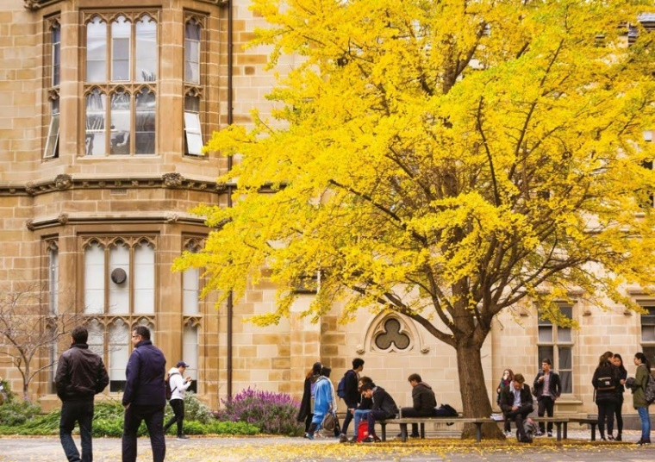Engaging in an active and vibrant campus life
* A focus on health and wellbeing
* Outstanding staff benefits in addition to competitive salary packages

Staff benefits on offer at the University include the opportunity to salary package everything from childcare and additional superannuation to subscriptions to the Melbourne Theatre Company. Benefits can be tailored to best suit individual needs and circumstances, including generous relocation support.

Course fees can also be salary packaged and come at a 25% discount for staff and their immediate families. Unsurprisingly, the University has high numbers of working parents. The University offers staff access to several program initiatives that assists in balancing their work and life commitments, including onsite childcare facilities, flexible work arrangements and access to internal grant schemes to support academics returning from career interruption. The University of Melbourne was one of the first winners of the Fair and Flexible Employer Recognition award.

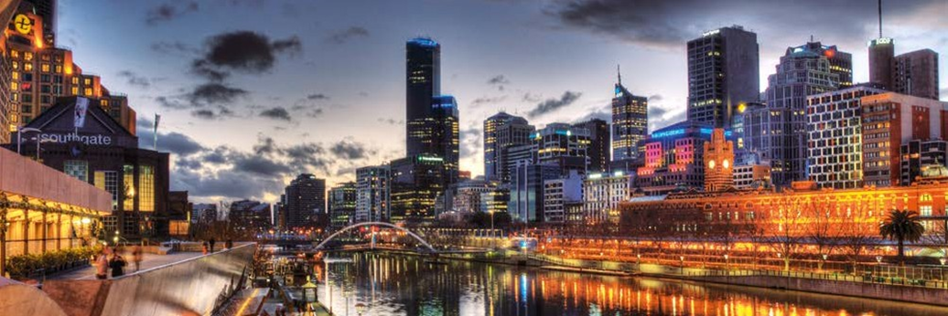

**Living and Working in Melbourne**

**Geography**

Melbourne is the capital city of Victoria and the second largest city in Australia. It is set around the shores of Port Phillip Bay and sits beside the Yarra River, around five kilometres from the bay.

Melbourne is home 4.5 million people and a metropolitan area of 9990.5 km2. The Economist Intelligence Unit has rated Melbourne one of the world’s most liveable city for six consecutive years, based on its education, entertainment, health care, research and development, tourism and sport.

The City of Melbourne municipality, in which the University’s main Parkville campus is based, covers 37.7 km2 and has a population of more than 143 000 people. It includes the city centre and a number of attractive inner suburbs with thriving communities and businesses.

The City of Melbourne is home to residents from 180 countries who speak more than 233 languages and dialects and follow 116 religious faiths. The Wurundjeri, Boonwurrung, Taungurong, Dja Dja Wurrung and the Wathaurung people of the Kulin Nation are the Traditional Owners of the land now known by its European name of Melbourne.

The City of Melbourne is recognised as Australia’s cultural capital with a number of world-class galleries and museums, internationally renowned food and wine regions, and an impressive year-round calendar of events catering for all tastes. Melbourne has many precincts, each with its own unique character and offering different cultural experiences, for example Greek culture around Lonsdale Street, Italian on Lygon Street Carlton, Chinese in Chinatown and French on Collins Street.

**Parkville Campus**

Parkville is the main campus of the University of Melbourne. It stretches across more than 20 hectares and is located just 1.7 kilometres north of the city centre. The campus is well connected by trams and buses and a short walk to Melbourne Central Station with frequent buses to North Melbourne Station. Plans to build an underground train line connecting North Melbourne to South Yarra, via the University and the Central Business District, have been approved with the construction to begin in 2018.

Other major University of Melbourne buildings are located off campus, east of Swanston Street and south of Grattan Street as far as Queensberry Street. The University has 12 residential halls and colleges, most of which line the northern boundary of the campus along College Crescent.

The Parkville campus environment is vibrant and dynamic where music, exhibitions, sporting facilities, libraries and excellent cafes can be found for all to enjoy. Numerous services are located on the Parkville campus for convenience.

There are multiple green spaces on campus as well as large public spaces located close by, including Royal Park and the Carlton Gardens.

The University of Melbourne is constantly expanding and improving its facilities to ensure that staff and students are working within world-class environments, and with top-quality resources.

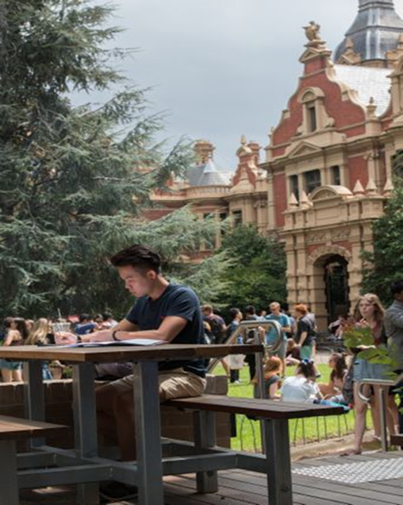

In an ongoing partnership with its neighbour, the Royal Melbourne Hospital, the University of Melbourne established the Melbourne Biomedical Precinct, a major global research and teaching powerhouse with 25 health service, research and academic partners sharing a formidable history of ground- breaking medical discoveries and developments. Partners within the Precinct include Walter and Eliza Hall Institute, Biomedical Research Victoria and CSL Ltd, all within a three kilometre radius, allowing them to share resources and engage in meaningful collaborations.

The University of Melbourne is also at the heart of a key initiative supporting the Victorian Government’s Defence Technologies Sector Strategy to develop an advanced manufacturing and research precinct. In 2016 the Victorian Government acquired a 37-hectare site at Fishermans Bend with the aim of creating a world-class design, engineering and technology precinct. The technology hub will become a centre of excellence attracting cutting-edge innovators in the areas of aerospace, defence, marine design and automotive design.

Recently, the University of Melbourne also opened a new building for the Melbourne School of Design, designed in collaboration with John Wardle Architects (Melbourne) and NASAAA (Boston). Retaining the original façade, the remainder of the building was completely reimagined and purpose built, providing integrated functional space for class workshops, private and group study and discussion pods. The building features architectural features and construction methods inspiring students and encouraging them to continue their learning outside of the classroom.

Another recently completed project is the Arts West Building. Opened in 2016 by the Faculty of Arts, it is a showcase of innovative learning spaces that support new ways of teaching and learning.

The Carlton Connect Initiative was recently launched and will build an innovative community precinct which draws on local talent and business to tackle complex problems. Working across sectors, the Initiative drives partnerships – connecting world- class talent with 21st century technologies to address global challenges that cannot be solved by one sector alone.

**Further Information**

**General Information about the University of Melbourne is available at its website** [**www.unimelb.edu.au**](http://www.unimelb.edu.au)

**About the University of Melbourne**

about.unimelb.edu.au

**The University of Melbourne’s Strategic Plan 2015 – 2020**

*Growing Esteem*

growingesteem.unimelb.edu.au

**2018 Annual Report**

<https://petercook.unimelb.edu.au/__data/assets/pdf_file/0003/3045171/2018-PeterCook_AnnualReport.pdf>

**Faculty of Arts**

arts.unimelb.edu.au

**Research**

University of Melbourne research strategy and implementation

research.unimelb.edu.au

**Teaching**

Teaching and Learning at the University of Melbourne

provost.unimelb.edu.au

**Engagment**

University of Melbourne Engagement strategy

about.unimelb.edu.au/strategy-and-leadership/engagement

**Careers**

https://about.unimelb.edu.au/careers

The Faculty of Arts promotes a workplace that actively seeks to include, welcome and value unique contributions of all people. People from Indigenous, culturally & linguistically diverse backgrounds, LGBTI people, and people with disabilities are encourage to apply, and if seeking support in submitting an application are welcomed to contact the Faculty by emailing their contact details and position number to [**arts-hr@unimelb.edu.au**](mailto:arts-hr@unimelb.edu.au)

**How to Apply**

Please submit your application via the below link http://about.unimelb.edu.au/careers, select the relevant option (‘Current Staff’ or ‘Prospective Staff’), then find the position by title or number.

**Enquiries**

Contact for enquiries only, please do not send our application to this contact:

**Name**: Mathilde Lochert  
**Email**: [mathilde@unimelb.edu.au](mailto:mathilde@unimelb.edu.au)