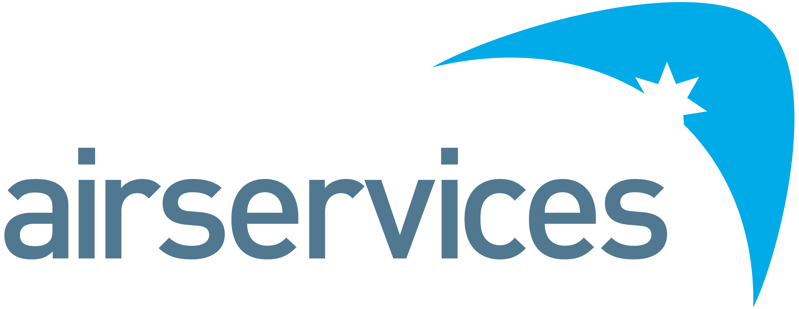
System Safety Engineer, OneSKY Australia Program
Position Detail
Reports To | OneSKY Service Capability Acceptance – Safety Manager | Group | OneSKY Australia Program
Classification | ASA 7B | Duration | 3 years fixed term
Budget Accountability | Nil | Location | Melbourne/Canberra/Brisbane
Delegations | Nil | Reports | Nil

Organisational Environment
Airservices is a government-owned organisation providing safe, secure, efficient and environmentally responsible services to the aviation industry. Each year we manage over four million aircraft movements carrying more than 90 million passengers, and provide air navigation services across 11% of the world’s airspace. Airservices has two major operating centres in Melbourne and Brisbane and a corporate office in Canberra. We operate 29 air traffic control towers at international and regional airports, and provide aviation rescue fire-fighting services at 26 Australian airports.
The OneSKY Australia Program is the most complex transformation of air traffic management in Australian aviation history. A partnership between Airservices and the Department of Defence, OneSKY will replace the current independent civil and defence air traffic management systems with an advanced integrated system known as the Civil Military Air Traffic Management System (CMATS).
The OneSKY Program will design and deliver an upgrade to the air traffic management system currently in use in regional towers by leveraging the existing solution used at major airport towers (referred to as RTS - Regional Tower Solution). This solution will be adapted to upgrade the air traffic management capability at four Australian Defence Force air traffic control towers, referred to as ADOT (Airservices Defence OneSKY Tower).
Primary Purpose of Position
The System Safety Engineer will assist the RTS/ADOT Project Team to ensure that the changes undertaken are performed in accordance to the Airservices Safety Management System and are acceptably safe.
The System Safety Engineer will report to the OneSKY Service Capability Acceptance -Safety as part of the team responsible for Safety, Technology, Security, Operational and Software Assurance of the OneSKY technology systems and products delivered as part of the harmonised ATM Service capability.
The System Safety Engineer will develop safety arguments, lead safety activities (with a focus on applying suitable hazard identification and risk analysis methods) and manage the safety program for the RTS/ADOT Project. These activities will be documented in safety plans and safety arguments.
The role will provide safety specialist advice, guidance and support change initiatives in relation to process and procedures, human systems integration and organisational change.OneSKY Service Capability Acceptance team to ensure that the interactions between the respective projects are appropriately managed and the resultant Service is acceptably safe.
You will form an integral part of the OneSKY Australia Program team; delivering and maintaining high quality safety artefacts to support the Airservices record of Safety, Environmental, WHS, Risk and Compliance excellence.
Accountabilities and Responsibilities
Position-specific:
- Contribute to the delivery of safe, secure fit-for-purpose processes and procedures as part of the change management delivered by RTS/ADOT.
- Develop and maintain the RTS/ADOT Safety Plans, Safety Argument and Safety Reporting documentation in accordance with Airservices SMS.
- Support the OneSKY Service Capability Acceptance team in the activities necessary to obtain the required approvals and no objections to support the delivery of the RTS/ADOT project.
- Support RTS/ADOT to ensure that all safety related requirements are managed to keep new and changed systems, processes and procedures acceptably safe.
- Lead assigned and applicable Work Groups, Technical Reviews and Workshops pertaining to Safety and human factors.
- Review safety documentation provided by OneSKY contractors and suppliers to inform the development of the service safety argument
- Ensure Safety related risks to RTS/ADOT project are managed to an acceptable level.
- Work to the plans and standards identified in the OneSKY Program Capability Assurance Plan and OneSKY Safety Plan.
- Develop safety assurance documentation with consideration of human systems integration.
- Identify and assess human factors risks to projects, with input from subject matter experts

People:
- Be part a high-performance team with an emphasis on accountable performance
- Contribute to a collaborative and inclusive culture with a high performing cohesive team
- Develop and maintain a highly effective working relationship within the OneSKY Program and other internal and external stakeholders to ensure open and transparent communication and resolution of safety and human factors related issues
- Develop and maintain trusting relationships with key internal and external stakeholders to ensure open and effective communication
- Assist in the planning and building of organisational capacity of the Program through education and guidance on the application of the Airservices Safety Management System on Program
Systems, Safety and Reporting Compliance
- Drive implementation of enterprise governance systems and policies, including safety, environmental, work health and safety, risk and compliance
- Demonstrate safety leadership and behaviours consistent with enterprise strategies, and manage the branch in accordance with work health and safety accountability requirements.

Key Performance Indicators
Efficient, Effective and Accountable
- Quality of safety program outputs measured through overall acceptance of outputs by accountable managers and the measure of rework required following project/safety assurance review.
- Builds and maintains effective relationships at strategic and working levels
- Provides team with clear direction, motivates and empowers others
- Takes responsibility for actions, outcomes and people
- Achievement of Program objectives.
People and Safety
- Effective and collaborative engagement within OneSKY, Airservices, Contractor(s) and Regulator(s)
- Capability improvement
- Compliance with regulatory standards, safety, risk, environmental and any other standards.
Key Relationships
- OneSKY Technology (RTS/ADOT) Project Managers
- Contractor delivering the System
- OneSKY Program Management Office
- OneSKY Service Capability Acceptance
- OneSKY Human System Integration Specialist
- OneSKY CMATS safety staff
- OneSKY Risk Manager
- OneSKY Project Systems Engineering Leads
- Airservices Safety and Assurance
- Airservices Regulatory team
- Airservices Safety Framework owners
- Airservices Technology Enablement team
- OneSKY team and stakeholders
- CASA
Skills and Competencies
- Significant (> 5 years) practical experience as a system safety engineer within a safety regulated industry (e.g. Aviation, Rail, Oil and Gas, Defence).
- Demonstrated experience applying industry best practice system safety analysis techniques/methodologies (e.g. ARP 4761, MIL-STD 882E, IEC-61508, Eurocontrol SAM)
- Demonstrated sound understanding and proven application of system safety engineering techniques (functional hazard analysis, fault trees, HAZOP, FMECA or equivalent).
- Demonstrated experience developing safety arguments/safety cases for large scale, complex projects within a safety regulated industry.
- Understanding of systems engineering processes, their influence on the timing of system safety engineering activities, and inputs/outputs that exist between the different disciplines that contribute to the systems engineering design process is essential.
- Tertiary qualifications in engineering, system safety or safety management.
- Understanding of human factors application in evaluating change is highly desirable.
- Effective and concise communication skills in written and verbal form.
- Demonstrated ability to engage stakeholders, foster relationships, facilitate partnerships and cooperation at all levels.
Security Clearance
- Negative Vetting Level 1 [SECRET]
Performance Standards and Behaviours
As a member of the OneSKY Service Capability Acceptance Team, OneSKY Program, Airservices or Defence, you will consistently demonstrate performance standards and behaviours that meet Airservices Code of Conduct or similar. This includes:
- Treating everyone with dignity, respect and courtesy
- Acting with honesty and integrity
- Acting ethically and with care and diligence
- Complying with all organisational policies and procedures, and applicable Australian laws
- Disclosing and taking reasonable steps to avoid any actual, potential or perceived conflict of interest
- Behaving in a way that upholds our vision, mission and values, and promotes the good reputation of the OneSKY Program and the organisations the Program represents.

