

|  |
| --- |
| **Position Description** |

|  |  |
| --- | --- |
| **Associate Lecturer** | |
|  |  |
| **Position No:** | NEW |
| **Business Unit:** | Office of the Provost |
|  |  |
| **Division:** | School of Psychology and Public Health |
| **Department:**  **Classification Level:** | Department of Psychology, Counselling and Therapy  Level A Teaching Focused |
| **Employment Type:** | Part-time (0.5FTE), Continuing |
| **Campus Location:** | Independent (Albury-Wodonga, Bendigo, Melbourne (Bundoora)) |
| **Other Benefits:** | <http://www.latrobe.edu.au/jobs/working/benefits> |

Further information about:

La Trobe University - <http://www.latrobe.edu.au/about>

**Position Context**

One of the larger Schools within the University, the School of Psychology & Public Health undertakes teaching and research across a broad range of disciplines, including: Neuroscience; Psychology; Counselling; Rehabilitation Counselling; Art Therapy; Family Therapy; Public Health; Digital Health and Analytics; Health Information Management; and Ergonomics, Safety and Health. The School comprises six academic units: the Department of Psychology, Counselling and Therapy; the Department of Public Health; The Bouverie Centre; the Olga Tennison Autism Research Centre (OTARC); the Centre for Alcohol Policy Research (CAPR); and the Australian Research Centre in Sex, Health and Society (ARCSHS). As a University our research is focused on five priority areas, linked to the United Nation’s Sustainable Development Goals. Our expertise across disciplines positions us to excel in these areas and positively impact our communities. Department staff are key contributors to [*Healthy people, families & communities*](https://www.latrobe.edu.au/research/research-themes/health-and-wellbeing), [*Understanding & preventing disease*](https://www.latrobe.edu.au/research/research-themes/understanding-and-preventing-disease) *and* [*Social change & equity*](https://www.latrobe.edu.au/research/research-themes/social-change-and-equity).

The Department of Psychology, Counselling and Therapy encompasses several broadly related disciplines, including clinical, developmental and social psychology; neuropsychology, cognition and behavioural neuroscience; rehabilitation and mental health counselling; and art and family therapy. The Department operates across multiple campuses and locations, including Melbourne (Bundoora), Bendigo, Albury-Wodonga, the Bouverie Centre in Brunswick, Mildura, and Shepparton, although it does not normally base staff at the latter two campuses.

The Department has a dynamic higher degree program in a range of areas, with large numbers of Honours, Masters and PhD students from Australia and overseas. It also offers a flexible range of undergraduate courses and entry to several postgraduate practice degree courses (both professional training and clinical practice) by which it aims to improve the health and wellbeing of individuals and communities through excellence in teaching and research. High-quality training opportunities are provided both through external placements and within onsite clinical settings, including the La Trobe University Psychology Clinic; the Bouverie Centre: Victoria’s Family Institute; the OTARC Clinical Assessment suites; and the Art Therapy Studio.

# Position Purpose

A Level A, Associate Lecturer with a teaching focused appointment is expected to contribute to developing curriculum, assist in the coordination of subjects, teach, assess, and support students as they learn. In addition, a teaching focused academic will support the administrative functions of the discipline and department as well as undertake scholarly work relevant to the scholarship of learning and teaching. An associate lecturer will provide general academic support for subjects in the department. This will include contributing to oversight of subject tutors, assisting in the coordination of subjects, timetabling and reporting and undertaking related teaching and marking.

**Duties at this level will include:**

* Under the guidance of subject coordinators, teach subjects providing a high-quality learning

experience that engages students through the conduct of lectures, tutorials and workshops,

and/or other sessions in online, blended or face-to-face modes.

* Assist with subject coordination.
* Provide constructive, fair and timely feedback on learning to students.
* Work with subject or course coordinators on innovative subject and course level curriculum

design, development and review in areas such as, but not restricted to, online and blended

delivery, and assist in taking an evidence-based approach to evaluate how these initiatives

improve the student experience.

* Develop a scholarly approach to learning and teaching by contributing to La Trobe’s SOLT

including sharing of good practice.

* Contribute to knowledge transfer and to building relationships at a local level.
* Undertake other duties and administrative functions commensurate with the classification

and scope of the position as required by the Discipline Cluster Lead, Head of Department or

Dean.

**Essential Criteria**

**Skills and knowledge required for the position**

* Completion of a Bachelor’s degree in a relevant discipline.
* Demonstrated ability to be effective in teaching and curriculum development in face-to-face,

blended and/or online modes, as evidenced by, for example, high results on student feedback

on teaching surveys relative to their peers, or through other forms of evidence.

* Effective oral and written communication skills, including the ability to interact effectively,

collaboratively and productively with staff and students from a diverse range of backgrounds.

* Experience in using subject administrative systems effectively, including timetabling, learning

management systems, results reporting, and student record systems.

* Evidence of innovative teaching-related initiatives undertaken in the last three years that have

improved the student experience.

* Demonstrated ability to work as a team member in a collaborative and collegial manner.
* Ability to engage with the Scholarship of Teaching and Learning.

**Capabilities required to be successful in the position**

* Ability to work collaboratively, recognise the value of diversity and model accountability, connectedness, innovation and care.
* Ability to think creatively, explore new ideas and respectfully challenge existing practices in order to improve current ways of working.
* Ability to implement improvements to local processes.
* Ability to build a culture of continuous improvement, implementing ideas generated by team members.

**Essential Compliance Requirements**

To hold this La Trobe University position the occupant must:

* hold, or be willing to undertake and pass, a Victorian Working With Children Check;
* hold a valid Victorian drivers’ license; AND
* take personal accountability to comply with all University policies, procedures and legislative or regulatory obligations; including but not limited to TEQSA and the Higher Education Threshold Standards.

**Other Information**

The position description is indicative of the initial expectation of the role and subject to changes to University goals and priorities, activities or focus of the job.

**Position Flexibility**

We offer flexible work arrangements that can assist you in balancing your work and other responsibilities.

**Why La Trobe:**

* Develop your career at an innovative, global university where you’ll collaborate with community and industry to create impact.
* Enjoy working on our inspiring and stunning campuses – the perfect hub for industry, students and academics
* Help transform the lives of students, partners and communities now and in the future

This is more than just a job. Working at La Trobe offers opportunities to demonstrate excellence and transform lives.

Here, you’ll join exceptional people, partners and communities, who power our operations with ambition and purpose.

Our success can be attributed to its strong sense of community. We have a long-standing commitment to diversity, inclusion and social justice; we are committed to providing a workplace where all staff feel valued, respected and supported to achieve their full potential. We strive to build a workplace where all employees of diverse backgrounds, abilities, experiences, sexuality, gender, religion and age are welcome, valued, respected and one that is representative of our community. We demonstrate our cultural qualities by holding ourselves accountable and creating a culture of trust and innovation while genuinely caring for one another.

**La Trobe’s Cultural Qualities:**

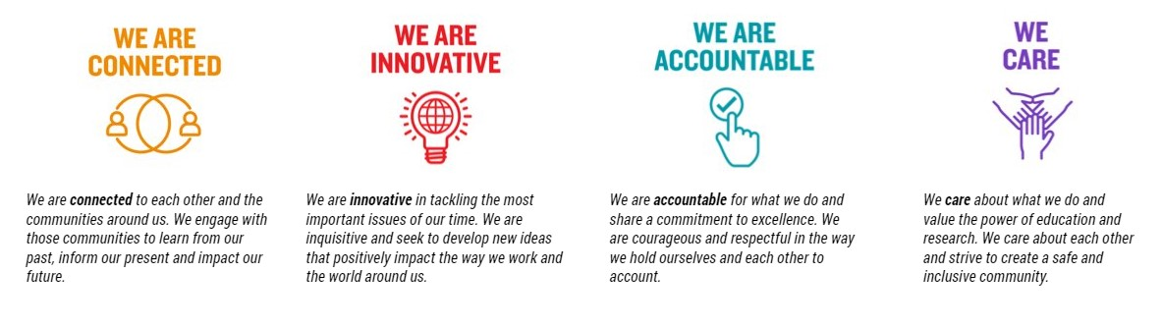

For Human Resource Use Only

Initials: Date: