**Youth support worker POSITION DESCRIPTION**

**counterpoint youth refuge**

**Northern region**

**At Anglicare Victoria our focus is on transforming the futures of children, young people, families and adults.** Our work is based on three guiding pillars: Prevent, Protect and Empower.

We strive to create an environment where employees feel valued and rewarded.

By living the Anglicare Victoria values and actively fostering fairness, equality, diversity and inclusion, our people make Anglicare Victoria a truly great place to work.

**So come and join us at Anglicare Victoria where there is a rewarding career ready for you** in a dedicated, professional team where respecting each other; leading with purpose; working together; and creating a positive difference are valued, and learning and creativity are encouraged.

**Position details**

|  |  |
| --- | --- |
| **Position** | Youth Support Worker |
| **Program** | Counterpoint Youth Refuge |
| **Classification** | SCHADS Award Level 3 (Youth Worker Class 2)  (Classification will be dependent on qualification and years of experience within the relevant field consistent with the SCHADS Award) |
| **Hours** | Casual |
| **Hours per week** | Weekend and sleepover shifts included |
| **Duration** | Casual |
| **Fixed term end date** | N/A |
| **Location** | Northern Suburbs |
| **Reporting**  **Relationship** | This position reports directly to the Team Leader, Counterpoint Youth Refuge |
| **Effective date** | March 2024 |

**Overview of program**

Counterpoint Young Women’s Refuge accommodates 17-24 year old young women who are currently homeless. The program offers short-term accommodation for a minimum of 6-8 weeks with the goal of sustainable housing upon exit. Young people who leave the program are then offered time limited outreach support.

Counterpoint aims to provide crisis accommodation and intensive case management support with a therapeutic orientation, for young women who have become homeless as a result of violence and sexual assault. Counterpoint is recognised as a safe house and as such the address is undisclosed.

The aim of the program is to provide a safe and secure environment for young women to ensure they have the physical and psychological space to enact positive change in their lives. The underlying philosophy of the program is the empowerment of women and the recognition of sexual assault and family violence in the community and its need to be addressed. Counterpoint has a broader role in advocating for and supporting disadvantaged and marginalised women and cultivating the idea of a right to safety outside the confines of Counterpoint.

**Position Objectives**

|  |  |
| --- | --- |
|  | To work as part of a therapeutic rostered youth work team, providing short term accommodation and support for young women aged 17-24 years who are homeless. |
|  | To support permanent staff members to provide appropriate support on the basis of negotiated individual case plans to each client in a safe and secure environment that will enhance a young person’s sense of empowerment. |
|  | To contribute to maintaining a positive living environment for young people who are facing multiple and complex challenges. |
|  | To work collaboratively with other team members to achieve positive outcomes for the young people at the refuge. |

**Key responsibilities**

The key responsibilities are as follows but are not limited to:

|  |  |
| --- | --- |
|  | Intake and assessment of young people referred to the program as per program guidelines. |
|  | To support case manager to implement case plan that has been developed with the young person and case manager comprising of behavioural indictors, goals and objectives and planned interventions. |
|  | Liaise with other professionals to ensure each young person is linked to appropriate services such as individual counselling, education/training, Centrelink, medical checks, drug and alcohol counselling, group work, family reconciliation counselling according to each case plan with client consent. |
|  | Contribution to the development and maintenance of a safe, secure and planned environment wherein residents' developmental needs are effectively met, as per program guidelines. |
|  | Providing time limited outreach support to young people who have exited the refuge. |
|  | Keeping Team Leader fully briefed about all matters relating to appointee's role in the program and service implementation, maintenance issues, and immediately reporting all critical incidents and issues, and participating in regular supervision. |
|  | Maintain appropriate case file documentation and engage in relevant data collection activities. |
|  | Undertake daily household duties. |

**Key Selection Criteria**

The Key Selection Criteria are based on role specific requirements ***and*** the Anglicare Victoria Capability Framework. Applicants are required to provide a written response to ***both*** a) and b).

1. **Role specific requirements**

Applicants are required to provide a written response to the role specific requirements. The five criteria are to be addressed individually (no more than 2 pages in total).

|  |  |
| --- | --- |
| C:\Users\David.Sandison\AppData\Local\Microsoft\Windows\Temporary Internet Files\Content.Outlook\GIF9U7N8\RoleSpecific_icon.jpg | 1. A relevant tertiary qualification in Youth Work, Social Work, Psychology, and/or related behavioural sciences at degree level with substantial experience; or associate diploma level with substantial experience in the relevant service stream, or less formal qualifications with specialised skills sufficient to perform at this level. |
| 1. Resilience to work with and support clients who have been exposed to trauma. |
| 1. An understanding of the needs of young people who are experiencing homelessness, including those who have suffered neglect, abuse, trauma and personal or family crisis. |
| 1. Commitment to the principles and practice of adequate support service access for the most vulnerable and disadvantaged young people and to promoting autonomy and self-determination for young people accessing the program. |
| 1. Ability to engage young people and where appropriate, their families, in co-operative, goal-directed working relationships aimed at addressing barriers to stable housing within the crisis accommodation period. |

**Key Selection Criteria (continued)**

1. **Anglicare Victoria Capability Framework**

Applicants are required to provide a written response to the Anglicare Victoria Capability Framework. Applicants are to describe how they demonstrate the characteristics in each of the two capability groups; **Personal Qualities and Relationship and Outcomes** (no more than 1 page in total).

The Anglicare Victoria Capability Framework describes the capabilities required to meet the expectations of clients, colleagues and communities in today’s changing environment.

These capabilities work together to provide an understanding of the knowledge, skills and abilities required of all employees.

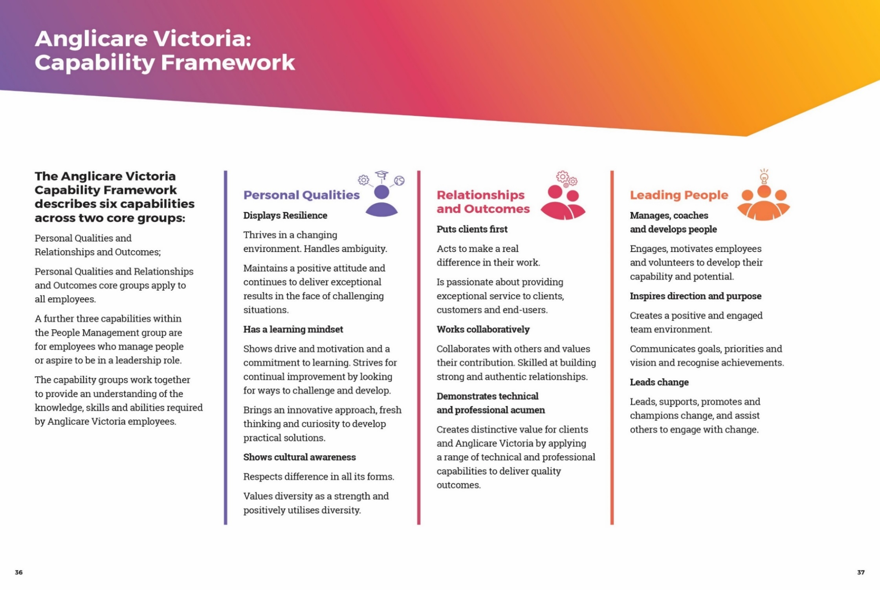

**Occupational health & safety (OHS)**

Anglicare Victoria is committed to ensuring the health and safety of its employees and any other individuals present in our workplaces.

In achieving and maintaining workplace health and safety, Anglicare Victoria will apply best practice in OHS in accordance with statutory obligations at all times.

All Anglicare Victoria employees, contractors and volunteers are required to:

* take reasonable care for their own health and safety and for that of others in the workplace by working in accordance with legislative requirements and the company’s OHS policies and procedures
* take reasonable care their actions or omissions do not adversely affect the health and safety of themselves and others
* cooperate with any reasonable directions, policies and procedures relating to health and safety in the workplace
* report all injuries, illness or ‘near misses’ to their Supervisor or Manager
* participate in relevant health and safety training based on roles and responsibilities
* as required, participate in the development and implementation of specific OHS hazard and risk management strategies.

In addition to the above, positions with supervision or management responsibility are required to ensure a safe and healthy work environment for all employees, clients, contractors and visitors. This can be achieved by ensuring all people are aware of and have access to OHS policies, procedures, training and reporting systems

**Cultural Safety in the Workplace**

Anglicare Victoria recognises the important and unique contribution Aboriginal and Torres Strait Islander employees make by bringing their unique skills, knowledge and experience to the workplace. They also contribute important insight into how Anglicare Victoria can provide for and engage with Indigenous clients and communities more effectively.

Our Reconciliation Action Plan (RAP) and Workforce Strategy outlines Anglicare Victoria’s commitment to leading and facilitating sustainable employment, training, retention and career development opportunities for Aboriginal and Torres Strait Islanders people.

**Conditions of employment**

* Salary and conditions are in accordance with the Social, Community, Home Care and Disability Services Industry Award (SCHADS) 2010. Salary packaging is offered with this position.
* All offers of employment at Anglicare Victoria are subject to a six month probationary period. The staff member will be asked to participate in an annual performance review linked to objectives set out for the position.
* All offers of employment are subject to a satisfactory Criminal History Check, a current Driver’s License and an Employment Working with Children Check prior to commencement.

**Acceptance of Position Description requirements**

To be signed upon appointment

**Employee**

|  |  |
| --- | --- |
| Name: |  |
| Signature: |  |
| Date: |  |