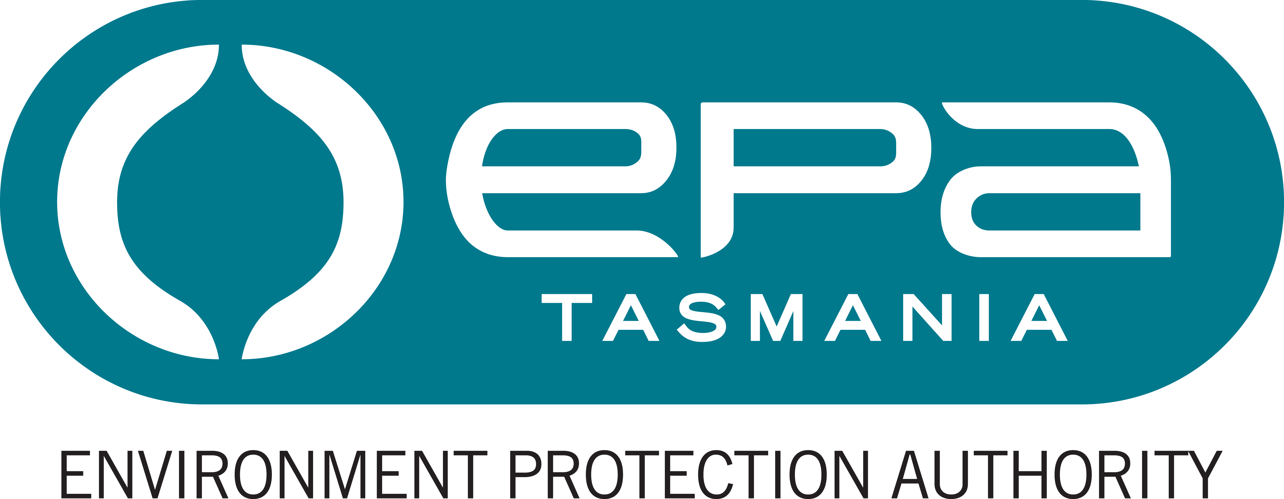
Environment Protection Authority

Project Manager (Remediation)

Statement of Duties

Position Number: 706190
Branch/Section: Environmental Assessments Division / Scientific and Technical Branch
Award/Agreement: Tasmanian State Service Award
Classification: Professional Stream, Band 3
Position Status: Permanent
Full Time Equivalent (FTE): 1.0 FTE (or part time hours, by negotiation)
Ordinary hours per week: 36.75 hours (or part time hours, by negotiation)
Location: Hobart
Reports to: Manager (Scientific and Technical)

Position Purpose
The purpose of the role is to manage and implement the Savage River Remediation Project and provide advice and input into other acid mine drainage remediation activities as required from time-to-time.

Major Duties
- As Project Manager prepare, manage and implement strategic work plans for the Savage River acid mine drainage remediation project, including the day-to-day management of the project’s resources, and provide leadership and guidance in the delivery of project activities.
- Develop, co-ordinate, implement and manage complex remediation studies associated with the remediation project.
- Develop and manage complex remediation project contracts in accordance with Treasury and Crown Law guidelines.
- Provide high level reports on studies and individual projects undertaken, and the overall remediation project in general.
- Liaise with industry, government agencies and EPA staff to ensure a coordinated approach in the management and implementation of the remediation project.
- Provide input and advice in relation to other acid mine drainage remediation activities, including in relation to the former Mt Lyell Acid Mine Drainage Remediation Project.
- Undertake emergency management activities including training and, commensurate with that training and relevant experience, participate in responses to incidents, particularly for matters for which the EPA is the lead agency or otherwise responsible for contributing relevant staff resources.
- Perform any other assigned duties at the classification level that are within the employee’s competence and training.

Responsibility, Decision Making and Direction
The occupant of the position is responsible, as a professional specialist, for:
- the efficient and effective program or service delivery including budget management, optimise use of resources and maintaining and/or modifying policy, administrative processes and research projects. This includes planning future activities, negotiating for appropriate resources and determining measures for accountability;
- for mentoring and role-modelling less qualified or less experienced staff;
- remaining abreast of contemporary developments in the discipline or field and related subject matter;
- the development of strategy, policy or program implementation especially with regard to new developments; with responsibility shared with relevant specialists and executive management; and
- for ensuring a safe working environment by complying with relevant Work Health and Safety (WHS) legislation, codes of practice and policies, procedures and guidelines issued under the EPA’s WHS Management System and for promoting the principles of managing diversity.
The decision making and direction received in relation to the role are that the occupant:
- operates with considerable autonomy and is required to provide leadership regarding the design, development and operation of function and/or program activities. Guidance and instruction may on occasion be received on the implementation of highly technically complex modification that provide solutions consistent with policy, regulatory and/or technological requirements and developments; and
- defines core program and service delivery issues to develop options and recommendations for operational change and/or for new research projects.

Knowledge, Skills and Experience (Selection Criteria)
- High level knowledge, expertise and extensive professional experience in the environmental management field, with ability and experience in the development and implementation of environmental remediation.
- High level project management experience and a broad knowledge and understanding of contemporary project management practices, methodologies and processes.
- Extensive professional experience in the development and management of complex contracts in accordance with Treasury and Crown Law guidelines.
- Highly developed management skills and expertise to lead an operational unit. An understanding of contemporary management practices and demonstrated experience and the ability to mentor and role-model less qualified or less experienced staff.
- The ability to communicate and provide authoritative advice on complex matters to non-specialists, high level liaison, presentation and conflict resolution skills and the capacity to represent the EPA.
- Highly developed conceptual and reasoning skills to research, investigate, analyse, evaluate and integrate relevant solutions from related disciplines or fields in the area of activity. Flexibility, creativity and innovation associated with research, investigative, analytical and appraisal skills.
- Demonstrated capacity to plan, organise, schedule and deliver, own outputs and those of a team, within set timeframes to achieve results particularly in a changing environment; project management experience with a knowledge and understanding of contemporary project management practices.
Position Requirements
Essential Requirements
- A Degree in science, engineering or environmental studies, relevant to the professional duties to be undertaken, as provided by a university.

Desirable Qualifications and Requirements
- Knowledge or experience in the field of acid mine drainage would be advantageous.
- A current motor vehicle driver’s licence.

The EPA’s Role
The Environment Protection Authority is Tasmania’s principal environmental regulator. The EPA administers the Environmental Management and Pollution Control Act 1994 and is an integral part of Tasmania's Resource Management and Planning System.​
The EPA’s purpose is to regulate developments and activities that may impact on environmental quality and to promote best practice, sustainable environmental management. Its goals are clean air, clean water, clean land, acceptable noise levels and sustainable use of resources.
The EPA comprises a Board and Director, supported by staff. Both the Board and the Director exercise powers at arm's length from State Government and have independent statutory powers under the Act.
Under Tasmania’s emergency management arrangements, the EPA is the management authority (lead agency) for various aspects of emergencies including marine pollution spills. Emergency prevention, preparedness and response activities are core business of this agency and potentially may involve all staff in some way.
The EPA website at epa.tas.gov.au provides more information.

Working Environment

Employees work within an environment that supports safe work practices, diversity and equity with employment opportunities and ongoing learning and development. We are committed to valuing and respecting each other as colleagues and peers. We value the diverse backgrounds, skills and contributions of all employees and treat each other and our customers with respect. We do not tolerate discrimination, harassment or bullying in the workplace.

The Environment Protection Authority has a culture of zero tolerance towards violence, including any form of family violence. We will take an active role to support employees and their families by providing a workplace environment that promotes their safety and provides the flexibility to support employees to live free from violence.

There is a strong emphasis on building leadership capacity throughout the EPA.

The expected behaviours and performance of the EPA’s employees and managers are enshrined in the State Service Act 2000 through the State Service Principles and Code of Conduct. These can be located at www.dpac.tas.gov.au/divisions/ssmo.

