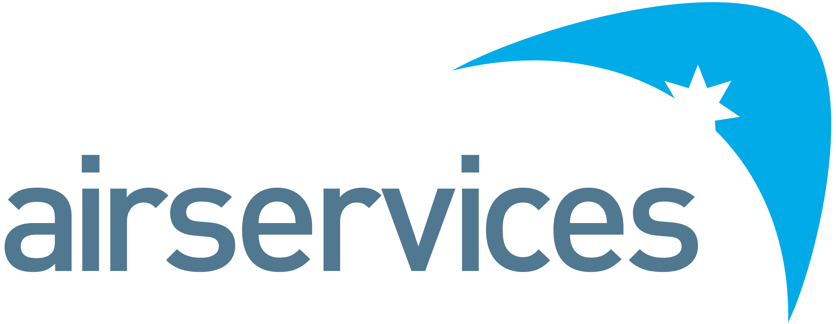

ENGINEERING SPECIALIST
Position Detail
Reports To | Aerodrome Platform Team Leader | Group | CTEO
Classification | Technology Professional Band 2 (TP2) | Location | Melbourne
Reports – Direct  Total | Nil | Term | Fulltime

Organisational Environment
Airservices is a government owned organisation providing safe, secure, efficient and environmentally responsible services to the aviation industry.
Each year we manage over four million aircraft movements carrying more than 156 million passengers, and provide air navigation services across 11 per cent of the world’s airspace.
Airservices has two major operating centres in Melbourne and Brisbane and a corporate office in Canberra. We operate 29 air traffic towers at international and regional airports, and provide aviation rescue fire fighting services at 26 Australian airports.
We are committed to continuing to improve our business by providing our customers with services they value, and embedding new ways of working and technology investments to further innovate and optimise.
Primary Purpose of Position
The Aerodrome Technology group in CTEO is responsible for the on-going management, maintenance and sustainment of Technology systems that form part of the National Airways System (NAS).
Within our remit are systems used across Australia at all airports, aerodromes and international partners in the aviation industry.
As Engineering Specialist working on the Aerodrome Platform portfolio of systems, you will be responsible for the technical performance, sustainment and enhancements of operational software-based airways systems, ensuring the systems meets its agreed technical performance requirements and continues to provide services to industry.
This includes:
- Perform system design, maintenance and support tasks throughout the system life-cycle in accordance with Airservices safety and system management policies, frameworks, guidelines and procedures; and
- Apply Systems Engineering and technical specialist expertise in the areas of planning, design, acquisition and implementation of new systems and upgrades to existing systems.

Accountabilities and Responsibilities
Position Specific
- Perform systems engineering tasks in accordance with the Airservices' Technology Management Framework (TMF) and other relevant processes, policies and guidelines. These include (but are not limited to):
  - Design and develop technical specifications and standards that meet customers’ requirements;
  - Manage in-depth investigations, analysis and diagnosis of complex system issues, and recommend and implement solutions;
  - Prepare test plans, test cases and participate in various levels of system testing for new system implementations, approved enhancements and software updates for existing systems;
  - Gather, analyse and report system performance data, recognise trends and identify areas in need of improvement to ensure reliability and maintainability of systems;
  - Prepare documentation related to system upgrade activities such as system requirements specifications, statement of requirements, project proposals and cost estimates; and
  - Participate in on-going system changes as they occur to assure technical integrity at the system level.
- Maintain the suite of engineering and technical documentation
- Provide specialist technical expertise to projects
- Actively participate in cross training to develop specialised skills and technologies
- Maintain awareness of industry and technology developments, standards and regulations
People
- Establish and maintain effective working relationships with other Airservices staff to ensure that there is effective coordination of all activities in support of organisational objectives
- Manage own performance in ways that earn the trust of management team and other members of the team, including consistent modelling of supportive behaviours
- Actively participate in knowledge sharing with and coaching/mentoring less experienced team members
- Be part of a high-performance team with an emphasis on an accountable performance culture
Compliance, Systems and Reporting
- Adhere to Airservices technology management framework, procedures and policies
- Adhere to Airservices security and information management policies and guidelines
Safety
- Demonstrate safety behaviours consistent with enterprise strategies
- Comply with Airservices WH&S, Safety & Risk Management processes, policies & guidelines
- Identify potential system safety risks and take appropriate action to prevent, address or escalate safety related system issues eliminating any adverse impact on the system or operations
- Participate in or contribute to hazard reviews, assessments and safety reports relevant to Air Traffic Management systems
Key Performance Indicators
Efficient, Effective and Accountable
- Effective time management and work prioritisation based on the significance and criticality of tasks undertaken
- Business group objectives and performance measurements are met in respect of solution architecture and system design
Commercial
- Nil
Safety
- Compliance with safety, risk, environmental and any other standards
Key Relationships
As a member of Chief Technology Enablement Office (CTEO) Group, your key relationships are:
- Aerodrome Technology engineering and technical teams
- Internal stakeholders including:
  - Air Traffic Controller and Network Co-ordination teams;
  - Internal engineering, security, architecture teams; technical services and
  - Project teams
- External suppliers and service providers

Skills, Competencies and Qualifications
The Airservices competency framework applies to this role. Behavioural competencies in line with the Technology Professional Band 2 (TP2) level apply with the focus areas as noted below. This role also utilises an occupation specific capability set which contains information from the Skills Framework for the Information Age (SFIA).
SFIA framework skills
Category | Sub-category | Skills | Level
Solution development & implementation | Systems Development | System Design (DESN) | 3
 |  | Safety Engineering (SFEN) | 3
 |  | Testing (TEST) | 4
 | Installation & Integration | Systems Integration (SINT) | 4
 |  | Systems Installation/decommissioning (HSIN) | 3

Qualifications and Experience
- Essential: A degree in Engineering or Information Technology from an Australian tertiary institution or certified equivalent qualification (for overseas qualifications)
- Essential: Be eligible for registration as a Professional Engineer in relevant area of engineering in accordance with relevant legislation e.g. Professional Engineer Queensland (RPEQ)
- Essential: Security - Able to obtain and maintain an Australian Government National Security Clearance at the required level. Australian Citizenship is therefore mandatory
- Essential: An understanding of and demonstrated experience applying Systems Engineering practices throughout the SDLC and system management processes.
- Essential: Experience in the design, development, testing and implementation of robust and reliable software systems. This includes the over-arching aspects of quality assurance and configuration management.
- Essential: Demonstrated experience in stakeholder and vendor management
- Essential: Demonstrated ability to take ownership of tasks and work as a member of a dynamic team, including ability to work under limited direction to achieve positive outcomes
- Essential: Strong documentation skills with experience in preparing and reviewing solution architecture documents and system design documents, including alignment to strategies and existing initiatives
- Highly Desirable: Experience in designing, maintaining and supporting technology systems, in particular:
  - N-tier architectures and distributed systems;
  - Real-time systems;
  - Message handling; and
  - Internet technologies.
- Highly Desirable: Satisfy the eligibility requirements for registration as a Chartered Professional Engineer (CPEng) with Engineers Australia.
- Desirable: Awareness of Information Security Manual (ISM) and demonstrated experience in adhering to ISM principles and applying ISM controls
- Desirable: Awareness of DO-278A guidelines, software assurance levels and relevant processes and artefacts
Performance Standards and Behaviours
As a member of Airservices, you will consistently demonstrate performance standards and behaviours that meet our Code of Conduct. This includes:
- Treating everyone with dignity, respect and courtesy
- Acting with honesty and integrity
- Acting ethically and with care and diligence
- Complying with all Airservices’ policies and procedures, and applicable Australian laws
- Disclosing and taking reasonable steps to avoid any actual, potential or perceived conflict of interest
- Behaving in a way that upholds our vision, mission and values, and promotes the good reputation of Airservices.

