

|  |
| --- |
| **Position Description** |

|  |  |
| --- | --- |
| **Consultant, Strategy Realisation Office** | |
|  |  |
| **Position No:** | NEW |
| **Business Unit:** | Chief Operating Officer |
|  |  |
| **Division:** | Chief Operating Officer Office |
| **Department:**  **Classification Level:** | Office of the Chief Operating Officer  HEO9 |
| **Employment Type:** | Full-Time, Fixed Term |
| **Campus Location:** | Campus Independent |
| **Other Benefits:** | <http://www.latrobe.edu.au/jobs/working/benefits> |

Further information about:

La Trobe University - <http://www.latrobe.edu.au/about>

**Position Context/Purpose**

The Strategy Realisation office partners with business units across the University to identify, deliver and embed end-to-end strategic projects. The division positions itself as an internal consulting practice and uses a lateral and inquisitive approach as well as a process and data driven mindset viewed across inter-connected streams and portfolios, to deliver and champion excellence across the university.

The Consultant will support the Senior Manager, Strategy Realisation Office with management and delivery of complex business initiatives that support University strategy. The role will be responsible to challenge current thinking and present alternate approaches to complex problems. The appointee will work independently as well as leading workstreams with a keen eye on quality and value, as well adhering to internal and external compliance and deadlines.

The successful appointee will recognise and apply industry best practice in strategy and operations to diagnose, identify and evaluate options, and develop integrated solutions to complex business problems. The appointee will be able to engender a sense of urgency whilst possessing strong coordination and leadership skills. The appointee will have a lateral thinking mindset with an eye on both the big picture and the smaller details.

It is anticipated that this role will be responsible for strategy realization of University City of the Future project. It anticipated that the major heavy lifting of strategy will be completed within 12 months.

**Duties at this level will include:**

* Leading workstreams and building strategic initiatives, identifying complex problems and co-designing creative options/solutions in a structured and hypothesis-driven manner
* Guiding the direction and delivery of research and analysis including determining the appropriate primary and secondary sources to gather and validate data and insights
* Creating and executing significant and complex project work plans impacting multiple areas of the University.
* Developing strong client relationships, working closely and collaboratively with senior leaders and key stakeholders within the university
* Supporting colleagues in the delivery of their work and coaching them to develop their own strategy consulting capabilities
* Contributing to the development of offerings, tools, and ways of working within the Strategy Realisation Office

**Essential Criteria**

**Skills and knowledge required for the position**

* A minimum of 3 years of strategy and operations consulting experience or equivalent time in a strategy or cross-functional team within a market leading/global company or University
* A bachelor’s degree, preferably in commerce, economics, law, finance, human resources, or information technology, or an equivalent alternate combination of relevant knowledge, training and/or experience.
* Strong analytical skills with the ability to research and analyse information to solve diverse problems through a structured problem-solving approach
* Outstanding emotional quotient with the ability to rapidly read and respond to diverse stakeholder requirements and expectations
* Ability to drive a sense of urgency and hold senior stakeholders accountable to achieve and meet intended outcomes
* Fundamental project management skills in scoping, designing, and planning projects. From pre-kick off to ongoing governance throughout the project lifecycle, to deliver best in class outcomes
* Highly effective communication skills, both written and verbal. The ability to negotiate, motivate, influence, and build strong relationships with colleagues
* Ability to inspire and motivate others towards shared objectives, actively facilitate communication and two-way feedback across the University and create and be part of a safe, inclusive, high-performing team culture – consistently modelling and enabling accountability, connection, innovation and care.

**Essential Compliance Requirements**

To hold this La Trobe University, position the occupant must:

* hold, or be willing to undertake and pass, a Victorian Working with Children Check; AND
* take personal accountability to comply with all University policies, procedures and legislative or regulatory obligations; including but not limited to TEQSA and the Higher Education Threshold Standards.

**Other Information**

The position description is indicative of the initial expectation of the role and subject to changes to university goals and priorities, activities or focus of the job.

**Position Flexibility**

La Trobe University is committed to providing a diverse, inclusive and respectful working environment for all staff. We offer flexible work arrangements that can assist you in balancing your work and other responsibilities.

**Why La Trobe:**

* Develop your career at an innovative, global university where you’ll collaborate with community and industry to create impact.
* Enjoy working on our inspiring and stunning campuses – the perfect hub for industry, students and academics
* Help transform the lives of students, partners and communities now and in the future

This is more than just a job. Working at La Trobe offers opportunities to demonstrate excellence and transform lives.

Here, you’ll join exceptional people, partners and communities, who power our operations with ambition and purpose.

We are forward-looking and culturally inclusive. We continuously review, improve and transform our processes to embrace new, flexible approaches. That means you’ll always have the opportunity to succeed and make a difference.

**La Trobe’s Cultural Qualities:**

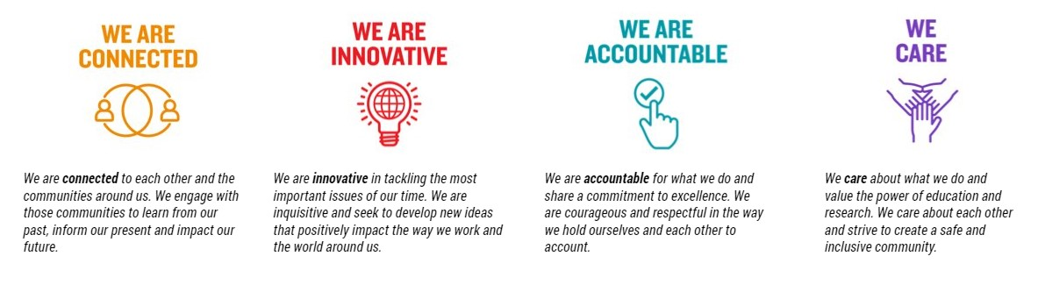

For Human Resource Use Only

Initials: Date: