

|  |
| --- |
| **Position Description** |

|  |  |
| --- | --- |
| **Director, Enterprise Services** | |
|  |  |
| **Position No:** | New |
| **Business Unit:** | Chief Operating Officer (COO) |
|  |  |
| **Division:** | Information Service (IS) |
| **Department:**  **Classification Level:** | Office of CIO  ESMC2 |
| **Employment Type:** | Full Time |
| **Campus Location:** | Melbourne (Bundoora) |
| **Other Benefits:** | <http://www.latrobe.edu.au/jobs/working/benefits> |

Further information about:

La Trobe University - <http://www.latrobe.edu.au/about>

**Position Context/Purpose**

La Trobe, a distinguished independent research university recognised for its world-leading contributions to research and global impact, seeks a transformative leader in enterprise services. The Director, Enterprise Services within the Information Services function holds a pivotal role at the university's technological forefront. Entrusted with guiding the institution's enterprise services strategy, this director leverages strategic vision and operational expertise to pioneer innovative solutions that propel La Trobe to the forefront of academic excellence and technological innovation.

This critical role reports directly to the Chief Information Officer (CIO), positioning the Director of Enterprise Services as a key strategic partner in the university's technological landscape. In addition to overseeing enterprise application initiatives, the director manages critical functions including Application Lifecycle Management, Application Development, Automation Management, Infrastructure Management, and Cloud Orchestration.

In this dynamic position, the Director, Enterprise Services acts as the primary driver of change, steering the integration of enterprise technologies and institutional imperatives to revolutionize teaching, learning, research, and administration. Beyond traditional IT stewardship, this role encompasses overseeing a transformative journey that redefines the university experience. The responsibilities spanning strategic formulation and tactical execution, the director transcends conventional boundaries to foster a culture of digital empowerment and technological fluency across the university community. Through adept leadership and collaborative approaches, they forge strategic alliances with stakeholders at all levels, promoting co-creation and collective ownership in pursuit of shared objectives.

Moreover, the director prioritises enhancing the end-user experience, leveraging technology to streamline processes, and providing the best possible experience to staff and students. The focus on optimizing enterprise workflows and fostering a seamless digital environment empowers the university community to thrive in the digital age.

**Key Duties and Accountabilities**

**Strategic Planning and Direction**

* Develop and execute a comprehensive enterprise services strategy aligned with the university's objectives.
* Define strategic priorities and initiatives to drive innovation and enhance enterprise application experiences.
* Provide visionary leadership to steer the university towards digital maturity and technological excellence.

**Application Lifecycle Management**

* Oversee the end-to-end lifecycle of enterprise applications, ensuring effective planning, development, deployment, and maintenance.
* Implement best practices for application maintenance, quality assurance, and user acceptance testing (UAT) to ensure high performance and reliability.

**Application and Automation Development**

* Lead the development of enterprise applications, including low-code development initiatives to accelerate delivery.
* Manage automation strategies to streamline operations, improve efficiency, and reduce manual intervention.

**Infrastructure and Cloud Orchestration**

* Oversee infrastructure management, ensuring availability and capacity meet the university's needs.
* Drive cloud orchestration efforts to optimize resource utilization and enhance service delivery.

**Configuration and Release Management**

* Implement robust configuration management practices to maintain system integrity and consistency.
* Oversee release management processes to ensure smooth deployment of applications and updates.

**Performance Monitoring and Capacity Management**

* Establish performance metrics and KPIs to track the effectiveness and efficiency of enterprise services.
* Regularly assess capacity and availability, ensuring infrastructure scalability aligns with institutional growth and demands.

**Infrastructure Portfolio Strategic Planning**

* Develop and manage the strategic plan for the university's infrastructure portfolio, aligning investments with strategic priorities.
* Allocate resources effectively to support key initiatives and operational requirements, optimizing ROI and cost-efficiency.

**Stakeholder Engagement and Relationship Management**

* Cultivate strong partnerships with internal stakeholders to understand their technology needs and priorities.
* Act as a trusted advisor to senior leadership, providing strategic insights and recommendations on enterprise services initiatives.
* Foster a collaborative and inclusive culture that promotes engagement, transparency, and accountability.

**Team Leadership and Development**

* Provide effective leadership and mentorship to a diverse team of IT professionals, fostering a culture of excellence and innovation.
* Empower team members to achieve their full potential through coaching, feedback, and professional development opportunities.
* Promote collaboration, teamwork, and knowledge sharing to drive collective success.

**Essential Criteria**

**Technical Skills required for this position:**

**Strategic IT Leadership:**

* Proven experience in developing and implementing strategic IT initiatives, with a focus on enterprise services, preferably within a large-scale organizational setting.
* Demonstrated ability to provide visionary leadership and steer the organization towards digital maturity and technological excellence.

**Technology Expertise:**

* Deep understanding of enterprise application technologies, including application lifecycle management, cloud orchestration, and automation strategies.
* Proven ability to identify, evaluate, and implement emerging technologies and innovative solutions to enhance productivity and user experience.

**Operational Management:**

* Demonstrated proficiency in overseeing IT operations, including infrastructure management, application development, and service delivery.
* Strong track record of driving operational excellence through continuous process improvement and optimization.

**Information Security and Compliance:**

* Knowledge of information security principles and best practices, with experience in implementing robust security protocols and ensuring compliance with regulatory requirements.
* Proven ability to collaborate with security teams to mitigate cybersecurity risks and vulnerabilities through proactive measures.

**Financial Planning and Budget Management:**

* Strong financial acumen with experience in budget development and management.
* Proven ability to allocate resources effectively to support strategic initiatives while ensuring financial sustainability and cost-efficiency.

**Stakeholder Engagement and Team Leadership:**

* Excellent communication and relationship management skills, with the ability to cultivate strong partnerships with internal stakeholders and act as a trusted advisor to senior leadership.
* Demonstrated ability to provide effective leadership and mentorship to a diverse team of IT professionals, fostering a culture of excellence, collaboration, and innovation.

**Other Skills and knowledge required for the position:**

* **Strategic Leadership:** Ability to articulate a clear vision and drive strategic initiatives within a large-scale technology environment.
* **Change Management:** Skilled in managing change, with a proven track record of leading technology transformations and driving adoption of new technologies.
* **Analytical Thinking:** Strong analytical skills, capable of tackling complex problems and making data-driven decisions.
* **Communication and Collaboration:** Excellent communication skills, adept at engaging with stakeholders across all levels of an organization and fostering collaborative relationships.
* **Project Management:** Strong project management skills, with the ability to oversee multiple projects simultaneously, ensuring timely delivery and alignment with strategic objectives.
* **Innovation and Adaptability:** Commitment to innovation and a keen ability to adapt to rapidly changing technology landscapes, ensuring the university remains at the cutting edge of technology trends.

**Essential Compliance Requirements**

To hold this La Trobe University, position the occupant must:

* Hold, or be willing to undertake and pass, a Victorian Working with Children Check; AND
* Take personal accountability to comply with all University policies, procedures and legislative or regulatory obligations; including but not limited to TEQSA and the Higher Education Threshold Standards.

**Other Information**

The position description is indicative of the initial expectation of the role and subject to changes to university goals and priorities, activities or focus of the job.

**Position Flexibility**

We offer flexible work arrangements that can assist you in balancing your work and other responsibilities.

**Why La Trobe:**

* Develop your career at an innovative, global university where you’ll collaborate with community and industry to create impact.
* Enjoy working on our inspiring and stunning campuses – the perfect hub for industry, students, and academics.
* Help transform the lives of students, partners, and communities now and in the future.

This is more than just a job. Working at La Trobe offers opportunities to demonstrate excellence and transform lives.

Here, you’ll join exceptional people, partners, and communities, who power our operations with ambition and purpose.

Our success can be attributed to its strong sense of community. We have a long-standing commitment to diversity, inclusion, and social justice; we are committed to providing a workplace where all staff feel valued, respected, and supported to achieve their full potential. We strive to build a workplace where all employees of diverse backgrounds, abilities, experiences, sexuality, gender, religion, and age are welcome, valued, respected and one that is representative of our community. We demonstrate our cultural qualities by holding ourselves accountable and creating a culture of trust and innovation while genuinely caring for one another.

**La Trobe’s Cultural Qualities:**

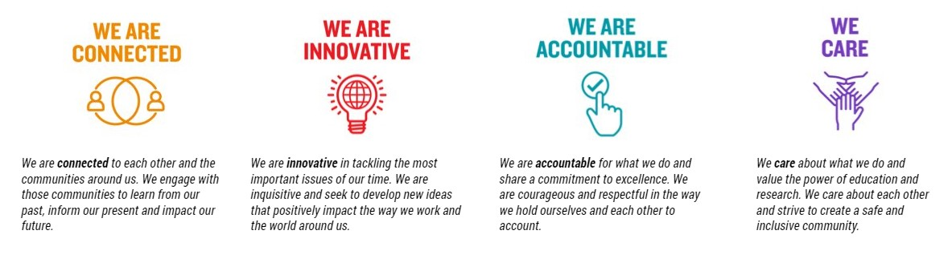

For Human Resource Use Only

Initials: Date: