

|  |
| --- |
| **Position Description** |

|  |  |
| --- | --- |
| **Associate Lecturer, Engineering (TF)** | |
|  |  |
| **Position No:** | NEW |
| **Business Unit:** | Provost |
|  |  |
| **Division:** | School of Computing, Engineering and Mathematical Sciences |
| **Department:**  **Classification Level:** | Engineering  Level A Teaching Focussed |
| **Employment Type:** | Full-Time, Continuing |
| **Campus Location:** | Melbourne (Bundoora) |
| **Other Benefits:** | <http://www.latrobe.edu.au/jobs/working/benefits> |

Further information about:

La Trobe University - <http://www.latrobe.edu.au/about>

**Position Context/Purpose**

This position is located in the Department of Engineering, part of the School of Computing, Engineering and Mathematical Sciences in Melbourne (Bundoora) campus. The School has three departments: Computer Science and Information Technology, Engineering, and Mathematical and Physical Sciences on both Melbourne (Bundoora) and Bendigo campuses. The School hosts three Research Centres: the Centre for Technology Infusion (CTI), the CISCO La Trobe Centre for Artificial Intelligence and Internet of Things, and the Centre for Materials and Surface Science, and one Research Node: the Cybersecurity Innovation Node. The School has a reputation for innovative course design, the maintenance of a supportive student-centered learning environment and an outstanding research profile. The School offers a range of general and specialist undergraduate and postgraduate courses that are rigorous, attuned to emerging trends and taught by staff at the forefront of their fields.

The Department of Engineering has a total of 22 staff and around 600 undergraduate and postgraduate students located in Melbourne and Bendigo campuses. The Engineering discipline at La Trobe continues to expand and revitalise its programs with an innovative curriculum that incorporates strong industry engagement. The department leads various industry sponsored multi-disciplinary research projects with national and international linkages.

Please note: The University may require this role to work at both the Bundoora and Bendigo campuses.

**Duties at this level will include:**

* Develop an evidence-based approach to evaluate learning and teaching initiatives.
* Develop a scholarly approach to learning and teaching by contributing to La Trobe’s SOLT including sharing of good practice.
* Under the guidance of subject coordinators, teach subjects providing a high-quality learning experience that engages students through the conduct of lectures, tutorials, practical classes, demonstrations, workshops, student field excursions, clinical sessions and/or other sessions in online, blended or face-to-face modes.
* Provide constructive, fair and timely feedback on learning to students.
* Work with subject or course coordinators on innovative subject and course level curriculum design, development and review in areas such as, but not restricted to, online and blended delivery, and assist in taking an evidence-based approach to evaluate how these initiatives improve the student experience.
* Assist in obtaining funding from internal or external sources for teaching improvement projects.
* Undertake other duties and administrative functions commensurate with the classification and scope of the position as required by the Head of Department or Dean.

**Essential Criteria**

**Skills and knowledge required for the position**

* PhD degree in Engineering or equivalent accreditation and standing recognised by the University/profession as appropriate for the relevant discipline areas.
* Demonstrate experience in designing, delivering, and assessing curriculums focused on soft engineering skills, including communication, teamwork, problem-solving, and adaptability, especially within the engineering context.
* Demonstrated ability to be effective in teaching and curriculum development in face-to-face, blended and/or online modes, as evidenced by, for example, high results on student feedback on teaching surveys relative to their peers, or through other forms of evidence.
* Evidence of innovative initiatives undertaken in the last three years that have improved the student experience.
* Ability to engage with the Scholarship of Teaching and Learning.
* Effective oral and written communication skills, including the ability to interact effectively, collaboratively and productively with staff and students from a diverse range of backgrounds.
* Demonstrated ability to work as a team member in a collaborative and collegial manner.

**Capabilities required to be successful in the position**

* Ability to demonstrate self-awareness, see things from another person’s perspective and actively seek out and act on feedback to improve knowledge, skills and behaviour.
* Ability to work collaboratively, recognise the value of diversity and model accountability, connectedness, innovation and care.
* Ability to think creatively, explore new ideas and respectfully challenge existing practices in order to improve current ways of working.
* Ability to demonstrate self-awareness, see things from another person’s perspective and actively seek out and act on feedback to improve knowledge, skills and behaviour.

**Essential Compliance Requirements**

To hold this La Trobe University position the occupant must:

* hold, or be willing to undertake and pass, a Victorian Working With Children Check; AND
* take personal accountability to comply with all University policies, procedures and legislative or regulatory obligations; including but not limited to TEQSA and the Higher Education Threshold Standards.

**Other Information**

The position description is indicative of the initial expectation of the role and subject to changes to University goals and priorities, activities or focus of the job.

**Position Flexibility**

We offer flexible work arrangements that can assist you in balancing your work and other responsibilities.

**Why La Trobe:**

* Develop your career at an innovative, global university where you’ll collaborate with community and industry to create impact.
* Enjoy working on our inspiring and stunning campuses – the perfect hub for industry, students and academics
* Help transform the lives of students, partners and communities now and in the future

This is more than just a job. Working at La Trobe offers opportunities to demonstrate excellence and transform lives.

Here, you’ll join exceptional people, partners and communities, who power our operations with ambition and purpose.

Our success can be attributed to its strong sense of community. We have a long-standing commitment to diversity, inclusion and social justice; we are committed to providing a workplace where all staff feel valued, respected and supported to achieve their full potential. We strive to build a workplace where all employees of diverse backgrounds, abilities, experiences, sexuality, gender, religion and age are welcome, valued, respected and one that is representative of our community. We demonstrate our cultural qualities by holding ourselves accountable and creating a culture of trust and innovation while genuinely caring for one another.

**La Trobe’s Cultural Qualities:**

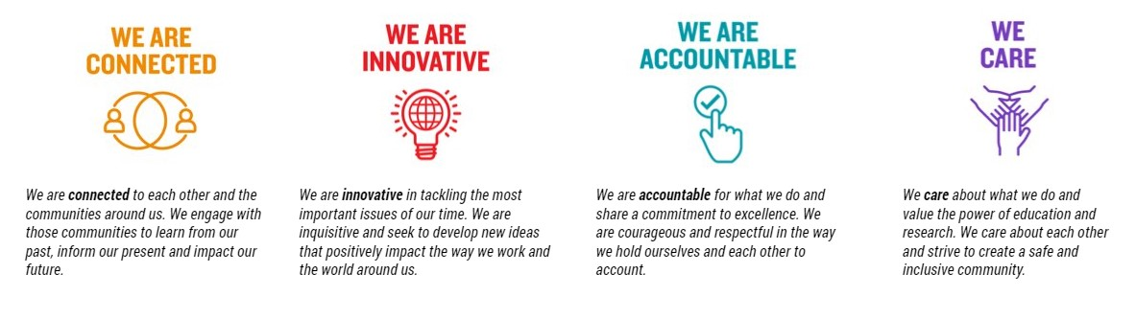

For Human Resource Use Only

Initials: Date: