

|  |
| --- |
| **Position Description** |

|  |  |
| --- | --- |
| **Lecturer, Engineering (TF)** | |
|  |  |
| **Position No:** | NEW |
| **Business Unit:** | Provost |
|  |  |
| **Division:** | School of Computing, Engineering and Mathematical Sciences |
| **Department:**  **Classification Level:** | Engineering  Level B Teaching Focussed |
| **Employment Type:** | Full-Time, Continuing |
| **Campus Location:** | Melbourne (Bundoora) |
| **Other Benefits:** | <http://www.latrobe.edu.au/jobs/working/benefits> |

Further information about:

La Trobe University - <http://www.latrobe.edu.au/about>

**Position Context/Purpose**

This position is located in the Department of Engineering, part of the School of Computing, Engineering and Mathematical Sciences in Melbourne (Bundoora) campus. The school has three departments: Computer Science and Information Technology, Engineering, and Mathematical and Physical Sciences on both Melbourne (Bundoora) and Bendigo campuses. The school hosts four Research Centres: the Centre for Technology Infusion (CTI), the CISCO Latrobe Centre for Artificial Intelligence and Internet of Things, Australian Centre for AI in Medical Innovation (ACAMI) and the Centre for Materials and Surface Science, and one Research Node: the Cybersecurity Innovation Node. The school has a reputation for innovative course design, the maintenance of a supportive student-centered learning environment and an outstanding research profile. The school offers a range of general and specialist undergraduate and postgraduate courses that are rigorous, attuned to emerging trends and taught by staff at the forefront of their fields.

The Department of Engineering has a total of 22 staff and around 600 undergraduate and postgraduate students located in Melbourne and Bendigo campuses. The Engineering discipline at La Trobe continues to expand and revitalise its programs with an innovative curriculum that incorporates strong industry engagement. The department leads various industry sponsored multi-disciplinary research projects with national and international linkages.

Please note: The University may require this role to work at both the Bundoora and Bendigo campuses.

La Trobe is a participant in the Athena SWAN Charter to enhance gender equality in Science, Technology, Engineering, and Mathematics disciplines. As such, we especially encourage female applicants to apply.

**Duties at this level will include:**

* Demonstrate effectiveness by taking an evidence-based approach to evaluate learning and teaching initiatives.
* Demonstrate a scholarly approach to learning and teaching by contributing to La Trobe’s SOLT, including sharing good practices.
* Coordinate and teach subjects, providing a high-quality learning experience that engages students through the conduct of lectures, tutorials, practical classes, demonstrations, workshops, student field excursions, clinical sessions and/or other sessions in online, blended or face-to-face modes.
* Initiate, and participate in innovative subject and course level curriculum design (including the embedding of employability capabilities), development and review in areas such as, but not restricted to, online and blended delivery, taking an evidence-based approach to evaluate how these initiatives improve the student experience.
* With mentoring support, as appropriate, obtain funding from internal or external sources for teaching improvement projects.
* Provide principle or co-supervision to Honours and Masters by coursework students.
* Contribute to knowledge transfer and to building relationships at a local level.
* Undertake other duties and administrative functions commensurate with the classification and scope of the position as required by the Head of Department or Dean.

**Essential Criteria**

**Skills and knowledge required for the position**

* PhD degree in Engineering or equivalent accreditation and standing recognised by the University/profession as appropriate for the relevant discipline areas.
* Demonstrate experience in designing, delivering, and assessing curriculums focused on soft engineering skills, including communication, teamwork, problem-solving, and adaptability, especially within the engineering context.
* Demonstrated effectiveness in teaching, curriculum development and subject coordination in face-to-face, blended and/or online modes, as evidenced by sustained high results on student feedback on teaching surveys, teaching excellence awards or through other forms of evidence.
* Evidence of innovative initiatives undertaken in the last three years that have improved the student experience, and the evaluation of effectiveness of these initiatives.
* Demonstrated ability to engage with the Scholarship of Teaching and Learning.
* Demonstrated high level oral and written communication skills, including the ability to interact effectively, collaboratively and productively with staff and students from a diverse range of backgrounds.
* Ability to supervise, or co-supervise, honours and postgraduate students.
* Ability to produce outputs related to the Scholarship of Learning and Teaching.

**Capabilities required to be successful in the position**

* Ability to demonstrate self-awareness, see things from another person’s perspective and actively seek out and act on feedback to improve knowledge, skills and behaviour.
* Ability to work collaboratively, recognise the value of diversity and model accountability, connectedness, innovation and care.
* Ability to demonstrate self-awareness, see things from another person’s perspective and actively seek out and act on feedback to improve knowledge, skills and behaviour.
* Ability to enable a safe, inclusive, high-performing team culture, prioritising staff mental health and wellbeing.

**Essential Compliance Requirements**

To hold this La Trobe University position the occupant must:

* hold, or be willing to undertake and pass, a Victorian Working With Children Check; AND
* take personal accountability to comply with all University policies, procedures and legislative or regulatory obligations; including but not limited to TEQSA and the Higher Education Threshold Standards.

**Other Information**

The position description is indicative of the initial expectation of the role and subject to changes to University goals and priorities, activities or focus of the job.

**Position Flexibility**

We offer flexible work arrangements that can assist you in balancing your work and other responsibilities.

**Why La Trobe:**

* Develop your career at an innovative, global university where you’ll collaborate with community and industry to create impact.
* Enjoy working on our inspiring and stunning campuses – the perfect hub for industry, students and academics
* Help transform the lives of students, partners and communities now and in the future

This is more than just a job. Working at La Trobe offers opportunities to demonstrate excellence and transform lives.

Here, you’ll join exceptional people, partners and communities, who power our operations with ambition and purpose.

Our success can be attributed to its strong sense of community. We have a long-standing commitment to diversity, inclusion and social justice; we are committed to providing a workplace where all staff feel valued, respected and supported to achieve their full potential. We strive to build a workplace where all employees of diverse backgrounds, abilities, experiences, sexuality, gender, religion and age are welcome, valued, respected and one that is representative of our community. We demonstrate our cultural qualities by holding ourselves accountable and creating a culture of trust and innovation while genuinely caring for one another.

**La Trobe’s Cultural Qualities:**

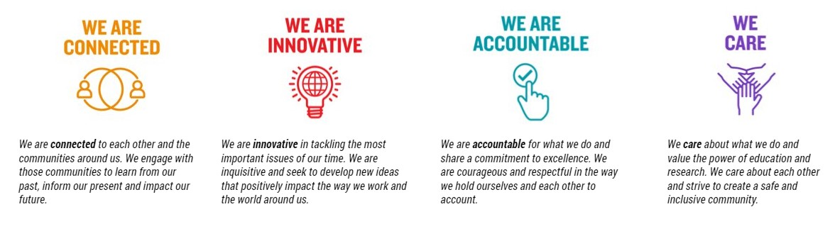

For Human Resource Use Only

Initials: Date: