

|  |
| --- |
| **Position Description** |

|  |  |
| --- | --- |
| **Position Title – Project Manager, Primary Health GP Clinic** | |
|  |  |
| **Position No:** | NEW |
| **Business Unit:** | School of Allied Health, Human Services and Sport |
|  |  |
| **Department:**  **Classification Level:** | School Office  HEO9 |
| **Employment Type:** | Full time, Fixed Term - 14 months |
| **Campus Location:** | Melbourne (Bundoora) campus |
| **Other Benefits:** | <http://www.latrobe.edu.au/jobs/working/benefits> |

Further information about:

La Trobe University - <http://www.latrobe.edu.au/about>

**Position Context and Purpose**

La Trobe University provides on campus general medical services to students, staff and the surrounding community and is seeking to enhance this program by building a dynamic, well-integrated health service that is responsive to the needs of its consumers. A key component of this initiative involves forming a partnership characterised by a strong alignment of values and joint commitment to the health and well-being of all members of the wider La Trobe University community.

The University has a strong desire for a partnership model that proactively delivers appropriately targeted and engaging health promotion services, wellness programs and associated activities, in addition to an outstanding primary health general practice. The University considers the provision of general practice services, complemented by other primary and secondary care health services to be a high priority for the University community as well as encouraging wider community participation by blurring the boundaries between the campus and surrounding neighbourhood.

This role will undertake a fixed term project to develop a scope of service for a provider that encompasses the services listed above as well as consider how a provider could support other health related curriculum programs on campus including on site student led clinic services. This role will also support the procurement process to appoint a provider from mid-2025 and assist to develop appropriate strategic and clinical governance frameworks.

The position will report to the Pro Vice Chancellor (PVC), Health Innovation and work with a range of stakeholders across all the health schools.

**Duties at this level will include:**

* Provide strategic support and advice to the PVC, Health Innovation requiring integration of a range of internal and external policies and demands, and an ability to achieve objectives operating within complex organisation structures.
* Design the scope of service, including relevant policies, for a Primary Health Clinic service provider, ensuring robust reporting and accountability oversight
* Support the implementation of a clinical governance framework.
* Be accountable for the achievement of significant organisational objectives and programs.
* Identify trends, strengths, weaknesses, opportunities, and risks in professional area of responsibility that may have an impact on the University to enable appropriate and timely action to be administered, reporting where appropriate.
* Conceptualise, develop and review major professional, management or administrative policies at the corporate level.
* Conceptualise, develop and review objectives, programs or strategies involving high level liaison with internal and external stakeholders, including framing relevant internal consultation and negotiation strategies for the clinic.
* Interact with senior colleagues across all areas of the University, with internal and external committees and other external bodies, providing high level input.
* Design robust systems and processes to ensure the delivery of high-quality medical services and to uphold standards of excellence.
* Formulate strategic frameworks to support the on-site student-led clinic services, fostering collaboration and enhancing services delivered across the campus.

**Essential Criteria**

**Skills and knowledge required for the position**

* A tertiary qualification or equivalent in health or project management, or an equivalent alternate combination of relevant knowledge, training and experience.
* Experience in the operational management of a medium-large health service and strong understanding of general practice operations within the wider context of Primary and secondary health care.
* Demonstrated ability to develop and implement innovative policies and practices in pursuit of continuous improvement.
* Demonstrated ability to establish and maintain sound working relationships internally and externally and to communicate effectively on a range of sensitive and complex issues.
* Demonstrated ability to operate effectively in a complex and political environment and balance a range of priorities and expectations.
* Proven record of developing innovative solutions and practical implementations for strategic change.
* Strong interpersonal skills including ability to negotiate, motivate, influence and build relationships.
* Demonstrated experience in strategic financial planning, budget modelling, monitoring and reporting within a health context.
* Demonstrated experience developing innovative solutions and contributing to strategic planning.

**Capabilities required to be successful in the position.**

* Ability to work collaboratively across functions, tailor communication in a way that is meaningful to the audience and contribute to a safe, inclusive, high-performing culture – consistently modelling accountability, connectedness, innovation and care.
* Demonstrated creative, critical and systems thinking, ability to promote a culture of innovation within local area, enabling staff members to evaluate current work practices and identify solutions to local and organisational problems.

**Essential Compliance Requirements**

To hold this La Trobe University position the occupant must:

* hold, or be willing to undertake and pass, a Victorian Working with Children Check; AND
* take personal accountability to comply with all University policies, procedures and legislative or regulatory obligations; including but not limited to TEQSA and the Higher Education Threshold Standards.

**Other Information**

The position description is indicative of the initial expectation of the role and subject to changes to University goals and priorities, activities or focus of the job.

**Position Flexibility**

The Project Manager will be required to be on-campus. There may be some capacity for flexible working arrangements, subject to the approval of the PVC, Health Innovation.

**Why La Trobe:**

* Develop your career at an innovative, global university where you’ll collaborate with community and industry to create impact.
* Enjoy working on our inspiring and stunning campuses – the perfect hub for industry, students and academics
* Help transform the lives of students, partners and communities now and in the future

This is more than just a job. Working at La Trobe offers opportunities to demonstrate excellence and transform lives.

Here, you’ll join exceptional people, partners and communities, who power our operations with ambition and purpose.

Our success can be attributed to its strong sense of community. We have a long-standing commitment to diversity, inclusion and social justice; we are committed to providing a workplace where all staff feel valued, respected and supported to achieve their full potential. We strive to build a workplace where all employees of diverse backgrounds, abilities, experiences, sexuality, gender, religion and age are welcome, valued, respected and one that is representative of our community. We demonstrate our cultural qualities by holding ourselves accountable and creating a culture of trust and innovation while genuinely caring for one another.

**La Trobe’s Cultural Qualities:**

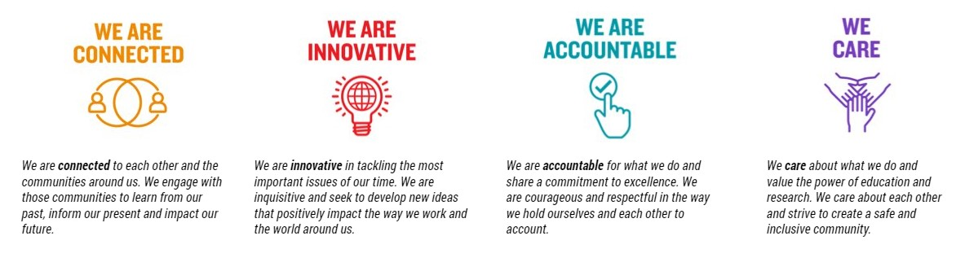

For Human Resource Use Only

Initials: Date: