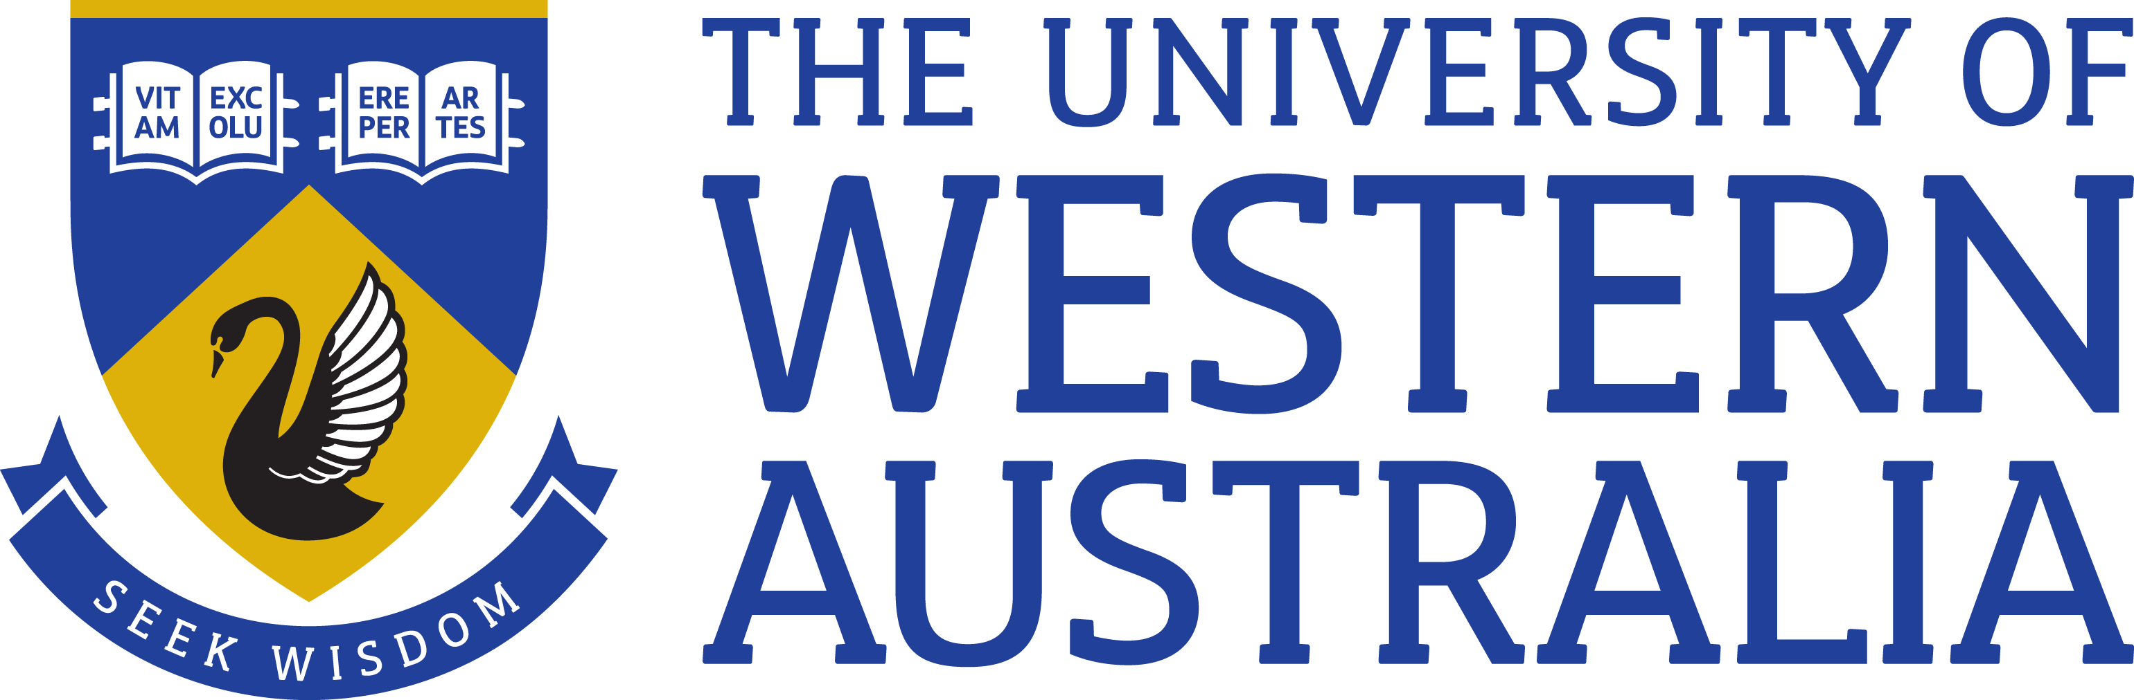

Position Title: Development Officer Bequests
Position Classification: Level 7
Position Number: 312224
Faculty/Office: Community & Engagement
School/Division: Development and Alumni Relations
Centre/Section: Central Unit
Supervisor Title: Development Manager Bequests
Supervisor Position Number: 308508

Your work area
Development and Alumni Relations [DAR] oversees the University’s alumni engagement and philanthropic strategy. The function works collaboratively across the University to ensure the advancement strategy is built into outreach efforts across campus. The core responsibility of the development team is to build on the University’s community relations and secure philanthropic support for the University.
DAR works with a broad range of individual and corporate stakeholders whose investment as ambassadors, advocates, volunteers and donors are key to the University’s long term future, inclusive of:
- Alumni including graduates, staff and former students and staff
- Donors
- Corporate and business entities
- Foundations and Trusts
- Community organisations
- Government
- Friends and Volunteers
Reporting Structure

Reports to: Development Manager Bequests

Your role
The Development Officer Bequests will participate in planning and implementing a range of fundraising initiatives and engagement opportunities designed to establish and cultivate relationships between the University and prospective bequest donors and engage meaningfully with confirmed bequest donors.
Key responsibilities
Under the guidance of the Development Manager, Bequests and focusing on the University’s fundraising priorities identify possible bequest prospects, develop targeted fundraising projects and proposals to solicit and secure bequest gifts
In line with the Prospect assignment protocols establish and manage a gifts pipeline of prospective bequest donors including the identification, cultivation, solicitation and stewardship of these donors
Liaise with bequest donors, Risk and Legal and other external agencies including lawyers, executors and trustees concerning the establishment and administration of bequests including the drafting of wills and other appropriate documentation
Realise bequest donors’ wishes to establish scholarships, prizes and memorial gifts and work within the University’s systems and processes to ensure their establishment
Work with the Development and Alumni Relations teams to build relationships with the University’s alumni groups and staff to leverage engagement initiatives to advance UWA’s bequest program
Plan and work with the DAR Engagement Officer to deliver engagement initiatives for the Winthrop Society in line with the University’s priorities
Liaise with the Donor Relations and Stewardship Team to ensure appropriate acknowledgement of and reporting to bequest donors
Actively seek information and assist in recording, monitoring and tracking prospect information on alumni, donors and supporters through the use of the CRM (REX) prospect-tracking module
Achieve the position’s performance outcomes as agreed with Development Manager, Bequests
Other duties as directed
Your specific work capabilities (selection criteria)
Relevant tertiary qualification or demonstrated equivalent competency
Demonstrated consultation, collaborative networking, negotiation and problem solving skills and the ability to develop high quality relationships with various constituencies including an older age demographic of volunteers, alumni, donors and staff to secure donations/bequests
Excellent communication and presentation skills both oral and written including experience in writing proposals and background research for the not for profit sector
Excellent organisational skills and the ability to work productively both independently and within a team to meet deadlines
Sound research and analytical skills, thoroughness and attention to detail
Proficient in a range of computing skills including word processing, spreadsheets, databases, internet and email
Professional skills and knowledge of advancement in higher education and an understanding of major international and national advancement and in particular bequest trends
Special Requirements (selection criteria)

Compliance
Workplace Health and Safety
All supervising staff are required to undertake effective measures to ensure compliance with the Occupational Safety and Health Act 1984 and related University requirements (including Safety, Health and Wellbeing Objectives and Targets).
All staff must comply with requirements of the Occupational Safety and Health Act and all reasonable directives given in relation to health and safety at work, to ensure compliance with University and Legislative health and safety requirements. Details of the safety obligations can be accessed at http://www.safety.uwa.edu.au
Equity and Diversity
All staff members are required to comply with the University’s Code of Ethics and Code of Conduct and Equity and Diversity principles Details of the University policies on these can be accessed at http://www.hr.uwa.edu.au/publications/code_of_ethics, http://www.equity.uwa.edu.au

