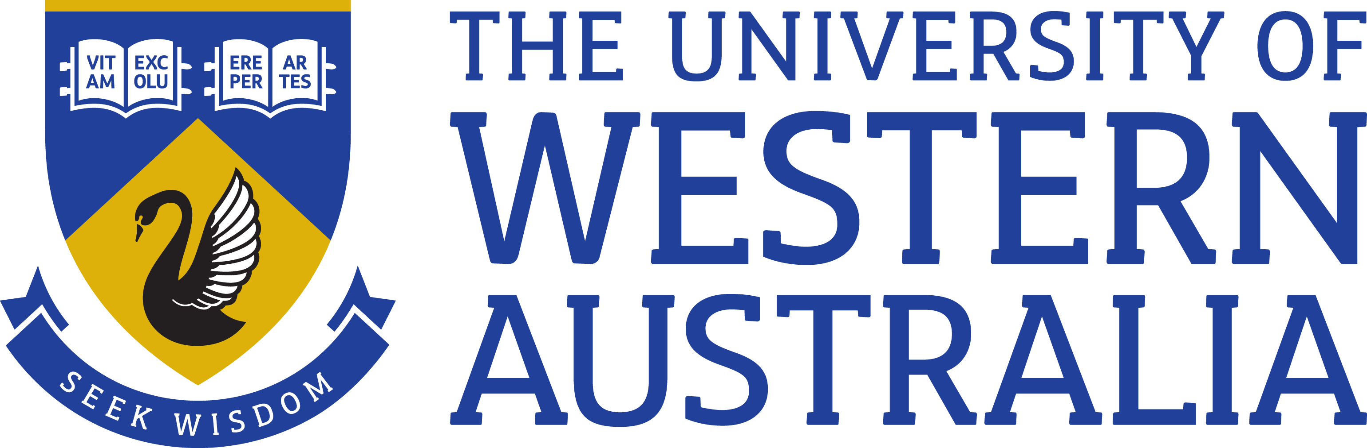

Position Title: Research Associate
Position Classification: Level A
Position Number: 317477
Faculty: Faculty of Engineering and Mathematical Sciences
School: School of Engineering
Centre: Australian Centre for Geomechanics
Supervisor Title: Senior Research Fellow
Supervisor Position Number: 305933
Your work area
The Australian Centre for Geomechanics (ACG) is a multi-disciplinary joint venture and UWA Research Centre which provides professional education, training, research and technology transfer services to the mining sector. The ACG works in the disciplines of underground, open pit and environmental mining geomechanics. The overall aim of the Centre is to improve mine safety and productivity.
The Centre’s research team conducts projects in the areas of underground, open pit and environmental geomechanics, and provides research positions for UWA Resource Engineering PhD and Masters students. The translation of research outcomes and technology transfer to industry forms part of the Centre’s mandate and is an important focus of the Centre. As a result, the Centre has a very good track record of transferring technology to the resources industry.
The software mXrap was developed over many years during the course of several research projects and now forms the cornerstone of the research translation and technology transfer strategy.

Reporting Structure

Reports to: Senior Research Fellow, Position No. 305933.

Your role
As the appointee you will, under direction of senior colleagues, participate in and coordinate experimental, analytical and other research work. You will collaborate closely with the mXrap development team to ensure that research outcomes will be translated to the industry in the form of mXrap apps. You will work with the Chief Investigator on the project titled “Ground Support Systems Optimisation – Phase 2” and will be responsible for managing and completing the sub-project 6 titled “Shotcrete specification in mining”. Ad hoc input to other ACG projects and non-research activities will also be required.

Key responsibilities
Conduct high quality research on the project.

Work collaboratively with other researchers and students engaged in the research team.

Promote research projects via publication of research papers and presentations at international conferences and workshops.

Participate in the research group’s activities and contribute to/organize group projects, workshops and other processes.

Collaborate in translation of research outcome through the development of software applications.

Publish research outcomes in journals and conferences.

Other duties as directed.

Your specific work capabilities (selection criteria)
At least 10 years of experience in mining geomechanics globally.
At least 5 years of experience in research and / or consulting services.
Experience in teaching mining and geotechnical engineering at university level.
Experience in short-term and long-term mine design.
Proven skills in numerical analysis of mining geotechnical structures for underground and surface excavations using. Experience in the use of Finite element, finite difference and boundary element codes. Experience in numerical analysis codes must include FLAC3D, UDEC, 3DEC.
A working level programming skills in FISH, python, octave or other.
Experience in using discrete fracture networks and distinct element methods.
Extensive experience in working in a team and managing projects and project teams.
Proficient in English.

Special Requirements
Occasional weekend work, some interstate and international travel.

Compliance

Workplace Health and Safety
All supervising staff are required to undertake effective measures to ensure compliance with the Occupational Safety and Health Act 1984 and related University requirements (including Safety, Health and Wellbeing Objectives and Targets).
All staff must comply with requirements of the Occupational Safety and Health Act and all reasonable directives given in relation to health and safety at work, to ensure compliance with University and Legislative health and safety requirements.
Details of the safety obligations can be accessed at http://www.safety.uwa.edu.au

Equity and Diversity
All staff members are required to comply with the University’s Code of Ethics and Code of Conduct and Equity and Diversity principles. Details of the University policies on these can be accessed at http://www.hr.uwa.edu.au/publications/code_of_ethics, http://www.equity.uwa.edu.au

