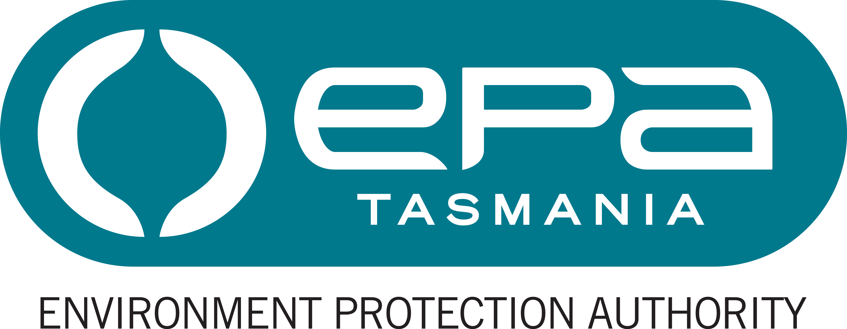
Environment Protection Authority
Statement of Duties

Position title Environmental Technical Officer
Position number 707432
Division/Business Unit/Branch Environmental Assessments / Scientific and Technical / Air
Award/Agreement: Tasmanian State Service Award
Classification General Stream, Band 3
Position Status Permanent
Full Time Equivalent (FTE): 1.0 FTE (part time hours, by negotiation)
Ordinary hours per week: 36.75 hours (part time hours, by negotiation)
Location New Town
Report to Scientific Officer (Air Monitoring)
Position Purpose
The purpose of the role is to provide specialist technical skills in the operation of the air filter weighing laboratory, operating, maintaining and calibrating field-based air quality monitoring equipment, in accordance with the National Association of Testing Authorities (NATA) accredited Quality Assurance System.

Major Duties
- Operate, calibrate and maintain scientific and analytical equipment associated with the air section weighing laboratory, including filter weighing, dispatch and receipt.
- Operate the Weighing Room databases.
- Maintain and calibrate air quality monitoring equipment and provide technical support for monitoring programmes which enable determination of compliance with relevant air quality standards.
- Follow established Quality Assurance / Quality Control protocols to ensure compliance with relevant Standards and contribute to the continued quality improvement of existing and future air monitoring programmes.
- Undertake field work as required to support the operation of the EPA’s ambient air quality monitoring programmes.
- Undertake emergency management activities including training and, commensurate with that training and relevant experience, participate in response to incidents, particularly for matters for which the EPA is the lead agency or otherwise responsible for contributing relevant staff resources.
- Perform any other assigned duties at the classification level that are within the employee’s competence and training.

Responsibility, Decision Making and Direction Received
The occupant of the position is responsible for:
- maintaining practices, methods and standards and their modification as appropriate to provide satisfactory solutions for complex operational issues;
- maintaining quality control of outcomes;
- assisting a supervisor to ensure less qualified or experienced staff receive appropriate instruction, guidance and performance feedback; and
- ensuring a safe working environment by complying with relevant Work Health and Safety (WHS) legislation, codes of practice and policies, procedures and guidelines issued under the Department’s WHS Management System.
The decision making and direction in relation to the role are that:
- general instructions are provided other than for more complex and unusual requirements which do not have clear guidelines or precedents;
- the occupant exercises independent judgment in the practices, methods and standards to be applied, and the planning and timing required to complete complex, diverse tasks; and
- creativity and initiative are required to provide options, recommendations and solutions to satisfy non-standard requirements and satisfy client and stakeholder requirements.

Knowledge, Skills and Experience (Selection Criteria)
- Knowledge and experience in performing a range of laboratory work including operation, calibration and maintenance of laboratory instruments and equipment, laboratory and field related quality assurance procedures and the capacity to understand relevant systems and procedures.
- Specialised technical knowledge of environmental monitoring programmes and the associated methodologies.
- Good communication and interpersonal skills in gaining the cooperation of others and the ability to deal effectively with challenging behaviour. The ability to explain operational procedures and provide information and liaise with clients, stakeholders and members of the public.
- The ability to make independent decisions and use initiative regarding and in the achievement of outcomes.
- Well-developed organisational skills, including the ability to set priorities and manage variable workloads for the planning and completion of tasks.
Position Requirements
Essential Requirements
- A Certificate III or Certificate IV in Laboratory Operations or Applied Science, or an equivalent level, relevant to the nature of the work to be undertaken, as provided by either a vocational education organisation or a registered and accredited training provider.

Desirable Qualifications and Requirements
- A current motor vehicle driver’s licence.

The EPA’s Role
The EPA was established as an independent statutory authority under the Environmental Management and Pollution Control Act 1994 (EMPCA) as an integral part of Tasmania's Resource Management and Planning System.
The EPA consists of a Board and a Director; the Board has an independent Chair, three other independent members – one of which is a Deputy Chair, alongside the Director. In addition, a Deputy Member may sit on the Board if a Board member is unable for any reason to perform his or her duties. As an Agency, the EPA Director has been appointed as the Chief Executive Officer and it is the role of all the EPA staff to support both the Board and the CEO with their respective functions and duties.

Statutory Functions
The regulatory system for environmental management and pollution control in Tasmania is provided for in legislation; planning and management systems; state-wide policies, and in particular the EPA's principal statutory functions are to administer and enforce the provisions of the EMPCA using its best endeavours to:
- further the sustainable development and environmental management and pollution control objectives of the EMPCA
- ensure that activities do not cause unacceptable pollution
- advise the Minister on any matter that may significantly affect the achievement of the objectives of the EMPCA, and
- ensure that environmental regulatory issues are considered in policy and program implementation.
The EPA’s website at www.epa.tas.gov.au provides more information.

Working Environment

Employees work within an environment that supports safe work practices, diversity and equity with employment opportunities and ongoing learning and development. We are committed to valuing and respecting each other as colleagues and peers. We value the diverse backgrounds, skills and contributions of all employees and treat each other and our customers with respect. We do not tolerate discrimination, harassment or bullying in the workplace.

The EPA has a culture of zero tolerance towards violence, including any form of family violence. We will take an active role to support employees and their families by providing a workplace environment that promotes their safety and provides the flexibility to support employees to live free from violence.

There is a strong emphasis on building leadership capacity throughout the EPA.

The expected behaviours and performance of EPA employees and managers are enshrined in the State Service Act 2000 through the State Service Principles and Code of Conduct. These can be located at www.dpac.tas.gov.au/divisions/ssmo.

