Position Description
Legal Counsel

Position Number: XXXXXX
Position Title: Legal Counsel Date Written: May 2019
Faculty / Division: Enterprise School / Unit: Legal Office
Position Level: Level 9

ORGANISATIONAL ENVIRONMENT
UNSW is currently implementing a ten year strategy to 2025 and our ambition for the next decade is nothing less than to establish UNSW as Australia’s global university. We aspire to this in the belief that a great university, which is a global leader in discovery, innovation, impact, education and thought leadership, can make an enormous difference to the lives of people in Australia and around the world.
Following extensive consultation in 2015, we identified three strategic priority areas. Firstly, a drive for academic excellence in research and education. Universities are often classified as ‘research intensive’ or ‘teaching intensive’. UNSW is proud to be an exemplar of both. We are amongst a limited group of universities worldwide capable of delivering research excellence alongside the highest quality education on a large scale. Secondly, a passion for social engagement, which improves lives through advancing equality, diversity, open debate and economic progress. Thirdly, a commitment to achieving global impact through sharing our capability in research and education in the highest quality partnerships with institutions in both developed and emerging societies. We regard the interplay of academic excellence, social engagement and global impact as the hallmarks of a great forward-looking 21st century university.
To achieve this ambition we are attracting the very best academic and professional staff to play leadership roles in our organisation.

UNSW BEHAVIOURS
UNSW recognises the role of employees in driving a high performance culture. The behavioural expectations for UNSW are below.
Please refer to the UNSW Behavioural Indicators for the expectations of your career level (Intermediate).

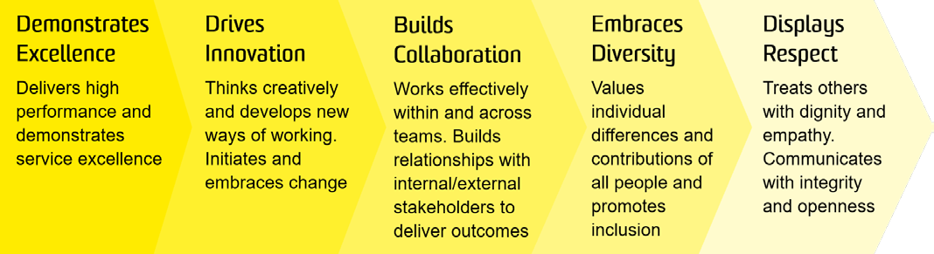

1

OVERVIEW OF RELEVANT AREA AND POSITION SUMMARY
The UNSW Legal Office provides legal support in the form of advice and transactional services to UNSW and its controlled entities on a wide variety of matters. The Legal Office comprises the General Counsel, who has overall responsibility for managing the legal, governance and compliance functions within UNSW, the Deputy General Counsel, a team of legal counsel, compliance and support staff.
The Legal Counsel acts with appropriate supervision and direction from the Head of Legal (Enterprise). The primary role of the Legal Counsel is to provide sound, practical legal support in a professional, timely and effective manner to assist commercial and IP-related transactions relevant to Enterprise. The Legal Counsel also assists as required with the general legal work of the UNSW Legal Office.
This position reports to the Head of Legal (Enterprise) and has no direct reports.

RESPONSIBILITIES
Specific responsibilities for this role include:
In an ethical, solution-focused, timely, practical and effective manner, taking into account applicable law and UNSW policies and procedures:
- Advise on and draft standard and bespoke commercial agreements for Enterprise’s consultancy, expert witness and continuing professional development service.
- Provide strategic legal advice to UNSW senior management (often on an urgent basis) on, and assist with the development of, technology-specific commercialisation strategies and legal frameworks and provide legal support for transactions executed under those frameworks.
- Develop and maintain Standard Operating Procedures relevant to the delivery of legal services to Enterprise and provide training for users and stakeholders.
- Assist with the development and delivery of legal training programs and projects including those designed for Enterprise. This involves coordinating the process of program delivery, from drafting, developing and implementing the training, in consultation with the Head of Legal (Enterprise), Legal Counsel acting for Enterprise, or other Legal Counsel in the UNSW Legal Office.
- Assist with management of legal and compliance requirements attached to the equity investments of NewSouth Innovations and UNSW.
- Draft, review and advise on commercial agreements for Enterprise, with a particular focus on technology commercialisation and industry related research agreements including collaborative research agreements, contract research agreements, IP Licensing agreements, and agreements relating to CRCs and other government funded industry partnerships.
- Provide legal support to Enterprise in complex technology commercialisation transactions, in each case acting under the general direction and supervision of the Head of Legal (Enterprise.
- Contribute to the development and updating of templates and model agreements for the UNSW Legal Office, particularly templates and model agreements relevant to the activity of Enterprise.
- Proactively assist with the day to day support and supervision of legal interns and the Junior Legal Counsel.
- Contribute to UNSW Legal Office team meetings, activities and programs, including training and knowledge management meetings and activities, and support of the internship program.
- Keep abreast of relevant law, including legislative and UNSW policy and procedure changes and their relevance and application in the UNSW Enterprise context.
- Participate in professional development opportunities as approved by the Head of Legal (Enterprise).
- Cooperate with all health and safety policies and procedures of the university and take all reasonable care to ensure that your actions or omissions do not impact on the health and safety of yourself or others.

SELECTION CRITERIA
- Tertiary qualifications in law with at least 8 years’ PQE providing legal support for commercial and preferably IP/technology-related transactions in either a high quality in-house or commercial law firm environment.
- Admission to the Supreme Court of NSW and a current practising certificate (or admission in another Australian jurisdiction and eligible to be admitted and practice in NSW).
- Thorough knowledge of IP law particularly relating to protection and exploitation of know-how and patentable inventions.
- Demonstrated thorough understanding of the application of the Corporations Law to privately held companies in the context of commercial transactions in an innovation/ technology related environment.
- Ability to independently review, draft and advise on both standard and more complex commercial agreements including agreements relating to technology commercialization and research.
- Demonstrated ability to develop insightful solutions to address client needs while effectively prioritising and executing tasks in a high-pressure environment.
- High level of attention to detail, an ability to organize and appropriately prioritise work, and deliver work in a timely way.
- An ability to work collaboratively as part of a team and, within a supervision framework, the ability to work independently and with initiative.
- Excellent written and verbal communication skills with demonstrated strong analytical and problem solving skills.
- Knowledge of health and safety responsibilities and commitment to attending relevant health and safety training.

It is not the intention of the position description to limit the scope or accountabilities of the position but to highlight the most important aspects of the position. The aspects mentioned above may be altered in accordance with the changing requirements of the role.

