Faculty: UNSW Medicine
School: Psychiatry
Position Level: Level E
Position Number: XXXXXX
Position Title: Head of School
Date Written: April 2018

ORGANISATIONAL ENVIRONMENT
UNSW is currently implementing a ten year strategy to 2025 and our ambition for the next decade is nothing less than to establish UNSW as Australia’s global university. We aspire to this in the belief that a great university, which is a global leader in discovery, innovation, impact, education and thought leadership, can make an enormous difference to the lives of people in Australia and around the world.
Following extensive consultation in 2015, we identified three strategic priority areas. Firstly, a drive for academic excellence in research and education. Universities are often classified as ‘research intensive’ or ‘teaching intensive’. UNSW is proud to be an exemplar of both. We are amongst a limited group of universities worldwide capable of delivering research excellence alongside the highest quality education on a large scale. Secondly, a passion for social engagement, which improves lives through advancing equality, diversity, open debate and economic progress. Thirdly, a commitment to achieving global impact through sharing our capability in research and education in the highest quality partnerships with institutions in both developed and emerging societies. We regard the interplay of academic excellence, social engagement and global impact as the hallmarks of a great forward-looking 21st century university.
To achieve this ambition we are attracting the very best academic and professional staff to play leadership roles in our organisation.

UNSW BEHAVIOURS
UNSW recognises the role of employees in driving a high performance culture. The behavioural expectations for UNSW are below.
Please refer to the UNSW Behavioural Indicators for the expectations of your career level (E).

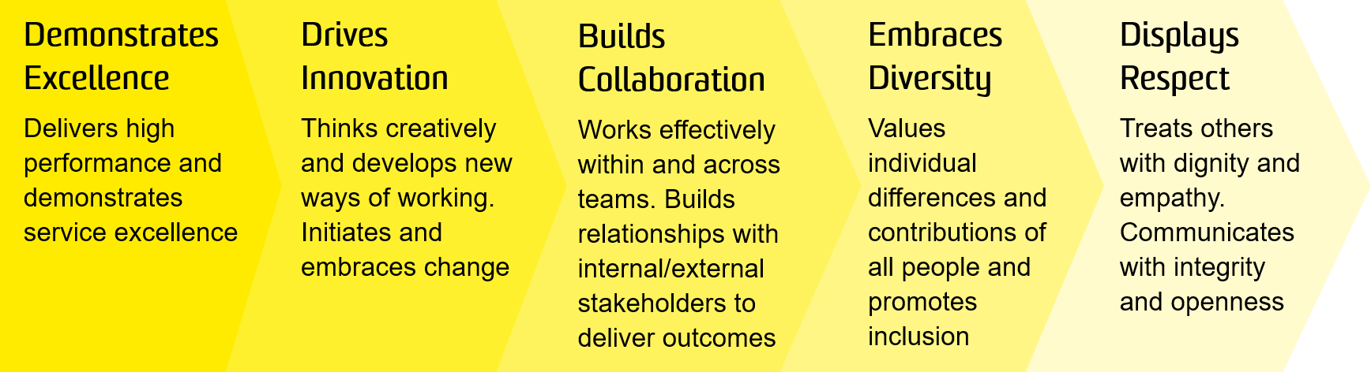

OVERVIEW OF RELEVANT AREA AND POSITION SUMMARY
UNSW Medicine is a national leader in learning, teaching and research, with close affiliations to a number of Australia’s finest hospitals, research institutes and health care organisations. With a strong presence at UNSW Kensington campus, the faculty have staff and students in teaching hospitals in Sydney as well as regional and rural areas of NSW including Albury/Wodonga, Wagga Wagga, Coffs Harbour and Port Macquarie.
The School of Psychiatry is the pre-eminent psychiatric department in the country and one of the leading university groups internationally. The school receives considerable research funds from the NHMRC through project grants and program grants. School members also receive funding from the other national peer-reviewed competitive funding bodies such as ARC. The School is located at the University’s teaching hospitals at Prince of Wales, St Vincent’s, St George and Liverpool; in UNSW-affiliated independent medical research institutes such as Neuroscience Research Australia; in other UNSW-affiliated health providers such as Justice Health, Karitane, the Rural Clinical School; and in a number of leading UNSW-affiliated private hospitals (including St John of God Hospitals at Burwood and Richmond, and Northside Group St Leonards Clinic).
The Head of the School (HOS) is a senior academic leadership role within UNSW Medicine with overall responsibility for the strategic and operational leadership of the School of Public Health and Community Medicine. The HOS supports the Faculty Dean through the provision of creative leadership in the development and implementation of innovative teaching and learning offerings and research programs within the School and across the faculty, the effective alignment and integration of the School’s teaching and research across the broader faculty and its partners and the effective management of teaching and research quality and impact within the School aligned to the Faculty and UNSW strategic objectives
The role of Head of School reports to the Faculty Dean and has all Academic staff and the School Manager as direct reports.

RESPONSIBILITIES
Specific responsibilities for this role include:
- Develop a strategic plan for the School which plays to the strengths, priorities, academic environment and strategic needs of UNSW Medicine, its stakeholders and local communities.
- Work in partnership with Institutes and Centres within UNSW to determine the strategic direction of the School, including new appointments, other academic opportunities, joint investment in research and teaching infrastructure and the development of common systems, policies and procedures.
- Promote high standards of academic excellence in teaching and learning, research and research training by establishing and communicating measures and expectations for academic and conjoint staff aligned to strategic needs and priorities.
- Enhance the research profile of the School by improving the quality and quantity of research output and cross-collaboration with other Schools through alignment with and support for the Thematic approach of the Faculty.
- Drive the overall teaching performance of the School by providing a valuable student education experience and fostering and promoting a culture of innovation and excellence.
- Recruit and retain academic staff that excel in teaching and research and who align closely with the goals of the UNSW Medicine Strategy.
- Implement quality assurance and improvement procedures to enhance all aspects of the School’s activities.
- Contribute to the further development of curricular and academic initiatives within the Faculty to ensure the School develops in alignment with UNSW Medicines response to the UNSW 2025 strategy.
- Work with the School Manager to oversee the financial management of the School, including the preparation of budgets and allocations of resources.
- Establish and maintain excellent relationships with external stakeholders such as Local Health Districts, Government, donors, alumni and potential students to ensure the interests of UNSW Medicine and the School are effectively promoted and achieved.
- Ensure that the School is effectively administered by optimising the allocation of resources, operating within budget and meeting relevant legislative and compliance obligations.
- Engage in high quality research projects, attract competitive grants, and publish research results in leading international journals and books.
- Supervise and actively participate in teaching and examining at both undergraduate and postgraduate levels.
- Participate in Faculty, UNSW or external committees or boards as required.
- Support UNSW initiatives, such as The Plus Alliance and NUW Alliance.
- Implement the UNSW Health and safety management system within the area of responsibility.

SELECTION CRITERIA
- Eligibility for medical registration in Australia, and possession of Fellowship of the Royal Australian and New Zealand College of Psychiatrists or equivalent specialty qualification
- A PhD in a relevant discipline area and an outstanding research record as evidenced by publications in top tier journals.
- A record of outstanding achievement and leadership in a managerial role in a University or professional setting.
- A distinguished record of academic excellence with an outstanding contribution to teaching and research at both undergraduate and postgraduate levels.
- Proven ability to attract research funding and publications in a relevant discipline.
- Successful interaction with relevant professional organisations and/or evidence of involvement in broader health system management.
- Demonstrated capacity for leading change in: delivery of education; conduct of research; and the health system at clinical, research or education level.
- A track record of innovation in education and development of new programs
- Excellent oral and written communication skills.
- Ability and capacity to direct and monitor the implementation and effectiveness of the safety management system.

It is not the intention of the position description to limit the scope or accountabilities of the position but to highlight the most important aspects of the position. The aspects mentioned above may be altered in accordance with the changing requirements of the role.

