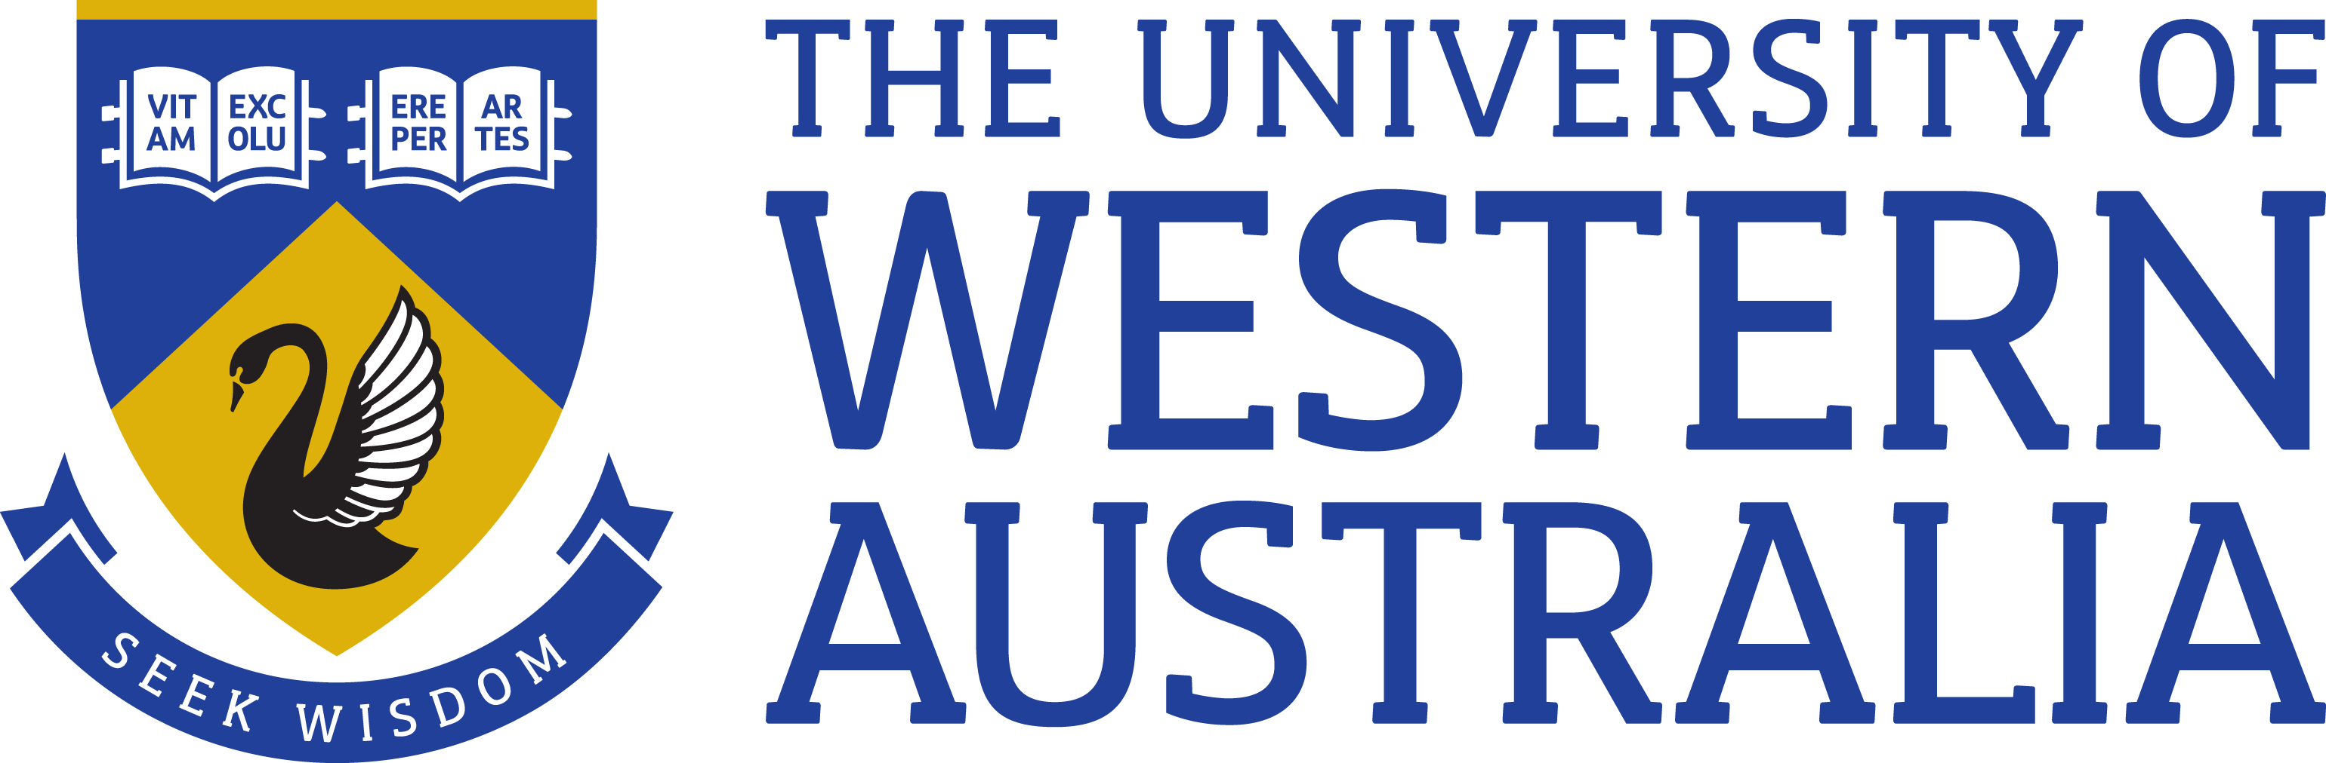

Position Title: | Human Resources Manager, Continuous Improvement
Position Classification: | Level 9
Position Number: | 315863
Faculty/Office:  School/Division:  Centre/Section: | Human Resources  Business Performance & Compliance  Central Unit
Supervisor Title: | Associate Director, Business Performance & Compliance
Supervisor Position Number: | 315333
About the work area

Human Resources (HR) enables the University vision, strategy and objectives by partnering with the business to provide high quality strategic and operational people and culture support across the organisation.

HR is responsible for providing efficient and fit for purpose organisational wide HR policy, process and systems and specialist advisory services covering culture, capability, talent, reward and employee relations. HR provides services both centrally and within the Service Delivery Centres.

Reporting Structures

Reports to: Associate Director, Business Performance & Compliance

Role Statement

The HR Manager, Continuous Improvement is responsible for supporting the transformation of HR service delivery by leading improvements in HR Policy, Process and Systems and data analytics across UWA. As such the role is subject to change over time.
The appointee will lead and work in partnership with the Central Unit and Service Delivery Centres to develop and implement streamlined, efficient and user friendly HR Policy, Process and Systems to deliver exceptional service across the employee lifecycle, including: workforce planning, attraction, talent acquisition, performance management and development, talent management, reward and recognition, employee administration and payroll.

Key Responsibilities

Strategy and Culture
- Provide leadership and direction on HR Policy, Process and Systems in line with the strategic directions and goals of UWA
- Act as key adviser and recognised specialist on HR Policy, Process and Systems and continuous improvement strategies and frameworks
- Further develop HR Policy, Process and Systems through continuous improvement initiatives to cultivate a streamlined, user friendly HR service delivery
- Contribute to, and promote the image and reputation of the University as an ‘Employer of Choice’ and a great place to work
Policy, Procedures and Performance
- Develop and deliver HR Policy, Process and Systems (in line with continuous improvement methodology) and frameworks, plans and initiatives to improve quality, reduce cost and eliminate non-value added work across the University

- Work in partnership with the BITS team to implement and enhance HR Management system, including requirements, making recommendations on systems modules, vendor selection and management
- Facilitate and roll out training and coaching to SDC HR teams related to new/ revised HR Policy, Process and Systems and Continuous Improvement methodology
- Deliver agreed projects, KPIs and service partner agreements including managing within resources allocated (financial and human)
- Develop and ensure HR data analytics, performance measurements/ KPIs and dashboards are established and aligned across the University for use in business decision making
- Drive continuous improvement in overall HR operations and efficiency by monitoring and updating analytical and reporting tools, systems modules and HR processes in response to changing business conditions
- Facilitate internal communities of practice related to HR Process and Systems
- Ensure website content related to HR Policy, Process and Systems is current
Team
- Lead and/ or support direct and virtual teams to achieve goals and provide high quality service
- Operate as the driver of HR Policy, Process and Systems and continuous improvement with the HR Managers in the Service Delivery Centres
- Deputise for the AD, Business Performance and Compliance in their absence
- Other duties as directed

Specific work capabilities (selection criteria)

Relevant Tertiary qualification, or demonstrated equivalent competency
Extensive knowledge and expertise of contemporary human resource practice and procedures,
particularly in the field of HR Policy, Process and Systems
Knowledge and expertise in project management and continuous improvement methodology e.g.
Prince 2, Lean, 6 Sigma
Experience establishing and facilitating HR Policy, Process and System (implementation) and
continuous improvement frameworks, processes and programs
Demonstrated ability to lead virtual project teams, motivate and influence others to achieve goals and
provide high quality service
Excellent written and verbal communication skills and high level consultation and negotiation skills
Excellent conceptual, analytical and problem-solving skills with the ability to develop creative solutions
to complex problems and business requirements
Excellent planning and organisational skills and demonstrated ability to drive results in a complex
environment with multiple stakeholders
Experience of delivery in a transformational workplace
Special Requirements
NA
Compliance
Workplace Health and Safety
All supervising staff are required to undertake effective measures to ensure compliance with the Occupational Safety and Health Act 1984 and related University requirements (including Safety, Health and Wellbeing Objectives and Targets).
All staff must comply with requirements of the Occupational Safety and Health Act and all reasonable directives given in relation to health and safety at work, to ensure compliance with University and Legislative health and safety requirements.
Details of the safety obligations can be accessed at http://www.safety.uwa.edu.au

Equity and Diversity
All staff members are required to comply with the University’s Code of Ethics and Code of Conduct and Equity and Diversity principles. Details of the University policies on these can be accessed at http://www.hr.uwa.edu.au/publications/code_of_ethics, http://www.equity.uwa.edu.au

