Position Title: | Future Student Advisor |  | Faculty/Division: | External Relations
Date Written: | 27 January 2017 |  | School/Unit: | Future Student Recruitment (Business)
 |  |  | Position Level: | 5

ORGANISATIONAL ENVIRONMENT
UNSW is currently implementing a ten year strategy to 2025 and our ambition for the next decade is nothing less than to establish UNSW as Australia’s global university. We aspire to this in the belief that a great university, which is a global leader in discovery, innovation, impact, education and thought leadership, can make an enormous difference to the lives of people in Australia and around the world.
Following extensive consultation in 2015, we identified three strategic priority areas. Firstly, a drive for academic excellence in research and education. Universities are often classified as ‘research intensive’ or ‘teaching intensive’. UNSW is proud to be an exemplar of both. We are amongst a limited group of universities worldwide capable of delivering research excellence alongside the highest quality education on a large scale. Secondly, a passion for social engagement, which improves lives through advancing equality, diversity, open debate and economic progress. Thirdly, a commitment to achieving global impact through sharing our capability in research and education in the highest quality partnerships with institutions in both developed and emerging societies. We regard the interplay of academic excellence, social engagement and global impact as the hallmarks of a great forward-looking 21st century university.
To achieve this ambition we are attracting the very best academic and professional staff to play leadership roles in our organisation.

UNSW BEHAVIOURS
UNSW recognises the role of employees in driving a high performance culture. The behavioural expectations for UNSW are below.
Please refer to the UNSW Behavioural Indicators for the expectations of your career level 5.

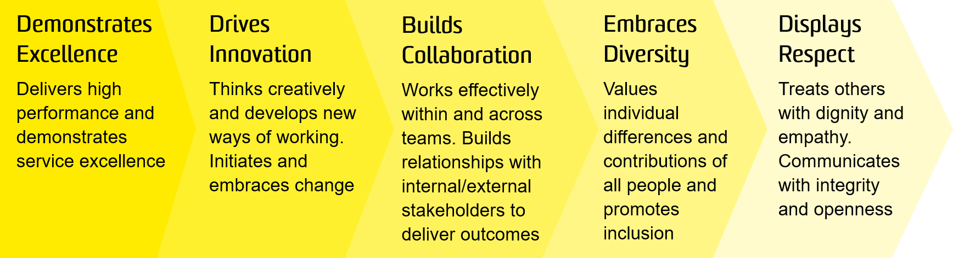

OVERVIEW OF RELEVANT AREA AND POSITION SUMMARY
The Division of External Relations, led by the Vice-President (Division of External Relations), is responsible for the following areas of activity:
- Global Partnerships
- Global Profile & Reputation
- Future Student Recruitment
- Service Excellence (across these functions)
The Future Student Recruitment pillar has been established to strengthen marketing efforts, ensuring UNSW is the premier destination in the state for local students and the premier destination in the country for internationals.
The Future Students Advisor (Business) is responsible for the provision of accurate, comprehensive and timely advice to prospective students as well as other University staff. While the Future Students Advisor (Business) will be responsible for all manner of enquiries they will be primarily focused on answering enquiries and providing advice related to the Faculty of Business. They must also be able to interpret often complex scenarios and detailed degree and admissions policies in order to properly advise enquiries, whether received by phone, email, web form or web chat, or email and utilise systems like CRM to capture and record data about particular interactions.
The Future Student Advisor (Business) reports to the Enquiries Manager and has no direct reports.

RESPONSIBILITIES
Specific responsibilities for this role include:
- Participate fully within the Future Student Experience Team, contributing to creating a respected and customer-focused service.
- Understand the University’s business, drivers, and processes, as well as culture, and how each Department/Faculty interacts effectively on an organisational level.
- Provide pre and post application support to potential students to progress them through the UNSW student recruitment cycle with a focus on the Faculty of Business.
- Provide accurate, timely and comprehensive information to stakeholders via phone, email and face-to-face.
- Achieve or exceed against set individual and team key performance indicators (KPI's) in the critical success areas of outbound contact success; quality response provision; minimal abandonment rates, turnaround times and lead nurturing in outbound communication activities.
- Maintain up-to-date records of enquiries and communication with applicants within the UNSW CRM.
- Maintain up-to-date knowledge of University policies and procedures, particularly those relating to students requiring case management.
- Represent UNSW at various recruitment and career events.
- Work collaboratively with stakeholders to develop accurate, up-to-date, high quality information content to contribute to various student or internal staff information channels.
- Become a champion of CRM for UNSW, by being an adopter and using CRM for all reporting, lead capture, contact management, follow-up processes and communications.
- Cooperate with all health and safety policies and procedures of the University and take all reasonable care that their actions or omissions do not impact on the health and safety of others in the University.

SELECTION CRITERIA
- A relevant degree with extensive experience or an equivalent level of knowledge gained through any other combination of education, training and experience.
- Proven ability to work in a high volume, process driven environment with variable workflow patterns and to fixed deadlines.
- Knowledge and experience in the tertiary education sector with experience in key source markets is desirable.
- Demonstrated ability to work flexibly and productively as an effective team member to ensure deadlines are met.
- Excellent written and verbal communication skills and the ability to liaise effectively with all levels of staff and external stakeholders.
- Advanced level of computer literacy with excellent skills in Microsoft Office applications and databases (e.g. CRM).
- Knowledge of health and safety responsibilities and commitment to attending relevant health and safety training.
It is not the intention of the position description to limit the scope or accountabilities of the position but to highlight the most important aspects of the position. The aspects mentioned above may be altered in accordance with the changing requirements of the role.

