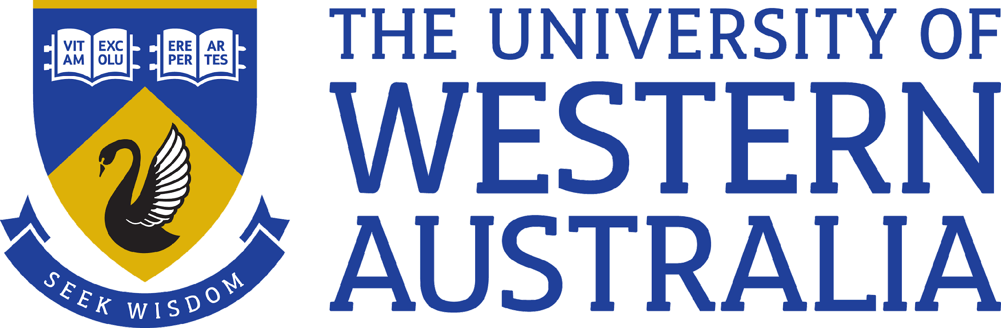

Position Title: Research Fellow
Position Classification: ALA A/B
Position Number:
Faculty: Engineering and Mathematical Sciences
Department: Mathematics and Statistics
Centre/Section: Applied Mathematics
Supervisor Title: CSIRO-UWA Chair in Complex Engineering Systems
Supervisor Position Number:
Your work area
The Australian Research Council Industrial Transformation Training Centre for Transforming Maintenance Through Data Science is a joint collaboration between Curtin University, the University of Western Australia, CSIRO and Industry partners BHP, Roy Hill, Alcoa, MRIWA and Core. The aim of the centre is to train the next generation of data science specialists needed transform maintenance practice in the resource industry. Research is being conducted by a team of 20 scientists and engineers at the three research institutes together with practicing engineers in the partner organisations. Activity is arranged thematically according the three research themes: Supporting the Maintainer; Supporting the Engineer; and, Supporting the Manager. The focus of each theme is to develop the tools and solutions necessary to support maintenance tasks across the organisation. Work within each theme is to be conducted by a group of postgraduate research students, academic and research staff, an academic lead, and post-doctoral researchers.

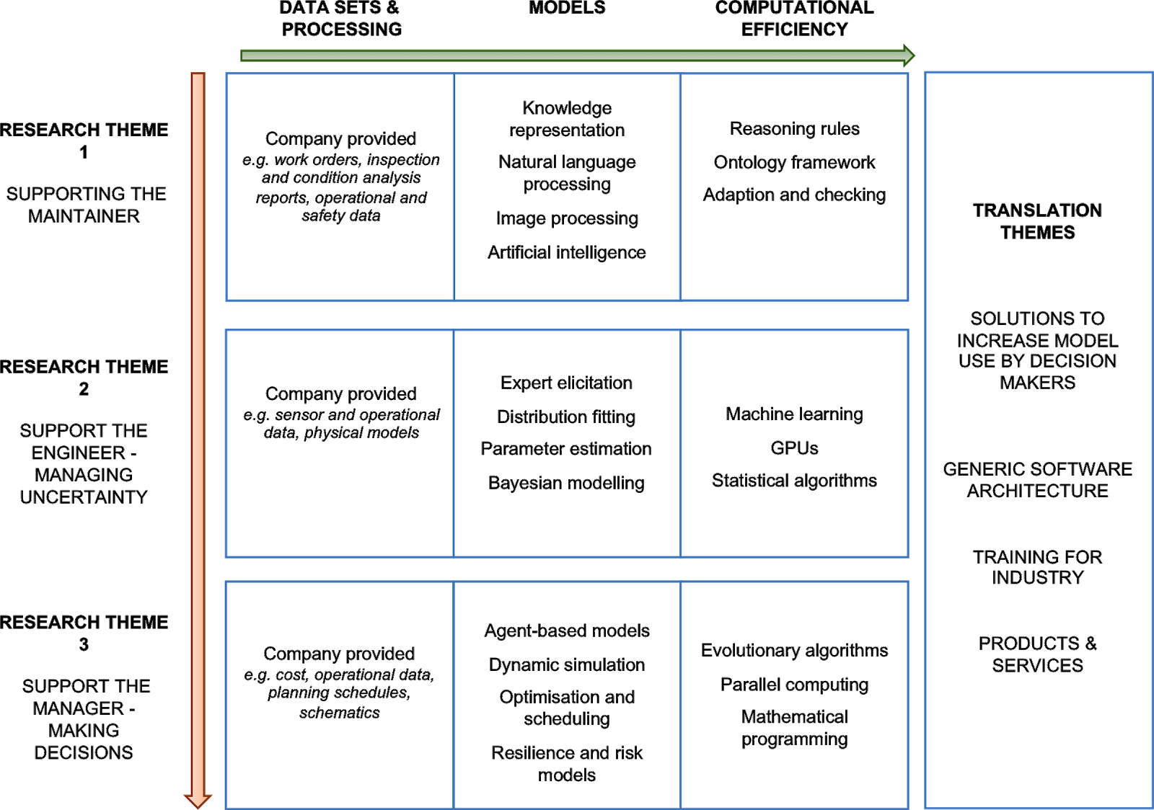

This position is for a postdoctoral Research Fellow to work within theme 2, Supporting the Engineer, in collaboration with research theme lead Prof. Michael Small. Prof. Small is the CSIRO-UWA Chair in Complex Engineering Systems and holds joint appointments at CSIRO’s Mineral Resources and UWA’s Faculty of Engineering and Mathematical Sciences in the Department of Mathematics and Statistics. The training centre is based at Curtin University in the Perth suburb of Bentley, adjacent to CSIRO’s Kensington Campus and approximately 10 km from UWA. The Centre Director Prof. Andrew Rohl is based in Curtin University’s Department of Chemistry.

Reporting Structure to: Academic Research Supervisor
If a leadership/ supervisory role:
Direct Reports:
Teams: ARC ITTC for Transforming Maintenance Through Data Science
Your role
The postdoctoral research fellow will be expected to conduct research leading to publication and industry impact relevant to the theme “Supporting the Engineer” within the ARC ITTC. This includes individual research, but is also expected to be largely research in collaboration with academics, researchers and engineers involved in the centre.
A large part of the postdoctoral research fellows duties will include mentoring and potentially supervising postgraduate research students within this theme. Each research student in expected to include a minimum of twelve months of industry placement (with partner organisations Roy Hill, BHP or Alcoa) during their candidature. The research fellow will be required to liaise with industry contacts and help students integrate properly with the respective teams.

Key responsibilities
- Drive the “Supporting the Engineer” research program in conjunction with the academics and industry partners in that theme.
- Supervise and mentor research postgraduate students, both in academia and during industry placements.
- Present research activities and results in reports, research publications, and to visitors, potential sponsors and peers.
- Publication in academic peer reviewed literature.
- Contribute to grant writing. Seek out sources of funding, including from grant awarding bodies and through consultation and industrial investment.
- Manage day-to-day activities related to operation of research within the centre.
- Develop and deliver training materials as required – both to ensure industry adoption of outputs of the research centre, and to equip and instruct postgraduate students.
- Perform other duties as directed..
Your specific work capabilities (selection criteria)

- PhD in engineering, physics, computer science, mathematics, or a relevant engineering discipline.
- Experience in working as a team player, preferably within a cross-disciplinary team. Willingness to work across institutions and act as a mentor for a cohort of research students during study and industry placement.
- Track record of research publication and in seeking and obtaining grant funding (relative to opportunity).
- Highly developed written and verbal communication skills in the preparation of high-quality reports, presentations and publications.
- An ability and willingness to direct and supervise final year undergraduate students and PhD students.
- Experience and willingness to work with industry partners on industry problems.
- Experience and/or enthusiasm in translating research outcomes to practise. This may include development and delivery of industry short-courses or relevant software development.
- Highly developed organisational skills and demonstrated ability to set priorities and to meet deadlines.
- (Desirable) Experience in translating academic outcomes and language into industry terms
Special Requirements
You will split your time between UWA and Curtin campuses. In addition you will be expected to spend time on industry partner sites.
Compliance
Workplace Health and Safety
All supervising staff are required to undertake effective measures to ensure compliance with the Occupational Safety and Health Act 1984 and related University requirements (including Safety, Health and Wellbeing Objectives and Targets).
All staff must comply with requirements of the Occupational Safety and Health Act and all reasonable directives given in relation to health and safety at work, to ensure compliance with University and Legislative health and safety requirements.
Details of the safety obligations can be accessed at http://www.safety.uwa.edu.au

Equity and Diversity
All staff members are required to comply with the University’s Code of Ethics and Code of Conduct and Equity and Diversity principles. Details of the University policies on these can be accessed at http://www.hr.uwa.edu.au/publications/code_of_ethics, http://www.equity.uwa.edu.au

