Position Number(s) | 006174/006175 | Manager’s Role Title | AM&D Planning Coordinator
Business Group | Operations & Maintenance | Manager Once Removed | Manager Maintenance Planning
Level of Work | VI SA Water Hierarchy Level | Direct Report’s Role Title(s) | Not applicable

Purpose (Unique value add)
The primary focus of the Maintenance Planner is to develop and monitor work schedules to support the delivery of preventive maintenance and capital programs, in accordance with SA Water Asset Management Strategies and Service Level Agreements.

Objectives
The objectives (maximum 6) of this role are to:
- Plan work initiated through various stakeholders, ensuring that the required resources are available and work is carried out in line with Asset Maintenance Plans, asset criticalities and Service Level Agreements (where applicable).
- Determine and monitor labour capacity in order to develop fortnightly work plans to maximise resource utilisation for the approval by Workshop Coordinators/Team Leaders.
- Liaise with AM&D Planning Coordinator and Maintenance Optimisation Coordinator to ensure preventive maintenance programs are delivered within target.
- Develop/review standard job plans in SA Water WMS to ensure a consistent approach is delivered for repetitive jobs.
- Ensure Work Management data quality and integrity to improve performance and improve management decisions.

Shared Organisational Goals
As a member of the Operations & Maintenance Group you are collectively accountable for delivering our goals and objectives.
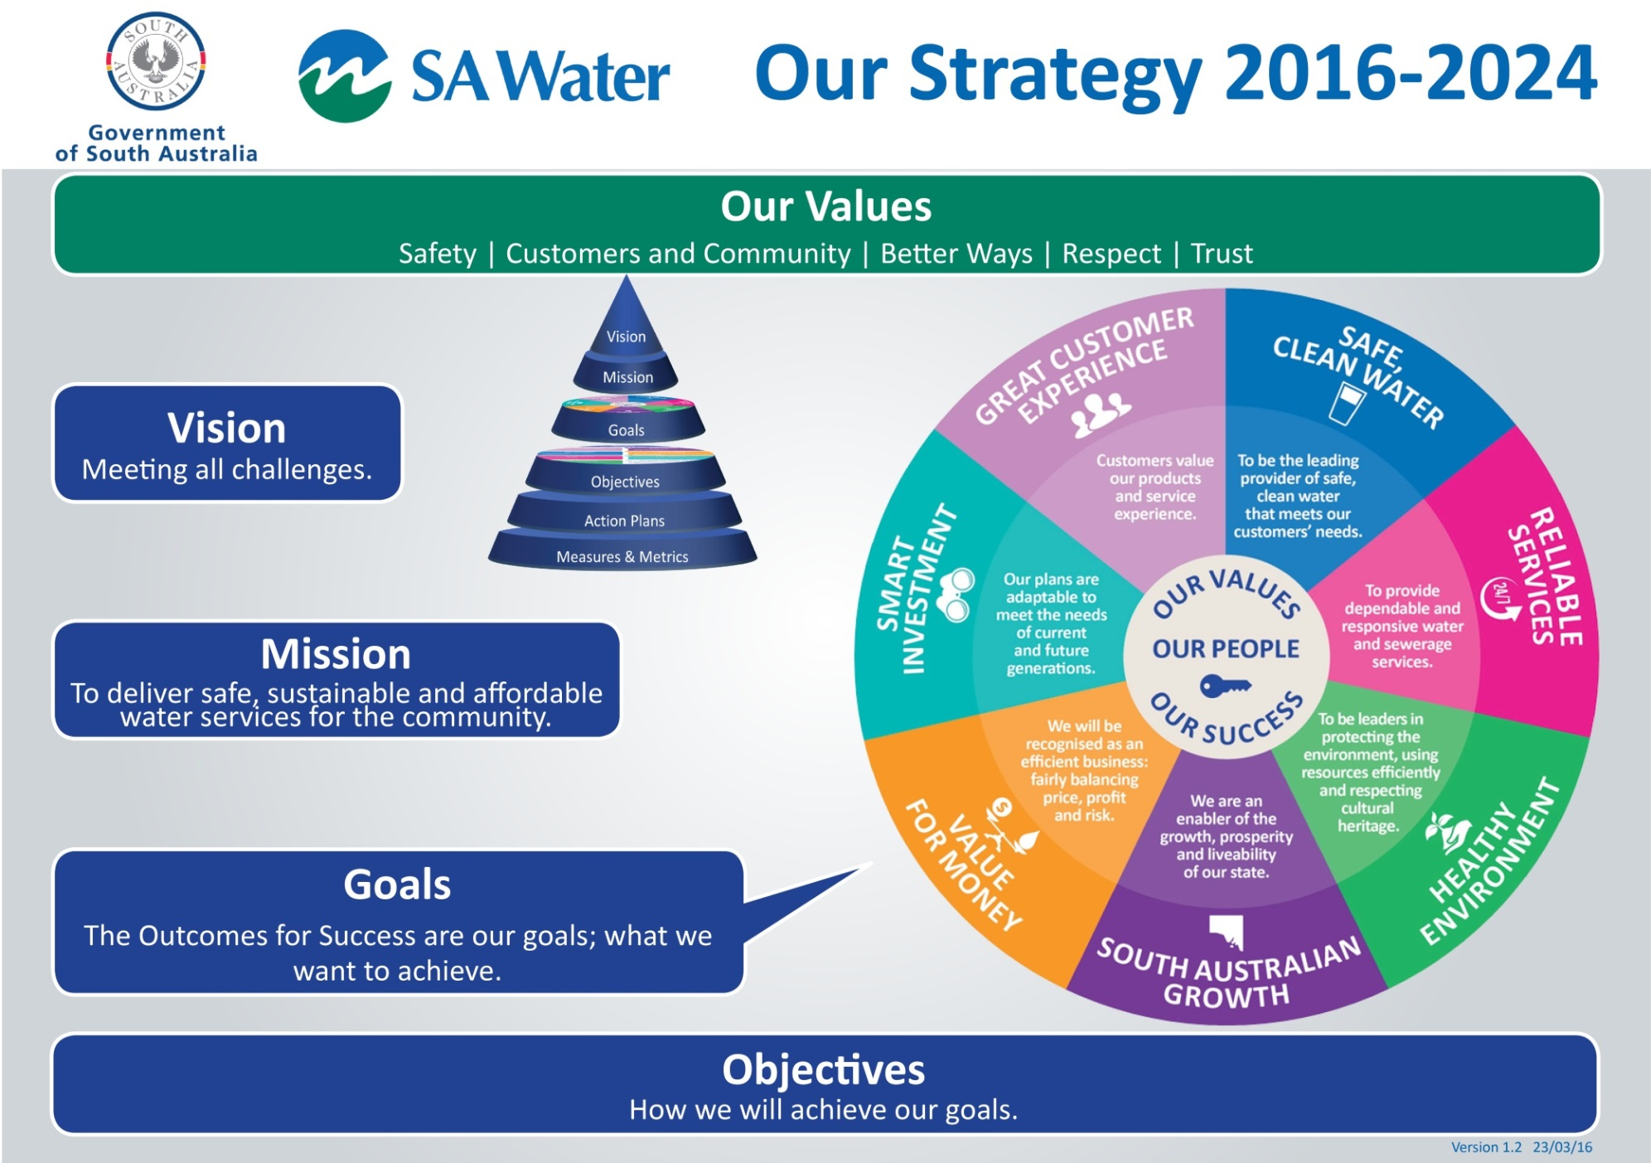
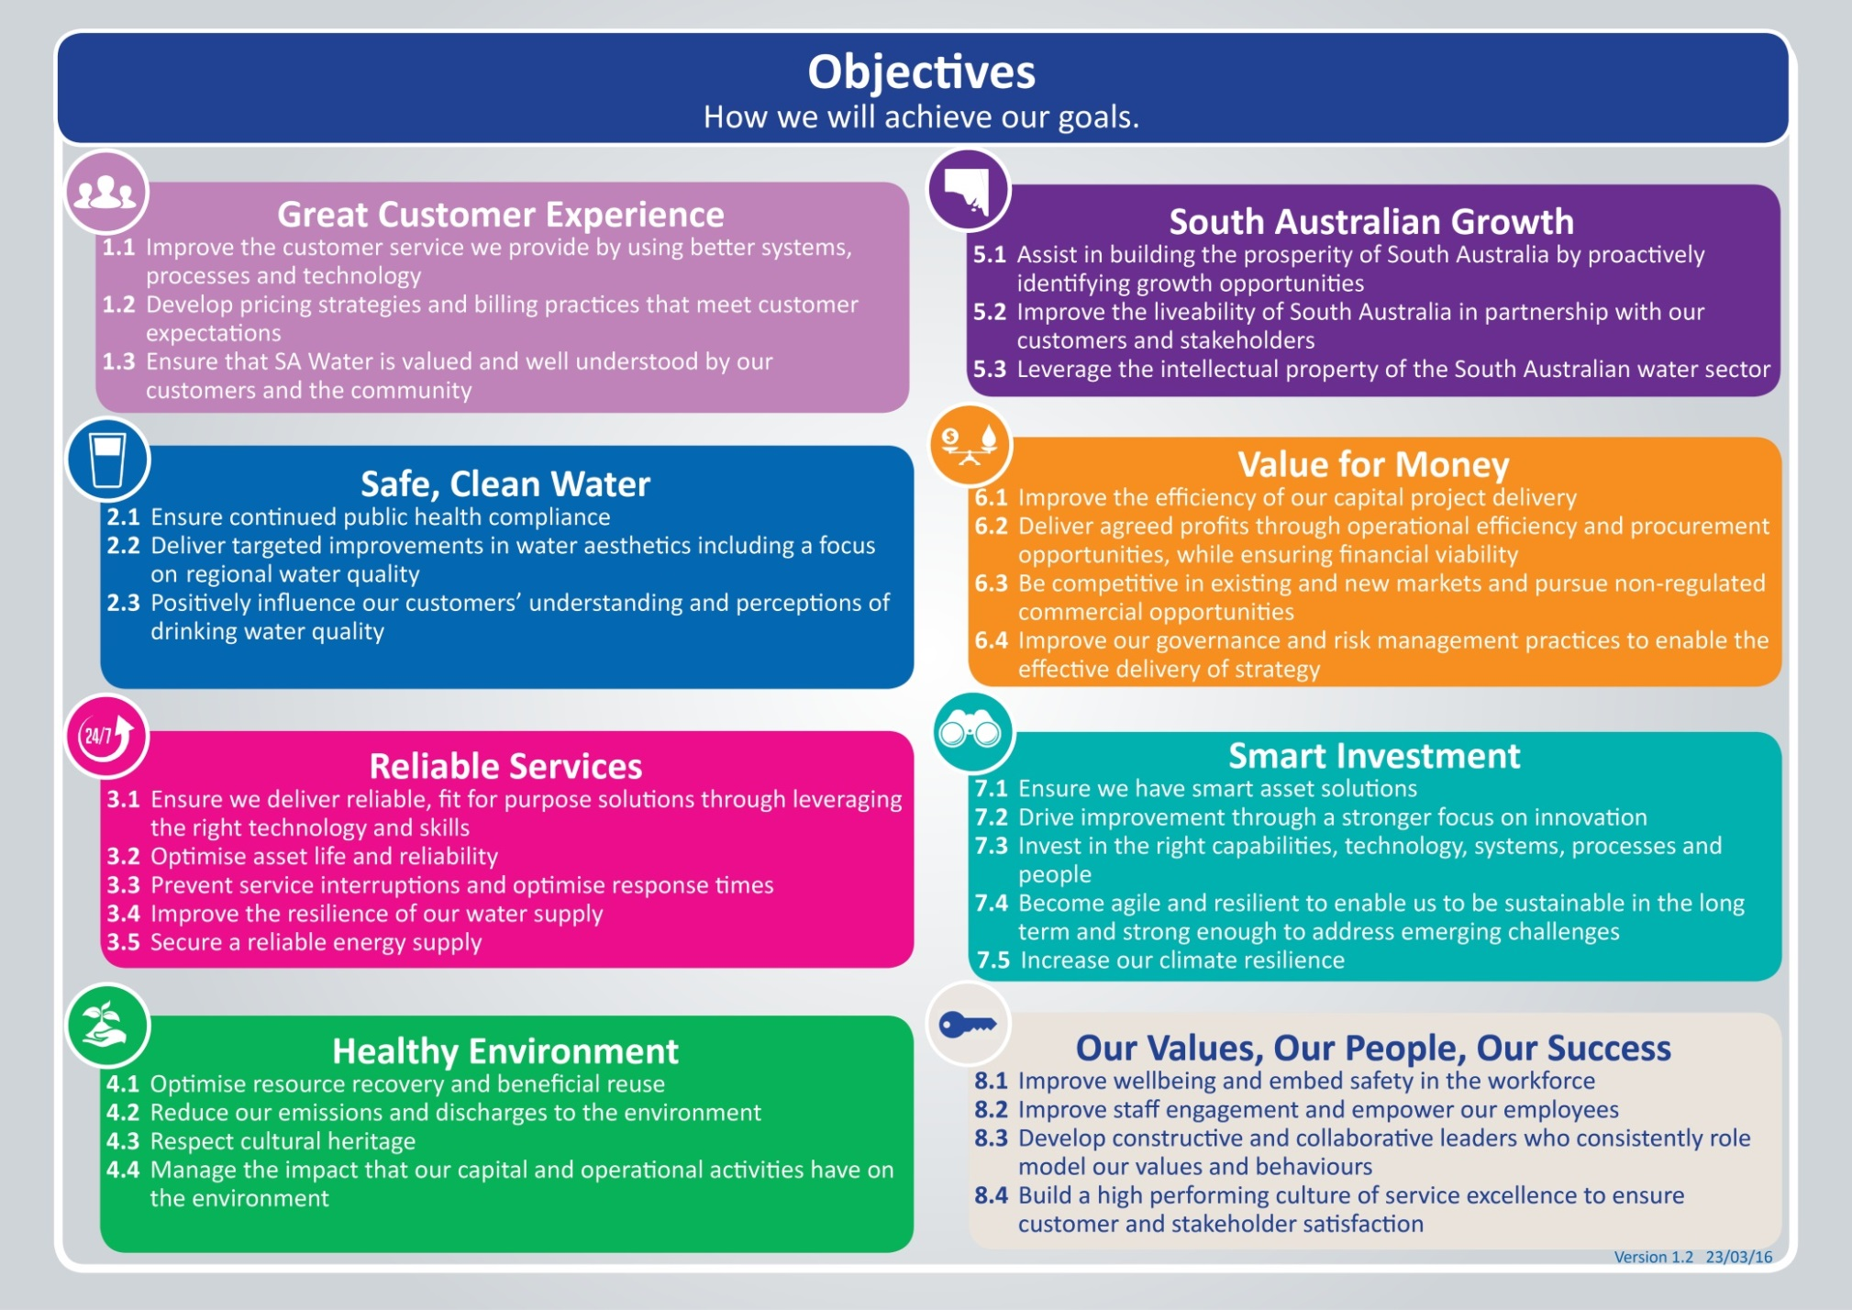

Key Accountabilities
The key accountabilities of this role are:
Key Accountabilities | Output/Measures
Mandatory accountability:  Contribute effectively to the team ensuring efforts are aligned toward achieving team goals | - Implement the direction set by your people leader.  - Complete specific tasks allocated.  - Collaborate effectively to ensure team goals are achieved by providing input into decision making and problem solving.  - Actively contribute to creating a culture of service excellence.
Mandatory accountability:  Put safety above all else | - Be aware of and apply roles and responsibilities in accordance with WHS Roles and Responsibilities Procedure.  - Take responsibility for the safety and wellbeing of yourself and others including your own fitness for work (e.g. under the influence of drugs, alcohol and/or fatigue).
Short term work planning | - Support response to breakdown and corrective work, assisting with obtaining required resources and collaborating with other O&M planners if required.  - Creation/approval of work orders where required.  - Tracking work order progress to completion.
Medium term work planning | - Determine/track labour capacity and ensure asset, labour, equipment and other resource requirements are available to meet work schedule needs.  - Generate fortnightly plans for workshops personnel and other relevant groups, applying relevant preventive, criticality and capital SLA targets where applicable.  - Attend weekly workshop planning meetings to discuss and develop work schedules.  - Management/tracking of work orders to completion and coordination of backlog work.  - Develop/review of standard job plans in SA Water WMS to ensure a consistent approach is delivered for repetitive jobs.
Long term work planning | - Liaise with AM&D Planning Coordinator and Maintenance Optimisation Coordinator to ensure preventive maintenance programs are delivered within target.  - Review and determine long term capacity in collaboration with AM&D Planning Coordinator up to three months ahead.  - Participate in Capital Project scoping and planning, relevant to AM&D Workshops.
Identify and initiate improvements in Works Management/Performance Measurement | - Identify improvements in the Works Management System (WMS).  - Perform ad-hoc analysis of data and provide reports as required.  - Participate in data accuracy.
Team effectiveness | - Participate actively in 1 on 1s and Performance Appraisals.  - Work collaboratively with other work planning staff.  - Work collaboratively with the AM&D Planning and Maintenance Optimisation Coordinators.  - Develop and builds positive relationships with team members.  - Participate effectively during team meetings.

Behavioural Competencies
Uphold SA Water’s Values:
- Put safety above all else
- Act in the best interests of customer and the community
- Seek and apply better ways
- Respect our people
- Be trustworthy

Behavioural Competencies | Behavioural Expectations
Customer Focus | - Anticipates needs of customer and follows through.  - Makes decisions that take into account value for customer.  - Speaks up and identifies problems arising.
Collaborate for Success | - Works co-operatively with others to achieve the best outcomes.  - Maintains effective working relationships with others in the team and across the business.  - Treats people in an honest, courteous and respectful manner.
Self-Management | - Focuses on delivering services despite challenges.  - Presents ideas clearly and concisely.  - Is responsive to the changing needs of our customers and business by adapting to change.
Achieve Results | - Takes personal responsibility for mistakes and learns from them.  - Looks for ways to continually improve and finds better ways.  - Focuses on achieving outcomes using good judgement and quick decisions that lead to business success.
Safety Culture | - Puts safety first when making decisions.  - Adheres to safety processes and procedures and reports when things are ‘not right’.  - Openly communicates ways of improving safety.

Knowledge, Skills and Experience

Foundation knowledge, skills, experience and qualifications | Essential or Desirable
Technical qualifications in mechanical and or electrical fields (such as Degree or Diploma in Mechanical or Electrical Engineering) and/or relevant experience | Essential
Ability to communicate effectively and to interact with employees from a broad range of disciplines | Essential
Experience and understanding of work management systems, planning processes and work prioritisation | Essential
Current Driver’s Licence | Desirable
Proficient computer skills | Desirable
High level organisational skills | Desirable
Demonstrated capacity to accurately record, manage, and analyse data electronically | Desirable
Ability to work under limited supervision and meet tight deadlines | Desirable
Understanding of customer privacy responsibilities | Desirable
Understanding of water quality, environmental and safety requirements for water and waste water systems | Desirable

Key Stakeholder Relationships
- Manager Maintenance Planning and AM&D Planning Coordinator
- AM&D Workshop Coordinators, Team Leaders and District Leaders
- Capital Project Officers and Managers
- Operations Field Force
- Operations Control Centre
- O&M Logistics
- Work Planners within and across SA Water functions
- Networks Managers, Treatment Managers, Asset Managers
- Third parties – suppliers, contractors, other utilities
- Corporate projects teams

Special Conditions
- Flexible hours and some after hours as required, some intra and interstate travel

Template: Position Description - L6-L7 Employee Version 3.00 19/07/16 -Document ID: SAWT-HR-0023

