Job Title: | Residential Youth Worker
Responsible To: | Residential Coordinator
Responsible For: | Residential supervision, provision of support and guidance to students in the program.
Founding Purpose | “This is how we know what love is: Jesus Christ laid down His life for us.  So, we also ought to lay down our lives for others.” (1 John 3:16)  Inspired by Jesus Christ, Mission Australia exists to meet human need and to spread the knowledge of the love of God.
Vision | Pathways for life  Our vision is to see a fairer Australia by enabling people in need find pathways to a better life
Organizations’ Core Values | Compassion Integrity Respect Perseverance Celebration
Organisation Mission | Walking alongside those in need, we help people discover:  - Pathways to strong families and healthy, happy children  - Pathways through a successful youth  - Pathways away from homelessness  - Pathways to skills and qualifications  - Pathways to sustainable employment
Position Purpose: | Acting as an appropriate role model to students, the Residential Youth Worker is responsible for maintaining an orderly residence where young people learn to live with others and develop appropriate living skills, including budgeting, meal preparation, house cleaning, general self care and personal hygiene routines.
Key Challenges | Managing challenging behaviours; applying appropriate boundaries and consequences where necessary, and assisting students to develop key skills in interpersonal relationships.
Key Result Areas | - Client support and supervision  - Program support  - Administration

- ORGANISATION CHART (What are the key reporting relationships for the role?)

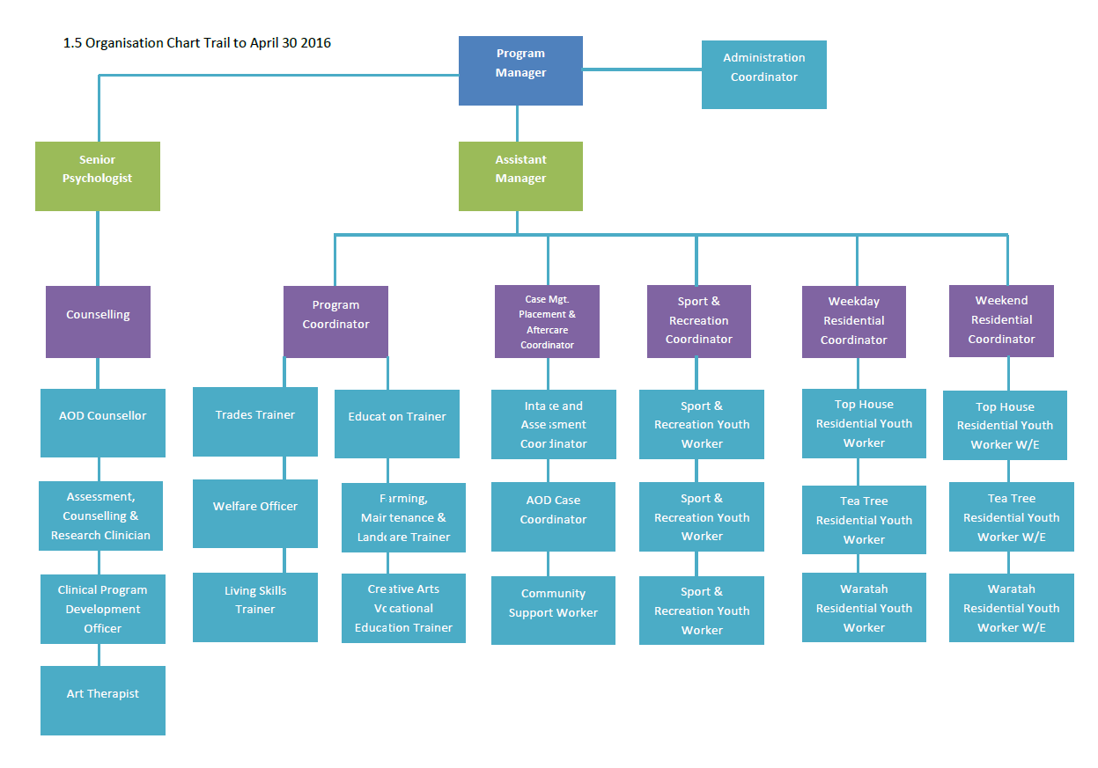

- JOB REQUIREMENTS (What are the key activities for the role?)

Key Responsibility Area 1 | Client Support and Supervision
Key Tasks: |  | Job holder is successful when:

- Induct students into the service including the property, facilities, regulations and expectations and the Student Handbook.  - Support the progress of student residents towards the achievement of their casework goals and their movement through the three stages of the Triple Care Farm program.  - Maintain acceptable standards of student conduct in accordance with the program’s established rules.  - Establish positive working relationships with student, endeavoring to understand and interpret their behaviour, thus influencing positive attitudinal and behavioural change.  - Develop cottage menus to ensure they are nutritious and varied, and that the special dietary needs of individual students are met.  - Provide education and guidance to students on meal preparation and food handling.  - Provide guidance and education as required monitor students’ ability to maintain satisfactory standards of personal care, hygiene and grooming.  - Ensure that all cottages are maintained in a tidy and hygienic condition at all times.  - Resolve student complaints or refer them to the Shift Team Leader  - Ensure the safe storage and distribution of student medications and the maintenance of essential medical records in each of the Farm’s cottages.  - Report student illnesses or injury to facilitate any necessary treatment or first aid.  - Ensure the maintenance of Log and Communication Books as described in the Policy and Procedure Manual including the recording of incidents and events occurring on residential shifts. | - Clients are thoroughly inducted into the service and are fully aware of their rights and responsibilities.  - Clients are supported in their progress towards targets with positive outcomes achieved.  - Students comply with internal and external regulations with minimal non-compliance maintained.  - As far as practicable, students demonstrate the ability to live successfully in a group setting with minimal con-compliance maintained.  - All cottage menus are nutritional and meet the needs of all students.  - Students are able to prepare, cook and serve a meal.  - Students observe daily personal hygiene routines including oral care; clothes are regularly washed.  - Cottages are clean hygienic and tidy at all times.  - Students actively participate in the daily chores roster.  - Student incidents are documented and addressed in a timely and effective manner.  - Student medications are kept secure at all times, administered appropriately and documentation is accurate and up to date.  - Full compliance with reporting policies and procedures is achieved.

Key Responsibility Area 2 | Program Support
Key Tasks: |  | Job holder is successful when:
- As required contribute to case planning-monitoring meetings with the Case Coordinator, to ensure the progress of individual students through their programs and towards the achievement of their goals.  - Assist, at every opportunity, the ongoing development of the Triple Care Farm program through the maintenance and expansion of life skills training and recreational, leisure and social activities aimed at the overall development of students.  - Participate in staff meetings, workshops, training courses as required, to improve professional knowledge and skills and the overall service quality offered at Triple Care Farm.  - Ensure cottage furnishings, equipment and stores are maintained and used with due care.  - Undertake any associated duties as requested or directed by the Residential Coordinator, the Assistant Manager, Program Coordinator or Program Manager.  - Ensure the maintenance of Log and Communication Books as described in the Policy and Procedure Manual including the recording of incidents and events occurring on residential shifts. |  | - Active participation and contribution to case planning-mentoring meetings is achieved.  - Students participate on a range of sporting, leisure and general fitness activities in line with their individual case plan and personal goals.  - Active contribution is made to the development of the program including participation in staff training and development.  - Cottages are well resourced and maintained at all times.  - Associated duties are completed efficiently.

Key Responsibility Area 3 | Administration
Key Tasks: |  | Job holder is successful when:
- Ensure the efficient maintenance of up to date records, case notes and reports on each of the students.  - Maintain residential files ensuring behaviour records, progress notes are filed in correct order.  - Ensure that all petty cash is accounted for and that relevant receipts are handed into administration.  - Ensure that all vehicle log books are signed and dated correctly.  - Ensure that fleet vehicles are well maintained, clean and that any damage is reported promptly.  - Ensure that timesheet details are accurate and all timesheets are handed in to Residential Coordinator. |  | - Appropriate notes are kept for all students and reports are written in line with required MA and external standards.  - Residential files are created and maintained, with 100% accuracy.  - Petty cash is kept up to date and balanced.  - All log books are completed and accurate.  - Vehicles are maintained in good condition.  - Timesheets are well managed, accurate and submitted on time in all cases.

Core Area of Responsibility | Purpose and Values
Key Tasks
- Actively support Mission Australia’s purpose and values;
- Positively and constructively represent our organisation to external contacts at all opportunities;
- Behave in a way that contributes to a workplace that is free of discrimination, harassment and bullying behavior at all times;
- Operate in line with Mission Australia policies and practices (EG: financial, HR, etc);
- To help ensure the health, safety and welfare of self and others working in the business;
- Follow reasonable directions given by the company in relation to Work, Health and Safety.

C. RECRUITMENT INFORMATION (The essential knowledge, experience, skills and personal attributes required for the job)
- Ability to work as part of a team
- Demonstrated sound interpersonal and communication skills
- Understanding of adolescent mental health issues
- Ability to communicate with adolescents
- Understanding of duty of care
- Computer literacy
- Apply First Aid Certificate

Experience and Qualifications
- Relevant degree or diploma and / or at least three years experience in adolescent residential care or related discipline.

D. APPROVAL
Manager | Gabriella Holmes
Approval date
Managers Signature
Residential Youth Worker Signature

