

**POSITION DESCRIPTION**

|  |  |
| --- | --- |
| Position Title: | Community Support Worker (CSW) |
| Reporting to: | Team Leader – Home Care |
| Business Area: | Community Services – Home Care |
| Location: | Depending on contracted roster |

**VISION, MISSION, AND VALUES**

The *Community Support Workers* contributes to Amana Living’s Vision, Mission, and Values.

**VISION**  A community where every older person is honoured and valued.

**MISSION** Together, we enable older people to maintain their individuality, providing what is needed to support a fulfilling life.

**VALUES**  **Compassion** We act with kindness, empathy, and respect to foster a community of caring

**Collaboration** We work together, so every person’s contribution advances our common purpose

**Curiosity** We are determined and creative in finding ways that deliver great outcomes

**Inclusion**  We celebrate diversity, ensuring everyone is welcomed and treated equitably

**Trust**  We take our responsibility seriously and are worthy of the trust placed in us

**AGED CARE CODE OF CONDUCT**

Aged care workers are covered by the Code of Conduct for Aged Care. The Code sets out how approved providers (Amana Living) and their workers (Amana Living staff) and governing persons must behave and treat consumers when providing aged care services, and strengthens protections for older Australians against unsafe, poor-quality aged care services.

Amana Living expects all staff covered by the Aged Care Code of Conduct to comply with Code and all remaining staff to provide care and/or service that is safe and respectful and to behave in a way that is in keeping with the Code.

**WORK HEALTH AND SAFETY**

*Community Support Workers* are required to take reasonable care for their own health and safety and the health and safety of other persons at the workplace. Throughout their employment they must comply with any reasonable instructions, policies and procedures relating to health and safety at the workplace.

PRIMARY OBJECTIVES:

Th*e role of Community Support Worker within Amana Living includes but is not limited to providing respite, transport, shopping assistance, personal care, meal preparation, medication services, social support and domestic duties.*

**KEY RESPONSIBILITIES:**

* Providing Direct Care to Clients in accordance with Care Plan.
* Supports, maintains, and assist client’s independence.
* To provide a clean, comfortable and safe environment.
* Supports the rights, interests and needs of the clients.
* Maintain effective communication in the workplace.
* Maintain appropriate records and information in accordance with Amana Living policies, procedures and confidentially agreement.
* Assist the client with personal hygiene which may include bathing, dental hygiene, dressing, grooming, toileting and continence hygiene needs.
* Assist with mobilising and transferring clients. (as per the Support Plan)
* Ensure clients can maintain adequate hydration and nutrition by providing assistance as needed.
* Assist the client to take correct medication.
* Assist client with communication and socialisation with others.
* Assist client with domestic tasks as identified in the Support Plan.
* Respond to additional client care needs and emergency situations.
* Respond to additional client needs as requested by Coordinator or Team Leader.
* Attend and actively participate in regular compulsory training and competency sessions.
* Attend and actively participate regular compulsory staff meetings.
* Assist and provide information to ensure all mandatory requirements are met.

**PERFORMANCE INDICATORS:**

* Attends and actively participates in compulsory training sessions and meetings as required by Team Leader.
* Manages regulatory compliance in occupational health and safety against Amana Living’s Policies and Procedures.
* Actively participates in client reviews and case discussions.
* Maintains effective communication in the workplace.
* Maintains compliance with Amana Living policies and procedures in the workplace.
* Attend and actively participate regular compulsory staff meetings.

**KEY PHYSICAL REQUIREMENTS:**

The work undertaken by a Community Support Worker involves fairly constant physical activity varying from a low to high intensity but predominantly of a moderate intensity. Their main roles involve attending to the needs of clients within the community, assisting with personal care activities, medication management, meal prep, domestic assistance, and taking on outings such as shopping & medical appointments. The following physical requirements are therefore required:

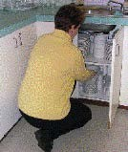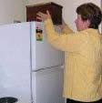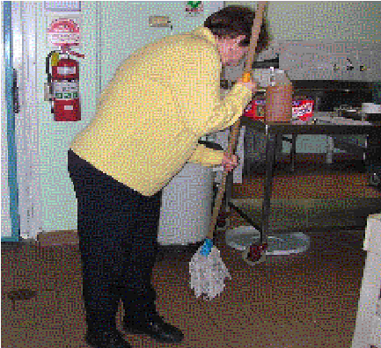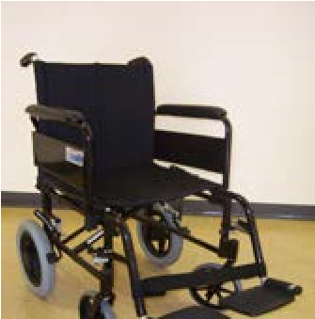

Lift up to 10kgs between waist and floor height, occasionally lift up to 10kgs above shoulder level, carry up to 10kgs over short distances, and occasionally push/pull w/chairs.

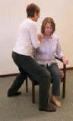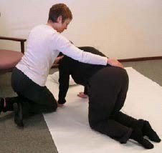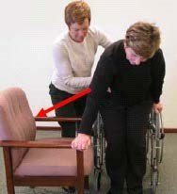

Alternation between seated, standing and walking activities, with the ability to maintain a crouched/kneeling position with a slight to moderate degree of lumbar flexion for a few minutes at a time.

**SKILLS, KNOWLEDGE, EXPERIENCE & COMPETENCIES REQUIRED:**

**Skills, Knowledge & Experience**

|  |  |
| --- | --- |
| **Mandatory**  **/**  **Desirable** | **Description** |
| M | Police Clearance Certificate less than 6 months old |
| M | Successful completion of pre-medical form and reference checks |
| M | Successful completion of the key physical requirements assessment |
| M | Proven organisational and time management skills |
| M | Ability to work independently and as a member of a team, as required |
| M | Confidence to take initiative whilst being aware of own limitations |
| M | Sensitivity and maturity to provide personal care to another person(s) |
| M | Current Flu Vaccination & Covid Vaccinations per Amana Living policy |
| M | Creative problem-solving skills when working independently |
| M | A valid “C Class” driver’s licence, WA registered vehicle and fully comprehensive motor vehicle insurance |
| M | Suitable and reliable vehicle |
| D | Experience caring for others |
| D | Senior First Aid Certificate |
| D | Previous experience working with people within the aged care industry |
| D | Certificate III Community Services (Aged Care Work) or equivalent |

**Core Competencies (assessed at 3 months and annually or every two years)**

|  |  |  |  |
| --- | --- | --- | --- |
| **Requirements** | **3months** | **Annually** | **Biennial** |
| Mandatory Training | X |  | X |
| Manual Handling Training | X | X |  |
| Medication Training | X | X | X |