Position Description

|  |
| --- |
|  |
| Pathways Coordinator |
| Three Rivers Department of Rural Health |
| Faculty of Science and Health |

|  |  |
| --- | --- |
| **Classification** | Level 7 |
| Special conditions | The appointment is contingent upon the successful applicant obtaining, complying with, and maintaining a valid ‘Working with Children Check’.  Periodic travel, sometimes involving overnight stays.  Out of hours and weekend work on occasions. |
| **Workplace agreement** | [Charles Sturt University Enterprise Agreement](http://www.csu.edu.au/__data/assets/pdf_file/0008/149831/enterprise-agreement.pdf) |
| **Date last reviewed** | September 2024 |

Faculty of Science and Health

Three Rivers Department of Rural Health

Three Rivers Department of Rural Health (DRH) is a Commonwealth Department of Health initiative embedded within Charles Sturt University. Our aim is to enhance the recruitment and retention of rural [nursing, allied health, and dental health professionals](https://threerivers.csu.edu.au/about-us/supported-health-professions). Three Rivers is an alliance that brings together the unique geographical knowledge and expertise of Charles Sturt and its partners.

The key activities of Three Rivers DRH are:

* Delivering effective rural training experiences for nursing, midwifery, allied health, and dental students (prior to gaining professional registration).
* Ensuring rural training experiences are of high quality.
* Developing processes to improve rural student recruitment.
* Engaging with the local community to support the delivery of training to students.
* Maintaining and progressing an evidence base and the rural health research agenda.
* Supporting improvements in Aboriginal and Torres Strait Islander health.
* Providing regional leadership in developing innovative training solutions to address rural workforce recruitment retention.

For more information, please see website: <https://threerivers.csu.edu.au/home>

Organisational chart

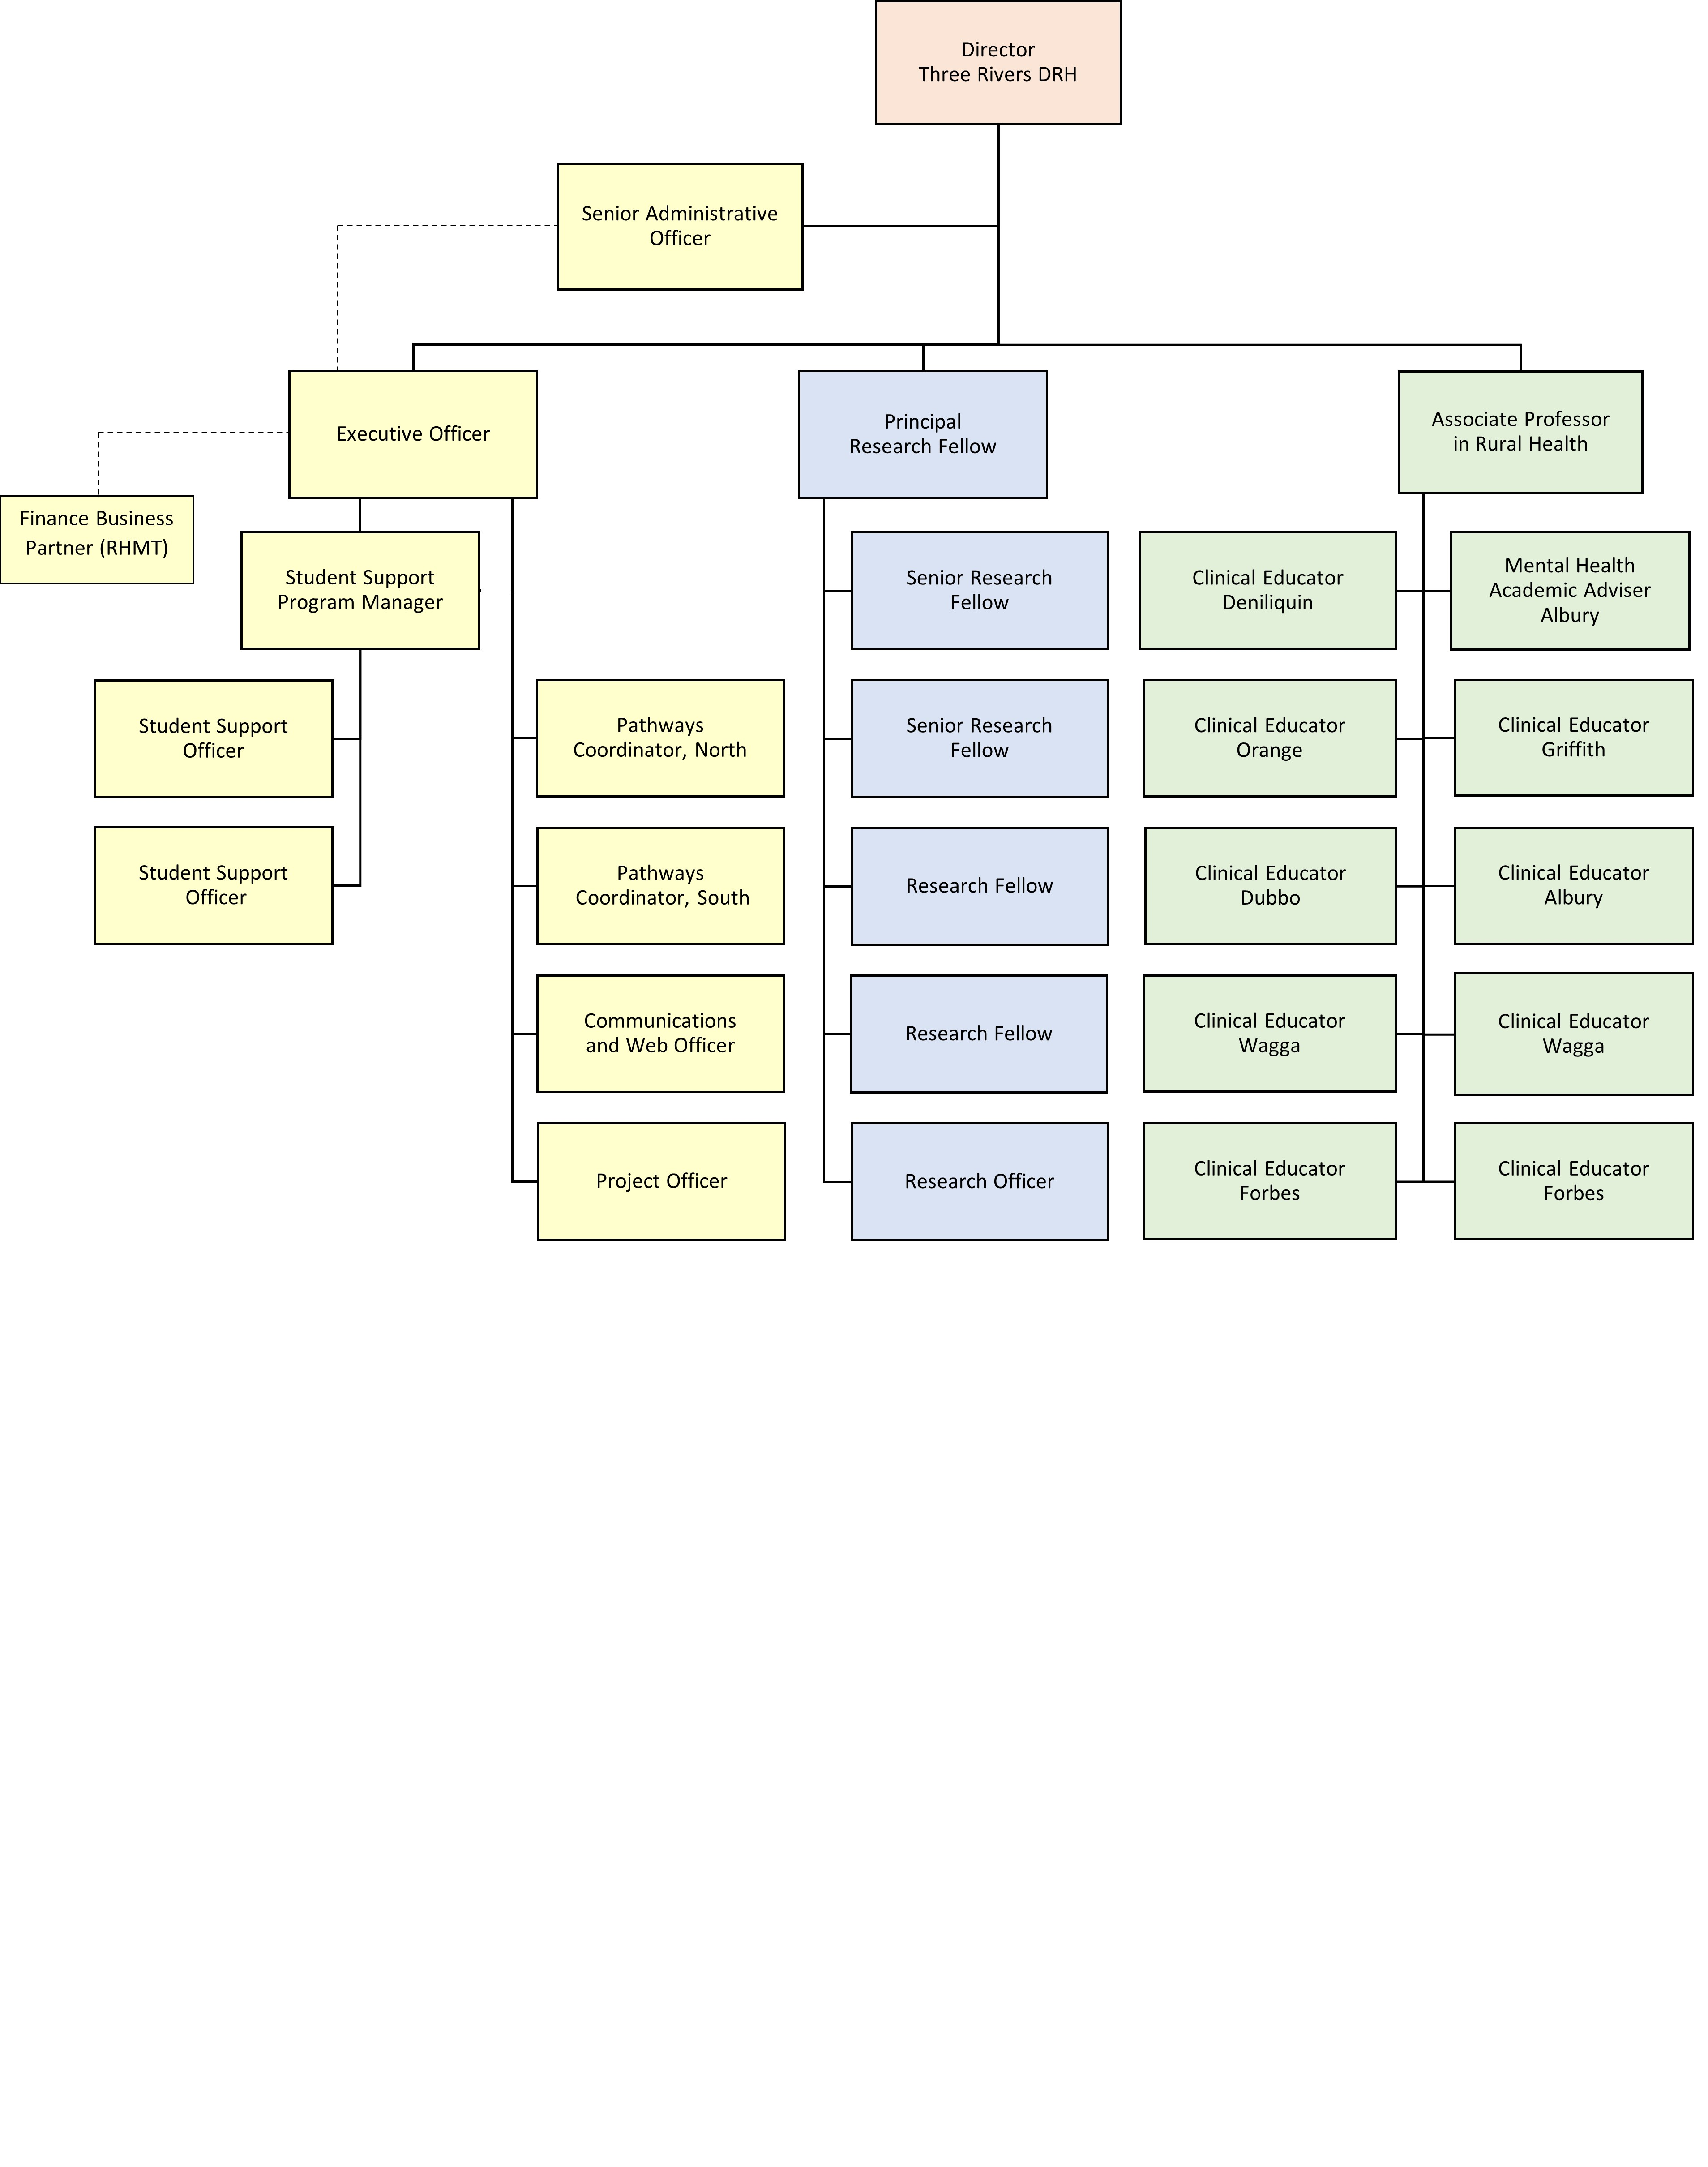

Reporting relationship

**This position reports to:** Executive Officer

**This position supervises:** Student Volunteers

Key working relationships

* Division of Student Success
* Student Rural Health Club Executives and members
* Charles Sturt Faculty and School Staff
* Charles Sturt Divisions, Offices and Centre Staff
* External partners including education institutions, intermediaries, and diverse community stakeholders.

Position overview

The Pathways Coordinators will develop and implement initiatives designed to encourage rural origin students to undertake health profession studies at Charles Sturt; whilst working collaboratively with First Nations Pathways in Health and work alongside both established and emerging Charles Sturt marketing programs

The Pathways Coordinators will apply teaching and learning methodologies to plan, develop, present, and evaluate activities, that facilitate engagement with prospective health students.

This position will also take a leading role in the guidance and support of the student led rural health club to promote and advocate for rural health and rural health workforce issues.

This position will appeal to individuals who are enthusiastic and committed to improving the student experience, rural health and working with rural people.

Principal responsibilities

* Lead the implementation and evaluation of Three Rivers DRH pathways initiatives designed to support current and prospective rural origin students to undertake health profession studies at Charles Sturt;
* Develop and align promotional activities with Charles Sturt marketing and First Nations Pathways in Health initiatives to support prospective students to convert aspiration to reality in undertaking health profession studies at Charles Sturt;
* Demonstrate a thorough understanding of student support services available across Charles Sturt and Three Rivers, and facilitate the connection of health professions students to appropriate services to promote the optimal university experience;
* Develop, implement, manage, and evaluate scholarships to support rural origin students to undertake health profession studies at Charles Sturt by working closely with the DRH leadership team and Scholarship’s office, whilst also managing the budget for these scholarships.
* Actively oversee and provide leadership and guidance to the student Rural Health Club (RHC), ensuring an inclusive approach across campuses and health disciplines whilst also managing and supporting student volunteers who are engaged in promotional and rural health activities.
* Facilitate and nurture external networks to support the expansion of pathways activities with a focus on Rural Health.
* Support the planning and execution of Three Rivers DRH student events across campuses, ensuring an inclusive approach across disciplines.
* Undertake data collection and analysis to support the evaluation and reporting of Pathways and Student Support activities, contributing to Department of Health reporting processes.
* Other duties appropriate to the classification as required.

Required capabilities

This section comprises capabilities from the Charles Sturt [Capability Framework.](https://cdn.csu.edu.au/__data/assets/pdf_file/0008/3076262/CSU-Capability-Framework.pdf) Read the Framework for more detail regarding these capabilities.

|  |  |  |
| --- | --- | --- |
| Capability | Capability Definition | Level of influence |
| Innovates | | |
| Creates Innovative Solutions | Uses methodologies that open up creative thinking and transform ideas into actionable plans and strategies. Reflects on outcomes and drives ongoing improvement. | Influence self |
| Connects | | |
| Builds Relationships | Implements interdisciplinary collaboration, adopts diversity and inclusion principles, and facilitates relationship building to work effectively with others. | Influence self |
| Communicates with Influence | Listens to understand the position of others and leverages effective communication and negotiation skills in order to influence and navigate toward mutually beneficial outcomes. | Influence self |
| Creates Alignment | Aligns behaviours with values, recognises interconnectedness in the environment and takes effective action. | Influence self |
| Achieves | | |
| Plans and Prioritises | Effectively plans and aligns priorities with strategy. Effectively allocates and utilises resources to achieve goals. | Influence self |
| Drives Impact | Collaboratively engages with peers and stakeholders in the community and industry. Places our people and students at the centre of design decisions. | Influence self |

This section comprises of Enabler and Manages Effectively capabilities from the Charles Sturt Capability Framework.

|  |  |  |
| --- | --- | --- |
| Capability | Capability description | Level of influence |
| Enablers | | |
| Manages Projects Effectively | Applies effective planning and coordinates effort using project management practices to deliver specific project objectives. | Influence self |
| Manages Effectively | | |
| Clarifies Purpose and Inspires Direction | Clearly articulates the purpose and strategies of Charles Sturt and alignment to teamwork priorities. Provides a sense of direction and motivates people and teams to strive for it. | Influence self |

Physical capabilities

The incumbent may be required to perform the following.

* Work in other environments beyond your base campus, such as other campuses.
* On occasion drive a vehicle distance up to 500km per day within the terms of the university’s [Driver Safety Guidelines](https://policy.csu.edu.au/document/view-current.php?id=184)
* Physically able to sit for extended periods of time to perform reading, writing and computing related activities including keyboard and mouse operations.

Selection criteria

Applicants are expected to address the selection criteria when applying for this position.

**Essential**

1. A degree with at least 4 years subsequent relevant experience to consolidate and extend the theories and principles learned; or extensive experience and management and or specialist expertise; or an equivalent level of knowledge gained through any other combination of education, training and/or experience.
2. Demonstrated experience in the development and delivery of programs or activities designed to engage and motivate students to further their education.
3. Highly developed communication, interpersonal and negotiation skills with the ability to consult with a diverse range of internal and external stakeholders to influence decision-making.
4. Demonstrated excellence in project management including design, delivery, implementation and evaluation of initiatives using available technology, flexible solutions and a variety of communication methods.
5. Demonstrated commitment to applying culturally respectful, inclusive and safe practices in the workplace.