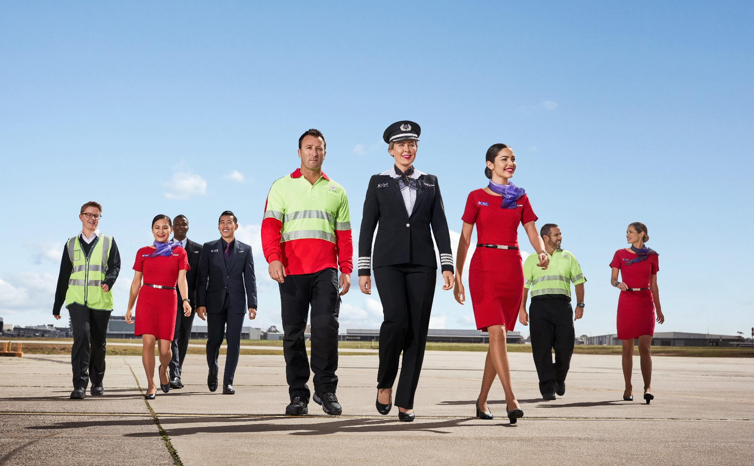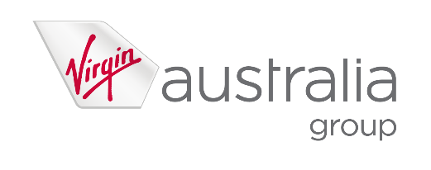

position description

|  |  |
| --- | --- |
| Position Snapshot | |
| Position Title: | Marketing Advisor |
| Business / Division / Department: | Commercial / Marketing / Airline Direct Marketing |
| Location: | Sydney or Brisbane |
| Reports to: | Direct Marketing Leader |
| Direct Reports: | N/A |
| Classification: | 1D |
| Date: | December 2021 |

|  |
| --- |
| Overall Impact Statement |
| Our vision is to build the airline people love, and we’ll do that by having happy people, happy customers, happy owners, by doing what matters, and by ensuring everyone is safe, always. We also believe that how you show up is as important as what you do.  The objective of the Marketing Advisor role is to drive revenue and service outcomes for Virgin Australia by developing and delivering owned channel communications across programs of work like V-mail, Guest and Velocity. Every campaign will delight our customers and you’ll always be hands-on, experimenting and looking at the results to optimise your work. |

|  |
| --- |
| Organisational Context |
| Virgin Australia Group is a major Australian airline group that operates domestic and international passenger services, charter and cargo services, and the award-winning loyalty program Velocity Frequent Flyer. The Group has been a competitor in the Australian aviation landscape for more than 20 years.    2021 is an exciting time for Virgin Australia as our tourism industry begins to recover from the impact of COVID-19. The Group took flight under new ownership last year, with a renewed sense of identity and focus on its mid-market heartland. We are ramping up our flying schedule as border restrictions ease, refreshing our offering to our core customers, and continuing to deliver the uniquely Virgin customer experience Australians know and love.  The Velocity Frequent Flyer group is committed to building and maintaining a global rewards program that is unique in its offerings and benefits to its members.    We’re a winning team and we attract the best: challengers, innovators, and seriously fun individuals with big hearts. At Virgin Australia Group, we pride ourselves on recruiting the right people to join our team and help us rise to the challenges ahead. No matter our role – we are united by our ambition to be the most loved airline in Australia, and always go one step further for our customers, colleagues and our wider community. |

|  |  |
| --- | --- |
| Key Accountabilities | |
| Accountability | **Major Activities** |
| Strategy & Planning | * Support the development of strategies that deliver outcomes for customer experience, flight revenue and ancillary/auxiliary revenue * Contribute to the campaign planning process * Define campaign level strategies * Own a program of work that you take charge on * Be an active and enthusiastic participant in the squad |
| Delivery | * Collaborate with broader team/squad to move campaigns and activities from concept into execution * Develop customer and omni-channel experiences with support * Work across multiple programs of work – like V-mail, Guest or Velocity member communications to deliver manual and automated campaigns * Manage owned channel campaigns from end to end, including maintaining campaign documents like registers, experience documentation and campaign briefs * Work across email, web, app, SMS, mobile and more for both Virgin Australia and Velocity * For some communications you’ll need to:   + Source assets and develop creative using Photoshop or working with the Studio   + Develop emails using Dreamweaver   + Create campaign workflow and delivery in Adobe Campaign, engage peers for QA tasks * Publish assets into CMS on time for each campaign * Effective legal, brand & stakeholder engagement to secure approvals * Deliver ad hoc requests where required * Be part of an on-call roster model * Ensure campaign compliance for spam, privacy and accessibility |
| Analysis and Optimisation | * Collaborate with squad to determine OKRs for campaigns * Apply tagging to assets and links during campaign creation to ensure accuracy in reporting * Utilise Adobe Analytics and other reporting tools to measure campaign success * Ensure results are socialised with squad and broader team * Every campaign considers test & learn principles * Results are always reviewed and considered when developing the next campaign |
| Customer | * Develop creative and campaigns that our customers will love * Always make sure the work is on brand and of the highest standard * Champion the customer’s needs and demands of us, look beyond the portfolio and articulate broader opportunities |

|  |  |  |
| --- | --- | --- |
| Key Requirements | | |
| Requirement | **Essential** | **Desirable** |
| Education / Qualifications | * Strong experience in marketing campaign management, techniques and processes in digital and direct channels * HTML skilled and formal Dreamweaver (or similar) product training | * Degree or post-graduate qualification in marketing, business, technology or related areas * Formal Adobe Experience Cloud (or similar) product training |
| Experience | * Experience in digital, data-driven and CRM techniques (particularly email channel) * Experience in A/B and multi-variate testing * Campaign reporting and analysis * Confident using Adobe Photoshop to generate assets for use in campaigns | * Multi-channel marketing campaign design and delivery * Experience with Adobe Experience Cloud: Analytics, Target and/or Campaign * Digital sales & eCommerce sector experience |
| Skills | * Strong collaboration with cross-functional teams or agile squads * Ability to prioritise tasks based on commercial needs * Proven time and work queue management skills * Attention to detail and accuracy * Proven experience within a commercial, retail or sales environment * Great communicator and presenter |  |
| Knowledge | * Able to apply Spam and Privacy compliance principles in direct marketing context | * Knowledge of aviation, travel and loyalty sectors |

|  |  |
| --- | --- |
| Virgin Australia Leadership Standards | |
| Standard | **Level 1 Behavioural Descriptors** |
| Passionately VA | * Displays a passion for delighting both internal and external customers * Seeks to understand customer needs by actively listening to their thoughts and concerns * Embraces diversity and is responsive to different experiences, perspectives, values and beliefs * Is curious and continuously looks for ways to learn and improve * Knows, understands and follows standard operating procedures * Is authentic and honest, can admit to making mistakes |
| Desire to be Better | * Strives to improve experiences for internal and external customers * Has a curious mind towards identifying opportunities and finding ways to be better * Demonstrates a high level of personal motivation to learn and develop * Resourceful and creative with coming up with solutions * Identifies and contributes ideas for improvement * Identifies, addresses and reports safety hazards |
| Collaborates | * Displays passion for sharing knowledge and ideas * Voices opinions and new ideas freely * Respects differences and seeks to understand diverse perspectives * Works constructively in and across teams, viewing every interaction as an opportunity to collaborate * Is curious and open-minded to new ideas, perspectives and approaches * Clarifies own understanding and embraces alternate view * Challenges behaviours that compromise safety |
| Inspires Team | * Participates in 2-way conversations, listening and discussing issues thoughtfully and openly * Understands and value the skills, knowledge and experiences that others bring * Engages with others, clearly conveying information and facts * Actively seeks to provide suggestions on how to be a better team * Informs team about work and progress * Understands personal obligations with respect to following standard operating procedures |
| Creates Future | * Welcomes change and remains positive in the face of ambiguity * Seeks information to understand change and impacts * Demonstrates a change mindset, flexibility and openness * Understands the need for VA Group to be innovative and drive business improvement * Seeks to understand Virgin Australia’s strategy and how they can contribute * Demonstrates forward-thinking and awareness of immediate consequences of actions ensuring safe outcomes |
| Drives Results | * Plans work to deliver within expected timeframes * Shows energy, enthusiasm and initiative for achieving own goals * Follows through on commitments to both internal and external customers * Seeks guidance and support to address obstacles and achieve set goals * Integrates feedback and takes responsibility for achieving own goals * Delivers outcomes within standards operating procedures. |

Notes

Collaborate with stakeholders across the business including Marketing team, Revenue Management, Velocity Frequent Flyer and Ancillaries teams to develop personalised and highly targeted campaigns with seamless delivery across retail, acquisition and other campaign activities

Co-ordinate campaign from concept through to design/copywriting and build of V-mail and automated VA guest eDMs in a timely manner from ideation to post campaign analysis

Conceptualise and brief in testing and targeting initiatives across VA websites and owned assets.

Optimise and test V-mail automated and manual campaigns based on insights and recommendations with a focus on VA Holidays

Communicate campaign progress, results and recommendations to stakeholders

Collaborate with external stakeholders on campaign activity, testing and targeting initiatives, and insights.

Ensure all campaigns are in accordance with brand style guidelines and spam compliance.

Design and advise on campaign content to engage and benefit V-mail subscribers, VA Guests and Velocity Frequent Flyer members

Conduct campaign reporting and evaluate campaign to continually improve campaign effectiveness. Present recommendations to key stakeholders.

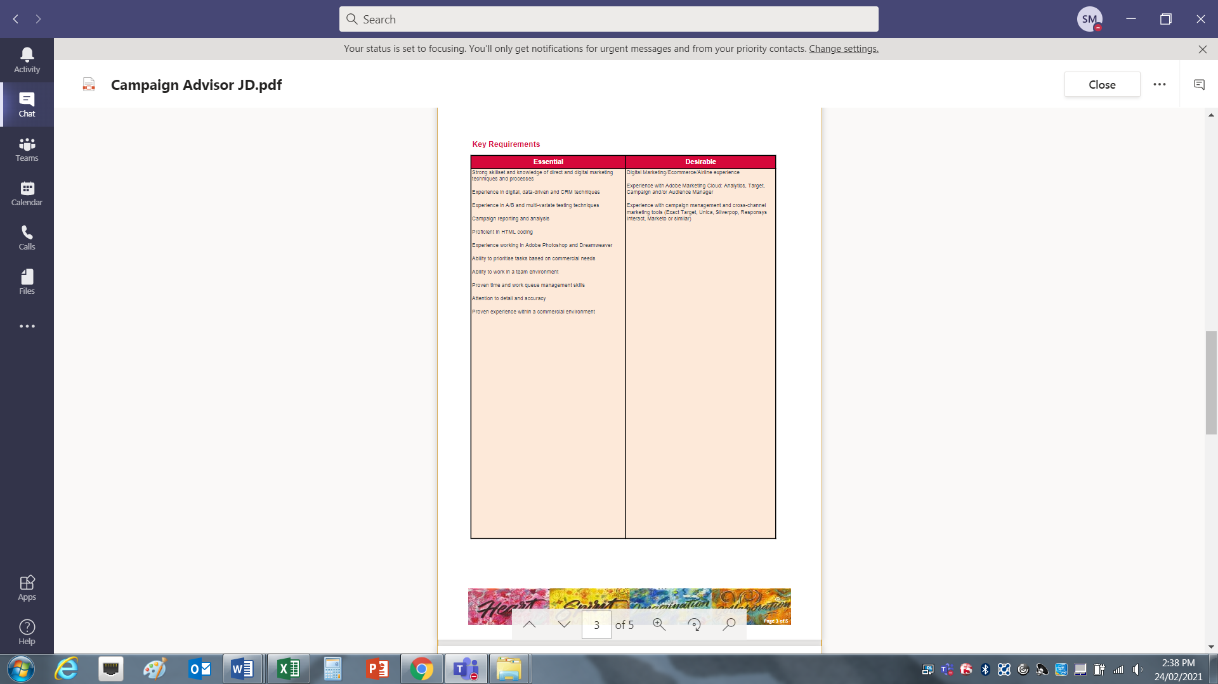

Strong skillset and knowledge of direct and digital marketing techniques and processes

Experience in digital, data-driven and CRM techniques

Experience in A/B and multi-variate testing techniques

Campaign reporting and analysis

Proficient in HTML coding

Experience working in Adobe Photoshop and Dreamweaver

Ability to prioritise tasks based on commercial needs

Ability to work in a team environment

Proven time and work queue management skills

Attention to detail and accuracy

Proven experience within a commercial environment

Digital Marketing/Ecommerce/Airline experience

Experience with Adobe Marketing Cloud: Analytics, Target, Campaign and/or Audience Manager

Experience with campaign management and cross-channel marketing tools (Exact Target, Unica, Silverpop, Responsys Interact, Marketo or similar)