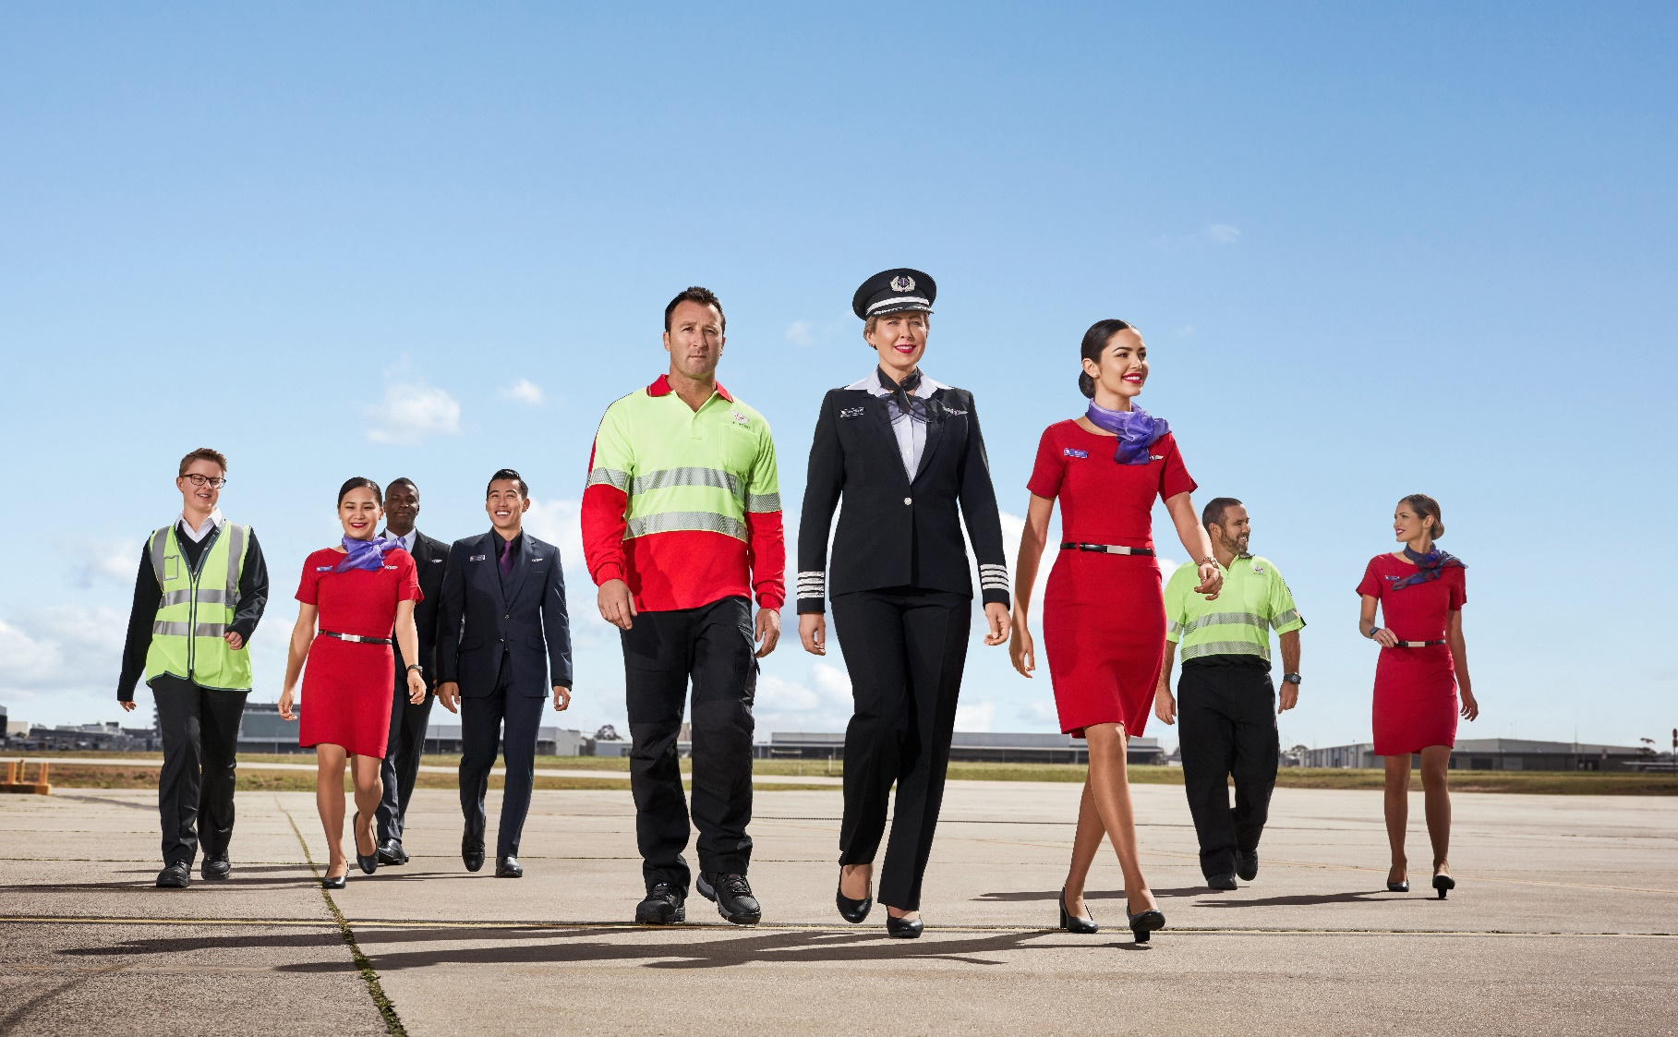

position description

Position Snapshot

|  |  |
| --- | --- |
| Position Title: | Marketing Specialist |
| Division / Department: | Velocity Marketing & Analytics Division / Velocity Marketing & Analytics |
| Location: | Sydney, Brisbane or Melbourne |
| Reports to: | Marketing Leader, Everyday Spend |
| Direct Reports: | 0 |
| Level: | 2A |
| Award: | N/A |
| Classification: | N/A |
| Date: | September 2024 |

Overall Impact Statement

|  |
| --- |
| Our vision is to build the airline people love, and we’ll do that by having happy people, happy customers, happy owners, by doing what matters, and by ensuring everyone is safe, always. We also believe that how you show up is as important as what you do.  The role of Marketing Specialist will be a key contributor to the marketing and campaign-level strategies across Velocity’s Everyday Earn partners and sit within the B3 Everyday Earn squad. The Marketing Specialist will work across digital marketing tools to execute cross-channel partner and Velocity-led campaigns. This role will drive paid media strategy and delivery, requiring a broad understanding of the media landscape, in particular digital and social channels. An analytical mindset and knowledge of customer lifecycle principals will be key to this role as the Marketing Specialist will lead the execution and ongoing optimisation of the Everyday Earn Points transfer lifecycle program.  Exceptional stakeholder management will be required to deliver best in class outcomes - with external big brand partners, agencies, and internal enabling teams. You’ll strive to achieve the objectives of your squad, while always balancing the customer experience of our Velocity members. |
|  |

Organisational Context

|  |
| --- |
| Virgin Australia Group is a major Australian airline headquartered in Brisbane, Australia. The company operates scheduled domestic and short-haul international flights, charter and cargo services, and the award-winning loyalty program Velocity Frequent Flyer. The Group has been a competitor in the Australian aviation landscape for more than 20 years and has always been known for its wonderful people who do their jobs with signature Virgin Flair.  Velocity Frequent Flyer is the award-winning loyalty program of Virgin Australia. Our vision is to become ‘Australia’s most loved loyalty program’ enabling members to engage and transact with our program through multiple channels every day. With over 12 million members, we are focused on transforming loyalty, and we continue to lead the way with game changing initiatives.  2024 is an exciting time for Virgin Australia, our tourism industry has bounced back from the impact of COVID-19 and travel demand is at an all-time high. Virgin Australia and Velocity Frequent Flyer took flight under new ownership, with a renewed sense of identity and focus on its mid-market heartland. We are ramping up our flying schedule, refreshing our offering to our core customers, and continuing to deliver the uniquely Virgin customer experience Australians know and love.  Virgin Australia team members are passionate believers in better. Every person that we come into contact with; our guests, our members, our customers, our colleagues, and the community will feel and experience better outcomes, based on the interactions we have with them.  Velocity works within an agile business structure. This role, Marketing Specialist, will report into the Marketing Leader, in this role, you will work within the Everyday Spend Squad, you'll have the opportunity to contribute to campaigns that drive engagement and growth for renowned partner brands.  . |

Key Accountabilities

| Accountability | Major Activities |
| --- | --- |
| Safety, Security & Business Resilience | * Ensure adherence to Virgin Australia Risk Management Framework (RMF) and adopt a proactive approach to the timely identification of operational and corporate risk and work to mitigate, resolve and escalate as required * Actively participate in relevant forums to improve Safety, Security, Resilience and Health and Wellbeing throughout the Group * Participate in Safety Shares in all meetings |
| Customer & Strategy | * Manage end-to-end marketing campaigns, with accountability for developing, implementing, and optimising initiatives that support business OKRs * Contribute to lifecycle-based marketing strategies and lead campaigns to engage Indirect Earn Financial Services members * Advocate for and utilise a data driven approach to ensure relevance and personalisation – this will include analysis and insight development of first and third-party data * Be on the look-out for opportunities to improve existing activity and surface growth opportunities to create a best-in-class CX * Monitor competitor activity and feedback on trends/analysis to internal stakeholders * Support budget management - budget setting, overarching tracking, and forecasting |
| Delivery and Optimisation | * End-to-end delivery of multi-channel marketing campaigns across email, web, social, paid media and other (emerging) channels. * Create compelling and personalised content across channels. * Leverage data to make informed choices on targeting, personalisation, and ongoing optimisation. * Work with stakeholders and partner suppliers (e.g., media and creative agencies) to build and launch complex campaigns using internal and external tools. * Consistently monitor and report to measure campaign outcomes and track against targets – proactively developing and implementing pivot strategies . * Demonstrate ROI from campaigns and adhere to finance processes, ensuring timely cost management and reconciliation. * Analyse campaign performance and draw conclusions based on data, present takeaways and recommend next steps to constantly improve and iterate. * Data-driven, with experience in paid media and skilled at analysing performance metrics, to fine-tune campaigns for maximum impact and ROI. |
| Leadership | * Champion and influence business to adopt digital marketing capabilities and an omni-channel approach * Support a culture of strong collaboration and genuine conversations to reach outcomes * A can-do strong entrepreneurial spirit to drive outcomes |

Key Requirements

| Requirement | Essential | Desirable |
| --- | --- | --- |
| Education / Qualifications | Relevant tertiary or equivalent business qualification | * Tertiary degree in business, marketing, communications, or related discipline |
| Experience | * 5+ years mid-level marketing management experience * Leading, planning, and optimising integrated marketing campaigns * End-to-end multi-channel marketing campaign delivery * Multi-level stakeholder management * Briefing and leading agency deliverables * Proven ability to build strong relationships * Adaptable to changing ways of working * Demonstrates role-model behaviours * Strong attention to detail * Ability to follow business process to required timelines * Commercial and budget management * Ability to critically analyse marketing program effectiveness * Takes initiative rather than wait for direction * Know when to escalate issues or opportunities * Independent operator – ability to take a brief and run with it, but comfortable to ask questions * Team player – willingness to pivot where needed and shift focus as priorities change | * Airline or loyalty experience * Financial Services marketing experience * Paid digital and social campaign delivery * Working with complex databases * Marketing process re-engineering * Worked in an agile structure |
| Skills & Knowledge | * Strong skillset and knowledge of data-driven and digital marketing techniques and processes * Strong experience with 1st party data and addressable omni-channel marketing campaigns. * Strong analytical, analysis and reporting skills * Ability to work with campaign management tools in complex environments * Digital marketing capability, using data and tools to enhance and optimise campaign constructs * CRM and lifecycle marketing experience * Campaign orchestration and lifecycle management * Ability to think logically and meet deadlines under pressure * Ability to prioritise tasks based on commercial awareness * Strong presentation, copywriting, and communication skills * Spam and privacy compliance in direct marketing context | * Experience with Adobe Experience Cloud * Digital product management I.e., CMS, CRM, Power BI, databases etc. |

|  |  |
| --- | --- |
| Virgin Australia Leadership Standards | |
| Standard | **Level 2 Behavioural Descriptors** |
| Passionately VA | * Initiates customer centric solutions * Supports initiatives to improve policies, processes, and customer interactions * Seeks and identifies opportunities to surprise and delight both internal and external customers * Recognises ideas of all stakeholders and encourages innovative approaches * Expresses own point of view and challenges basic assumptions * By example, sets the direction for team members regarding safety performance and following procedures |
| Desire to be Better | * Takes into consideration the impact to customer experience when making decisions * Applies learning from previous experiences to improve future approaches and solutions * Seeks and provides feedback and opportunities to learn, valuing contribution of self and others * Identifies issues in existing systems and processes that may not be obvious to others * Challenges the status quo and offers progressive ideas and solutions * Actively seeks out risks to safety and resolves as a priority |
| Collaborates | * Promotes understanding of VA’s purpose and strategy and how the team’s work contributes to its achievement * Actively seeks opportunities to partner with others to achieve extraordinary outcomes * Builds trusting, cooperative partnerships, supporting others in challenging situations * Builds rapport and proactively strengthens connections with others * Embraces collaboration by connecting with others across different VA functions |
| Inspires Team | * Encourages others to bring whole self to work and contribute freely to achieving our vision * Builds empathy and understanding of different people, integrating diverse perspectives into approaches and outcomes * Facilitates interactive discussions, actively listening and reaching agreement through flexibility and compromise * Promotes and encourages excellence, growth and autonomy in self and others * Shows personal accountability for achievement of job-specific outcomes |
| Creates Future | * Embraces change, seeing it as an opportunity to drive business improvement * Acts as a change advocate, sharing information and promoting change to others * Demonstrates persistence and perseverance in the face of obstacles * Considers whether short term goals support long term objectives and consequences * Displays and drives resilience and flexibility, remaining focused on achieving outcomes whilst remaining safe |
| Drives Results | * Recognises the implication of organisational issues, identifying potential impact on achievement of own results * Identifies the processes, tasks and resources required to achieve an outcome and plans accordingly * Communicates key objectives within own area to deliver results aligned to business strategy * Tailor messages for maximum impact * Uses data to drive continuous improvement to processes, outcomes, and safety. |