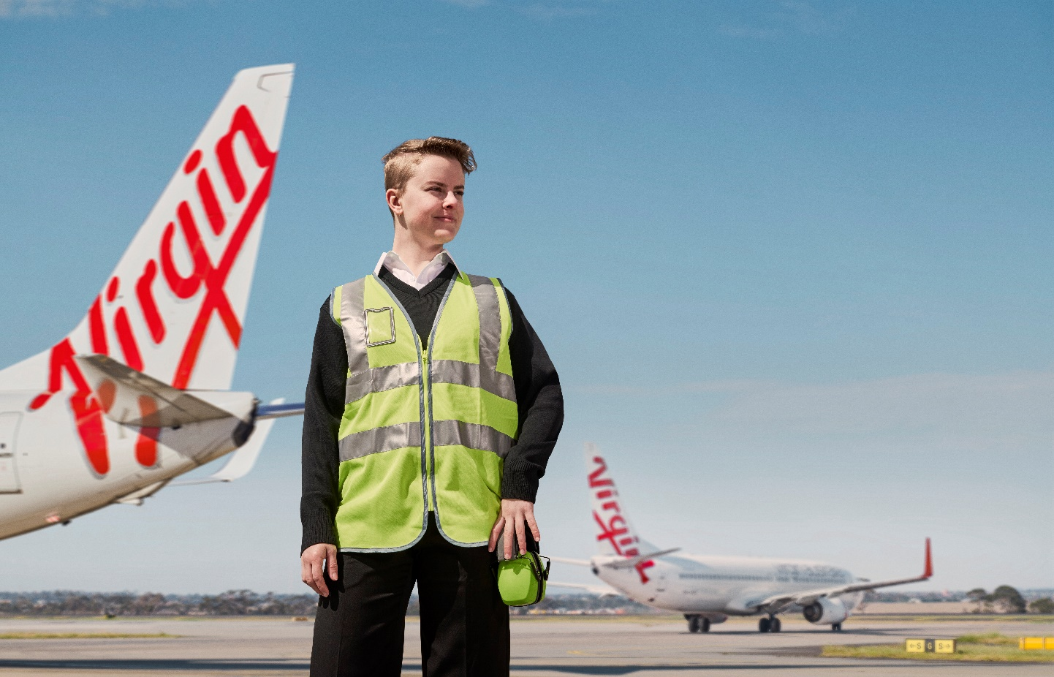

The Virgin Australia Aircraft Maintenance Apprenticeship Program is a unique opportunity to play an integral role in the evolution of Australia’s most loved airline, and to become a part of a dynamic company that genuinely believes and demonstrates that its people are its greatest asset.
A career as an Aircraft Maintenance Engineer requires a high level of dedication and passion. In return you will be placed in a world class maintenance organisation and will receive the benefits of training in a large Civil Aviation Safety Authority (CASA) Part 145 maintenance organisation.
Once you successfully complete the program, you can look forward to an exciting career as an Aircraft Maintenance Engineer with the Virgin Australia team.
We recommend you review the Frequently Asked Questions (FAQs) prior to commencing an application to ensure you understand the requirements of the course and the role.

_{Training}
An apprenticeship will offer you the ability to work for an ESA Part 145 organisation while undertaking training to achieve a nationally recognised qualification within the aerospace industry.
- You will be supported by an international and nationally recognised training organisation
- You will undertake practical training developing the required practical skills and knowledge required to be granted a nationally recognised Certificate IV in Aeroskills
- You will also participate in courses such as Elevated Work Platform, Confined Space and Aeronautical Radio Operators Certificate to name a few.
- You’ll be rotated through the Engineering department as required for completion of their practical elements
- You will be involved in working on our new 737-8/10 Max Aircraft
- You will be involved in overnight maintenance and line maintenance activities on our fleet of Boeing 737’s, which involves engine changes, installation of Wi-Fi systems, routine servicing of the aircraft and defect rectification
- During practical training at the workplace, you will be required to work permanent night shift
- Pay will be in line with our current EBA.

Aircraft Maintenance Engineer (AME) opportunities

Mechanical
As an AME Mechanical you will be responsible for the inspection, troubleshooting, maintenance, and overhaul of the mechanical components of an aircraft.
This includes:
- Aircraft engine systems
- Aircraft structures
- Landing gear, wheels, and brakes systems
- Hydraulic/pneumatic systems
- Flight control systems
- Environment control systems

Structures
As an AME Structures you be responsible for the dismantling, reassembly, inspection, repair and replacement component of aircraft frames.
This includes:
- Inspecting, maintaining, and repairing the structural frame
- Preflight examinations and evaluation of aircraft systems
- Defect identification and rectification

_{Frequently asked questions}
When will the apprenticeship commence?
The apprenticeship is expected to begin in mid-January.
Do I need to have any practical experience to apply for the Engineering Apprenticeship program?
Practical Engineering experience is not a requirement, however, experience in a mechanical or electrical field is advantageous.
What are the minimum education requirements?
The minimum requirement is the successful completion of year 10.
Do I need to have completed a Certificate II in Aircraft Line Maintenance or a Certificate IV in Aeroskills?
No. You can apply for the apprenticeship program without the completion of either certificate however, if you have completed this it will be advantageous.
Is this a fulltime apprenticeship or are part time options available?
This is a full-time course only. The duration of the apprenticeship is 4 years.
Will my apprenticeship be shorter if I have a Certificate IV or other qualifications?
No. All Apprentices in the Program will complete the full course of training. Recognition of prior learning may be possible; however, it is an expectation that candidates will start the course at the same level.
Will I be guaranteed a role with Virgin Australia at the end of the Engineering Apprenticeship program?
Apprentices who successfully meet all requirements of the course and meet all the Virgin Australia Behaviour Standards and Terms of Employment will get the opportunity to apply for a permanent position. This apprenticeship can also open doors into other areas within the engineering department.
Where will I be based for the duration of my apprenticeship?
Our apprenticeship program will operate out of Brisbane, or Melbourne You will be based at the port for which you apply and are accepted.
I am a current Virgin Australia employee. If successful for this program, will I be seconded to the training provider for the duration of my training and be employed under the terms and conditions of the Apprenticeship Program.
The aim of the Program is to commence a long-term career as an Engineer with Virgin Australia. As such, the apprenticeship positions are offered on a permanent basis only. If you are offered and accept a position, you will be employed on a permanent basis under the terms and conditions of the apprenticeship contract.
I have a criminal record Am I eligible for the Apprenticeship Program?
If you have been convicted, found guilty or subject to proceedings for criminal or motor vehicle offences, this may affect your eligibility to be issued with an ASIC. Employment with Virgin Australia will be conditional on being eligible to hold an ASIC and if you fail to be issued with an ASIC or authority to hold an ASIC is withdrawn, withdrawal from the program or termination of your employment may result.
If you have been cautioned, warned, or convicted of a criminal offence (this could include traffic or parking offences) we suggest you check whether you will be able to obtain an ASIC by visiting the CASA website.
How long will the selection process take?
The selection process is expected to take 4 weeks from the close of advertising. You will receive notification if you have been short listed to participate in our assessment process within four weeks of the application close date.
What is involved in the recruitment process?
The recruitment process begins with your application, which must be submitted online through the Virgin Australia Careers website. Your online application should provide information about your professional and educational background to demonstrate that you meet the requirements of the role. It is also important that you take the time to read the position information carefully to make sure that your experience and skills match the role requirements.
If your application meets the minimum requirements and is short-listed, you will be required to complete a short video interview questionnaire and phone interview. Shortlisted candidates will then be invited in for an assessment day.

If I am successful in being invited to attend an assessment day, what will I need to bring?
You will be given full details of what you need to bring with you prior to your attendance.
What if I am unable to attend the assessment day?
Assessment Days will be held on specific days at each port. If you are unable to attend the Assessment Day at your closest port, you may have the opportunity to attend at a different port. This however will be at your own cost and will be subject to Assessment Day availability. If you cannot attend an Assessment Day, you will have to withdraw your application and reapply for the following year.
What should I wear to attend my assessment day?
We are looking for people who will role model Virgin Australia brand and uniform standards. Therefore, we expect candidates to attend wearing appropriate business attire.
Are there expenses involved in participating in a selection process?
There is no fee associated with submitting an application, however if successful you may be asked to pay for the costs associated with obtaining a Medical and a Pre-employment Drug & Alcohol Screen, this will be discussed with you as required.
Will Virgin Australia assist with travel and expense during the recruitment process?
If you are invited to attend an Assessment Day, you will be required to make your own arrangements to attend, at your own cost.
Can I ask for feedback on my application if I am not progressed throughout the recruitment process?
Due to the high interest and number of applications we receive, it is not possible to provide individual feedback to unsuccessful applicants throughout our process. We encourage candidates to reflect on their application and review our program requirements.
.

