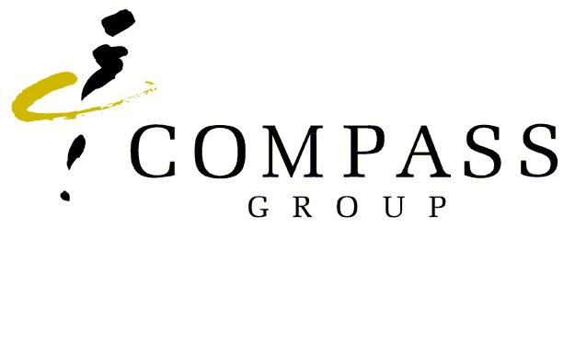

**Job Description**

|  |  |  |  |  |  |  |  |  |  |  |
| --- | --- | --- | --- | --- | --- | --- | --- | --- | --- | --- |
| **Job Title** | | **Manager – Business Development** | | | **Location** | **Brisbane, Sydney, Melbourne** | | | | |
| **Employee Name** | | **INSERT NAME** | | | **Business Sector** | **Healthcare & Senior Living** | | | | |
| **Responsible to** | | **Senior Manager - BD** | | | **Work Level** | **Above -Unit Level** | | | | |
| Overall, Purpose of the Role  This role is responsible for company growth through identification and conversion of direct sales opportunities within the Healthcare, Senior Living and IFMS sectors. The role will focus on identification and conversion of opportunities within our existing Client base estate as well as converting new business opportunities from the external market. The role will canvass the markets identifying and qualifying multiyear pipelines of opportunity. The role will also assist with retaining existing contracts when re-tenders are required. Promotion and support of Our Safety Culture framework is expected. | | | | | | | | | | |
| **Key Accountabilities - MAP** | | | | | | | | | | |
| **New Business Development** | | | |  | | | | | | |
| * Develop and qualify new customer contacts consisting of decision makers and business influencers for the Company’s various product and service offerings. * Design and deliver presentations to selected prospects to expand on the benefits of the Company’s service and product offerings. * Actively follow-up on proposals to ensure customer satisfaction of all elements of the Company’s offering. * Secure orders to ensure achievement of both personal and sector business growth plan targets. * Maintain customer contact to ensure all current and future management requirements are satisfied by the Company. * Promote the Company’s products and services to market segments whose requirements match the benefits of the Company’s offering. * Developing new products, services or solutions by combining several existing products/services and generating leads to establish a corresponding market sector in order to gain new business for the organisation. | | | | * Source and develop new market segments for the Company’s products and services. * Ownership of all new account sales, including full control of the sales process (prospect identification, pipeline management, proposal development, writing and delivery, project costing, closing and contract negotiations). * Undertake special assignments from time to time as directed * Communicate with the customer to determine the correct alignment of Medirest & Morrison Living services to customer requirements. * Drive innovative, creative and compelling proposals that represent best company and industry practice. * Building and leveraging effective senior and executive stakeholder relationships to achieve business objectives * Generating deals and new business/financial models, and drafting and negotiating contracts. | | | | | | |
| **Strategic Sales Analytics** | | | | | | | | | | |
| * Engage, with the communications and marketing teams to develop of portfolio specific sales collateral based on industry insights and analysis * Conduct market research into key industry trends and market dynamics, making recommendations to support sector strategic growth plans | | | | * Work with the operations teams and support functions to develop and market test customer facing service solutions | | | | | | |
| **Financial Performance** | | | |  | | | | | | |
| * Achieve sales targets and work within budgets | | | |  | | | | | | |
| **Planning & Reporting** | | | |  | | | | | | |
| * Develop annual sales plans for accounts including strategies to achieve quarterly and annual goals and targets. * Provide regular sales activity reports to assist in regular review and reports Senior Manager - BD | | | | * Bid Strategy development and articulation | | | | | | |
| **Above Unit Costs** | | | |  | | | | | | |
| * Actively manage the individual budget, including conference and sponsorship spend, travel spend and general sales related expenses | | | |  | | | | | | |
| **People Map** | | | |  | | | | | | |
| * Perform - Maintain and work in accordance with the Company’s Quality System, identifying process improvement opportunities and assisting with the implementation of continuous improvement. * Perform – Conduct reviews of the competitiveness of the Company’s products and service offerings making recommendations to the Senior Manager BD * Engage - Work effectively with HC/SL sector business operational leaders to identify new business within the existing client portfolio by providing specialised support and expertise during re-tenders. | | | | * Engage - Provide feedback to the Senior Manager BD in order to maintain their awareness of market expectations of service levels and changes in market trends and client buying behaviour. | | | | | | |
| **Health & Safety Responsibilities** | | | | | | | | | | |
| * **Follow Compass health, safety and security procedures** * Adhere to health, safety and security procedures * Maintain safe personal presentation standards * Provide feedback on health safety and security * Report all incidents *immediately* * Identify and report all hazards * **Follow Safe Manual Handling Practices** * **Promote and maintain *Our Safety Culture* framework by:**  1. Setting high standards 2. Communicating openly 3. Confronting risk and 4. Involving the workforce   This will be achieved by personally demonstrating the *Above Unit Management* behaviours detailed in the Compass Group Our Safety Culture Framework document and encouraging your reports to always carry out the *Unit Management* and *Everyone* behaviours. | | | | | | | | | | |
| **Skills and Experience** | | | | | | | | | |
| **Essential** | | | | | **Desirable** | | | | |
| * Strong sales and/or operational experience * 3-5 years’ experience working within the IFM Services Industry in Healthcare/Senior Living sector * Excellent written and verbal communication skills. * Experience in consultative selling, influencing situations and negotiation outcomes * Advanced problem-solving skills * Account management experience * Presentation Skills * Knowledge of Microsoft Office and high level of   computer literacy   * Minimum of entry-level of financial literacy and/or commercial acumen. * Business acumen * Qualifications in Marketing / Management or Business Studies | | | | | * Consistent B2B sales record, ideally within support services or business & industry sectors * Knowledge of customer driver’s, transactional processes, and the sales process. * Previous Operational P&L accountability within the IFM services industry would be an advantage * Tertiary qualifications in Sales/Marketing or Business Studies * Proven pedigree in deal closure (desirable) | | | | |
| **Key Contacts and Working Relationships** | | | | | | | | | | |
| * Senior Manager – Business Development * General Manager – Growth * General Manager Operations (Hospitals & Senior Living) * Operations Managers (Hospitals & Senior Living) * General Manager Bid, Commercial & Contacts * Estimators * Estimation Team * Tendering & Bid Team * Clients and Potential Clients | | | | | | | | | | |
| This role profile is a guide to the work you will initially be required to undertake. It may be changed from time to time to incorporate changing circumstances, and you may be required to be flexible and perform other duties as required by your manager. It does not form part of your contract of employment. | | | | | | | | |
| **Employee Declaration** | | | | | | | | | | |
| **I have read and understood my position description:** | | | | | | | | | | |
| Signature: |  | | Date: | |  | |  |  |