

|  |
| --- |
| **Position Description** |

|  |  |
| --- | --- |
| **Lecturer, Physiotherapy** | |
|  |  |
| **Position No:** | NEW |
| **Business Unit:** | Office of the Provost |
|  |  |
| **Division:** | Allied Health, Human Services and Sport |
| **Department:**  **Classification Level:** | Physiotherapy, Podiatry and Prosthetics and Orthotics  Level B Teaching & Research |
| **Employment Type:** | Continuing, Full time |
| **Campus Location:** | Melbourne (Bundoora) |
| **Other Benefits:** | <http://www.latrobe.edu.au/jobs/working/benefits> |

Further information about:

La Trobe University - <http://www.latrobe.edu.au/about>

**Position Context/Purpose**

This position will contribute to teaching and research within the Discipline of Physiotherapy.

The School of Allied Health, Human Services and Sport offers a range of general and specialist undergraduate and postgraduate courses that are rigorous and attuned to meeting the needs of students in ensuring their readiness to work in changing environments. The School comprises four Departments and 10 disciplines across La Trobe’s multi campus operations and has an outstanding reputation for research excellence, research translation and for building strong relationships with industry partners.

La Trobe University is positioning itself as a leading provider of health and wellbeing education and research in Australia. This strategy includes construction of a new Clinical Teaching Building and student-led clinic, providing additional state of the art facilities for physiotherapy education and an outstanding student and staff experience.

**Duties at this level will include:**

* Demonstrate effectiveness in teaching by taking an evidence-based approach to evaluate learning and teaching initiatives.
* Demonstrate a scholarly approach to learning and teaching and contribute to disciplinary teaching pedagogy and research.
* Coordinate and teach subjects providing a high-quality learning experience that engages students through the conduct of lectures, tutorials, practical classes, demonstrations, workshops, student field excursions, clinical sessions and/or other sessions in online, blended or face-to-face modes.
* Participate in innovative course level curriculum design, development and review.
* Conduct and publish, or otherwise disseminate high quality and/or high impact research as a member of a team or independently and produce conference/seminar papers and publications from that research.
* With mentoring support, obtain necessary research funding from external funding sources.
* Co-supervise or, where appropriate supervise, Honours or Higher Degree by Research (HDR) postgraduate students as required.
* Contribute to knowledge transfer and to building relationships at a local level.
* Undertake other duties and administrative functions commensurate with the classification and scope of the position as required by the Head of Department or Head of School.

**Essential Criteria**

**Skills and knowledge required for the position**

* PhD degree or equivalent accreditation and standing recognised by the University/profession as appropriate for the relevant discipline areas.
* Demonstrated effectiveness in teaching and curriculum development.
* Evidence of high quality and/or high impact research conducted and published or otherwise disseminated, relative to opportunity.
* Demonstrated high level oral and written communication skills, including the ability to interact effectively, collaboratively and productively with staff and students from a diverse range of backgrounds.
* Knowledge, expertise and skills in the discipline’s key areas.

**Capabilities required to be successful in the position**

* Ability to demonstrate self-awareness, see things from another person’s perspective and actively seek out and act on feedback to improve knowledge, skills and behaviour.
* Ability to work collaboratively, recognise the value of diversity and model accountability, connectedness, innovation and care.
* Ability to think creatively, explore new ideas and respectfully challenge existing practices in order to improve current ways of working.
* Ability to build a culture of continuous improvement, implementing ideas generated by team members.

**Essential Compliance Requirements**

To hold this La Trobe University position the occupant must:

* be registered with AHPRA as a Physiotherapist
* hold, or be willing to undertake and pass, a Victorian Working With Children Check; AND
* take personal accountability to comply with all University policies, procedures and legislative or regulatory obligations; including but not limited to TEQSA and the Higher Education Threshold Standards.

**Other Information**

The position description is indicative of the initial expectation of the role and subject to changes to University goals and priorities, activities or focus of the job.

**Position Flexibility**

We offer flexible work arrangements that can assist you in balancing your work and other responsibilities.

**Why La Trobe:**

* Develop your career at an innovative, global university where you’ll collaborate with community and industry to create impact.
* Enjoy working on our inspiring and stunning campuses – the perfect hub for industry, students and academics
* Help transform the lives of students, partners and communities now and in the future

This is more than just a job. Working at La Trobe offers opportunities to demonstrate excellence and transform lives.

Here, you’ll join exceptional people, partners and communities, who power our operations with ambition and purpose.

Our success can be attributed to its strong sense of community. We have a long-standing commitment to diversity, inclusion and social justice; we are committed to providing a workplace where all staff feel valued, respected and supported to achieve their full potential. We strive to build a workplace where all employees of diverse backgrounds, abilities, experiences, sexuality, gender, religion and age are welcome, valued, respected and one that is representative of our community. We demonstrate our cultural qualities by holding ourselves accountable and creating a culture of trust and innovation while genuinely caring for one another.

**La Trobe’s Cultural Qualities:**

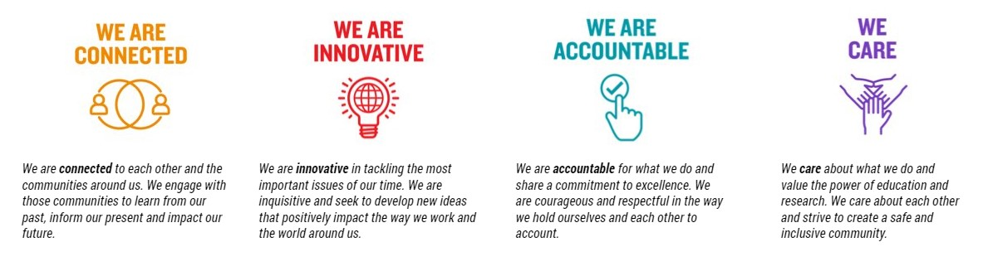

For Human Resource Use Only

Initials: Date: