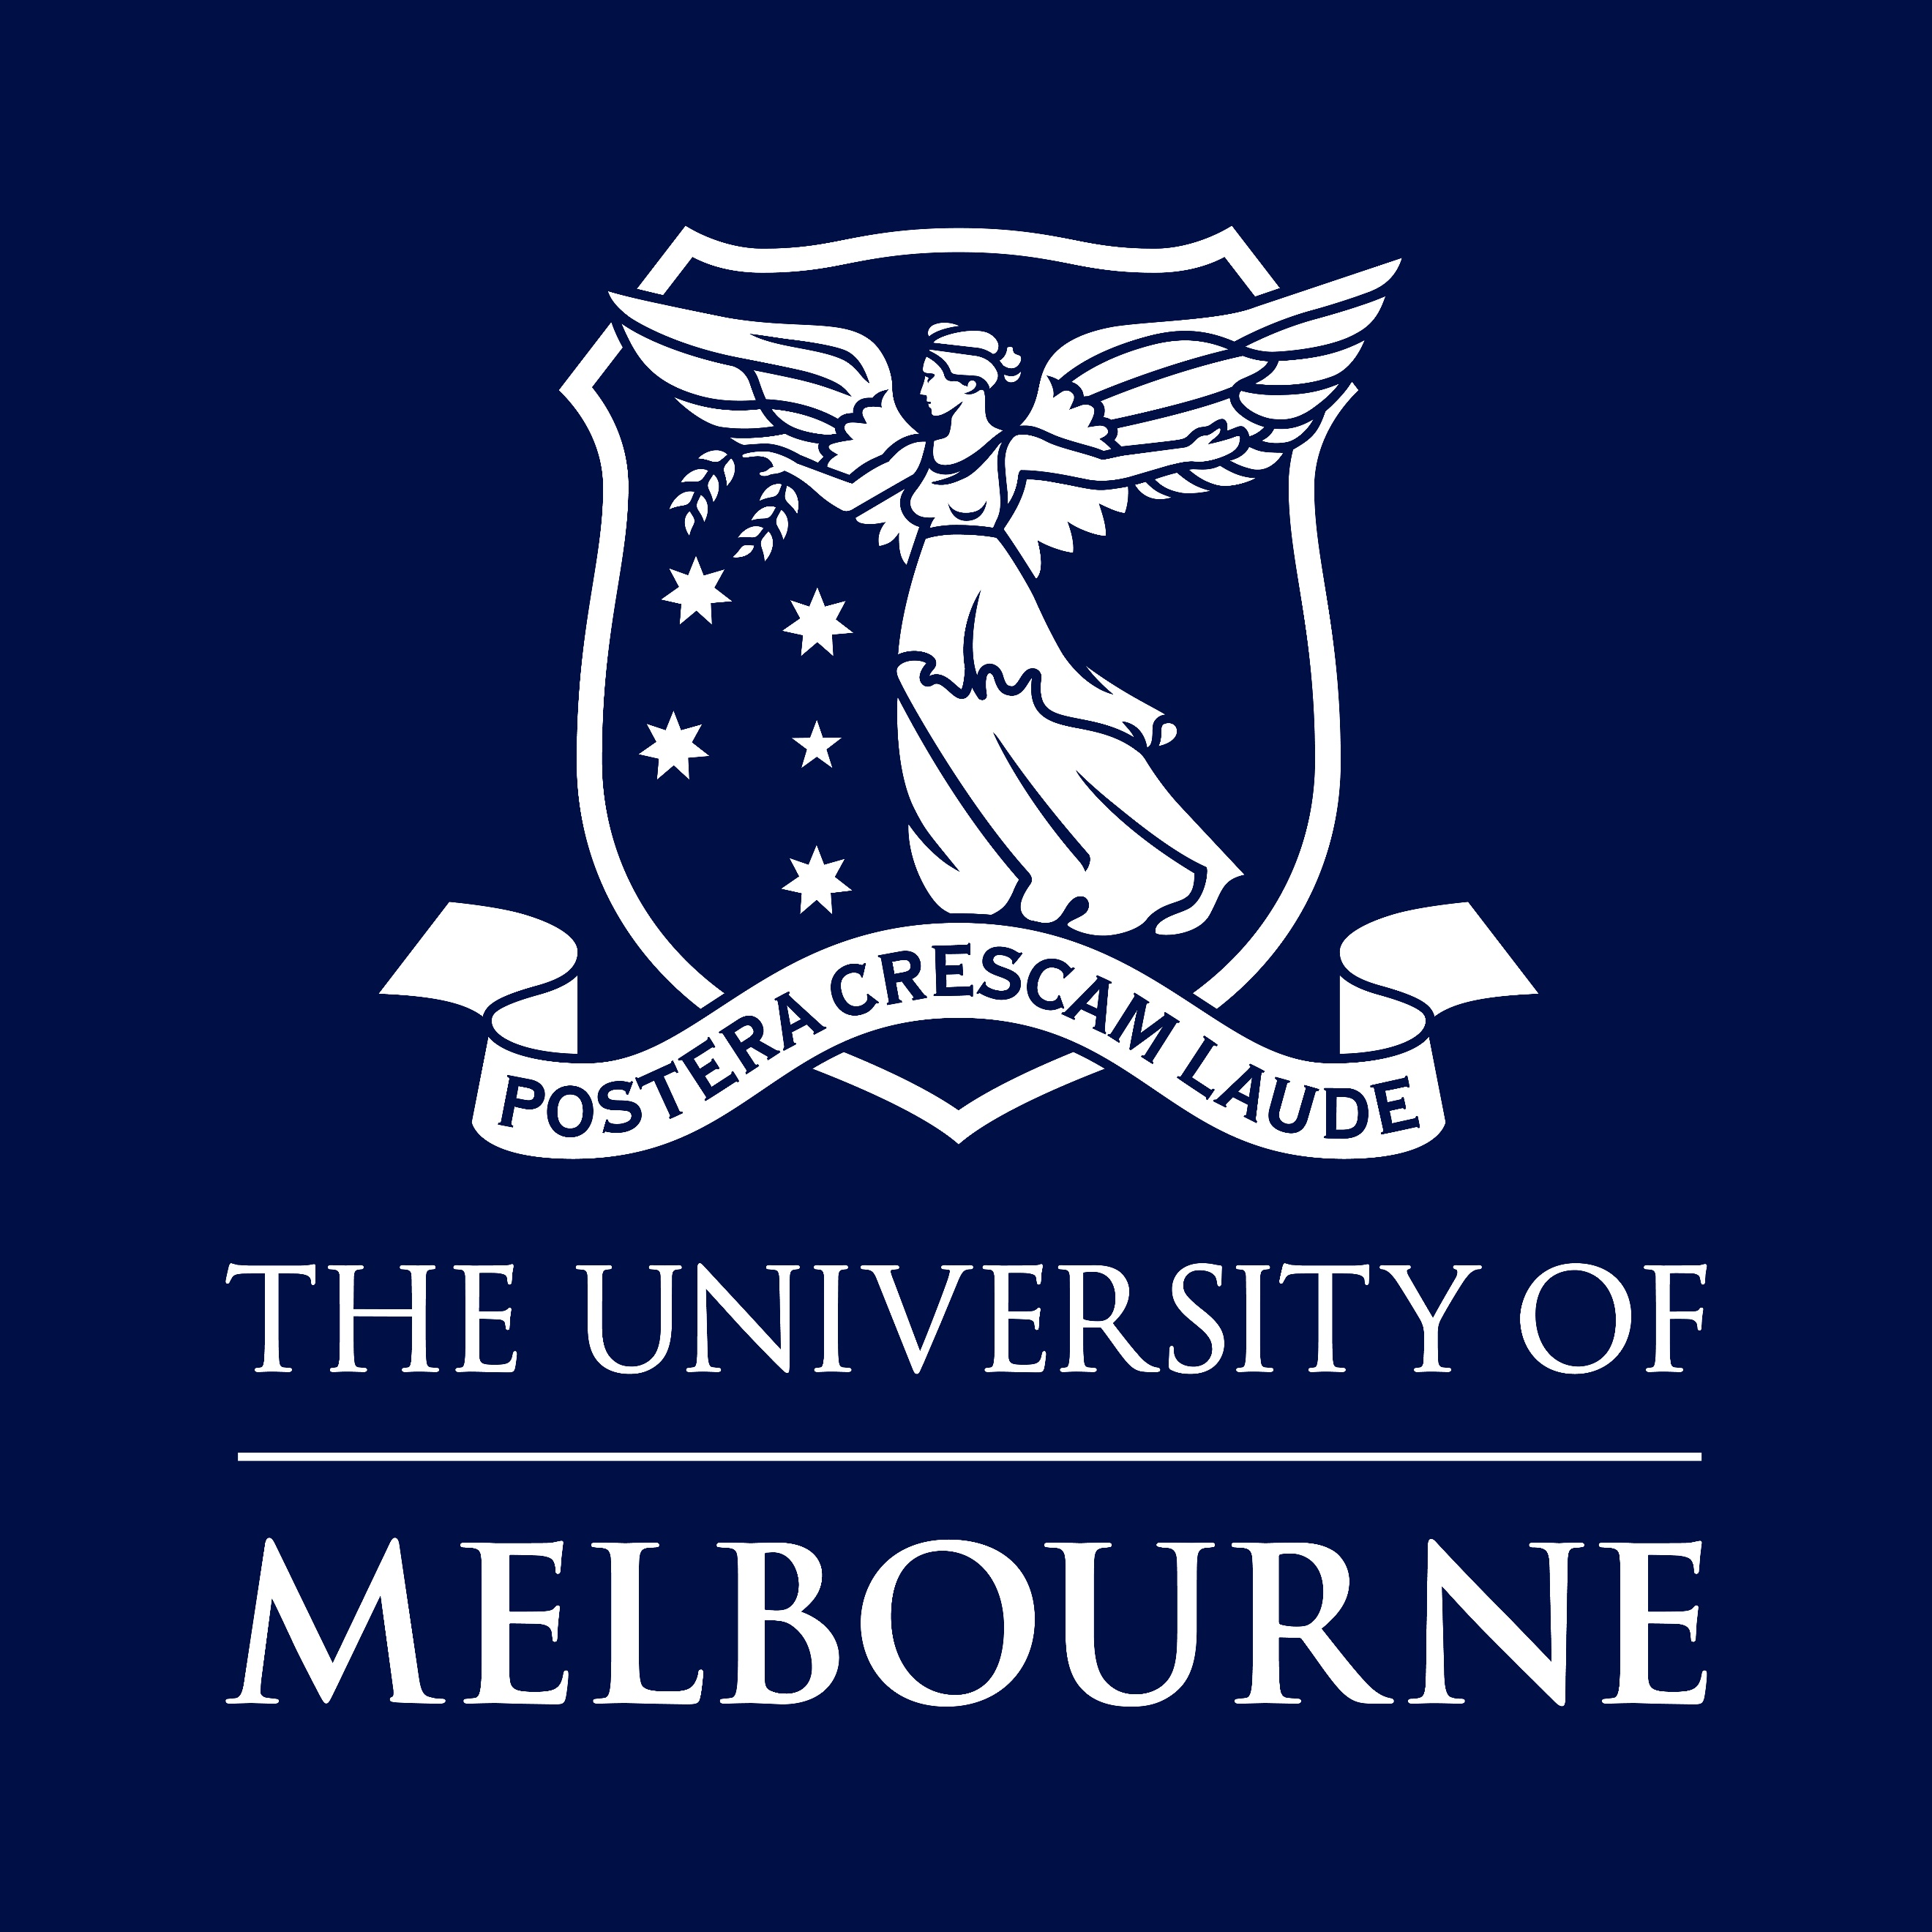

POSITION DESCRIPTION

Employment Compliance Directorate
Office of the Provost
Associate Director, Policy, Change & Communications

Position No | 0064199
Classification | Senior Manager 1
Salary | Attractive remuneration package by negotiation
Superannuation | Employer contribution of 17%
WORKING HOURS | Full time (1.00 FTE)
BASIS OF EMPLOYMENT | Continuing
Other Benefits | https://about.unimelb.edu.au/careers/staff-benefits
How to Apply | Online applications are preferred. Go to http://about.unimelb.edu.au/careers, select the relevant option (‘Current Opportunities’ or ‘Jobs available to current staff’), then find the position by title or number.
contact  For enquiries only | Susan Bradley  Email susan.bradley@unimelb.edu.au  Please do not send your application to this contact
For information about working for the University of Melbourne, visit our website:
about.unimelb.edu.au/careers

Acknowledgement of Country
The University of Melbourne acknowledges the Traditional Owners of the unceded land on which we work, learn and live: the Wurundjeri Woi Wurrung and Bunurong peoples (Burnley, Fishermans Bend, Parkville, Southbank and Werribee campuses), the Yorta Yorta Nation (Dookie and Shepparton campuses), and the Dja Dja Wurrung people (Creswick campus).
The University also acknowledges and is grateful to the Traditional Owners, Elders and Knowledge Holders of all Indigenous nations and clans who have been instrumental in our reconciliation journey.
We recognise the unique place held by Aboriginal and Torres Strait Islander peoples as the original owners and custodians of the lands and waterways across the Australian continent, with histories of continuous connection dating back more than 60,000 years. We also acknowledge their enduring cultural practices of caring for Country.
We pay respect to Elders past, present and future, and acknowledge the importance of Indigenous knowledge in the Academy. As a community of researchers, teachers, professional staff and students we are privileged to work and learn every day with Indigenous colleagues and partners.

Position Summary
The Associate Director, Policy, Change & Communications is responsible for leading a strategic team that drives consistent communication and timely, reliable and clear instructional guidance to University stakeholders, ensuring they understand and meet their workforce-related obligations to the University community.
Reporting to the Executive Director, Employment Compliance, the Associate Director oversees a small team, led by the Change & Communications Lead, which is focused on effective change and communications delivery and the HR Policy Lead who will be the operational custodian of the University HR Policy and Work Instruction Framework. The Associate Director, Policy, Change & Communications will ensure both the quality and timeliness of deliverables produced by the Policy, Change & Communications team, which will set University stakeholders up for success with regards to meeting their obligations as employees, leaders and in other capacities.
The Associate Director will partner closely with the University Organisational Development team, which also resides within the Chief People Officer Portfolio, to ensure the delivery of coordinated training, both content and delivery.

Key Responsibilities

Leadership
- Establish and embed the Policy, Change & Communications team as a key enabler of employment related compliance across the University.
- Proactively foster key relationships with colleagues across the University to identify, validate and respond to compliance training needs, rightsizing for impact and effectiveness.
- Represent the ECD in University working groups and other forums, including as a delegate of the Executive Director, Employment Compliance.
- Build relationships within the Australian higher education sector, taking a sectoral leadership position on the delivery of an effective HR compliance training, policy and work instruction ecosystem, while ensuring continued awareness of emerging practices from both within the higher education sector and industry more broadly.

oversight of change & communications
- Support the Change & Communications Lead in the development and implementation of the University HR Change Management Framework and relevant plans such as engagement & communication plans to drive positive acceptance and adoption of change in the HR context.
- Oversee and lead the development and delivery of University training programs that contribute to the achievement of compliance with the University’s various employer and other obligations. This includes ensuring that the University is making best use of its technology assets that support training delivery, while also ensuring that all delivery modes are considered when designing training programs.
- In the context of work performed by the HR Policy Lead, ensure the effective and timely delivery of change management when changes are made to the University’s expectations of its workforce.

OVERSIGHT OF HR POLICY
- Provide strategic oversight of the development, implementation and maintenance of the HR Policy and Work Instruction Framework, including the communication of its purpose and benefits to the University community.
- Provide the first level of review of new policies, procedures and other work instructions that are authored by the HR Policy Lead.
- Support the HR Policy Lead in the development of cohesive working relationships with members of the broader University community who both require and generate work instructions.

Selection Criteria

Essential
- Post-graduate qualification/s in a relevant discipline, and extensive relevant experience, or an equivalent combination of experience and/or education/training.
- Extensive knowledge and experience with provision of complex compliance advice and guidance.
- Experience with employment legislation and employment related university regulations.
- Demonstrable experience engaging with stakeholders at all levels within a large and complex organisation with the ability to influence outcomes.
- Strong leadership experience with the ability to lead a team to support the achievements of positive improvements and embedding a culture of compliance.
- Excellent verbal and written communication skills with the ability to prepare high quality communications including reports and presentations, tailored to diverse audiences.
- Strong interpersonal skills with the ability to establish develop strong working relationships with staff across the University to achieve desired outcomes.

Desirable
- Experience in higher education and/or the Victorian public sector is desirable

other JOB-RELATED information
- This position requires the incumbent hold a current and valid Working with Children Check. The University of Melbourne is dedicated to safeguarding the welfare of all community members, especially those most vulnerable. As part of our commitment to child safety and in line with the Victorian Child Safe Standards, this position will be required to hold a valid Employee WWCC, regardless of where in the University an employee may work or what work they do.

Job Complexity, Skills, Knowledge

Level of Supervision / Independence
Reporting to the Executive Director, Employment Compliance, the Associate Director, Policy, Change & Communications will operate with significant independent, exercising discretion and sound judgement in undertaking the position’s responsibilities. This position requires the incumbent to navigate complex issues autonomously while aligning with the strategic priorities of the Employment Compliance Directorate.

Problem Solving and Judgement
The Associate Director requires exceptional analytical and pragmatic problem-solving skills, coupled with the ability to adapt to new and evolving situations and quickly assimilate new concepts. The role demands confidence in handling complexity, change and ambiguity. The Associate Director will be responsible for diagnosing and addressing issues within compliance, change and policy contexts, applying both sectoral knowledge and practical insights to recommend solutions aligned with University objectives.

Professional and Organisational Knowledge
The role requires an extensive understanding and knowledge of the University’s systems and processes, as well as a high degree of theoretical and applied expertise in employment compliance, policy and change management.
The Associate Director must maintain a deep understanding of University policies and standards, the University’s Enterprise Agreement, and applicable employment legislation and regulations, essential in interpreting and applying compliance standards across a broad range of initiatives.

Resource Management
The Associate Director will oversee resources within the Policy, Change and Communications team, ensuring optimal allocation and utilisation of team capacity to meet operational goals and deliverables. This includes strategic planning for resource deployment to address competing priorities and maintaining high performance within the team.

Breadth of the position
The role spans a broad spectrum of activities, from policy oversight and compliance management to leading change initiatives and fostering stakeholder relationships. The Associate Director will interact with senior University leaders, external peers, and cross functional teams, positioning the Policy, Change and Communications team as a strategic partner in advancing the University’s employment compliance objectives. The role requires a holistic approach to aligning team outputs with broader University strategies, ensuring cohesive integration across compliance, policy and communications functions.

Equal Opportunity, Diversity and Inclusion
The University is an equal opportunity employer and is committed to providing a workplace free from all forms of unlawful discrimination, harassment, bullying, vilification and victimisation. The University makes decisions on employment, promotion, and reward on the basis of merit.
The University is committed to all aspects of equal opportunity, diversity and inclusion in the workplace and to providing all staff, students, contractors, honorary appointees, volunteers and visitors with a safe, respectful and rewarding environment free from all forms of unlawful discrimination, harassment, vilification and victimisation. This commitment is set out in the Advancing Melbourne strategy that addresses diversity and inclusion, equal employment opportunity, discrimination, sexual harassment, bullying and appropriate workplace behaviour. All staff are required to comply with all University policies.
The University values diversity because we recognise that the differences in our people’s age, race, ethnicity, culture, gender, nationality, sexual orientation, physical ability and background bring richness to our work environment. Consequently, the People Strategy sets out the strategic aim to drive diversity and inclusion across the University to create an environment where the compounding benefits of a diverse workforce are recognised as vital in our continuous desire to strive for excellence and reach the targets of Advancing Melbourne.

Occupational Health and Safety (OHS)
All staff are required to take reasonable care for their own health and safety and that of other personnel who may be affected by their conduct.
OHS responsibilities applicable to positions are published at:
https://safety.unimelb.edu.au/people/community/responsibilities-of-personnel
These include general staff responsibilities and those additional responsibilities that apply for Managers and Supervisors and other Personnel.

Other Information

The University of Melbourne
Established in 1853, the University of Melbourne is a leading international university with a tradition of excellence in teaching and research. The main campus in Parkville is recognised as the hub of Australia’s premier knowledge precinct comprising eight hospitals, many leading research institutes and a wide-range of knowledge-based industries. With outstanding performance in international rankings, the University is at the forefront of higher education in the Asia-Pacific region and the world.
The University employs people of outstanding calibre and offers a unique environment where staff are valued and rewarded.
Further information about working at The University of Melbourne is available at http://about.unimelb.edu.au/careers

ADVANCING MELBOURNE
The University’s strategic direction is grounded in its purpose. While its expression may change, our purpose is enduring: to benefit society through the transformative impact of education and research. Together, the vision and purpose inform the focus and scale of our aspirations for the coming decade.
Advancing Melbourne reflects the University’s commitment to its people, its place, and its partners. Our aspiration for 2030 is to be known as a world-leading and globally connected Australian university, with our students at the heart of everything we do.
We will offer students a distinctive and outstanding education and experience, preparing them for success as leaders, change agents and global citizens.
We will be recognised locally and globally for our leadership on matters of national and global importance through outstanding research, scholarship, and a commitment to collaboration.
We will be empowered by our sense of place and connections with communities. We will take opportunities to advance the University and the City of Melbourne in close collaboration and synergy.
We will deliver this through building a brilliant, diverse and vibrant University community, with strong connections to those we serve.
The means for achieving these goals include the development of the University of Melbourne’s academic and professional staff and the capabilities needed to support a modern, world-class university. Those means require a commitment to ongoing financial sustainability and an ambitious infrastructure program that will reshape the campus and our contribution to the communities we engage with. This strategy and the priorities proposed are centred around five intersecting themes: place, community, education, discovery and global.

Governance
The Vice-Chancellor is the Chief Executive Officer of the University and responsible to Council for the good management of the University.
Comprehensive information about the University of Melbourne and its governance structure is available at https://about.unimelb.edu.au/strategy/governance

