

Recruitment Management  
Instance Configuration Guide – RPM Modules

Table of contents

1. Recruitment Module – RPM module overview 3

2. Base 4

2.1. Dashboard 6

2.2. Job Card 8

2.3. Campaign Card 26

2.4. Recruitment Processes 28

2.5. Manage jobs 38

2.6. Manage applications 42

2.7. Applicant card / features 46

2.8. System Settings – Base 48

3. Application Form Builder 63

4. Bulk Activities 78

5. Internal Form Builder 83

6. Job Search & Mail – non-cloud 91

7. Job Templates 97

8. Permissions 103

9. Management Reports 111

10. Source Management 121

11. Google Analytics 129

12. Audit 131

# Recruitment Module – RPM module overview

Below is a list of all the sub-modules that make up the RPM (Recruitment Process Modules) of the Recruitment Module.

**Description**

When clients purchase our Recruitment Module, at a minimum they implement our RPM sub-modules (Recruitment Process Modules). 9 sub-modules are included within RPM.

|  |  |
| --- | --- |
| Module | Description |
| Base | Provides the platform for all other modules to plug into seamlessly. |
| Application Form Builder | Allows users to create tailored application forms to filter and highlight applicants according to specific job criteria. |
| Job Templates | Allows you to build a library of job templates for ongoing use. This saves time for the user as key job criteria, sourcing and categories are saved to be used over and over. |
| Job Search and Mail | Allows you to build a searchable jobs list, making it possible for applicants to filter results by location, work type, keyword search and job family. Applicants can register to receive job mail, where they are notified of jobs matching their search criteria. |
| Source Management | Allows you to post jobs to multiple job boards from within the system. This module also tracks the source of your applicants to monitor source effectiveness. |
| Bulk Activities | Allows a range of bulk actions such as sending personalised emails to a large group at once, moving a group of applicants to a different application status or sending multiple applicants to another user. |
| Management Reporting | Provides Analysis, Dynamic Cube and Raw Data reports that can be run at any time from your system at the click of a button. These reports are very detailed and allow the user to see the “big picture” in the organisation’s recruitment function. Helps managers identify gaps and bottlenecks in the recruitment process. |
| Permissions | Sets various access levels for your internal and external users. Different users may have fields viewable or not, or set at and read only functionality depending on their level of access. |
| Internal Form Builder | Creates a library of forms specific to your applicable steps that form part of your recruitment process; such as phone screens, reference checks or any additional information you would like to capture and store against an applicant. |

**NOTE:** The RPM concept was only introduced in 2008. This means that some of our older clients may not have all current RPM modules implemented. *Internal Form Builder* was introduced to RPM approximately 12 – 18 months later so again, some RPM clients may still be missing this module.

## 

# 

# Base

**Description**

The base module is where the bulk of data is stored. Base includes your job card, recruitment processes, privacy statements, look up field data, etc.

**Once-off features (mandatory)**

All of these features must be activated for your client prior to go LIVE. Many are related to the client’s website URL so it is likely to be towards the end of implementation that you will have the information required to set these features. **sClientSeed** should be set immediately prior to the project starting. All other features can wait until closer to go LIVE.

|  |  |  |
| --- | --- | --- |
| Feature | Value | Description |
| sClientSeed | MUST be a unique random string  *e.g.*  *bnkj345knsendxj$346* | Used to create encrypted passwords and must be set before clients begin to log into the system!  Use the website - <http://www.random.org/strings/> to generate a random string and add to this feature. Be sure to search master features to make sure no other client has the same string as your client. Every client must be unique |
| sApplicantLoginURL | Client website URL  *e.g.*  *http://www.telstra.com.au* | TBC |
| sApplicationFormURL | Client’s apply URL – just add instance ID to the URL below  *e.g.*  *https://secure.pageuppeople.com/apply/539/aw/applicationForm* | Sets the URL for the applicant form when using the ‘new applicant’ and ‘new application’ functionality in the admin system |
| sCareerWebsiteURL | Client’s website URL – add the client’s CNAME  *e.g.*  *http://careersearch.telstra.com* | TBC |
| sJobPreviewURL | Client’s website URL – add the client’s CNAME  *e.g.*  *http://careersearch.telstra.com /jobDetails.asp?stp=&sJobIDs=* | Allows user to hit this symbol  from the manage jobs page and other areas of the system to preview the job advertisement. |
| sURL | Client website URL  *e.g.*  *http://www.telstra.com.au* | TBC |
| sWebsiteURL | Client’s website URL – add the client’s CNAME  *e.g.*  *http://careersearch.telstra.com* | TBC |
| sEmailClosing | Email sign off  *e.g.*  *Regards,*  *The Telstra Recruitment Team.* | Adds the email sign off for certain emails in the system |
| sEmailPrefix | Client’s name  *e.g.*  *Telstra* | Used as the from address prefix in hard coded communication templates |
| sFromEmailAddress | Client’s career email  *e.g.*  *telstra.careers@team.telstra.com* | This is the email address that all emails from the website will appear to be sent from |
| sResetEmailLeadout | *e.g.*  *If you wish to change your password, please visit our Careers website at http://careers.telstra.com/, in the menu, click on Existing Applicant Login, and enter your email address and password. Once logged in, underneath the 'Other facilities' heading, select the option to 'Change Password' and follow the prompts.* | Sets the text sent in the reset password email. This needs to be updated with the client's job search page URL. |
| sToEmailAddress | Client’s career email  *e.g.*  *telstra.careers@team.telstra.com* | TBC |
| sTitle | Client name  e.g.  Telstra | Sets the subject line in the 'reset password' email. |

**Configuration guide**

## Dashboard

|  |  |  |
| --- | --- | --- |
| Feature | Value | Description |
| bDashboard | True | Activates the dashboard – set to true and standard for all clients |
| bShowUsersWithoutJobs | True | If set to TRUE, all users will display in the ‘Teams & Users’ section even if they have no jobs open. If set to FALSE, the user list will be reduced to those with current jobs. Very handy to set to FALSE for clients with lots of users. |
| bJobSection | True | Enables the job section of the dashboard – set to true and standard for all clients |

**Configuration guide**

The dashboard is the landing page for users logging into the **administration** system. The dashboard is split into 4 main areas.

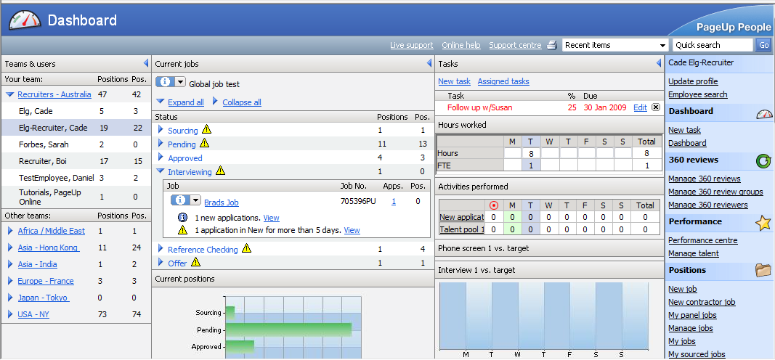

1. **Teams and users** – if the user has access to view jobs raised by their own team members or by other teams, they will see a ‘teams and users’ column on the left hand side. In the example above, Cade Elg-Recruiter belongs to the Recruiters-Australia team which is made up of 6 members. Cade has 19 jobs open with 22 positions attached (some jobs may have multiple positions to fill). Cade can see how many jobs and positions other team members have to fill. Cade also has access to ‘Other teams’. By clicking the blue arrow, he can expand each team, view the members of that team and see their recruitment activity.
2. **Current jobs –** this column shows all current jobs group by job status. From here, you can see the jobs and positions open per current job status, the number of applicants that have applied, alerts for new applications to be reviewed, etc. If a user clicks on the name of a team member in the left side column, the page will refresh to show that particular users dashboard. Handy for recruiters who need to assist another recruiter with their jobs and recruitment.
3. **Tasks** – this area allows you to create tasks for yourself or assign tasks to other users.
4. **Right side menu -** Based on the user’s permission settings, this column allows the user to access different areas of the system (e.g. create new job, add application forms, review applications, etc.)

**Permissions**

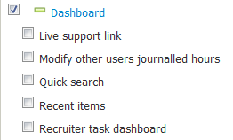

|  |  |  |
| --- | --- | --- |
| Permission | Path | Description |
| Live support | Dashboard >  Live support link | Adds the ‘Live support’ link under the **Help** link in the top bar of the page |
| Modify other users journalled hours | Dashboard >  Modify other users journalled hours | Allows you to edit the ‘Hours worked’ table on the dashboard for those users you have access to via ‘teams and users’ on the left side of the dashboard page |
| Quicksearch | Dashboard >  Quicksearch | Adds the **quick search** look up field to the top right of the page |
| Recent items | Dashboard >  Recent items | Adds the **recent items** drop down to the top bar of the page |
| Recruiter task dashboard | Dashboard >  Recruiter task dashboard | Gives the user access to the admin system. If this is not ticked, the user will be presented with the simpler Recruitment Centre dashboard |

## Job Card

|  |  |  |
| --- | --- | --- |
| Feature | Value | Description |
| sJobDisplayedFields | Values | **Job card** – sets the fields drawn on the position information tab of the job card |
| sJobRequiredFields | Values | **Job card** – sets the mandatory fields drawn on the position info tab on the job card. Simply enter the corresponding field on the job card that needs to be mandatory into this feature. |
| bMultiJobPositions | True/False | **Multiple job position:** Enables multiple job positions on the job card.  In **sJobDisplayedFields** ensure you REMOVE (1) lPeople and (2) lReplacementPeople and add (1)lMultiJobPositions instead  **NOTE:** You will need to set up job cancelled reasons if using multi positions  **NOTE:** You must contact a developer before enabling this feature. Database changes need to be made, otherwise client data loss will result. |
| bMultiJobPositionAutoPositionNumberPopulate | True/False | **Multiple job position:** Populates the first position number in the Multi-job position grid based on the position selected from the ‘Select a job template’ page |
| bMultiJobPositionAutoPositionNumberPopulateUseDefault | True/False | **Multiple job position:** When additional positions are added, the position number is defaulted to the position selected from the ‘Select a job template’ page |
| bShowTypeInMultiPositionGrid | True/False | **Multiple job position:** If set to ‘False’ the Position type column and selector is not shown in the Multi-job position grid (i.e. the new vs. replacement drop down) |
| bSearchDialogAddSite | True/False | Only relevant for clients using **lSiteID** on the job card (i.e. where will the successful applicant be located).  Setting this to True enables users to create new site ‘on the fly’ from the site dialog box on the job card (instead of needing system settings access) |
| bSearchDialogAddProvider | True/False | Setting this to True enables users to create new users ‘on the fly’ from user dialog boxes in the system. The user will be placed into the default team and permission group set in **manage users** |

**Configuration guide**

**What is the job card?**The job card facilitates the online collection of information relating to the job requisition and subsequent approval commonly used by clients. The job card is usually a replication of the paper based forms or previous system based forms.

To raise a new job, users click **‘New Job’** from the right side menu to access their job card. The job card is made up of different tabs.



  
   
This is where the details o fthe job are captured and can be tailored for each client using **sJobDisplayedFields –** mandatory fields for this card can be set using **sJobRequiredFields.**

Recommend this is switched OFF for new clients (and is off by default in new instance). This is older functionality which allowed users to set categories against a job.

  
Users have the ability to create and edit notes against a job. You can permission this so users can only see notes and not edit notes (this is sometimes the permission setting for HMs)

  
This is the tab which allows users to source jobs to any sourcing channels they have set up. This is often visible to SuperUsers and Recruiters only. You have the ability to give a user access to this tab BUT restrict the actual sources they can advertise to. For more information, refer to the Source Management guide.

  
This is where users can upload documents relevant to the requisition they are raising. Documents must be given a document category so that the system knows what the user is saving. Every document category needs to be given a document type so the system knows when to show the document category. For example, on documents that are of type ‘job document’ show in the documents tab on the job card.

* **Document category –** What document is it? E.g. Resume, CV, Reference check notes, Police check form, etc
* **Document type –** What type of document is it? E.g. Job doc, Recruiter doc, Offer doc, etc

To set up document categories, go to system settings > base > documents (shown below)

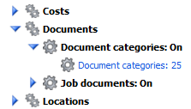

**Position info tab configuration guide**

**What fields are required on the job card?** Collate any documentation provided by the client related to information collected during the job requisition process. This may be a paper based form, or a screenshot of the incumbent system. Below are high level scoping questions which will help you determine the best set up for the job card for your client

|  |  |
| --- | --- |
| Scoping question | Possible Outcomes |
| What information is necessary to capture for approval purposes? | Why is information being requested on the job card? Is it for approval processes? If an approver reviews the job card, will they have everything they need to approve the job? |
| What information is necessary for reporting purposes? | Again, why is information being requested on the job card? Is it crucial for reporting? Often clients want to report on information that they are not asking for….if it’s not being asked, we can’t report! Understand the reporting needs of your client to ensure there is somewhere in the system capturing this information. |
| What information is relevant for selection of the appropriate candidate? | Is there certain information that needs to be captured at the requisition stage that will assist users reviewing the job card to determine the type of candidate being sought after? If a manager completed the job card, what information do they need to provide recruitment in order to recruit appropriate candidates? |
| What information is also used for offer purposes? | Some information from the job card is often needed at the offer stage (e.g. anticipated salary, relocation details, etc.). Ensure your client starts to think about the full recruitment cycle – does anything need to be captured at the requisition stage in order to better facilitate the offer process? |

When configuring a client’s position info tab on the job card, follow these steps.

1. **What fields are required on the job card?** Discuss ALL fields required as if a SuperUser was viewing the job card. KEY QUESTION – is the field needed for (1) Reporting purposes for (2) Approval purposes. If the answer is NO for both questions, query why it needs to be on the job card!
2. **Does the terminology of the fields make sense for your client?** If not, update the text using field AS label (e.g. lWorkTypeID AS Employment category)
3. **What order should these fields be in?** Create logical sections on the job card using labels (e.g. DrawLabel1 AS …)
4. **Of these fields, which should be mandatory?** If it’s crucial for clients to report on a particular field, ensure it’s mandatory.
5. **Which permission groups should see which fields?** Once the job card is configured, review each of your permission groups. Do some groups need fields hidden from their view (e.g. Date closed is needed for reporting purposes and is handy for recruiters to see when they go back to look at historical jobs BUT Hiring Managers probably don’t need to see this field)

**Configure sJobDisplayedFields**

The feature **sJobDisplayedFields** contains a comma delimited list of the fields that will display on the job card. The easiest way of previewing fields configured on the job card is to select the ‘New job’ link once logged into the administration system, and skipping the ‘Select a job template’ page.

New client instances will have instance 100 copied across, including a generic job card. This job card is a base to get your clients started, but it also contains fields that should remain on the job card. Base fields are as follows:

|  |  |
| --- | --- |
| Field type | Description and examples |
| sTitle | The job title – can be used in quick search and also populates through to the sourcing channels for advertising |
| sExternalJobID | The job reference number - can be used in quick search and also populates through to the client’s sourcing channels so that applicants can also search for jobs by job number |
| lMultiJobPositions | Headcount management – The instance 100 job card is loaded with multi-job positions as this is most commonly used by clients. Review the next section in this guide on headcount management for more informaton |
| dAddedDate | The date the job was added into the system – important for time to fill reporting |
| dFilledDate | The date the job was closed - – important for time to fill reporting. This is often hidden from Hiring Managers but visible to recruiters so they can see this information against requisitions historically. |
| lBrandID > lDepartmentID > lSubDepartmentID > lDepartmentID | The organisational hierarchy/structure. The majority of clients report up to 3 levels but lDepartmentID is also available as a 4th level |
| lWorkTypeID | The employment type – often used as a search criteria on client websites |
| lCostCentreID | A look up field of costs centres that the requisition sits under – clients often wish to report based on cost centre |
| lSiteID | Site (internal only) – the physical location of the job (e.g. 91 William Street, Melbourne, VIC, Australia). This information can be displayed in the job panel on the offer card and is often used to merge into letters. |
| lLocationID | Location (external) – the location of the job for advertising purposes. Often used as a search criteria on client websites but locaton also sets the privacy statement for the job when applicants apply |
| lApplicationStatusGroupID | Adds the ‘recruitment process’ field on the job card. Sets which application statuses the applicants who apply should run through, along with communications they will receive |
| sApplicationDetails | Advertising – Summary field. Populates to the sourcing channels and from there, is displayed in job advertisements that are sourced for that job |
| sOverview | Adverting – Job description. Populates to the sourcing channels and from there, is displayed in job advertisements that are sourced for that job |

**Headcount Management**Capturing the number of positions per job card raised is very important for reporting purposes and needs to be discussed with your client. There are 2 options when setting up headcount on the job card:

**Option 1: Multi-positions**The following table will displayed on the job card when you add **lMultiJobPositions** to sJobDisplayedFields and activate the feature **bMultiJobPositions** is set to true. Multiple new and replacement positions can be added to the job. You can add up to 20 new and 20 replacement positions at one time. As positions are filled, the name of the successful applicant will appear in the multi-positions box on both the job card and offer card. The system will not allow a user to offer a position to an applicant if all positions have been filled.

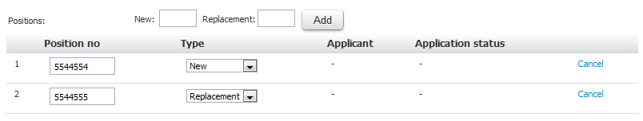

**Option 2: Standard positions**A simpler position table will appear when you add **lPeople** and **lPeopleReplacement** to sJobDisplayedFields. You can still add multiple new and replacement positions however, the system will not stop you offering more positions than set. This is often used for clients who have an integration with a HRIS where users must pick one position number per requisition.



**NOTE:** You can only have 1 option activated. Do not add lPeopleID and lPeopleReplacementID to the job card IF lMultiJobPositions is set (and vice versa)

**Client specific job card configuration:**When configuring the job card, you need to review any additional information that your client wishes to capture (outside of the standard fields described above) and determine the most suitable fields from the list of supported job card fields to use. Ensure you **Use fields designed for their purpose** wherever possible. If a client wants to capture cost centre information on their job card, use lCostCentreID. Always check to see if there is a field designed to capture the information requested.

**Field types:** Below are field types available on the job card that you can use to meet your client’s requirements.

|  |  |  |
| --- | --- | --- |
| Field type | Screenshot | Description and examples |
| Date fields |  | E.g. dAddedDate  No additional configuration required once added to the job card |
| Select Lists |  | E.g. lWorkTypeID  The data within select lists need to be configured once added to the job card. This is usually completed via system settings > base. For instance, the options displayed in lWorkTypeID are set via system settings > base > work types  If you add a select list to your job card and cannot find an corresponding field under system settings > base module, it may be a field that can only be accessed via a developer. A database update will be required. Use these fields with caution. If you can’t update the data, neither can your client! |
| Hierarchy select lists – Org Structure |  | lBrandID >  lDepartmentID >  lSubDepartmentID >  lDepartmentPositionID  The above is our organisational hierarchy (up to 4 levels). Choose a brand (level 1) to give you Department options (level 2) linked to that brand. Choose a SubDepartment (level 3) link to that department, etc |
| Hierarchy select lists – Payscales |  | lPayScaleID >  lPayScaleTypeID >  lPayScaleAreaID >  There are 3 levels of payscale data that can be added – when you select a lPayScaleID you can pre-populate the lPayScaleType and lPayScaleAreaID for that payscale.  You can also use the drop down fields independently (i.e. they can be 3 individual drop down fields that do not link to one another) |

**Miscellaneous fields:** If the client has requested a field on the job card that cannot be added using specific job card fields created for a specific purpose, there are generic free text and yes/no fields that can be used and labelled as anything you wish. There are also fields available for creating headings and additional text as required.

|  |  |  |
| --- | --- | --- |
| Field | Description |  |
| Headings |  | e.g. DrawLabel1 AS JOB ROLE  These are used to add headings and sections to your job card  *There are 10 of these available on the job card (DrawLabel 1 through to DrawLabel10)* |
| Help text |  | e.g. DrawSubText1 AS eg Website/Seek/Agency  These are used to provide guidance text for fields as required  *There are 10 of these available on the job card (DrawSubText 1 through to DrawSubText10)* |
| Single line free text fields |  | e.g. sOther1 AS Requisition billing reference  *There are 10 of these available on the job card (sOther 1 through to sOther10)* |
| Medium or Large free text fields |  | e.g. *sTAOther1 AS Probabtion conditions*  *There are 10 of these available on the job card (sTAOther 1 through to sTAOther10)*  **NOTE:** To make the the box larger, and the word LARGE to the field (e.g. sTALargeOther1).  **IMPORTANT:** sTAOther1 and sTAOtherLarge1 are the same field!!! Adding the Large just makes it bigger. |
| Yes/No radio buttons |  | e.g. bOther1 AS Customer facing?  *There are 10 of these available on the job card (bOther 1 through to bOther10)* |
| Generic select lists |  | e.g. GenericListType_AgencyFee  Unlimited generic lists can be created. Review section below for further information on features and set up. Use with caution – these fields are not currently supported in our standard reporting dataviews and should be used only when all other drop downs have been used AND if the client does not need to report. |

**Generic select lists:**

Generic drop downs are supported on both job and offer cards. Features include:

* Values selected in a generic drop down field can be included within contract templates as each will have its own specific merge field to be used within the template
* If the same generic drop down is used on the job and offer card, the offer card will automatically pull across the value populated from the job card. The value can be updated on the offer card and it will not change the original value on the job card
* When a generic drop down is added, it can be permissioned off
* You can create parent/child generic drop down lists
* Data in the generic drop downs can be included in outbound export integrations

**To create:**

1. Go to System Settings > Base > Generic Lists > New
2. Add the following information against your generic drop down field:
   * Title (Give a title that represents the purpose of the field)
   * Draw field title (Give the field the ‘draw field title’. This must be unique and this is what you use to add to the display features for the job or offer in order to have this field displayed). If you enter in a non-unique value, the system will notify you accordingly.
   * Client title (Optional. It is used in integrations where the client provides a code to represent the title to display in our system but wants the code in the export/outbound integration.)
   * Parent (Ignore this for now)

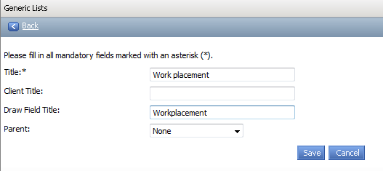

**To add data to a generic drop down**

1. Click on “manage values” against that field

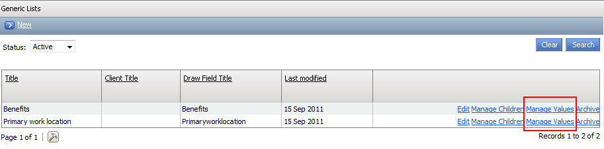

1. Then click on “New” and complete the following fields
   * Value (This is the title of the data)
   * Client value (optional - used in integrations where the client provides a code to represent the value to display in our system but wants the code in the export/outbound integration)

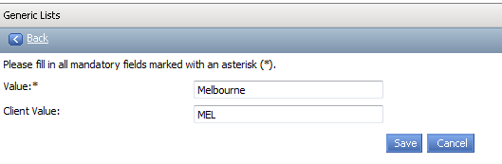

**Create parent/child drop down relationships?**

1. Click on “manage children” against that field that is to be the parent

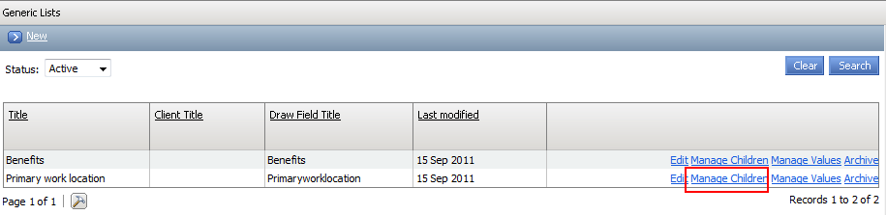

1. Click on ‘new’
2. Complete the following fields as needed:
   * Title
   * Client title (optional – purpose is same as previously mentioned)
   * Draw field title (must be unique - purpose is same as previously mentioned)
   * Parent (this should be already pre-populated for you but you can change the parent that this child belongs to)

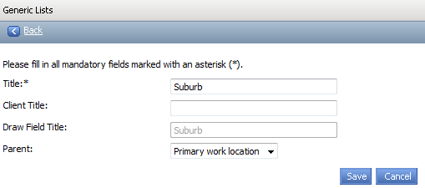

1. Then populate the values under that child field created by clicking on ‘manage values’

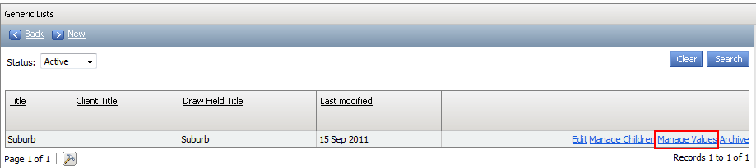

1. Click ‘New’
2. Complete the following fields accordingly:
   * Value
   * Client value
   * Parent value (this determines what can be selected based parent value selected. I.e.: You can then select Richmond if Melbourne had been selected as the state. You would change the parent to be Sydney if you wanted this value to available for selection based on Sydney being selected as the State instead of Melbourne)

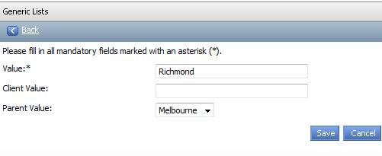

**How to add a generic drop down field to the job or offer card and make it mandatory?**

1. Simply add the “draw field title” of the generic drop down field to the job or offer card display field feature in feature manager in the following format “GenericListType_[DRAWFIELDTITLE] AS XXXXX”.

I.e.: GenericListType_Primaryworklocation AS Primary work location

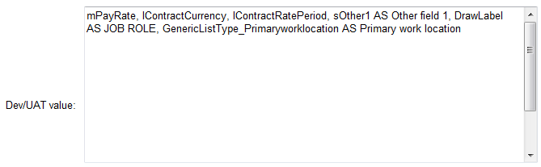

1. To make the generic drop down mandatory, simply repeat the same process but on the job or offer mandatory field feature in feature manager.

**Where do I find out what the corresponding merge field is for the generic drop down inclusion in a template?  
NOTE:** Refer to the offer module guide for information on merge field templates. Merge field documents is available functionality with the offer module.

1. Simply go to Manage Documents > Upload a new document
2. Then click on the merge field help icon

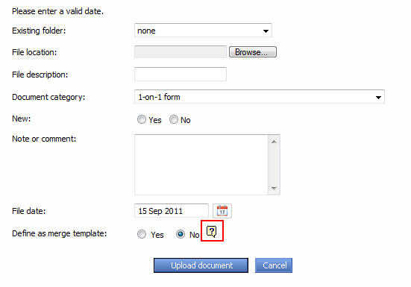

1. The corresponding list of merge fields for each generic drop down field create is display under the heading of “Generic merge fields”

**Panel Member Functionality**This functionality is optional and typically only used by our university and some government clients. This functionality allows the user completing the job card to set a 1 Chairperson and multiple Panel Members against a job. These users will then have access to review and rate applicants who apply for the job.

To add Panel Member functionality, add **lJobAdditionalProviderID** to the job card. This will activate the box below.   
**NOTE: lJobAdditionalProviderID** AS Panel Member (for example) will add the words Panel Member in the 4 spots below.

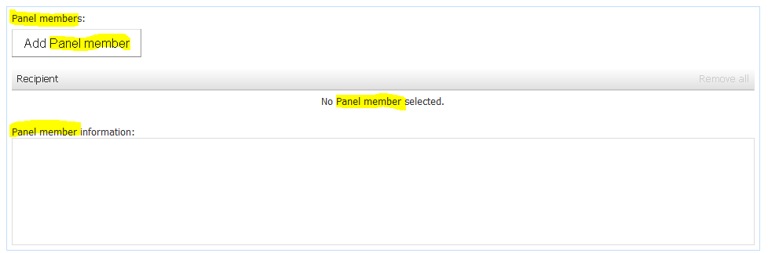

Users can click the ‘add panel member’ button to add multiple users into the panel to review applicants.

To add the chairperson, there are 2 options:

**Option 1:** Add **lChairProviderID** to the job card.

This will add another user look up field so that you can specify the chairperson for that job. The main difference between the Chairperson and a Panel Member is that the permission View other panel member responses can be set so that only the chairperson can see the rating made by the whole panel. Panel members will only be able to see their own ratings.  
  
**Why choose this option?** If the person raising the job is not usually the chairperson, this allows the client to record who raised the job and who is set as the chairperson (e.g. PA raised a job on behalf of the Chair)

**Option 2:** User the **originator field** as the chairperson

If lChairProviderID is not added to the job card, the Originator field will act as the Chairperson  
 **Why choose this option?** Suitable if the person raising the job is also the chairperson – means the users has one less field to complete.

**Setting the panel member scoring**Clients can tailor the responses the panel make against their applicants. The ratings may be 1-5 or Yes, No, Maybe, etc. To set up, go to feature manager, search for your client and click **ITM.** From here, select **Set up panel scoring** and follow the instructions.

**Supported job card fields**

Below is a list of commonly used fields on the job card. A full list of fields available for use on the job card is currently in review

|  |  |  |
| --- | --- | --- |
| **Field** | **Default Field Title** | **Description** |
| COMMONLY USED UNDER JOB ROLE | | |
| sTitle | Job title | Used as the job title of the job. |
| sExternalJobID | Job reference No. | Used as the job number of the job. |
| sBody1 | Contact email | Text field which lets you specify which email address you want messages about the job are sent to. |
| COMMONLY USED UNDER HEADCOUNT MANAGEMENT | | |
| lPeople | New positions | Used to record if the job is a new position. Used in conjunction with lPeopleReplacement. |
| lPeopleReplacement | Replacement positions | Used to record if the job is a replacement position. Used in conjunction with lPeople. |
| lReasonID | Reason | Drop down of job reasons. |
| sReplaceFor | Current/previous  incumbent name | The name of the previous incumbent if a replacement position. |
| dSeparationDate | Previous incumbent leave date | Used as the date that the previous incumbent had left the position. |
| dAddedDate | Date opened | When the job was created. |
| dFilledDate | Date filled | When a job was filled. |
| dNeededDate | Date needed | When a job is needed by. |
| sLikelySource | Likely source | How the job is mostly likely to be filled by. |
| COMMONLY USED UNDER POSITION INFO | | |
| lTeamID | Team | Drop down of teams, used with lProviderID |
| lProviderID | User | Owner of the job |
| lReportsToPositionID |  | Reports to manager position ID |
| lReportsToProviderID | Reports to manager name | The person the applicant will report to.  This is an arbitrary piece of data that should not do anything, however and some point this field was made to show jobs on the task list (Westrac use this).  This should not have occurred, instead lAssistantProviderId should be used to do this. |
| lRequestPositionID |  | Requisitioner position ID |
| lRequestProviderID | Requisitioner | The person requesting the position (typically the hiring manager).  This makes jobs appear in “my jobs” (a special hiring manager page) |
| lAssistantProviderId |  | Somebody who is assisting with a job, typically another recruiter or a very involved hiring manager. This makes jobs appear on the task list.  **NOTE:** Technically jobs can only have one owner, and the counts of jobs that display on the task list are only based on the owner of the job (lProviderId). It is not possible to get the counts to also appear for lAssistantProviderId – as the numbers will no longer add up. |
| lBrandID | Brand | Brand drop down, only shows if there is more than one brand. |
| lDepartmentID | Department | Drop down of departments. |
| lDepartmentPositionID | Position/Sub Department | Drop down of positions/sub department.  If using sub department, need to enter turn on manage sub-department in system settings under organisational hierarchy. |
| lWorkTypeID | Employment type | Drop down of employment types. |
| sEmploymentDuration | Duration | Used to specify the duration of employment if a temporary or contract position. |
| lHoursPerWeek | Number of hours | Used to specify how many hours of work is required for the week. |
| dPositionStart |  | Start date of a contractor or temporary person |
| dPositionEnd |  | End date of a contractor or temporary person |
| sSalary | Salary | Salary of job |
| sJobCostTitle | OPEX cost centre | Cost centre field. |
| lCostCentreID | Payroll cost centre | Cost centre lookup |
| lPayScaleID | Pay scale | To use this field, the feature bManagePayScales must also be turned on. |
| lPayScaleAreaID | Pay scale area |  |
| lPayScaleTypeID | Pay scale type |  |
| lLocationID | Location | Used to specify the job’s advertising location. |
| lSiteID | Site | Used to specify exactly where the job will be located. I.e. Mitcham Branch |
| lApplicationStatusGroupID | Recruitment process | Select recruitment process, always displays required field. |
| sApplicationDetails | Summary | Summary text field |
| sOverview | Description | Job ad description |
| lStatusID | Status | Job status |
| sRole | Role | Used for position roles or position names. |
| **Field** | **Default Title** | **Description** |
| dAudit |  |  |
| dClosingDate | Close |  |
| dCreated | Date created |  |
| dExpiryDate | Job expires |  |
| dOpeningDate | Open | When the job was created |
| sAreaOfStudy | Area of study |  |
| sConditions | Conditions |  |
| sConditions2 |  |  |
| sCustomSources |  |  |
| sDualHolderComments |  |  |
| sDesirableSkills | Desirable skills |  |
| sEmailResponse |  |  |
| sEndTime |  |  |
| sJobStyle |  |  |
| sJobSubStyle |  |  |
| sKeyGUID |  |  |
| sKeywords | Keywords |  |
| sMandatorySkills | Mandatory skills |  |
| sMinYearStudy | Min. year of study |  |
| sOperationType | Operation type |  |
| sOverview | Description |  |
| sPositionNos | Position numbers |  |
| sProductType | Product type |  |
| sSites |  |  |
| sStartTime |  |  |
| sState |  |  |
| sStreet1 | Template title |  |
| sStreet2 |  |  |
| sSuburb |  |  |
| sTestPositionNo |  |  |
| sURL |  |  |
| lAccountManagerID |  |  |
| lApplications | Not displayed | Field use to store the number of applcations for a job |
| lApprovalProviderID |  | Approval Provider lookup |
| lAssistantProviderID | Assistant recruiter | Assistant Provider lookup |
| lAuditProviderID |  | Used in revision history |
| lCategoryID | Category | industry drop down |
| lChangeProviderID | Not displayed | Saves the provider who last made a change |
| lDesignTemplateID | Design template | Drop down of design templates configurable in Manage design templates |
| lHired |  |  |
| lHitsSearch |  |  |
| lHitsView |  |  |
| lIndustryID | Industry |  |
| lInstID |  |  |
| lJobID |  |  |
| lJobDateID |  |  |
| lJobFunctionID | Function |  |
| lJobOtherID |  |  |
| lJobParentID |  |  |
| lJobSectorID | Job sector |  |
| lJobTemplateID |  |  |
| lJobTypeID | Employee group |  |
| lOrgUnitID | Team |  |
| lPersonnelAreaID | Personnel area |  |
| lPersonnelSubAreaID | Personnel sub area |  |
| lPositionID |  |  |
| lPositions |  |  |
| lProfileID |  |  |
| lRoleID | Job name |  |
| lRoomID | Site room |  |
| lVenueID |  |  |
| lWorkPayStructureID | Employee sub group |  |
| bCustomSources |  |  |
| bDefaultTemplate |  |  |
| bDualHolder | Dual holder |  |
| bGlobal |  |  |
| bGlobalJob |  |  |
| bJobFeed |  |  |
| bSendApplication |  |  |
| bSpecific | Is this job Graduate specific? |  |

**Permissions**

|  |  |  |
| --- | --- | --- |
| Permission | Path | Description |
| Job card > Displayed fields | Jobs section >  Job management >  Edit jobs >  Displayed fields | Determines the fields on the Job card that the user will be able to see. Fields can also be set to read only mode. Be aware, if a user is raising a job and a mandatory field is set to read only, they will not be able to add data and hence, won’t be able to save the job card |
| Job card > Job notes | Jobs section >  Job management >  Edit jobs >  Job notes | Adds the notes tab to the job card. Notes can be made read only |
| Job card > Job notes | Jobs section >  Job management >  Edit jobs >  Job notes >  Edit and delete notes | Once the notes tab is set, sets whether the user can edit and delete job notes (as opposed to just adding notes, as long as read only is not activated) |
| Job card > Position details tab > Job approvals | Jobs section >  Job management >  Edit jobs >  Job approval | Sets if the approval process section of the job card will display. Within this field you can also set if the user will (1) See the job status field and (2) See the recruiter field |
| Job Card > Create a job | Jobs section >  New job | Adds the **new job** link to the right side menu |
| Right side menu > My panel jobs | Jobs section >  My panel jobs | Adds **My panel jobs** to the right side menu |
| Panel responses | Panel >  View other panel member responses | Allows the whole panel, not just the chair, to view the responses of the panel |
| Right side menu > My source jobs / My Jobs | Jobs section >  My jobs | Adds **My sourced jobs** AND **My Jobs** to the right side menu |

**Frequently asked questions**

**Q: I have added a drop down field to me job card but it is not displaying. Why?  
*A:*** *Do you have any data added to the drop down field? For some drop downs, if you add a drop down field but there is no data in the back end in this field, the system will not display it as it’s empty. The same thing applies if you only have 1 option in a drop down – the system won’t display it as it won’t make a user choose from one option – it just defaults it. Add more data to the field and it should appear.*

**Q: How do you relabel fields on the job card?**  
**A:** *To give a field an alternate label, use the AS syntax - E.g. lWorkTypeID AS Employment type*

**Q: Are all job card fields reportable?  
A:** *Over time, more and more job card fields have become reportable with our ‘build your own reports’ data views. In particular, the majority of job card fields are available on the Jobs (Inc. TTF) data view. Not all job card fields are available across all data views. You will need to consult with your client about specific reporting needs and identify crucial items that must be reported on so you can ensure any fields you are using are available in the data view requested*

## Campaign Card

|  |  |  |
| --- | --- | --- |
| Feature | Value | Description |
| bCampaignModule | True | Enables the campaign job card |
| sRedeploymentDisplayedFields | Values | **Campaign card** – sets the fields drawn on the position information tab of the campaign job card |
| sRedeploymentRequiredFields | Values | **Campaign card** – sets the mandatory fields drawn on the position information tab of the campaign job card |

**System Scoping**

|  |  |
| --- | --- |
| Scoping question | Possible Outcomes |
| Do you run any types of campaigns – i.e. Graduate campaigns or Expression of Interest campaigns? | Understand if this will be required for the client. This section of the guide simply covers setting up the campaign card BUT there are many components to an actual campaign drive (app forms, recruitment processes, etc.) |
| Who manages the applicants that apply to the campaign? | Ownership is important. Clients often want to set up an EOI campaign but do not consider the applicant care associated with this – so applicants apply and receive an acknowledgement but may never hear anything further. |
| Typically configuration of a (1) Campaign to source to your website (2) Specific application form and (3) recruitment process and comms need to be created specifically for the campaign | Start discussing how the application process for the campaign differs from recruitment to a particular role. Alternative versions of the items stated may be required. |

**Configuration guide**

**What is the campaign card?** The campaign card is another type of job card that clients receive as part of base. It differs from the standard job card in the following ways

* The card is designed to be a shortened version of the standard job card
* Campaigns are excluded from time to fill reporting
* The campaign card does not support approvals, even if the client has the **online requisition module**

Campaigns are typically used if the client doesn’t have any specific roles on offer but wants to build their ‘talent pool’. For example, campaigns are used for expression of interest for various roles or graduate campaigns.

**Accessing the campaign card:**To create a new campaign, the user must have access to **manage jobs**. From this page, there is a link to **new campaign**

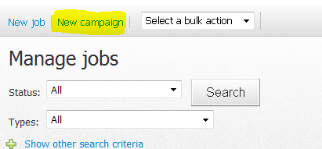

**To configure the campaign card:**New client instances will have instance 100 copied across, including a generic campaign card. The feature **sRedeploymentDisplayedFields** contains a comma delimited list of the fields that will display on the campaign card. Follow the same instructions used when configured the job card. You will find that the campaign card is usually a shell version of the job card. Fields on the job card are also supported on the campaign card.

**Setting up a campaign drive**The following is a high level checklist of what is required when setting up a campaign drive. This example is for an Expression of Interest (EOI) campaign. Yu will need to review specific module guides for further information (e.g. review the application form builder guide for item 3 below)

1. Campaign requisition created and owned by an appropriate member of the team
2. EOI advertising copy for when sourcing to your website/intranet etc.
3. An EOI specific application form
4. An EOI specific recruitment process
5. EOI specific communications attached to the recruitment process

**Permissions**

|  |  |  |
| --- | --- | --- |
| Permission | Path | Description |
| Campaign module | Campaign module | Adds the **new** **campaign** link to the manage jobs page so that the user can create campaign jobs |

## Recruitment Processes

|  |  |  |
| --- | --- | --- |
| Feature | Value | Description |
| bEmailOnApplicationWithdrawn | True | E-mail job owner when applicants withdraw their application |
|  |  |  |

**System Scoping**

|  |  |
| --- | --- |
| Scoping question | Possible Outcomes |
| Discuss a typical recruitment process, starting from when a job need is identified and raised through to making an offer to an applicant? | Establish a baseline. What does a typical recruitment process look like for this client. Once an applicant applies, what happens from here? Does recruitment perform screening and send to manager for review ? How many interviews do applicants attend? Who runs the interviews? At what points are mangers involved? etc. You will find that as a generic process is described “exceptions to the rule” will be identified (e.g. All applicants go through 1 interview…unless it’s a senior role and then they go through 2”.  Identify the exceptions to determine how many recruitment processes are required |
| Recruitment processes can differ based on the role being recruited for or the business unit the recruitment is occurring within. How different are your applicant steps? | Multiple recruitment processes are created for 2 main reasons   1. The steps applicants go through are very different or 2. The steps are the same but the communications need to differ   Users have the ability to skip steps if necessary so if the differences are minor (example 1 vs. 2 interviews) you may be able to create one process for both types of recruitment. Fewer processes are easier to maintain and it is also easier for users to know which process to choose if the list is manageable. |
| How do you currently communicate with applicants? | Clients may already have communication templates set up – determine when communications should be sent during the recruitment process |
| Who are emails sent from? | Clients will typically send communications from a generic address (e.g. [careers@telstra.com](mailto:careers@telstra.com)). Some clients prefer emails to be sent from the user. Clients will often send emails from a generic address at the start of the process and then change to the users address (e.g. once face to face contact is made).  Also discuss when communications should stop (i.e. when will you call regarding an unsuccessful application as opposed to emailing the information) |
| How will unsuccessful applicants be tracked in the recruitment process? | Client will typically add an unsuccessful status for each relevant application step (e.g. Interview 1, Interview 1 unsuccessful) – this makes it easy to see where applicants reached in the recruitment process |

**Configuration guide**

**What are recruitment processes?**Recruitment processes define the steps that applicants will progress through once they have submitted an application for a job.

* Multiple recruitment processes can be created
* A recruitment process is set per job. This means that ALL applicants that apply to a job will have the same list of steps to run though

**Recruitment process configuration guide**

Go to system *settings > base > recruitment processes > recruitment processes > new recruitment process*

You will be presented with the option to create a new process from scratch of to copy and existing recruitment process. We will review creating a process from scratch first.

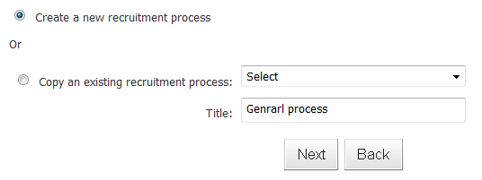

On the next screen, name the process. You will then be asked to set up incomplete application managements.

**Incomplete application management**

**Settings:** When an applicant applies for a job, they remain in a status of ‘incomplete’ until they finish all mandatory questions and click the **submit** button. At this point, they are moved into the status of **New** and receive an automatic acknowledgement email pre-defined in the system. In order to clear out incomplete applications from the system, each recruitment process can be set with its own options for incomplete applications, shown below.

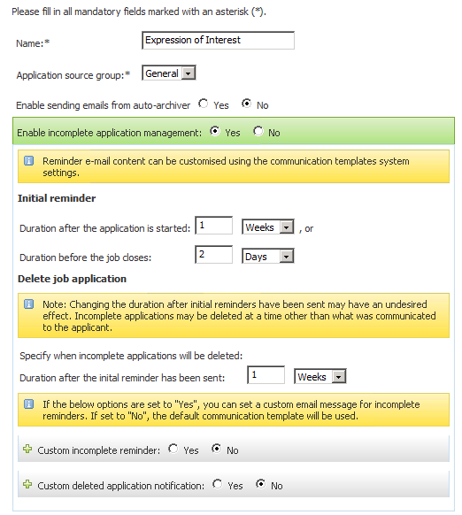

Incomplete applications will receive an initial reminder either X day AFTER the applicant started the application of X days before the job closes (whichever comes first). After this initial reminder, if the applicant still does not complete their application, they will receive another email X days after the initial reminded stating that their application will be deleted from the system.

**Communications**: A generic (1) Initial reminder and (2) Delete application email is set via system settings > communication templates. However, you can set specific comms per recruitment process via the above page if required. If the communication options are set to NO, then the default comms in system settings will be sent.

**Manage recruitment processes page**

Once you create your recruitment process, you will be directed to the recruitment process page where you can add and edit processes. Against each process you will see the follow

* **Set as default:** You have the ability to set 1 process as the default process. When a new job is created, this process will be automatically selected against the job card.
* **Edit:** Takes you to the incomplete application management settings for that process to amend. You can also set the application source group(refer to the Base – System settings section of this guide).
* **Application statuses** – see detailed guide below
* **Archive –** Archive when a process is no longer required. Archive (compared to delete) means that historical data will not be lost.

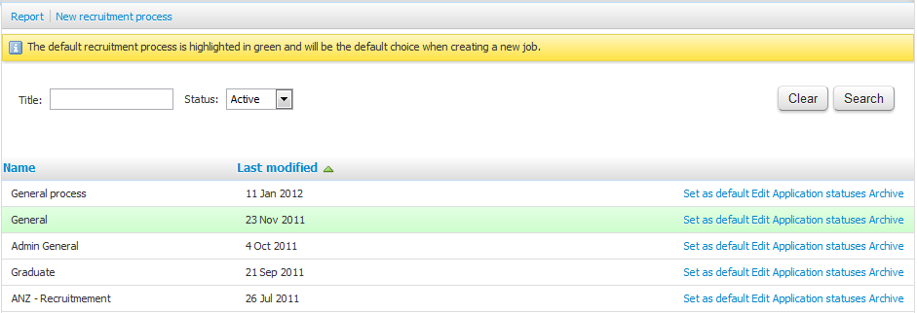

**Creating application statuses**Recruitment processes are made up of application statuses. These are the steps that applicants should go through following the submission of their application. There are 2 types of application statuses

1. **System statuses –** These are pre-defined statuses in the system that are required for the process to function correctly. For example, when an application is submitted, the applicant will automatically move through the status Submitted into New. The system automatically creates these types of statuses when a new recruitment process is created. More system statuses will be available based on the modules the client has switched on. For example, if a client has the Online Testing module switched on, the system will automatically create the online testing related system statuses every time a new process is created.
2. **Client specific statuses –** These are statuses that clients can create based on their specific processes. For example, Interview 1, Reference checking, Screening unsuccessful, etc.

**How to distinguish *system statuses* from *client statuses* –** When you open a system status, the Title will be in read only mode. Also, system statuses do not contain an archive button. The only way to edit the title or archive is to temporarily change the status so it is NOT a system status (not accessible to clients) and switch back when done.

**Application status settings**

**Section 1: General Settings** *(all clients)*

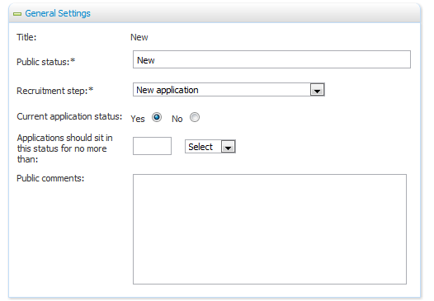

**Title:** The name of the status. This is for **internal purposes** and needs to make sense to recruiters who will move applicants through this status

**Public Status:** This is the name of the status for **external purposes** and what applicants see when they log into applicant services. For example, the Title of a status might be Interview unsuccessful BUT the public status might be Interview outcome.

**Recruitment Step:** This is used for reporting purposes. It allows clients to (1) Have consistent reporting across recruitment processes regardless of terminology used and (2) Allows the system to understand what part of the recruitment process a particular application step is referring to. Below are some common application statuses and the recruitment step they should be linked to across all recruitment processes to ensure consistency.

|  |  |
| --- | --- |
| Application status | Recruitment Step |
| Incomplete | Not reportable |
| Submitted | New application |
| New | New application |
| Ineligible | Unsuitable – not suitable for employment |
| Unsuccessful statuses  E.g. Interview 1 unsuccessful, Screening unsuccessful | Unsuitable – at this time |
| Withdrawn  Removed | Withdrawn |

**Current application status:** Defines if the step is current (an open step where the applicant is still being processed) or non-current (a closed step where the applicant has reached an end point)

**Applications should sit…:** Defines when an alert should appear on the job owner’s dashboard if applicants have not been moved out of this status within the set time frame.

**Public comments:** Optional additional information you can provide applicants when the login into application services

**Section 2: Applicant emails** *(all clients)*

At every application status change, clients have the option to email applicants. This is where you can set the default template for the status. On a status move, users do have the ability to tweak the default if required. You can add merge fields to this communication – **show merge field information** will show you the merge fields available for this communication. Delays can also be added to the email.

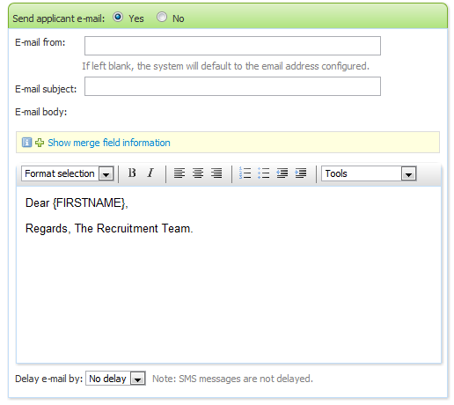

**Section 3: Agency emails** *(agency mgmt. module required)*If your client has the agency module, you can set agency specific communications against application statues. When an applicant is submitted via an agency, the system will track this and will send agency specific comms for these applicants if set. If an applicant has been applied via an agency and no agency comms are set, the applicant comms will send by default if set.

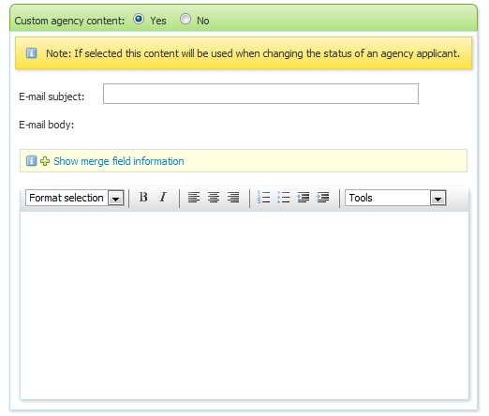

**Section 4: SMS** *(all clients)*Clients have the option to send SMS on status changes. Each SMS is charged separately of the client’s monthly account fees. SMS do not support merge fields. Applicants choose when they apply if they wish to receive SMS. If an applicant says NO and you try and send an SMS, the system will tell you that it will not send. Current charge rate (Jan 2012) is approximately $0.15.

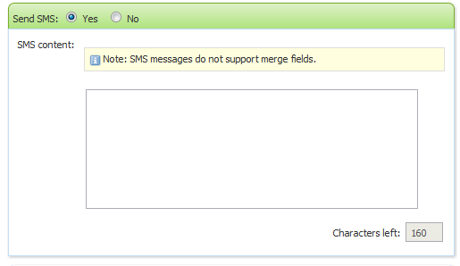

**Section 5: Assign application for review** *(all clients)*If this section is set, a change into this status will prompt the user to send the application for review by selecting a user from a look up field. The user will be asked to approve or decline the applicant.

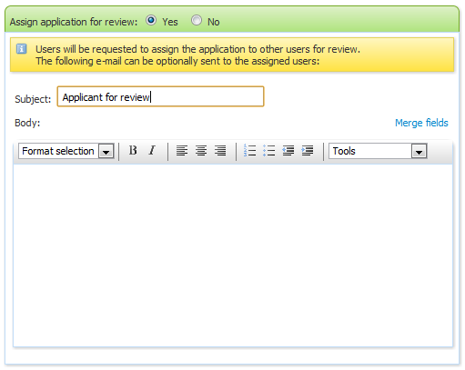

**Section 6: Set flags**Please refer to the Base – System settings section of this guide to review flag functionality. The option below lets you set a flag when a status change is performed**.**

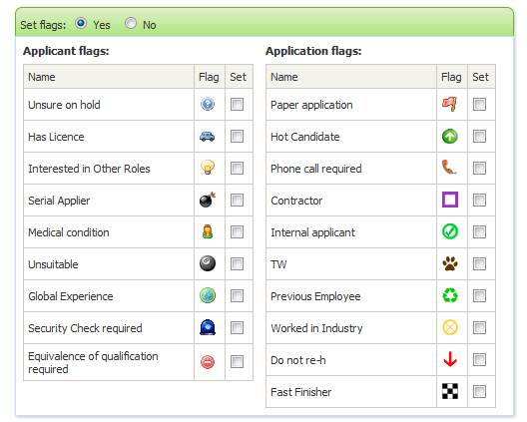

**Section 7: System Settings**

The options in system settings are related to different modules. Please refer to the specific module guide for set up information boxed in red or blue.

**Status triggers offer?: I**f set to YES, the offer card will be displayed when a user moves an applicant into this status. The user will be asked to complete the status change as normal (i.e. review comms, set talent pool, etc.) but when the change status page is saved, the offer card will launch. This should be set to a status towards the end of the recruitment process based on the client’s requirements. When does the client need to start filling in the offer card?

**Default offer accepted:** If set to YES, when the offer card is launched on this status change the yes/no field of “offer accepted” will default to YES.An example status this would work for is “Verbal offer accepted”. When you move the status of the applicant here, you can set ‘status triggers offer’ to YES to launch the offer card AND default offer accepted to YES in one go**.**

**Default start date (days):** Sets the start date of an applicant based on number of days from today. This includes public holidays. If the feature is set for 5 days and you make an offer on Jan 12th, a start date of Jan 17th will be populated automatically. Not something used by many clients as start dates always vary.

**Job status:** Job statuses can be aligned to application status. When you move into an application status with this field set, the system will prompt you to update the job status. For example, the *application status* of Interview 1 may be linked to the *job status* of Interviewing. When you move the first applicant into “Interview 1” the system will ask if you are ready to also move the job into ‘interviewing”. This is useful for reporting – reminds user to update job status.

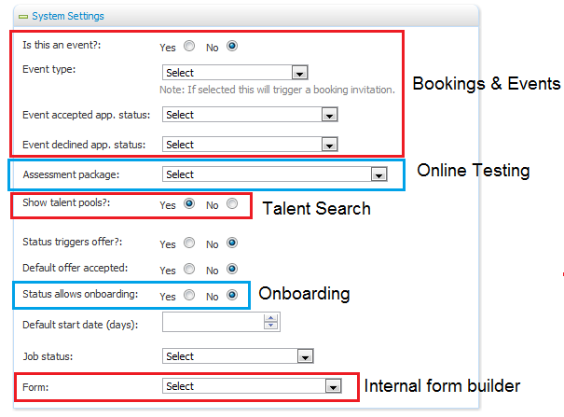

**Section 8: Hiring Manager shortlist settings** *(all clients - activated when bRCOutcomesShortList is switched on)*

Defines if an application status should prompt the Hiring Manager on the job card (to which the recruitment process is attached to) to review applicants and select outcomes for those applicants. Recruitment Centre release notes provide further detail regarding this functionality - <http://yoda/Information%20Wiki%20related%20documents/Gazelle%20Rexxx%20Project%20-%20Internal%20Release%20Notes%20v1.3.htm>

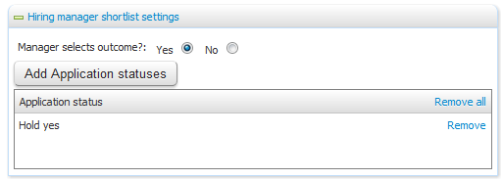

**Section 9: Guidance information** *(all clients)*When performing a status change, guidance information can be displayed with any additional information or instructions required at that step for recruiters to review.

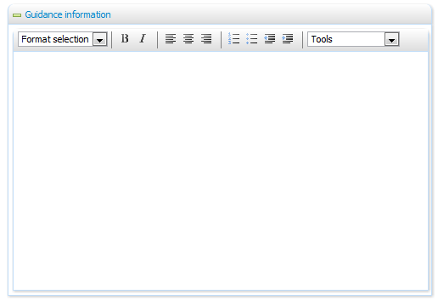

**Creating recruitment processes for your clients**

Best practice recruitment processes have been created in instance 100. This will be copied into all new client instances as a base. For existing clients, you can still use instance 100 as a way to talk through best practice recruitment process and to help your clients understand what the process will look like in the system.

**Helpful hints, tips and tricks**

* **The back end set up is the default but can be changed! -** What is set up against each application status in the back end should be what occurs at that step 95% of the time. Setting up default communications is designed to speed up the process for moving applicants through statuses. Users will be given a preview and can make amendments to the default text if necessary. They can also decide not to send an email on that occasion if required.
* **Unsuccessful statuses** – Some clients choose to have 1 generic unsuccessful status that all applicants move into – others prefer to have an unsuccessful status after each step (e.g. Interview 1, Interview 1 unsuccessful). Having multiple unsuccessful steps means that you can clearly see when viewing an applicant card how far an applicant progressed in a previous recruitment process.
* **Agency communications (if relevant) –** the easiest way to configure this is to firstly start with your applicant communications. These can then be tweaked to be agency specific (i.e. Instead of starting the email with “Dear APPLICANTNAME” you can start with “Dear AGENCYNAME”. Applicant comms can be tricky enough for clients so finalise those before you move onto agency communications.

**Frequently asked questions**

**Q: Can application statuses be made mandatory?  
*A:*** *No, all steps are optional and are designed to provide guidance to recruiters regarding the process. We do not force steps to allow flexibility for our clients. If a recruitment team requires certain steps to be followed by the team, this is an internal process and training exercise for the client.*

**Q: My client no longer needs a particular recruitment process. If I archive it, will this affect current jobs and applicants using this process?***A: No –existing jobs and applicants will still be able to run through the archived process. Archiving means that the process won’t be available for selection for new jobs only. Old jobs can run their course through to completion.*

**Q: What happens if I update the Initial reminder days within the recruitment process? Will this update effect applications which were already submitted before the change?  
A:** *The change WILL work for pre-existing applicants as the code checks if they are over the value set and if they haven’t been sent an initial reminder email before.*

## Manage jobs

Manage jobs is the page where users can search for jobs in the system. Both current jobs (open jobs being recruited for) and non-current jobs (filled jobs, cancelled jobs, etc.) can be accessed from this area. The two many configuration items for this page are (1) The search criteria available to users to search for jobs and (2) The result columns that appear once a search is completed.

**Configuration guide**

|  |  |  |
| --- | --- | --- |
| Feature | Default value | Description |
| sManageJobsColumns | sExternalJobID AS Job No., dJobCreated AS Date created, sInitials AS User CALL GetUserDetails(sInitials sFName sLName), sTitle AS Title, sBrandName,sDepartmentName AS Department,sJobStatusDesc AS Status, lApplications AS Applications, sSiteTitle AS Site, dMinLocalOpeningDate AS Opening date, dMaxLocalClosingDate AS Closing date, sRequestProviderFName AS Hiring manager CALL GetRequestProviderName(sRequestProviderFName sRequestProviderLName), bCurrentlyOpen AS Sourced CALL ParseAsTickCross (bCurrentlyOpen) | Sets the columns on the **manage jobs** page |
| sManageJobsSearchFields | lStatusID, sTitle, sJobNo, lBrandID, lDepartmentID, lTeamID, lProviderID, lApplicationStatusGroupID, lSiteID, lRequestProviderID | Sets the search criteria on the **manage jobs** page |
| sJobPreviewURL | <http://clientsCNAME/jobDetails.asp?sJobIDs>=  OR  <http://clientsdns.clients.pageup.com.au/jobDetails.asp?sJobIDs>=  UAT version of this link is http://uat.pageup.com.au/website/lInstID/jobDetails.asp?sJobIDs= | Allows user to hit this symbol  from the manage jobs page and other areas of the system to preview the job advertisement. |

*Manage Jobs Columns (sManageJobsColumns)*

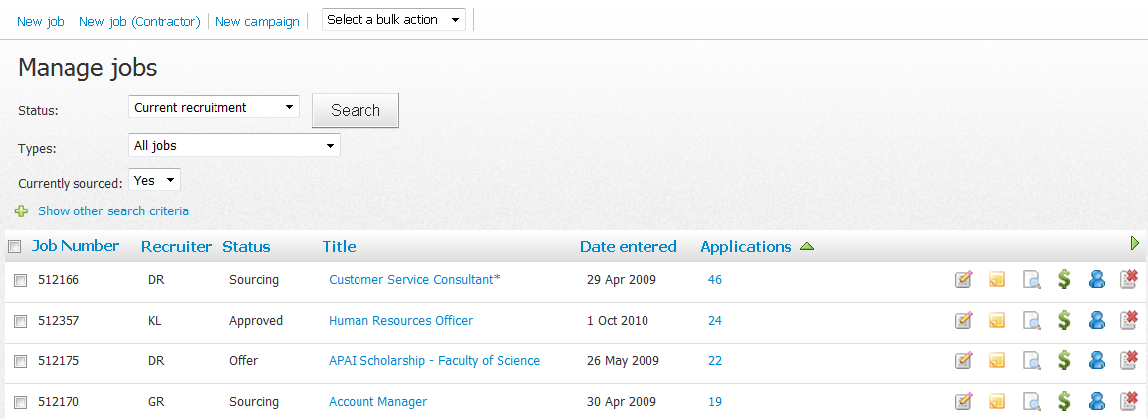

*Available manage job columns*

|  |  |  |
| --- | --- | --- |
| Column | Value | Description |
| Job number | sExternalJobID AS Job No. | Job number |
| Job created date | dJobCreated AS Date created | Job creation date |
| Job closing date (local) | dMaxClosingDate AS Closing date | Job closing date (displays the max closing date for all sourcing channels selected) |
| Job closing date (international) | dMaxLocalClosingDate AS Closing date | Job closing date (displays the max closing date for all sourcing channels selected). The **local** date takes into account international time zones. |
| Initials of the job provider | sInitials AS User CALL GetUserDetails(sInitials sFName sLName) | Displays the job owners initials (lProviderID on the job card) |
| Job title | sTitle AS Title | Job title |
| Number of applications | lApplications AS Applications | Number of applications (includes incomplete applications) |
| Site | sSiteTitle AS Site | Job site |
| Status | sJobStatusDesc AS Status | Job status |
| Brand | sBrandName AS Brand CALL TruncateBrand(sBrandName) | Level 1 - Organisational hierarchy |
| Positions | lPeopleTotal AS Pos. | Displayed the total number of positions from the job card (adds new & replacement) |
| New Positions | lPeople AS New Pos. | Displays the number of new positions from the job card (not usually used as total should suffice) |
| Replacement positions | lPeopleReplacement AS Rep Pos. | Displays the number of replacement positions from the job card. (not usually used as total should suffice) |
| Job currently sourced? | bCurrentlyOpen AS Sourced CALL ParseAsTickCross (bCurrentlyOpen) | Displays a tick in the column if the job is currently sourced |

*Manage Jobs search criteria (sManageJobsSearchFields)*

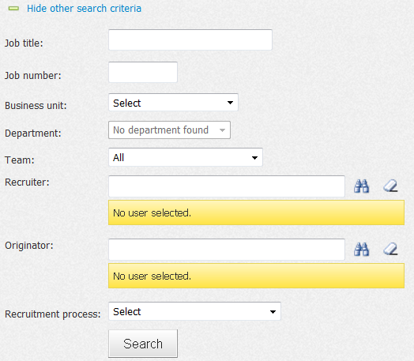

*Available manage job search criteria (sManageJobsSearchFields)*

|  |  |  |
| --- | --- | --- |
| Field | Value | Description |
| Job status | lStatusID | Job status |
| Job title | sTitle | Job title |
| External Job Number | sJobNo | Job number |
| Brand | lBrandID | Level 1 - Organisational hierarchy |
| Department | lDepartmentID | Level 2 - Organisational hierarchy |
| Team | lTeamID | Drop down of teams in the system |
| Recruiter | lProviderID | Owner of the job |
| Recruitment process | lApplicationStatusGroupID | Recruitment process |
| Site | lSiteID | Site |
| Hiring Manager | lRequestProviderID | Originator of the job (person raising the request) |
| PageUp Job Number | lJobID | Job number |
| Currently open | bCurrentlyOpen | ?? |
| Originator business unit | sRequestProviderOrgUnitLayer3 | ?? |

**Permissions**

|  |  |  |
| --- | --- | --- |
| Permission | Path | Description |
| Right side menu > Manage jobs | Jobs section >  Manage jobs | Adds **Manage jobs** to the right side menu |
|  |  |  |

## Manage applications

Manage applications is the page where users can search for applicants in the system based on job. User must search for a job/campaign in order to search. The two many configuration items for this page are (1) The search criteria available to users to search for applicants and (2) The result columns that appear once a search is completed.

**Configuration guide**

|  |  |  |
| --- | --- | --- |
| Feature | Default value | Description |
| sRBAColumns | dApplicationSubmitDate AS Submitted, sApplicationStatusDesc AS Status, sPrefName AS Pref Name, sFName AS First name, sLName AS Last name, sPhone1 AS Phone, sPhone2 AS Mobile, sEmail AS Email, sReferral AS Ref. ORDERBY(DESC) CALL ParseAgency(sReferral), mApplicationScore AS Score, sDuplicateApplicant AS Dup ORDERBY(DESC) CALL ParseDuplicate(sDuplicateApplicant), lLKP_NominatedEmploymentStatusID AS Employee CALL ParseNominatedEmploymentStatus([lLKP_NominatedEmploymentStatusID] [sNominatedEmploymentStatus_EN]), sApplicationSourceShortTitle AS Source, sApplicationSubSourceShortTitle AS Sub-source | Sets the columns on the **manage applications** page |
| sManageApplicationSearchFields | lApplicationSourceID, lApplicationStatusID, sCountry, sState, sSuburb, sEmail, sFName, sLName, dApplicationSubmitDate, lApplicantNumber,sNominatedEmploymentStatus | Sets the search criteria on the **manage jobs** page |

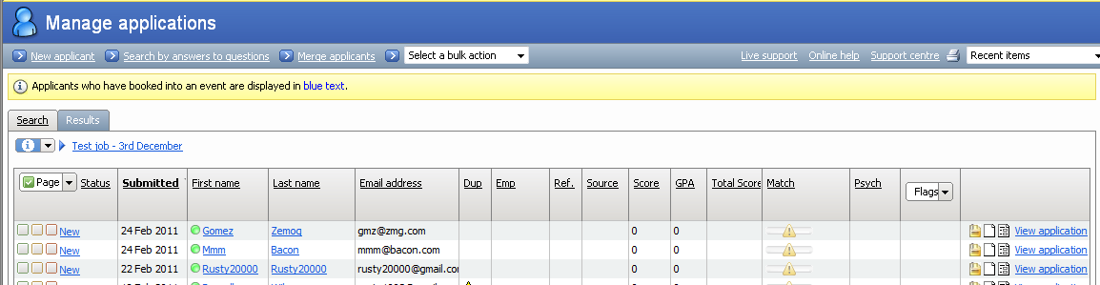

*Manage applications Columns (sRBAColumns)*

|  |  |  |
| --- | --- | --- |
| Column | Value | Description |
| Application submitted date | dApplicationSubmitDate AS Submitted | Date that the application was received. |
| Application status | sApplicationStatusDesc AS Status | Current application status of the application. |
| First name | sFName AS First name | First name of the applicant |
| Last name | sLName AS Last name | Last name of the applicant |
| Email Address | sEmail AS Email | Email address of the applicant |
| Locked to a provider | lLockProviderID AS Lock CALL ParseLockProvider(lLockProviderID) | Displays whether or not the applicant has been locked or not. |
| Duplicate applicant | sDuplicateApplicant AS Dup ORDERBY(DESC) CALL ParseDuplicate(sDuplicateApplicant) | Displays the duplication applicant flag. |
| Score | mApplicationScore AS Score | Displays the applicants score if scoring is used. |
| Source | sApplicationSourceShortTitle AS Source | Displays the source that the applicant came from. |
| Sub-Source | sApplicationSubSourceShortTitle AS Sub Source | Displays the sub source that the applicant came from. |
| Employment status | sEmploymentStatus AS Employment status CALL ParseEmploymentStatus(sEmploymentStatus) | Displays the applicant’s employment status with the client. |
| Score (automated from application) | mApplicationScore AS Score | If application scoring is used, the score is displayed here. |
| Agency applicant flagging | sReferral AS Ref. ORDERBY(DESC) CALL ParseAgency(sReferral) | Required if Agency module is purchased. |
| Additional score | mAdditionalScore AS Additional Score | If additional scoring is used, the score is displayed here. |
| GPA | mUniMarkScore AS GPA | If GPA scoring is used, the GPA score is displayed here. |
| Total Score (both automated and additional scoring together) | lTotalScore AS Score | Displays the scoring total of automated and additional scoring. |

*Available manage applications search criteria (sManageApplicationsSearchFields)*

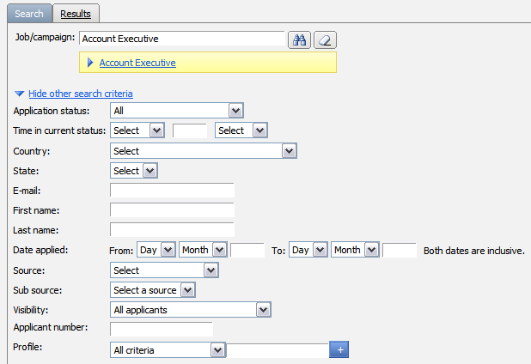

|  |  |  |
| --- | --- | --- |
| Field | Value | Description |
| Applicant number | lApplicantNumber | Allows for the searching of applicants by their applicant number. |
| Application source | lApplicationSourceID | Allows for the searching of where the application came from. |
| Application status | lApplicationStatusID | Allows for the searching of applications by their status. |
| Application submitted date | dApplicationSubmitDate | Allows for the searching of applications by the date they were submitted by. |
| Availability | lAvailabilityID | Allows for the searching of applicants by their last name. |
| Country | sCountry | Allows for the searching of which country the applicant comes from. |
| Date of Birth | dDOB | Allows for the searching of applicants by their date of birth. |
| Email address | sEmail | Allows for the searching of the applicant by their email address. |
| First name | sFName | Allows for the searching of applicants by their first name. |
| Last name | sLName | Allows for the searching of applicants by their last name. |
| Gender | bFilterByGender | Allows for the searching of applicants by their gender. |
| Onetest status | sOneTestStatus | Applicable to CML only. |
| Reference check status | bManageReference | Applicable to CML only. |
| State | sState | Allows for the searching of which state the applicant comes from. |
| Suburb | sSuburb | Allows for the searching of which suburb the applicant comes from. |
| Visibility | bApplicantVisibility | ? |

**Permissions**

|  |  |  |
| --- | --- | --- |
| Permission | Path | Description |
| Right side menu > Manage applications | Applicant section >  Review by application | Adds **Manage applications** to the right side menu |
|  |  |  |

## Applicant card / features

The applicant card is a complete summary of an applicant in the system including their personal details and application history. Different components of the applicant card are activated depending on the modules set (for example, the actions drop down against each application will vary from client to client depending on the modules they have activated, the Talent Search section will only display for clients with Talent Search activated, etc.).

The applicant card is not highly configurable and very similar amongst our clients but there are some aspects of person details that can be configured using the features below:

|  |  |  |
| --- | --- | --- |
| Feature | Value | Description |
| sPersonalDetailsFields | sAddress,sPhone,sEmail,sGender,dDOB,sNationality, sBadgeID AS Employee No, sEmploymentDepartment AS Business unit, sEmploymentManager AS Managers Name, sEmploymentStatus AS Employment status, sEmploymentDate AS Employment date, sAlternateContact AS Applicant e-mail (if agency), lApplicantNumber AS Applicant No | Sets the fields available under the ‘details’ section of the applicant card |
| sEditApplicantDisplayedFields | sTitle, sFName, sLName, sPrefName, sStreet1, sSuburb, sState, sPostcode, sCountry, sPhone1, sPhone2, sPhone3 | Sets the fields available on the **edit applicant** page (accessed from the actions drop down on an applicant card) |
| sEditApplicantRequiredFields | sTitle, sFName, sLName, sStreet1, sSuburb, sState, sCountry, sPhone1 | Sets the mandatory fields on the **edit applicant** page |
| sNewApplicantMandatoryFields | sTitle, sFName, sLName, sPrefName, sEmail, sStreet1, sSuburb, sCountry, sState, sPostCode, sPhone1, sPhone2, sPhone3, sResume, sOtherDoc1, sOtherDoc2, lJobID, sSocialSecurityNo, sPersonID | Set the **mandatory** fields on the new applicant page. The fields on this page are not configurable except for the ability to switch on and off the employment status question (next feature below). |
| bNewApplicantEmploymentStatus | True | Adds employment status dropdown to the New Applicant page. **bUseNominatedEmploymentStatus** MUST be set to yet for this feature to work. Speak to a developer before proceeding with this change as there are impacts to the client’s applicant services page. |

**Permissions**

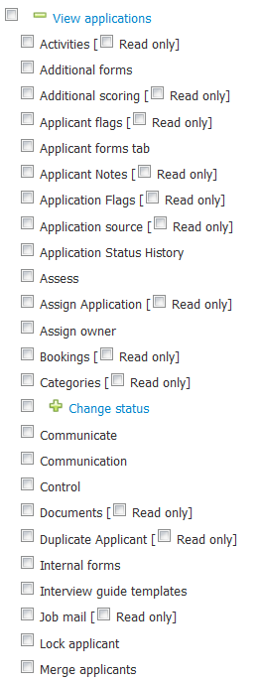

|  |  |  |
| --- | --- | --- |
| Permission | Path | Description |
| View applications – Control the applicant card  (shown above) | Applicant section >  Review by application >  View application | Under the view applications section are multiple features which determine what is / is not available on the applicant card. You also have the option to make some items available but in read only mode. |
| Edit applicant > Displayed fields | Applicant section >  Edit applicant >  Displayed fields | Determine what fields the user will have access to on the ‘edit applicant’ page from the applicant card |

## System Settings – Base

**Configuration guide**

Below are guidelines on how to configure critical items within Base - System settings. Please note that the base module has lots of functionality that needs to be switched on/off based on your client requirements. The list below is a summary of items that you need to review at a minimum as part of your Base setup.

**Application reasons**Description: The items in this list set a ‘reason’ drop down in 2 areas of the system.

1. ***Applicant*** reasons for withdrawing an application or declining an offer. E.g. Offered another job
2. ***User*** reasons for changing an applicant's statuses into an unsuccessful recruitment step. E.g. Was not a good cultural fit

Some reasons may be suitable for both applicants and users (e.g. unable to relocate) but others may only be relevant for applicants or for users (e.g. Failed medical is user specific reason)

For every reason you add into this area, set whether the reason is

* + - **Applicant specific** (i.e. options in red for when an application (1) Withdraws and application of (2) Declined an offer OR whether the reason is
    - **User specific** (i.e. option in blue for when a user (1) Changes the status into an unsuccessful style status – supported options are listed on the page below)

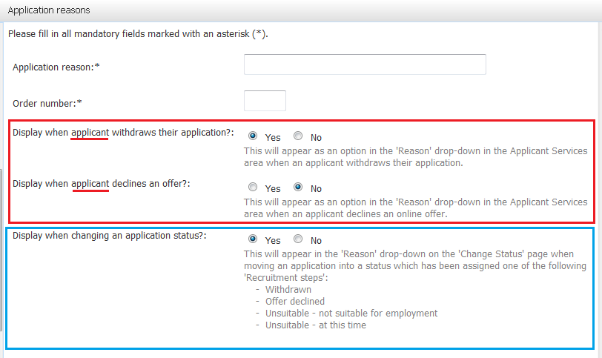

**Application sources**Description: Used to capture the source on an applications (i.e. Where did the applicant hear about the job).  
Location: *System settings > Bases > Application sources*  
Setup:

1. **Create an application source group** – Clients need at least 1 group but they can have multiple groups. Different groups should be created if the list of advertising sources is very different based on the recruitment process. E.g. Clients may have a general application source group (standard recruitment) vs. a Graduate source group because the sourcing channels for grads differ to standard recruitment (grads may have heard about the job at a grad fair, uni website, etc.).
2. **Create applications sources –** These are the high level source groups. For example (1) Internet (2) Print media (3) Referral. These are used to group the actual sub-sources
3. **Create application sub-sources and link to relevant application source groups –** For every application source you create, click the **view sub source** link to create the options for each. For example, under the Print Media application source option, you may add the sub-sources of (1) The age (2) The Herald Sun (3) The Financial Review, etc. For every source, choose with Application source group (step 1) it should belong to

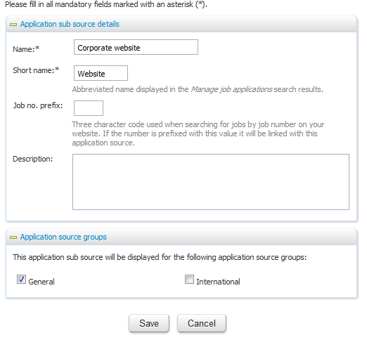

**Communication templates**Description: This is the area were ad-hoc templates that are sent outside of recruitment process communications are configured. This area consists of system communication templates (i.e. templates that are added based on modules switched on for clients) as well as client created communication templates.  
Location: *System settings > Base > Communication templates*  
Setup:

**System vs. User templates:**On the communication template page you will see a column stating the system template being used. If this column is blank, it is a user created template. System templates cannot be deleted by client SuperUsers. Below are examples of system templates

System templates need to be reviewed so that the **From address** is set to your client’s requirements (usually something like [jobs@clientname.com](mailto:jobs@clientname.com) or [careers@clientname.com](mailto:careers@clientname.com). Refer to specific modules to determine which communication templates are linked to it and when they trigger. From a configuration perspective, the default content of these emails will allow the system to function correctly, however clients can update the content if required. Highly recommend that they do not change pre=defined merge fields as they have been added to the system template for a reason.

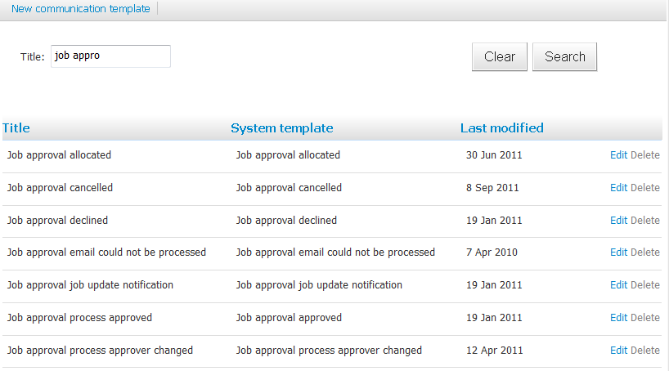

**Creating user templates**Some clients may wish to create ad-hoc communication templates prior to go LIVE. Click **new communication template** and fill in all mandatory fields. These templates will be available when users use **communicate** or **bulk communicate**.

**Flags**Description: Flags are used to set visual cues for users when reviewing applications. Flags can be manually added against applicants by users OR can be automatically attached to applicants based on their response to questions in application formsLocation: *System settings > Base > Costs > Job costs > Job cost categories*Setup: Review the flags with your clients and determine key information they want to flag about applicants to assist with the screening process. Set these wisely. Once a flag is in use, it is very difficult to change the flag without affecting historical data. Not all flags need to be set – ensure any flags you are setting can’t capture information in another way

* **APPLICANT flags –** relates to the applicant across multiple applications (e.g. ineligible to work in Aus.)
* **APPLICATION flags**– relates to a specific application, not the applicant as a whole (e.g. reference check performed)

**Job costs**Description: Allows clients to track the cost of recruitment and report on this information via PageUp PeopleLocation: *System settings > Base > Costs > Job costs > Job cost categories*  
Setup: **Create job cost categories** – E.g. Advertising costs, Agency fees, Travel, etc. Once created, users can click the symbol throughout the system to add costs against jobs

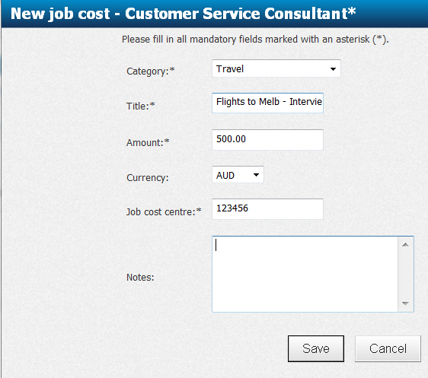

**Job statuses**Description: Job statuses indicate how far a requisition has progressed through the recruitment process.  
Location: *System settings > Base > Job statuses > new*  
Setup: Job statuses generally reflect the recruitment process steps that the client has set up. Recommend that recruitment process are created and signed off first before you determine appropriate job statuses.

Typical job statuses include (1) Pending approval (2) Approved (3) Declined (4) Sourcing (5) Screening (6) Hiring Manager Review (7) Interview (1, 2, 3 etc.) (8) Offer checks (includes things like medicals, reference checks etc.), (9) Offer made (10) Filled (11) On hold (12) Cancelled

Complete the following to create your job status

* **Title -** The name of your job status (e.g. Job approved)
* **Recruitment step -** This is used for reporting purposes. Choose a suitable recruitment step from the list (e.g. Approved)
* **Current recruitment status -** On the **manage jobs** page users can search via current status (i.e. open jobs) or non-current status (closed jobs)
* **System status -** This is PU admin access only and allows PUP administrators to set system job status.

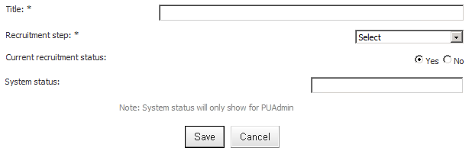

|  |  |  |  |
| --- | --- | --- | --- |
| System Job status | System Status | Description | Current recruitment step? |
| Pending | statusPENDING | Where a job generally starts – jobs awaiting approval stay in the status of pending | Yes |
| Approved | statusAPPROVED | Jobs can automatically move into this status once fully approved | Yes |
| Declined | statusDECLINED | Jobs can automatically move into this status if declined during the approval process | Yes |
| Filled | statusARCHIVE | Once a job has been filled, it moves into this status to indicate the job is closed | No |
| On hold | statusSUSPENDED | If a job was open but needs to be put on hold, this status can be used | Yes / No – depends on the client and if they want these jobs to show up on their dashboard |
| Cancelled | statusDELETED | If a job was open but needs to be completed withdrawn/cancelled, this status can be used | No |

**Privacy Statement**Description: This is the statement that applicants must agree to before they are permitted to submit an application.  
Location: *System settings > Base > Privacy statements > manage privacy statements > new privacy statement*  
Setup: Give your privacy statement a name and ensure the privacy statement type is set to Job Privacy statement

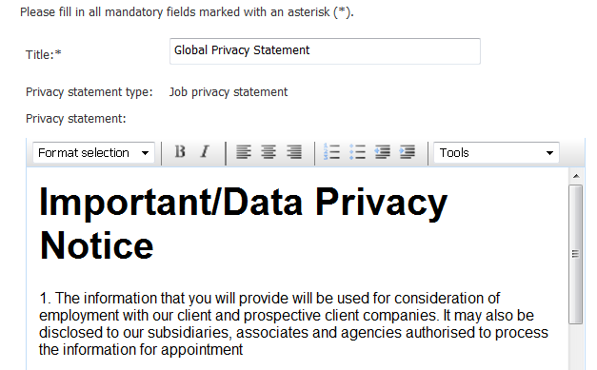

Go to *system settings > base > locations > locations* and click edit next to a location

**Option 1: Link Privacy statement to Locations**A list of all applicant privacy statements will be displayed in the **privacy statement** drop down list. Choose the appropriate statement. Every time a job card has this particular location set on the position details page of the job card, the specified privacy statement will display for applicants.

**Why choose this method?** Works well for clients that have only 1 statement across the who business OR if they do have multiple statements, different regions use different statements and there is no overlap (e.g. Adelaide is set with the Australia statement and New York is set with the US statement)

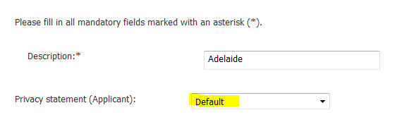

**Option 2: Link Privacy statement to Source (Now performed via FM Apply)**Go to system *settings > source management > sourcing channels > manage application forms*. You will be presented with a list of application form prefixes (i.e. the different applicant services pages that have been setup up for the client). This is typically completed when clients have multiple brands so multiple websites are created and styled differently. Click Edit against each source. From here you can set the privacy statement to display.

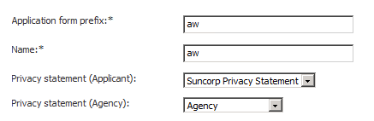

**Why choose this method?** For example – a client may have 2 different brands with 2 different privacy statements. Both use the location “Melbourne’ on their search page. By linking the statement to the source, NOT the location, both brands can still use Melbourne as a location search criteria BUT the correct statement will display based on the source of the job. Use this method if simply setting to location is not suitable.

**Job position cancelled reasons**Description: When you cancel a position on the job card (when using multi-positions), the user is asked to give a cancelled reason. This is mandatory.  
Location: *settings > base > job positions cancelled reason > New*  
Setup: Add any reasons that make sense for the client. At a minimum, suggest “No longer required” or “Position not approved”

**System Settings**Below is a summary of all of the links under system settings > base.   
  
**NOTE:** The majority of items in this area will have a default setting and not every single item needs to be reviewed and changed. The list will provide an explanation of what each item does so that you have basic understanding should specific configuration be required for your client. If in doubt, complete a master features search and see the settings for the majority of other clients.

|  |  |  |
| --- | --- | --- |
| Title in system settings | Feature (if applicable) | Description |
| Enabled: On | bBaseModule | Activates the base module |
| Offer details: On | TBC | TBC – Discussions with Product Management in progress regarding the location of these offer related items (19/01/12 – BEC) |
| Activities: On | Redundant? | Redundant – To be discussion with Product Management |
| Advanced applicant search: On | bAdvancedApplicantSearch  sAdvancedApplicantSearchDisplayedFields | Adds the **application search** link to the right side menu under **applicants**. You can also set the columns and search criteria for this page by updated the **advance applicant search settings** |
| Allocations: On | bAllocations | TBC – Completed for Coles to allow postcode search on the website |
| Applicant feedback: On | bEnableRefChecks | Allows the system to send a referral form to referees to complete – Functionality needs to be tested |
| Applicant locking: On | bApplicationLocking  lLockingExpire | Allows applicants to be locked by users. Locking expiry days must also be set so the system knows when to lift the lock |
| Application sources | n/a | Refer to Base – System settings guide above for information on application source configuration |
| Categories: 188 | n/a | This is where all categories are created. Categories are searchable applicant classifications and can be set manually by users on the applicant card OR applicants can auto categorise themselves based on answers to questions in application forms. Refer to the application form configuration guide for information on setting up categories |
| Competency framework: Off | TBC | TBC |
| Configure page fields/columns | bManagePageFields | TBC |
| Costs | sJobCostDisplayedFields | Data under **Cost Centres** populates to **lCostCentreID** on the job and offer card. Job cost categories are also set from here. Refer to Base – System settings guide above for information on job cost configuration |
| Documents | n/a | Refer to Base – Job card configuration guide above for information on documents configuration |
| Locations | bLocations  bManageLocationGroups | Refer to Job Search & Mail configuration guide for information on setting up locations/groups |
| Logout settings | bCloseWindowAfterLoggingOut  sLogoutRedirectUrl | Allow you set what happens when a user logs out – standard log our takes you back to the PUP login page (<https://admin.pageuppeople.com/default.aspx>) but some clients redirect to their own website (mainly uni clients) |
| Organisational hierarchy: 19 | n/a | Data populates to **lBrandID, lDepartmentID, lSubDepartmentID** and **lDepartmentPositionID** on the job card - Refer to Base – Job Card configuration guide for information on this configuration |
| Password settings | bAllowResetPasswordWhenExpired  sBadPasswordList  bEmailNewProviderSetPasswordLink  lDaysAdminPasswordExpiryLink  bEnhancedPasswordSecurity  sPasswordChangePeriod  lPasswordMinimumLength | Allows you to add security around passwords in the system – e.g. you can set a ‘bad password list’ preventing users creating these types of passwords, expiry the ‘reset password’ link after a specified number of days, etc. Review the items in system settings for descriptions |
| Pay scales: 12 | n/a | Data populates to **lPayScaleID**, **lPayScaleTypeID** and **lPayScaleAreaID** on the job card - Refer to Base – Job Card configuration guide for information on this configuration |
| Position Hierarchy | bPositionHierarchy  bShowPositionsWithoutTitles | TBC |
| Privacy Statements: On | n/a | Refer to Base – System settings guide for information on this configuration |
| Profiles | Search ‘profile’ in feature manager to see all the back end features for all profiles | Sets the settings for all profile questions used on the application forms. You can set which fields per profile are visible and mandatory as well as default items / maximum items |
| Recruitment processes | n/a | Base – Recruitment process guide for information on this configuration |
| Search field details | TBC | TBC |
| Show Quick Links in menu: Off | bQuickLinks  sFacebookURL  sLinkedInURL  sOtherURLs  sSeekURL  sTwitterURL | Adds an additional quick links box to the dashboard. Specific URLs can be set to appear as a quick link in this area |
| Sites: 9 | n/a | Data populates to **lSiteID** on the job card |
| Sms settings | TBC | TBC |
| Teams | bShowUsersWithoutJobs | If set to True, all users will be displayed in the teams and users column on the dashboard even if they do not have any current jobs open. Handy to set to false for clients with very large teams so that users aren’t presented with a huge list of people with no current activity |
| Update hierarchy tables from OrgUnit data: On | TBC | TBC |
| Withdraw/remove settings | bEmailOnApplicantRemove  bEmailOnApplicantRemove  bJobApplicationWithdrawalSettings | Allows you to specify if applicants will be emailed when they withdraw or remove their application/profile  **Job application withdrawal settings** allows you to prevent applicants from withdrawing an application if they have passed through a particular recruitment step. Select the steps that should prevent an applicant withdrawing if they are in the step or have passed through it – recruitment steps are linked back through to recruitment processes |
| Standard reports | TBC | TBC – Needs to be discussed with Product Management. Adds additional grad specific cube reports |
| Title in system settings | Feature (if applicable) | Description |
| Agreement types | n/a | Data populates to **lAgreementTypeID** on the job card |
| Allow paper based applications: Off | bAllowPaperBasedApplications | TBC |
| Applicant pool legacy: On | bApplicantPoolLegacy | TBC |
| Applicant visibility: On | bApplicantVisibility | Adds the **visibility** panel to the **new applicant** page so that users can create applicants visible to (1) All users (2) Them only or (3) Their team only. An eye symbol will be displayed against the applicant indicating they are hidden |
| Application reasons: 11 | n/a | Data populates to **lReasonID** on the job card. Review **Key areas of system settings** section of this guide for configuration information. |
| Archive job applicant warning: On | bShowCurrentOnArchiveJob | When closing a job, the system will prompt the user if there are any applicants in a current application step (need to ensure all application statuses within the recruitment process have current/non-current steps set correctly) - refer to recruitment process section of the base guide for further information |
| Build provider email from applicant: On | bBuildProviderEmailFromApplicant | TBC |
| Client Data Mapping | bManageClientDataMapping | TBC |
| Communication templates: 503 | bManageCommunicationTemplates | This is where all ad-hoc communication templates not attached specifically to a recruitment process live (e.g. job approval request emails, agency forgotten password email, etc.). The number of system communication templates will vary from client to client depending on the modules activated in the system.  Clients can also create ad-hoc communication templates themselves which can be sent using bulk communicate for example. |
| Companies: none | TBC | TBC |
| Current recruitment: On | bCurrentRecruitment | Adds Current recruitment stepto the “create new **job status”** page. This allows users to search for current vs. non-current jobs on the **manage jobs** page |
| Design templates: 27 | n/a | Allows clients to build ‘design templates’ for use on their website/intranet sourcing channels. Typically PUP will create these templates for clients during implementation – there is no limit to the number of templates created. Template selection is completed via the sourcing channel |
| Duplicate detection on name only: Off | bDuplicateNameOnly | Manages how duplicates are found.  **TRUE** – will flag duplicates based on name only **FALSE** – will flag duplicates based on name, postcode, DOB and phone number |
| Employee search settings | bProviderEmployeeSearchSettings | Controls the search criteria and columns on the Employee Services page (right side menu) |
| Employee Services Footer | sESFooter | TBC |
| Employee services system styling | bSystemStyling | TBC |
| Flags | n/a | Area to set ‘applicant’ and ‘application’ flags. |
| Generic Lists | bManageGenericLists | This area gives you the ability to create as many custom generic list questions as required. Refer to the job card section of the base module configuration guide for setup information |
| Generic select lists | bOtherSelectLists | 5 generic select lists were created as part of the Origin CHARM project. This can be relabelled and used on the job card |
| Industries: 1 | n/a | Data populates to **lInudstryID** on the job card |
| Integration files: 7 | TBC | TBC |
| Job position cancelled reasons: 2 | n/a | Allows you to specify a reason for cancelled a position against a job. Added via system settings |
| Job preview on sourcing tab: On | bJobPreviewOnSourcingTab | Adds the **job preview** link in the actions drop down against each open source on the sourcing tab |
| Job sectors: 2 | n/a | Data populates to **lJobSectorID** on the job card |
| Job statuses: 45 | n/a | Allows you to create job statuses - Refer to the job status section of the base module configuration guide for setup information |
| Job types: 4 | n/a | Data populates to **lJobTypeID** on the job card |
| Media player: On | bMediaPlayer | TBC |
| PageUp People Footer | n/a | Allows you to add a custom footer to the bottom of the admin system |
| Permitted File Extensions: .doc,.docx,.pdf,.txt,.rtf,.htm,.html,.msg | sAdminFileExtensionsAllowed | Extensions of files allowed to upload in Admin system |
| Primary resume: On | TBC | TBC |
| Reasons: 3 | n/a | Data populates to **lReasonID** on the job card |
| Recruitment centre: On | bRecruitmentCentre | This is a redundant feature as access to recruitment centre is now controlled via permissions. Review the dashboard section of the base module configuration guide. |
| Recruitment step settings | bRecruitmentStepDisplay | ??? |
| Recruitment steps: On | bRecruitmentSteps | ??? |
| Relocation types: none | n/a | Data populates to **lRelocationTypeID** on the offer card |
| Research applicant: On | bResearchApplicant | Adds the ‘research applicant’ link to the applicant card so that recruiters can research via social media website (e.g. Facebook, LinkedIn) |
| Revision history: On | bRevisionHistory | Enables the revision history link in the system (e.g. On the job card) |
| Roles: 115 | n/a | Data populates to **lRoleID** on the job card |
| Skill types: none | n/a | Data populates to **lSkillTypeID** – can be added to the website for searching purposes but unable to find a client who does this – test before use |
| Targets | TBC | TBC |
| Time to fill |  | Allows you to set time to fill settings for reporting purposes. Important for clients who implement **Online Requisition** as they can set TTF to commence from date job opened OR date job approved. |
| Trigger job status change: On | bTriggerJobStatus | Allows the ‘update job status’ option to display on the ‘new application status’ page so that users can be prompted to update job statuses at certain points in the process |
| Upload Purchase Order Information | TBC | TBC |
| View document before virus scan: Off | bViewDocBeforeVirusScan | Should be set to false – If true, users are able to download documents form the system prior to the virus scan being completed. Virus scan does not occur in the UAT environment so you may want to switch this ON during testing so users can open uploaded documents |
| Work day availabilities: | n/a | Data populates to **WorkDayAvailabilityPreference** on the job card |
| Work types: | n/a | Data populates to **lWorkTypeID** on the job card AND Work type search criteria on website/intranet sourcing channels |

**Permissions**

|  |  |  |
| --- | --- | --- |
| Permission | Path | Description |
| System settings  (example below) | System settings section >  General settings | This section of permissions allows you to give users some access to system settings without giving them full SuperUser access. When logged in, the user will see **system settings** in their right side menu but it is a shorter version, not grouped by module as shown to the left. Each of the items under **general settings** links to a specific configuration page in system settings. |
| System settings > Update personal details | System settings >  General settings >  Update personal details | One field that you may switch on for your clients is the ability for users to update their personal details (including password) from the dashboard. To activate, ensure **System settings** section is ticked on – untick all of **general settings** and then tick **update personal details** only**.** This will activate the update profile link at the top of the right side menu without giving users access to system settings. |

**Configuration audit**

|  |  |  |  |
| --- | --- | --- | --- |
| # | Task to Complete | Owner | Status |
| 1 | **Initial feature set up –** Have you updated all email / URL specific features as per the Base Guide – once-off feature setup? |  |  |
| 2 | **Job card -** Once all fields have been configured, have you tested that you can create and save a job card successfully? |  |  |
| 3 | **Job card -** Review all drop down and look up fields – have all been populated with data as required? |  |  |
| 4 | **Job card - Multi-positions –** Create a test job with 2 positions and save. Re-open the job and ensure the two positions you entered are saved. If the positions have cleared, you need to remember to activate the feature **bMultiJobPositions** |  |  |
| 5 | **Recruitment process** (including communication templates) complete |  |  |
| 6 | **Incomplete application settings** – Configure against each individual recruitment process |  |  |
| 7 | **Application source groups / Application sources** – Configure and check your recruitment process has an application source group attached |  |  |
| 8 | **Costs > Job costs –** Will your client need to capture job costs for reporting? If so, job cost categories need to be configured |  |  |
| 9 | **Document categories –** Add additional document categories required by the client (outside of the default) |  |  |
| 10 | **Privacy statements –** Configure at least 1 privacy statement and link to either locations or source based on requirements |  |  |
| 11 | **Application reasons –** Configure both applicant and user reasons |  |  |
| 12 | **Communication templates** – ensure these have been reviewed and From address are updated to reflect your clients email. |  |  |
| 13 | **Flags –** Flags are set in system settings and automatic flags are set up in application forms as required |  |  |
| 14 | **Job position cancelled reasons –** Add reasons as required |  |  |
| 15 | **Job statuses –** Configure and set prompts to change job status against relevant recruitment processes |  |  |
| 16 | **Google Analytics –** Has this been set up. Refer to Google analytics set up guide |  |  |

**Frequently asked question**

**Q: ADD  
*A:*** *ADD*

**Q: ADD  
*A:*** *ADD*

**Q: ADD  
*A:*** *ADD*

# 

# Application Form Builder

**Description**

This module allows the user to create multiple and custom initial application forms for applicants to complete when they apply to a job. For every source a job is advertised to, the user can select the application form that applicants will complete. The answers submitted in application forms can be made “smart” and searchable using rules, flags and categories.

**Related documents**

|  |  |
| --- | --- |
| Document | File location |
|  |  |
|  |  |

**Acronyms, Terms and Definitions**

|  |  |
| --- | --- |
| Acronym/Term | Definition |
|  |  |
|  |  |

**Once-off features (mandatory)**

|  |  |  |
| --- | --- | --- |
| Feature | Value | Description |
| bFormBuilder | True | Activates right side menu item manage forms where users can create initial application forms |
| bRetireFormBuilderItems | True | Activates the ability to retire questions on the application form (can be set on a question by question basis). Questions no longer required on a form are archived, never deleted or you will lose historical data |
| bUpdatableQuestions | True | Activates the ability to allow applicants to update specified questions following submission (can be set on a question by question basis in all forms) |

**Optional Features**

|  |  |  |
| --- | --- | --- |
| Feature | Value | Description |
| bEnableHiddenAnswers | True | Allows you to hide the answers provided by an applicant on a particular page within a form when reviewing the application. These answers can be pulled into a report instead. Should be used when information is required for reporting, not selection purposes |
| bAdditionalScoring | True | Ability to provide additional scoring of the application form. |
| sItemTypes | Value - See table below | Enables the below ‘**custom question’** types in application forms. Standard custom questions are set by default but this feature lets you add additional custom questions as required |

**System Scoping**

|  |  |
| --- | --- |
| Scoping question | Possible Outcomes |
| How do your applicants currently apply for roles? | Understand how your client currently captures information from applicants. What kind of information do they capture? Does the client wish to replicate current paper based forms online? How will you need to tweak questions to suit an online application? (E.g. online allows for conditional questions so that applicants only see what is relevant). Collect any forms currently in use by the client to get an understanding of the type of information collected. |
| Do you have different application forms/questions for different types of roles? | Do all applicants complete a generic application form with high level and generic questions or does the client have tailored forms for different roles? What base information is captured across all applicants (e.g. eligibility, education history, etc.)? This information should be consistent across all forms and then role specific information added as required to individual forms. |
| Are there any eligibility rules we need to consider – i.e. are there certain roles where you must be a resident or have a work permit to be considered for employment. Anyone who does not meet this will be automatically made ineligible? | Ineligibility rules will need to be incorporated into your forms but use with caution – knock out questions should only be used if a certain response to a question will 100% rule you out for a role. If you are going to use knock outs, the questions need to be very clear so that applicants do not accidently knock themselves out because of misinterpretation |
| Is there any information you need to ask applicants for reporting purposes only – e.g. Equity and Diversity | Hidden questions may be required along with reporting codes. Hidden questions mean answer to E&D questions will be hidden on the applicant card. Reporting codes allows the questions to be available in the *applications* data view. |
| What information needs to be mandatory versus non-mandatory | If clients start to create very long forms with lots of non-mandatory questions, this needs to be discussed. What is the information being used for? If the question is non-mandatory it may be missed by applicants (and again, if the client says ‘that’s ok’ question why it’s being asked in the first place”. Forms need to be concise for the applicant but detailed enough to provide recruiters will the information they need to screen successfully. |

**Configuration guide**

**How does the module work?**

Finalising content of application forms can be a difficult task for clients. You need to balance the applicant and recruiter experience. Application forms need to

1. Provide the recruiter enough information to screen their applicants and move to the next phase of recruitment
2. Provide enough information to review the applicant for other potential roles in the future
3. Be concise and straight forward for the applicant to complete.

**Standard application process**

1. **Applicant searches for a job and clicks APPLY (standard – all clients)**The applicant services area will appear (this is where applicants complete applications, update their personal details, etc.). The first thing the applicant will see is a privacy statement which they must agree to before they can proceed. The content of the privacy statement can be tailored to the client’s requirements.’

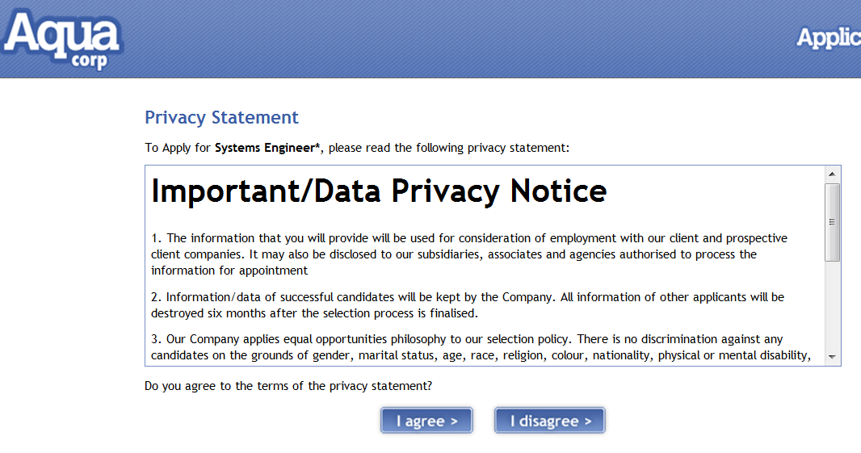

1. **Begin job application (standard – all clients)**The application will be asked to enter in their email address to start their application. If the applicant already has an account, the system will prompt them to enter their password.

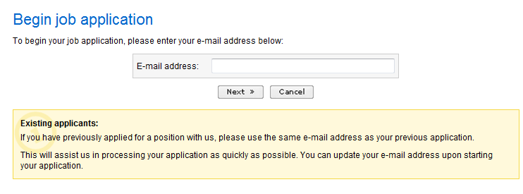

1. **Save time on your application (requires the Talent Search module)**With the Talent Search module, applicants are asked to upload their resume or log into LinkedIn so that the application form can be pre-populated using our Artificial Intelligence technology (Burning Glass). This step is optional for applicants and cannot be featured to be mandatory.



1. **Personal Details (standard – all clients)**A generic personal details page is presented for applicants to complete. This will be the first page of any application process, regardless of the application form that has been selected by the user at the time of sourcing. As this information is standard, clients do not need to configure personal detail information within the tailored application forms.

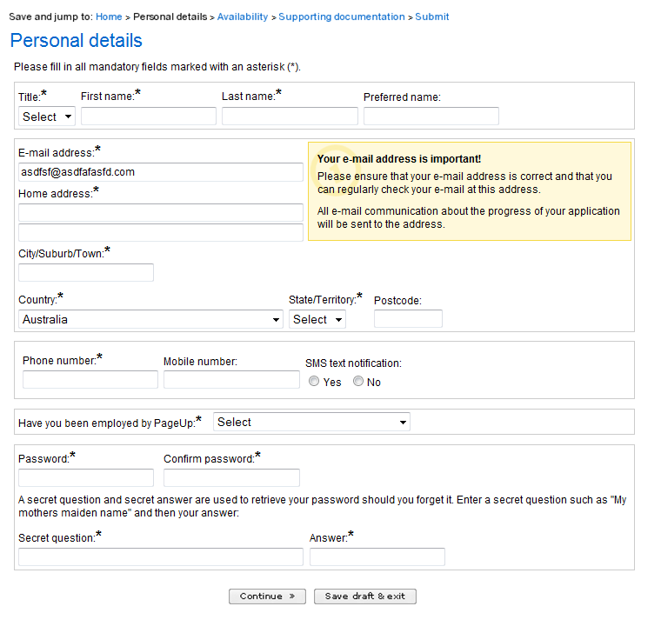

1. **Application form begins (tailored for each client)**Once the applicant completes the personal details page, the actual application form questions configured by the client will appear.
2. **Submit page (standard – all clients)**Once all mandatory questions in the application form have been completed the applicant will be presented with the Submit Application page. They will be asked to complete the question “How did you hear about this job?” – please review Base – Application sources for further information.

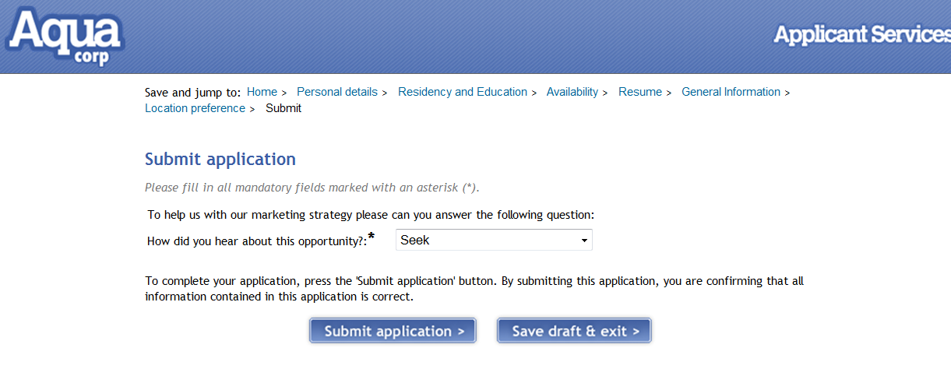

**Configuring an application form from scratch**At a minimum, 1 application form needs to be created for your client. Whenever you source a job to the website/intranet/seek/ etc. the user will be asked to select an application form for that source.

**Step 1: Create and name your initial application form**  
From the right side menu click **manage forms > new form.****NOTE:**

* The list of available forms will differ from client to client based on the modules they have activated. The form type relevant to this module is the **Initial application form.**
* You need to select the form type before giving it a name. If you name the form first, this will be deleted when you select the form type.

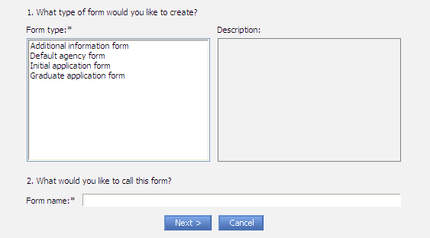

**Step 2: Create pages within your form**Once your form is created, you can create multiple pages within the form. This is a good idea because it means the information is broken down into small chunks (instead of having one very long page with lots of questions). Pages can be titled however the client wishes but typically clients use page titles such as (1) Education history (2) Employment history (3) Document uploads, etc.

The title you give to a page will also be used as a bread crumb in applicant services. In the example below, this application form as 2 pages (excluding personal details and submit which is generic across all forms and clients). These pages are (1) Availability (2) Supporting documentation.

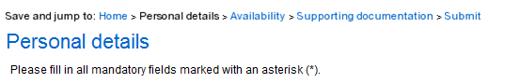

**Step 3: Create application form questions using profile or custom questions**Profile and Custom questions are the 2 styles of questions available for use when creating initial application forms.

**Profile questions** allow users to build a form from existing content in order to facilitate building an applicant profile, or history, so they can best be matched to current jobs as well future jobs. There are 8 profile questions available:

|  |  |
| --- | --- |
| Profile question title | Description |
| Education | Allows applicant to select from a variety of education related options, such as institution, qualifications, results and years attended.   There is a default of three 'Education type' fields with the ability to add more. |
| Employment | Allows applicant to select from a variety of employment related options, such as job title, company, parent company, work dates, responsibilities, roles, etc.   There is a default of three 'Employment status' fields with the ability to add more. |
| Salary | Applicants can detail their salary expectations and requests, as well as current salary information |
| Residency | Applicants must respond as to their authorisation to work legally in the job's location. Can also include specific work Visa information. |
| Availability | Allows applicants to select various work availability options, such as 'Full time' or 'Part time', Commencement dates, available days, minimum or maximum hours or any other relevant information that might affect the applicant's employment status |
| Language | Applicants can detail any relevant language skills, including reading and writing proficiency |
| **Licences | Allows applicants to details any relevant licence information that may relate to a job application, such as a driver's licence, etc.   Licences are configured in System settings > Licences. |
| **Location preference | Allows applicant to select the location(s) that they would prefer to work in when applying for a job as a first or second preference. List is based on the locations in the system used for job search purposes. |

*** **NOTE:** You can configure the **data** that appears for the licences and location preference questions. Go to system settings > base > profiles > licences OR system settings > base > locations to see the data that will appear for these questions. All other data that appears in the questions above (e.g. list of degrees in the education profile questions) are managed via PageUp People tables that are shared across all clients. Any requested changes to this data will affect all clients and requires product approval.

* **PROS -** These questions are completely set up for you and don’t require major configuration. The questions are also searchable without needing to configure them to be searchable.
* **CONS** – We can hide fields within each question and make some fields mandatory/non mandatory BUT we can’t change the labels or order. These are set and shared amongst all of our clients.
* **How to edit what is/isn’t visible** – go to system settings > base > profiles. You will see a list of profile questions and graduate profile questions. Click on each profile question to set what is/is not visible and what is/is not mandatory.

**NOTE:** Clients should be encouraged to use profile questions. If they do no use any profile questions, the power of Talent Search is reduced. Talent Search works best when users can combine search criteria, one of these being profile questions.

**Custom Questions -** Custom questions allow you complete control over the content of a particular question. They are ‘question types’.

* **PROS –** You can create any type of question you like and ask applicants to provide specific responses. There is little restriction on what can be created.
* **CONS** – They take a little more time to create AND you must add categories, rules and flags to responses to make them searchable

Custom questions available in application forms (set via sItemTypes)

|  |  |  |
| --- | --- | --- |
| Custom question | Value | Description |
| (default value) | sAttributeValCombo | Select list (one item answer) |
| (default value) | sAttributeValText | One line text answer |
| (default value) | sAttributeValTArea | Multi-line text area |
| (default value) | sAttributeValTAreaLarge | Multi-line text area |
| (default value) | sAttributeValTextGroup | Text field group |
| (default value) | sAttributeValPlainText | Instructional text (supports formatting and links) |
| (default value) | sAttributeValTitle | Section title |
| (default value) | sAttributeValSubTitle | Section subtitle |
| (default value) | sAttributeValCheckBoxes2 | Multiple selection boxes (DO NOT USE FOR Yes/No answers) |
| (default value) | sAttributeValDMYCombo | Date |
| (default value) | sAttributeValFile | File upload (configure file types by editing question) |
| (default value) | sAttributeValUniDet | List of universities (only use if profile education question not on form) |
| (default value) | sAttributeValUni4 | Uni results – use in conjunction with ‘Universities’ (only use if profile education question not on form) |
| (default value) | sAttributeRadioRank | Survey radio buttons (needed for survey module) |
| (default value) | sAttributeValCountryItem | Country look up |
| (default value) | sAttributeValRadioItem | Radio buttons – use for Yes/No questions or as an alternative to the select list |
|  | sAttributeValSocialSecurityNo | Used to capture national ID’s (e.g. social security, passport no. etc.) turn on bSocialSecurityQuicksearch to search number like an e-mail address from Quick search |
|  | sAttributeReferees | Profile type question to capture referee details (good for retail/junior roles/grad) |

**Default value for sItemTypes:**sAttributeValCombo, sAttributeValText, sAttributeValTArea, sAttributeValTAreaLarge, sAttributeValTextGroup, sAttributeValPlainText, sAttributeValTitle, sAttributeValSubTitle, sAttributeValCheckBoxes2, sAttributeValDMYCombo, sAttributeValFile, sAttributeValUniDet, sAttributeValUni4, sAttributeRadioRank,sAttributeValCountryItem,sAttributeValRadioItem

**Speeding up the application form creation process**  
Once you start to create application forms, you can use these tools to speed up the configuration time required to create multiple forms

* **Copy application form**

Once an application form is created, you can use the ‘create a copy’ link next to the form to create an exact replica of the form (i.e. all questions, conditional questions, rules, scores, flags, etc. will be copied over to the new form).

* **Import existing pages within a form**Once an application form is created, you can import pages from existing application forms into another. Very handy for when you need to create application forms with generally the same information but with minor tweaks. This ensures consistency were possible amongst all applicants.

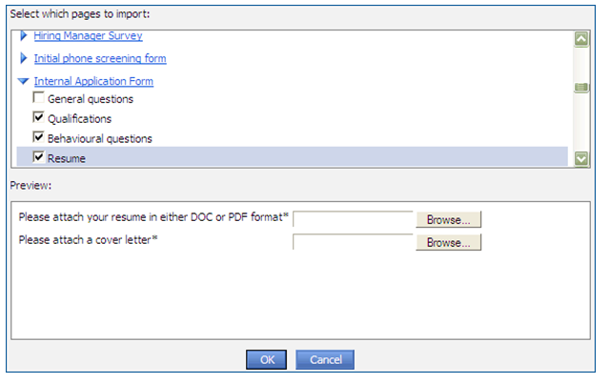

**Making application forms “smart”**Application forms are a tool for recruiters to use during their initial screening of applicants. It is important that the forms are as smart as possible by using the tools below

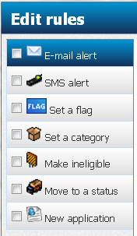

To set a rule against a profile question, click **edit** next to the applicable response within the custom question – the options above will be displayed

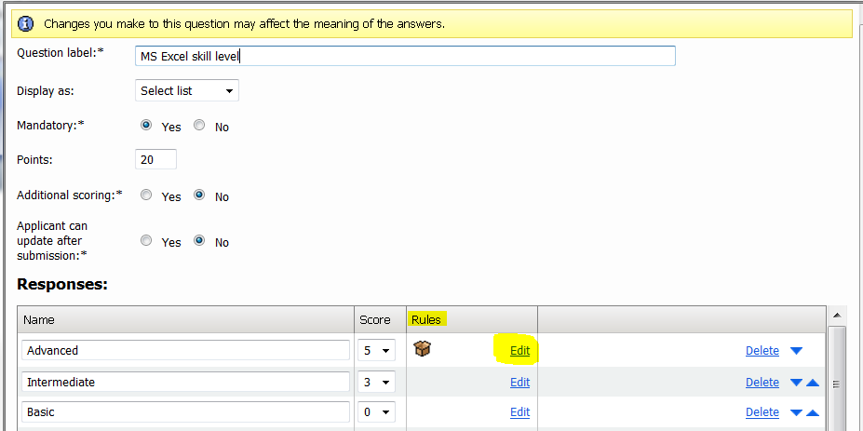

**Flags – Set a rule**Located in **system settings > base > flags.** Flags can be set against responses to questions as shown above.

* Clients have access to **10 applicant** flags (i.e. related to the actual applicant regardless of the job they have applied for such as a “visa” flag)
* Clients have access to **10 application** flags (i.e. related to a particular job that has been applied to such as a “medical passed” flag)
* Clients can label their flags anything they like – what’s important is that the flag makes sense to them. Flags are visible via manage applications and on the applicant card and can also be searched on in Talent Search.

**Categories – Set a rule**Categories are a good way to make custom questions searchable but do require some time to set the categories up and apply to questions. Ensure you complete this item with care as it’s easy to add an incorrect category if you are not paying close attention.

* **Step 1:** Create your question and corresponding answers

*Example:**Where are you willing to relocate to?*

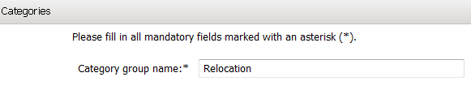

* **Step 2:** Create your category group and categories

*Example:**Category group = Relocation*

*Example:**Categories = Melbourne, Atlanta, Beijing*

**How:** System settings > base > categories > manage category groups > new (create the group)

**How:** Go to system settings > base > categories > new (to create the categories under the group). The system type should remain as NONE.

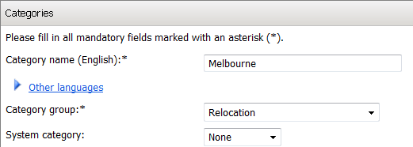

* **Step 3:** Add your new categories to your original question

**How:** Go back into your question and click **edit** next to each response that needs a category set. Check the **set a category** rule, search for your category group in the list and click **add** against the category to be set

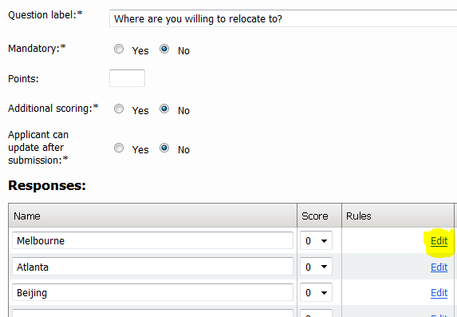

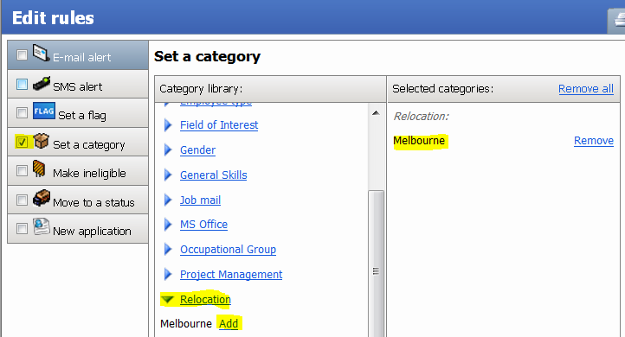

**Handy tip:** once you have set all of your categories, go to right side menu view reports > additional reports > [Form builder > Rules to set categories](https://adminint.pageuppeople.com/v5.3/provider/manageReports/BlackBoxReport.aspx?sData=p9UZroh6%2F%2BtrL5IMbq1WzAfN6ZNhk4Sg02pepnX6DpwOHFR8BPzxGVDIQd8xraN93zsKLUZHEk8%3D). This will show you on one page all application form questions that have categories set so you can ensure the task is completed correctly.

**New application – Set a rule**Is it possible to move applicants who apply to one job or campaign into another job or campaign via the **new application** rule.

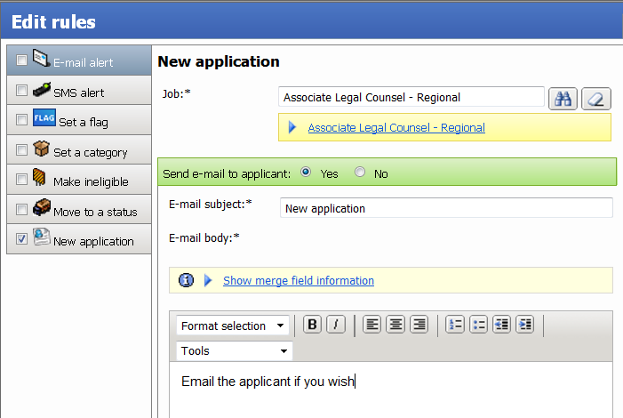

**Important things to note:**

* The applicant will be applied to (1) The original job they applied to and (2) The new job they have been automatically applied to via the above rule
* Applicants can only be auto applied to 1 other job or campaign per application form. If you use a checkbox style question for example and try to add new application rules to each option, it will appear to work when you set it up BUT it will only apply the applicant to the first rule set.
* You have the option to email the applicant if you wish but it is optional

**Make ineligible vs. Move to a status – Set a rule**

These rules are most commonly used when a client wants to make someone automatically ineligible for work rights reasons.

* **Make ineligible –** as soon as the applicant enters a response that makes them ineligible and they click to the next screen, a popup will appear telling then them are ineligible. They will move into this status and will be unable to complete their applicants any further.
* **Move to a status –** as above, once the applicant enters a response with a rule set, they will move into the set status BUT they will be able to complete their application and will not know this rule has happened in the background. Clients will often add a delayed unsuccessful email in these scenarios.

**Hidden Answers**Hidden answers are predominantly used when clients would like to capture information from their applicants that is not necessarily related to the selection process – e.g. Equity and Diversity information. Applicants can be asked information up front but when users review the application form, the answers to these questions are hidden and are only accessible via a report (only once reporting codes have been added to the questions).

If hidden answers are enabled, a yes/no radio button will appear on each page of your application form asking if you would like to hide all answers on the **page.** Hidden answers work on a page by page basis, not question by question basis.

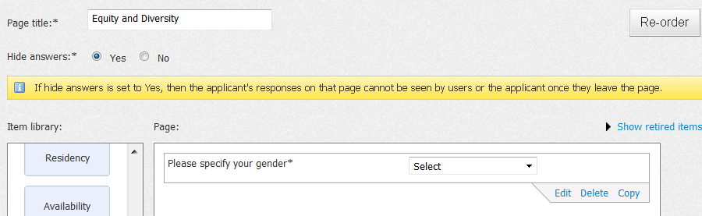

The answers to these questions which has reporting codes behind them are located in the **applications** dataview. Please refer to the Management Reports module guide for information on reporting codes.

**Scoring**Application form scoring is typically used for graduate application forms (where applicant volumes are quite high and scoring assists in filtering top applicants). Please refer to the PageUp people Online Help guide for more information if your client wishes to use this functionality.

**Permissions**

|  |  |  |
| --- | --- | --- |
| Permission | Path | Description |
|  | Jobs section 🡪  Form designer | Activates Manage forms in the right side menu |

**Configuration audit**

|  |  |  |  |
| --- | --- | --- | --- |
| # | Task to Complete | Owner | Status |
| 1 | Have all required application forms been created? |  |  |
| 2 | Have custom questions been configured to contain relevant flags, categories and other rules? |  |  |
| 3 | Have you added all relevant categories and checked them via the category report – it is better to add more categories that may not be used than to leave them to help future proof future talent search requirements |  |  |
| 4 | Spell check – application forms are public facing so copy and paste your forms into word and perform a final spell check |  |  |
| 5 | Hidden questions – if the client is reporting on equity and diversity you need to ensure the questions are hidden (if required) and importantly, reporting codes are set |  |  |
| 6 | Have you used a combination of profile and custom questions? Profile questions are closely linked to Talent Search. Clients who do not use profile questions will not be able to search for this information reducing the effectiveness of Talent Search. Clients do not need to use ALL profile questions but should use a few at a minimum and explained the consequences on Talent Search if the questions are not used. |  |  |
| 7 | Have you sourced a job and completed an end to end application, ensuring the test applicant is added to the system as NEW |  |  |

**Frequently asked question**

**Q:** **Can I make the ‘Save time –upload your resume’ page mandatory**  
**A:**  *No, this is optional and cannot be featured to be mandatory.*

**Q: Can I hide the LinkedIn upload button from the ‘Save time – upload your resume’ page?**  
**A:** *No, this is on by default when you have the Talent Search module*

# Bulk Activities

**Description**

The bulk activities module allows for the performing of applicant and application processing functions in a bulk manner. The bulk activities can be tailored to show only the required bulk action items that the client requires. The below screenshot is a screenshot of all of the bulk activity items that can be enabled on the manage applications page.

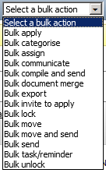

**Related documents**

|  |  |
| --- | --- |
| Document | File location |
|  |  |
|  |  |

**Acronyms, Terms and Definitions**

|  |  |
| --- | --- |
| Acronym/Term | Definition |
|  |  |
|  |  |

**Once-off features (mandatory)**

**NOTE:** Although all bulk activities are optional, we recommend that everything is set to TRUE and only actions specifically requested by the client to be switched off are updated.

Features marked with ** can be hidden via permissions. All other bulk actions are on by default and cannot be permissions off.

|  |  |  |
| --- | --- | --- |
| Feature | Value | Description |
| bBulkActivities | True | Activates the bulk activities module |
| bBulkApply | True | Activates *Bulk apply* |
| bBulkCategories** | True | Activates *Bulk categorise* |
| bBulkAssignApplication | True | Activates *Bulk assign* |
| bBulkCommunicate** | True | Activates *Bulk communicate* |
| bBulkPrint | True | Activates *Bulk Compile and Send* |
| bBulkDocumentMerge** | True | Activates *Bulk document merge* |
| bBulkExport** | True | Activates *Bulk export* |
| bBulkInviteToApply | True | Activates *Bulk invite to apply* |
| sWebsiteURL | <http://clientsCNAME>/  OR  http://clientsdns.clients.pageup.com.au/ | Must be activated for Bulk Invite to apply to function |
| bBulkLock | True | Activate bulk lock. Must also set lLockingExpire |
| lLockingExpire | Value | Must enter a number in this field for Bulk Lock to work (i.e. number of days before the lock expires. |
| bBulkMove** | True | Activates *Bulk move* |
| bBulkMoveAndSend | True | Activates *Bulk move and send* |
| bBulkSend | True | Activates *Bulk send* |
| bBulkTask | True | Enables Bulk task when Talent Management is turned on. |

**Optional Features**

|  |  |  |
| --- | --- | --- |
| Feature | Value | Description |
| sBulkOfferDetailsFilter | Value | Specifies the fields that will display on a bulk offer – requires the offer module. Review the offer module guide for more information. |
| sBulkContractOfferDetailsFilter | Value | Specifies the fields that will display on a bulk offer (contract offer card)– requires the contractor - base module. Review the offer module guide for more information. |

**System Scoping**

Configuration for this module is limited – it’s just a matter of given access to bulk actions

|  |  |
| --- | --- |
| Scoping question | Possible Outcomes |
| Is there a need for users to ‘lock’ applicants when they are being reviewed? This is generally the only bulk action a client may wish to switch off | Some clients like to lock applicants so that they are not pursued by other recruiters/business units while in the middle or recruitment. Switch locking off if required |

**Configuration guide**  
 **How does the module work?**When viewing applications, you can select multiple applicants via the checkboxes on the manage applications page and then selecting a bulk action to perform on your selected applicants.

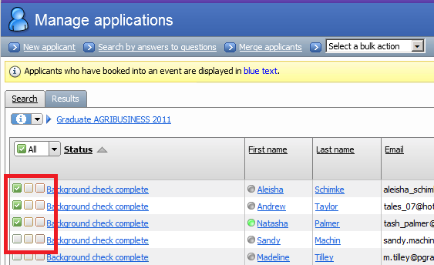

The checkboxes come in 3 colours – green, amber, red. Applicants can be sorted into the 3 buckets and a bulk action performed on each bucket. For example, if we use ‘bulk move’ to change an application status, we may decide that all applicants in green move to interview 1, all applicants in yellow move to ‘maybe’ and all applicants in red more to ‘unsuccessful’. The buckets can mean whatever the clients want them to mean – they are just a way of categories people in buckets so that bulk actions can be performed in one step.

**Useful functionality –** When you are reviewing an applicant card, the checkboxes appear in the top right corner. You can set applicants into a coloured bucket and the system will remember your selections when you go back to the manage applications screen. You can then perform your bulk action as per the notes above.

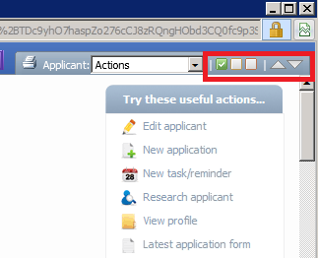

**What does each bulk action do?**

* **Bulk apply –** Allows the user to bulk apply applicants to another job.
* **Bulk categorise:** Allows the user to add categories in bulk across multiple applicants
* **Bulk assign –** Allows the user to bulk assign applications to another user.
* **Bulk communicate –** Allows for the bulk sending of an email to applicants. Please note that there is also the option to export to excel the details of the applicants that you’ve selected as part of the bulk communicate function as well as specifying a limit for bulk SMS sends.
* **Bulk compile and send –** Allows the user to bulk compile applicant documents into a PDF and send these to a user in one action
* **Bulk document merge –** Allows the user to bulk merge documents for applications. To enable, the following two features need to be enabled:
  + bBulkDocumentMerge
  + bDocumentCategories
* **Bulk export –** Allows the user to bulk export applicant personal details and applicant forms into excel. Once the bulk export is completed, a task will be created and accessible on the dashboard. After a few minutes, there will be a link to the export.
* **Bulk invite to apply** – Allows for the inviting of applicants in bulk to apply for other roles. To enable, the following steps need to be taken:
  + Enable the feature of **bBulkInviteToApply**
  + Add the client’s website to the feature of **sWebsiteURL.** If this is not completed, the link that the applicant clicks on in the email will not work.
* **Bulk lock –** Allows for the bulk locking of applicants. To enable, change the feature to on. You must also set a locking expiry date or bulk lock won’t work. The feature is **lLockingExpire.** This does not affect single lock.
* **Bulk move –** Allows the user to move applicants into another application status.
* **Bulk move and send –** Performs a bulk send followed by a bulk move.
* **Bulk send –** Allows for the bulk sending of applications to another user.
* **Bulk task/reminder –** Allows the user to send a task/reminder regarding multiple users
* **Bulk unlock –** Allows you to unlock a previously locked applicant

**Permissions**

|  |  |  |
| --- | --- | --- |
| Permission | Path | Description |
|  | Applicant section 🡪  Review by application 🡪 | This will show or hide the bulk actions from the manage applications page. Some bulk actions cannot be permissions offer (as per the feature manager section above). This means that these bulk actions will display to users who have access to manage applications. |

**Configuration audit**

|  |  |  |  |
| --- | --- | --- | --- |
| # | Task to Complete | Owner | Status |
| 1 | Confirm that **Bulk lock** and **Bulk invite to apply** are functioning correctly. All other bulk actions are standard functionality only requiring the feature to be activated. The above bulk actions require multiple features to be set and should be tested |  |  |

**Frequently asked question**

**Q:** Bulk lock is not working?  
**A:** *Have you set a value in lLockingExpire. This is required to work.*

**Q:** Bulk invite to apply is not working?  
**A:** *Have you set a value in sWebsiteURL. This is required to work.*

# Internal Form Builder

**Description**

Creates a library of forms specific to the applicable steps that form part of the recruitment process; such as phone screens, reference checks or any additional information you would like to capture and store against an applicant.  
  
**Related documents**

|  |  |
| --- | --- |
| Document | File location |
|  |  |
|  |  |

**Acronyms, Terms and Definitions**

|  |  |
| --- | --- |
| Acronym/Term | Definition |
|  |  |
|  |  |

**Once-off features (mandatory)**

|  |  |  |
| --- | --- | --- |
| Feature | Value | Description |
| bInternalForms | True | Activates this module – Activates the ‘new form’ drop down in applicant actions on the applicant card AND allows internal forms to be created in manage forms. |
| sInternalFormTypes | Add the following:  *referenceCheckForm, phoneScreenForm, genericInternalForm* | This will activate (1) Reference Check Form (2) Phone Screen form and (3) Other internal forms as form options under manage forms. Must be used in conjunction with bInternalForms |

**Optional Features**

|  |  |  |
| --- | --- | --- |
| Feature | Value | Description |
| bAdditionalForms | True | Enables the ‘form’ drop down on the application status page within recruitment processes. You can set a status to trigger the sending of an additional form – when an additional form is completed, you can also set the application status the applicant should move into once the form is completed |

**System Scoping**

|  |  |
| --- | --- |
| Scoping question | Possible Outcomes |
| Does your recruitment team currently use set templates to conduct phone screen and reference check forms? | Yes and the client wants to continue using them – client to supply forms for configuration into the system |
| How are phone screens and reference checks currently conducted? | Discuss how the forms will be completed – Users have two options (1) Open the form in PUP and type directly into the forms (2) Hand write forms and type into the PUP online form later (3) Hand write forms, scan and upload into PUP later. Option 1 is the most efficient way by all options are available depending on the client’s process |

**Configuration guide**  
 **How does the module work?**Users are able to add ‘internal forms’ (i.e. phone screens and reference checks are the most common) to an applicant card. Some users open the forms straight from the system and type in responses as they conduct the phone screen or reference check. Others prefer to print these forms and upload them into the system after a face to face interview. Both options are available (thought option 1 is less work for the user)  
  
**There is a long list of forms in the system - What forms are available to clients with this module?** There are a number of forms that can be created in the system they are based on having certain modules activated. Below is a list of the forms available and the module required to activate the functionality:

|  |  |
| --- | --- |
| Form | Module required |
| Additional Information Form | Offer module |
| Job Feedback Survey | Survey module |
| Initial Application Form | Application Form Builder module |
| Graduate application form | Application Form Builder module |
| Interview guide template | Interview Guide Builder module |
| Interview guide | Interview Guide Builder module |
| Other internal form | Internal Form Builder module |
| Phone screening form | Internal Form Builder module |
| Reference check form | Internal Form Builder module |
| Applicant feedback form | TBC – Will be LIVE in Feb 2012 |
| Survey form | Survey module |

**How do I create internal forms?**

Click on manage forms > new form and select the form type you would like to create. A brief description will be shown to explain the type of form you have selected.

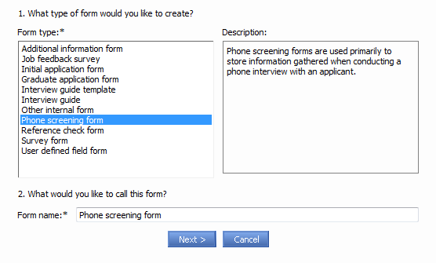

**Question types:**

The functionality to create new forms is very similar to that of creating new initial application forms except **profile questions** are not available for use (as these are really relevant at the initial application phase). Question types available are as follows:

* *Reportable question*

Common questions used on the type of form you have selected. Reportable questions are added by default to every internal form type. If they are not required you can delete them. – (Bec) May be a report somewhere pulling this information but have never seen it before and support are not aware of such a report - I bvelieve this is old functionality no longer in use. Show in grid also seems to be related to this and my no longer be relevant. Further investigation with the development team required.

* *Custom questions*

Question types that can be added to your form so that any client specifc questions can be created – use question types such as drop down list, free text fields, etc to create the form as required (for more information on custom questions, please refer to the **application form** **builder** guide in this document)

**Attaching a form to an applicant card**Once your internal forms have been created, you can attach this to your applicant cards

**Step 1:** Go to the relevant Applicant card and locate the 'Applications' section.

**Step 2:** Click the 'Actions' drop down list next to the relevant application (additional forms are added against jobs, not the applicant as a whole – i.e. you may have different reference check forms for example for different jobs the applicant has applied to). Click new form

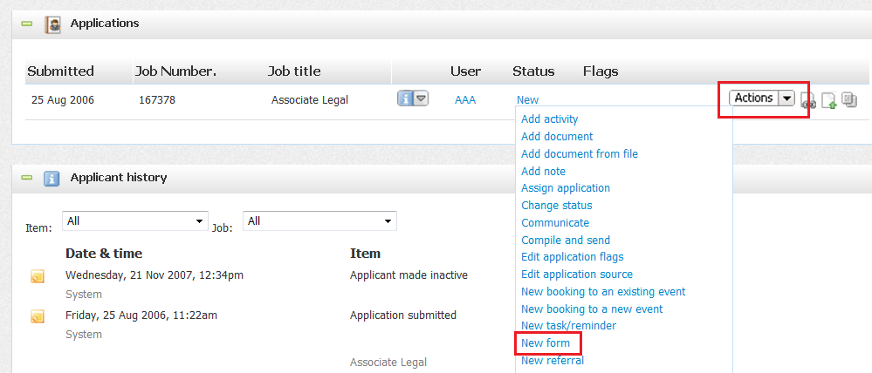

A listing of all additional information forms that exist in the system will be displayed. Click on the name of any form to see a preview in the Form **preview** panel. When you have found the form you wish to add to the applicant card, click **'Next'**. The selected form will be displayed in an editable format:

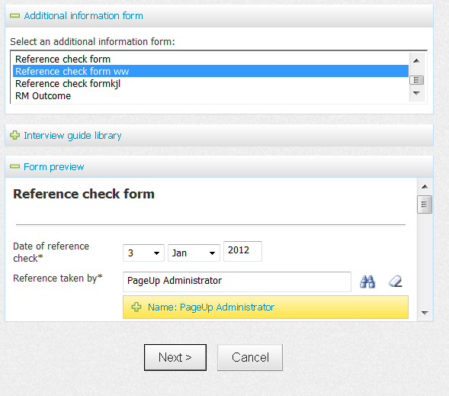

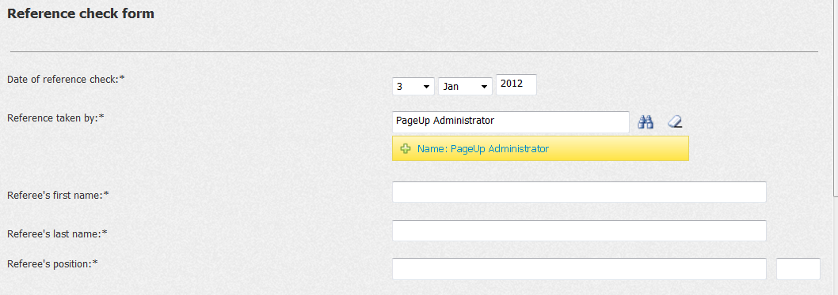

**Step 3:** When the form has been completed, either select **'Save'** or **'Save draft'**. A link to the form will then be stored in the Applicant history section of the Applicant card. Forms saved as drafts are displayed in the Applicant history with the status of 'In progress'

**From Applicant history:**

* Click the **'View'** link next to a form listed to view the form in read only format.
* Click the ‘**Edit'** link next to a form listed to edit the form’s details.
* Click the **'Delete'** link next to a form listed to remove the form from the applicant card completely.

**Bulk compile and send**

Users have the ability to bulk compile and send phone screen forms, reference check forms, etc. Forms attached to the applicant card will be picked up in this action:

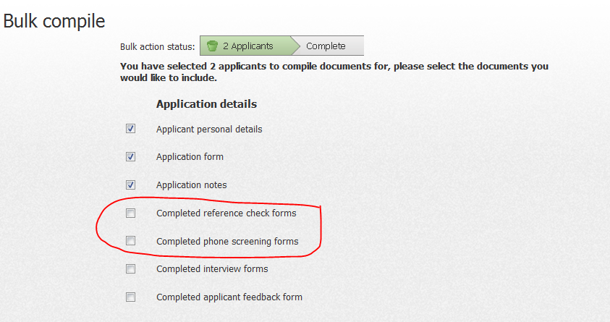

**Internal form scoring**

Similar to initial application forms, internal forms can have scoring applied to them. Internal forms can be broken into difference **scoring sections**, a feature specific to this module and not available in initial application forms. Each section will receive a score and then an overall score for the form will be calculated.

When you are creating your form, you will see a scoring section on the left hand side. Multiple scoring sections can be created but you need to ensure that ever **scoring section start** has a corresponding **scoring section end.**

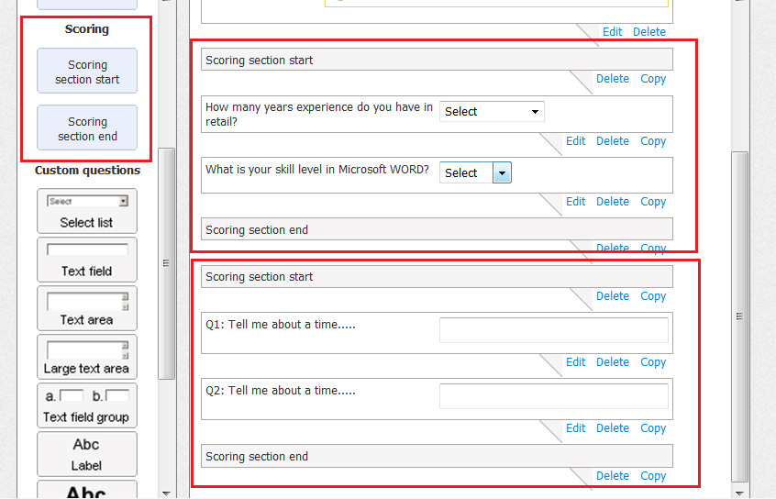

When you create a new form you will see each section scored individually along with the full score for the form.

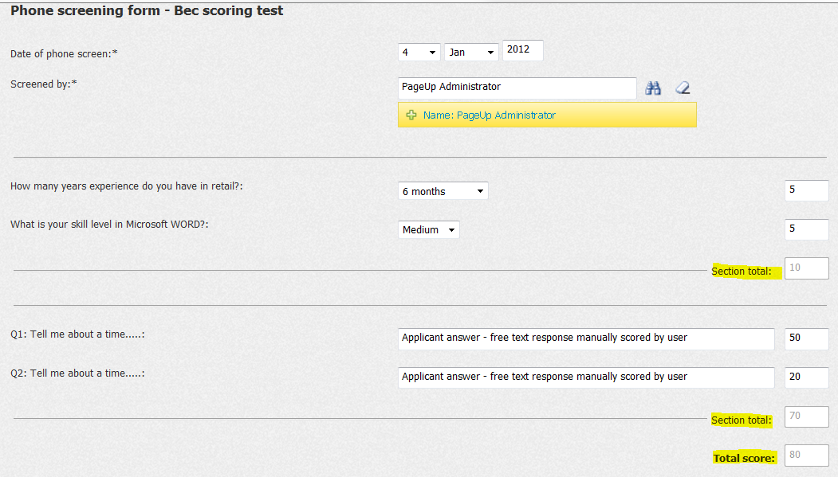

**Mapping scores to manage applications**

It is possible to map the overall score of an internal form to the manage applications page. A wiki on how to do this is located here: <http://yoda/product/Product%20Wiki%202/Internal%20form%20score%20mapping.aspx>

This work is typically completed for graduate recruitment and is only relevant for clients who score their application forms.

(04/01/11 – Bec) – I have never implemented this but it is currently being completed by Nadia Gishen. Guide to be updated shortly.

**Permissions**

|  |  |  |
| --- | --- | --- |
| Permission | Path | Description |
|  | Jobs section >  Form designer | Activates **Manage forms** in the right side menu |
|  | Applicant section >  Review by application >  View applicants >  Internal forms | Activated the **new form** drop down in applicant actions. Without this switched on, this permission cannot add internal forms to an applicant’s profile |

**Configuration audit**

|  |  |  |  |
| --- | --- | --- | --- |
| # | Task to Complete | Owner | Status |
| 1 | Have all required phone screen and reference check forms been configured? |  |  |
| 2 | Do relevant users have access to the ‘new form’ action drop down item? |  |  |
| 3 | Has form scoring been discussed and implemented if required? |  |  |

**Frequently asked questions**

**Q: ADD  
*A:*** *ADD*

**Q: ADD  
*A:*** *ADD*

# Job Search & Mail – non-cloud

**Description**

Job Search & Mail refers to the set of pages that are used by applicants when searching for jobs or registering for job alerts. This module is activated for our client’s websites and intranets. The guide below explains how to set up this module from a feature manager perspective only. Updates to the look and feel of websites (including the adding of search fields) need to be completed view website properties.

**Related documents**

|  |  |
| --- | --- |
| Document | File location |
|  |  |
|  |  |

**Acronyms, Terms and Definitions**

|  |  |
| --- | --- |
| Acronym/Term | Definition |
|  |  |
|  |  |

**Once-off features (mandatory)**

|  |  |  |
| --- | --- | --- |
| Feature | Value | Description |
| bJobSearchModule | True | Activates the job search and mail module |
| bJobSearchCategories | True | Activates search categories on all website and intranet sourcing channels in the sourcing tab |
| bJobMail | True | Activates the Job Mail section of the job search and mail module |

**Optional Features**

|  |  |  |
| --- | --- | --- |
| Feature | Value | Description |
| bManageJobSearchCategoryGroups | True | Activates ‘category groups’ – useful for clients who want to have lots of job search categories. E.g. Category group is IT and the categories under the group are (1) Developers (2) Testers (3) Network Support, etc. |
| bManageLocationGroups | True | Activates ‘location groups’ – useful for clients who have lots of locations across states/countries. E.g. Location group is Australia and the locations under the group are (1) Vic (2). Location group is US and the locations under the group are (1) New York (2) Los Angeles, etc. |
| bJobSourceMultipleLocations | True | Allows sourcing to multiple locations from the sourcing page of all website/intranet sources |

**System Scoping**

|  |  |
| --- | --- |
| Scoping question | Possible Outcomes |
| What type of information will assist your applicants in finding jobs with your organisation – should they be able to search by location, category, etc. | Understand how applicants would like to search for jobs – it will differ from client to client, particularly based on industry |
| What type of search categories and locations make sense for the applicant when searching | Search criteria needs to make sense for an external audience. Even though a term may make sense to a client internally (e.g. PUP’s :Implementation Analyst” this may not been much to applicants unfamiliar with this terminology. “Project Coordinator” might be a better term |

**Configuration guide**

**How does the module work?**

This module is closely linked to the creation of client websites and intranets. Clients implement at least 1 website with a recruitment module implementation and the job search and mail module is used to set the search criteria on the website/s.

**Available search criteria for job search and job alert pages are:**

|  |  |
| --- | --- |
| Value | Information is drawn from: |
| Jobnumber | Position info tab – Automatically generated or created by the user |
| Keywords | Sourcing tab –from the advertising details |
| lBrandID | Position info tab – *System settings > base > organisational hierarchy > new brand* |
| lDepartmentID | Position info tab - *System settings > base > organisational hierarchy > manage department* |
| lSkillTypeID | Position info tab – *System settings > job search > job search categories > new skill type* |
| lCategoryID | Sourcing tab – *System settings > base > organisational hierarchy > new category* |
| lWorkTypeID | Position info tab - *System settings > base > work types > new* |
| lLocationID | Position info tab OR the sourcing tab (if multi locations is switched on) - *System settings > base > payscales > new pay scale* |
| lPayScaleID | Position info tab - *System settings > base > payscales > new pay scale* |
| lJobSectorID | Position info tab - *System settings > base > job sectors > new* |

Determine the fields that the client would like to have as search criteria and configure the data as per the paths above.

**NOTE:** This data is often used for 2 purposes. For example, when creating a client’s work types, ensure the language is applicant friendly. The client may call a certain work type something that makes sense internally but may not make sense to an applicant.

**Location groups**Clients will always add a location search criteria to their search page for applicants to use when looking for jobs. If the client has lots of locations, location groups can be used. So, instead of having 1 list of locations (e.g. Brisbane, Melbourne, Adelaide) you can have locations sit under groups (e.g. Location group = Australia. Brisbane, Melbourne, Adelaide all site under the group Australia).

To set up location groups, activate the feature ***bManageLocationGroups***. Go to*system settings > locations >**location groups > manage location groups* and create your groups. Once this is completed, create your locations and you will have the option to attach to a location group.

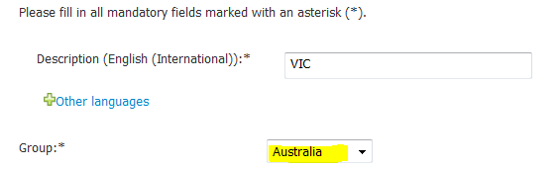

**Client examples:**

* Standard locations (Spotless): <http://careers.spotless.com/jobSearch.asp?stp=AW&sLanguage=en>
* Location groups (BHP): <http://jobs.bhpbilliton.com/jobSearch.asp?stp=AW&sLanguage=en>

**Category groups**The same principle for location groups applies to category groups. To set up category groups, activate the feature ***bManageJobSearchCategoryGroups.*** Go to*system settings > job search > job search category groups > job search category groups > new category group* and create your groups. Once this is completed, create your job search categories and you will have the option to attach to a category group.

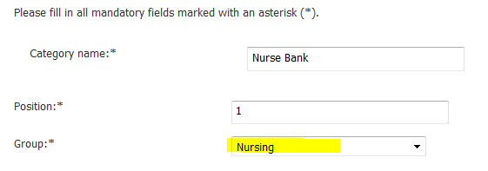

**Client examples:**

* Standard categories (John Holland): <http://careers.johnholland.com.au/jobSearch.asp>
* Category groups (Alfred Health): <http://careers.alfredhealth.org.au/jobSearch.asp?stp=AW&sLanguage=en>

**Job search types**Once all your search criteria is set up, this functionality allows you to pick and choose which options will appear on which client websites and intranets hosted by PageUp People. A good example is Commonwealth Page. They have a number of websites in their instance for their different brands. Each website has different locations available for selection.

* **CBA website -** <http://www.careers.commbank.com.au/jobSearch.asp?stp=AW>
* **KIPT (NZ site) -** <http://careers.kipt.co.nz/jobSearch.asp?stp=KIPT>

As you can see, KIPT has a smaller list of locations as the full list of CBA locations are not relevant.

To set, go to *system settings > job search > job search types.* You will be presented with a list of all the client’s website and intranets. Click Edit to see the criteria the client has set. By default, if no options are selected than ALL options will appear on the website (configuration setup for 95% of clients). However, if you do want to set specific locations, categories, etc. you can do so here*.*

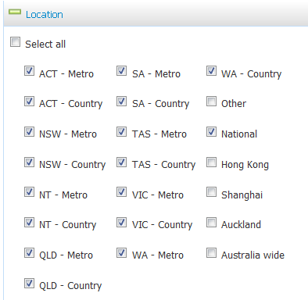

**Setting up Job Mail  
NOTE:** This is only required for non-cloud websitesJobMail needs to be set up for all PageUp People hosted websites and intranets that have been added as a sourcing channel for the client.

* Go to *System Settings > Source Management > Sourcing Channels*. Click on ‘Job Mail’ for Website (and Intranet if client has the Intranet module). JobMail will not appear as a link near sourcing channels that do not require this set up (e.g. Seek)

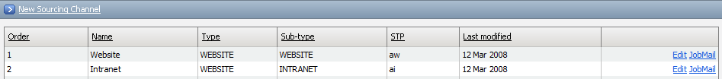

* Enter in the following information per source (using correct source pointer in links):
* Job details URL: Client CNAME followed by /jobDetails.asp?stp=aw&sJobIDs=
* Job mail URL: Client CNAME followed by /jobMail.asp?stp=aw
* Careers home URL: Client CNAME
* Email from: Client [“instanceID-sourcepointer”@ezine.pageup.com.au](mailto:)
* Site name: Name of clients careers page
* Email subject: Clientname Job Alert’
* Job mail text: Job Alert

Example of information to be entered:

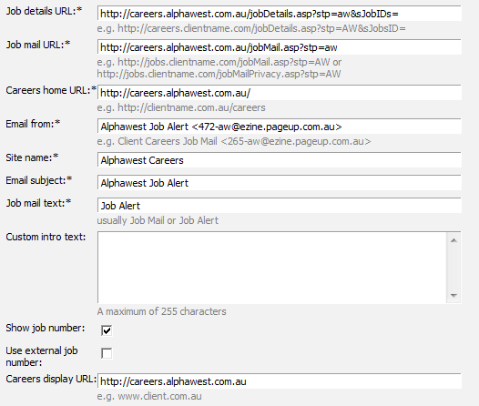

**Permissions**

Not applicable

**Configuration audit**

|  |  |  |  |
| --- | --- | --- | --- |
| # | Task to Complete | Owner | Status |
| 1 | Have you added all relevant job search/job mail search criteria data into system settings? |  |  |
| 2 | If the client needs different data to appear on different websites/intranets, have you set Job Search Types? |  |  |
| 3 | Have you set up all JobMail settings for PUP hosted websites/intranets (non-cloud) |  |  |
| 4 | Have you ‘subscribed to job alert’ – test that the email address is as expected |  |  |
| 5 | Have you ‘emailed a job to a friend’ – test that the email address is as expected and the link to the job works. If not, you will need to update website properties using Feature Manager. |  |  |

**Frequently asked questions**

**Q: ADD  
*A:*** *ADD*

**Q: ADD  
*A:*** *ADD*

# Job Templates

**Description**

This module allows you to build a library of job templates for ongoing use. This saves time for the user as key job criteria, sourcing and categories are saved to be used over and over.

**Acronyms, Terms and Definitions**

|  |  |
| --- | --- |
| Acronym/Term | Definition |
|  |  |
|  |  |

**Once-off features (mandatory)**

|  |  |  |
| --- | --- | --- |
| Feature | Value | Description |
| bJobTemplates | True | Activates the Job Templates module – manage job templates menu item is displayed in the right menu |
| sSelectTemplateDisplayedFields | lBrandID, lDepartmentID, lSubDepartmentID, lTemplateID  OPTIONAL – if the client has an inbound integration (HRIS to PUP) you can add lPositionID so that users can select a position number to populate the job card.  OPTIONAL – To add instructional text, use SubText AS XXX | Controls the fields available on the ‘Select a job template’ page which is presented when you click the ‘new job’ link in the right side menu |

**Optional Features**

|  |  |  |
| --- | --- | --- |
| Feature | Value | Description |
| bAllowUpdateJobTemplate | True | Adds the ‘save a copy of this job as a template’ to the bottom of your job card |
| sJobTemplateDisplayedFields | sTitle, lLocationID, lBrandID, lDepartmentID, lApplicationStatusGroupID, sApplicationDetails, sOverview | Controls the fields available on the ‘new job template’ page which is where new job templates can be created and saved. Fields from the job card that the client wants to auto-populate should be added to this page so that the details can be added to the relevant template. |
| sJobTemplateRequiredFields | lBrandID, lDepartmentID. etc. | Controls the mandatory fields available on the ‘new job template’ page which is where new job templates can be created and saved |
| bApplyJobSourceTemplates | True | Adds an ‘Apply job template’ link from the sourcing tab so that templates can be applied when sourcing. Handy for clients who do not want managers choosing templates when they create jobs |

**System Scoping**

|  |  |
| --- | --- |
| Scoping question | Possible Outcomes |
| Do you often use the same advertising text when sourcing similar jobs? | Yes – then job templates can speed up the process – instead of copy/pasting from word every time, you can choose a template to auto-populate the job card |
| Do you want to have generic templates (usually when you only want to populate basic advertising details – top and tail advertising details) or do you require job specific job templates? | If generic, create a basic template. If job specific, ask for the information they want to pre-populate).  If clients don’t have job specific templates, the generic templates are a good way to ensure the top and tail of advertisements are consistent. |
| Do you have specific templates associated with certain brands/business units | Is yes, set up the ‘brand’ filter on the select a template page so that users can search for templates based on the organisational hierarchy of the company. If the client only has a hand full of templates, it may be better to remove the hierarchy filter and only display the template look up field. The more templates, the more filters you should add to make searching easier (for example, if the client has 100 templates it might be best to switch on the first 2 levels of the hierarchy to filter more specifically) |
| Who can create or update job templates? | Typically recommend that only SuperUsers or Recruiters have access to this. If you give access to Hiring Managers you run the risk of different managers creating duplicate templates which can become difficult to manage. |

**Configuration guide**

**How does the module work?**When you click on **new job**, the user is presented with the **Select a job template** page. By choosing a pre-defined template, the job card can be pre-populated with relevant job information.

**Why use templates?**Job templates are designed to save users time when creating new jobs. It can be especially handy for advertising details for commonly recruited roles. Instead of having to copy and paste the same advertising details every time a particular role is recruited for, a job template can be created to pre-populate the job card for the user. Clients have control over how much information is populated.

**How do I configure the ‘Select a job template’ page?**This is very dependent on the number of templates the client is going to create. If the client has lots of templates, it helps to add the organisational structure to this page to help filter through the templates. If the client does not have many templates, they may find it easier to only have the template drop down and filter through the whole list.

The Job Template page will by default display the following fields :-

* Select ‘No Template’ if there is no suitable template available
* Business Unit (lBrandID)
* Department (lDepartmentID)
* Template (lTemplateID)
* Preview

**Example of default template page:**

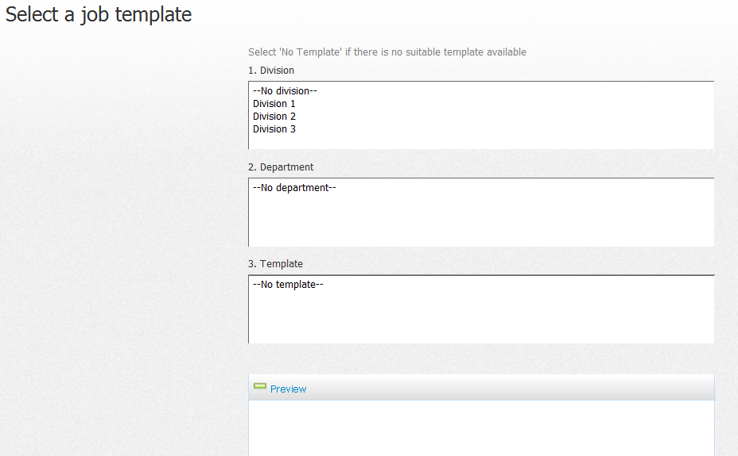

**My client has a HRIS integration – do I need to set up anything differently?**Clients with an integration to another system (SAP, Aurion, PeopleSoft, etc.) and are sending us position number information will add a position look up field on the ‘select a template’ page. This allows users to select a position number from their HRIS which will have information such as org hierarchy, cost centre, etc. attached to it. These fields attached to the job number can then be pre-populated onto the job card.

As the position number will contain job information against it, many clients only have the position look up field display on the select a template page (i.e. they may not create any job templates because the position number already has all of the job information loaded)

Add **lPositionID** to the feature **sSelectTemplateDisplayedFields**

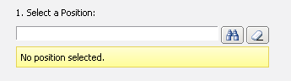

**Creating a job template ‘on the fly’**If a user has permission to do this, they are able to create a job template after they have created a new job card. At the bottom of the job card, they will see a link asking if they would like to save the job they just created as a template. Recommend this is only given to recruiters and superusers so that users do not create too many duplicates (some clients only allow access to SuperUsers to ensure templates are controlled). Ticking the box below will create a template (the title of the template will be the title of the job just created)

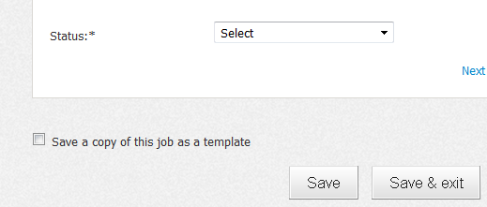

## 

**Selecting a template from the sourcing channel page**If you activate the feature **bApplyJobSourceTemplates** an apply job template’ button will appear on the sourcing tab so that advertising details can be applied directly to the source. This is handy for clients that have Hiring Managers create requisitions who have no involvement with advertising. Hiring Managers can create jobs (and not see any template information) and then recruiters can attach template information from the sourcing tab once ready to source.

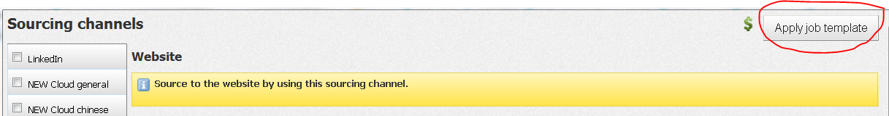

Clicking this button will display all the templates in the system which you can apply to your source.

**Permissions**

|  |  |  |
| --- | --- | --- |
| Permission | Path | Description |
|  | Jobs section >  Job management >  Allow save job template | Activates the ‘save a job template’ link at the bottom of the job card when first creating a job. Gives a user the ability to turn the job they have created into a template in the library for use in the future by all users. |
|  | Jobs section >  Job management >  Allow update job template | Similar to the ‘save a job template’ permission but this allows a user to update a template when on an already saved job card. Any changes made to the job card when re-opened will be saved into the template being used by that job. |
|  | Jobs section >  Manage job templates | Adds **Manage job templates** to the right side menu, allowing the creation and editing of job templates |
|  | Jobs section >  New job >  Select a job template | Allows users to select a job template when creating a job – if this is switched OFF, users will go straight to the job card when the select ‘new job’ |
|  | Jobs section >  New job >  Select a job template >  Display fields | Sets the fields to be displayed on the ‘select a job template’ page |
|  | Jobs section >  New job >  Ignore mandatory role and pos on select job template | If the client has an integration and users select a position number based on a feed of positions linked to them, this selection can be made mandatory. Setting this permission to YES will override this so you create a job without a position number. NAB and Origin are client examples with this setup.  **NOTE:** For clients who simply have a position look up (i.e. all positions), this cannot be made mandatory and this permission is irrelevant. |

**Configuration audit**

|  |  |  |  |
| --- | --- | --- | --- |
| # | Task to Complete | Owner | Status |
| 1 | Configure the ‘Select a job template’ page. Ensure the right fields are displayed based on how the client wishes to use the templates (i.e. do you need to add PositionID if there is a HRIS integration?) |  |  |
| 2 | Configure the ‘new job template’ page (i.e. the page where you can create templates). All fields that need to be populated as part of a template need to be displayed on this page) |  |  |
| 3 | Configure mandatory fields on the ‘new job template’ page – it’s important that the fields are mandatory if the client requires them to be populated in the template |  |  |
| 4 | Create client specific job templates |  |  |

**Frequently asked question**

**Q:**  **My client has a HRIS integration and selects a position number on their template page. Can my client still use our standard job templates**?  
**A:** *Client with an integration will generally only have the position number look up on the template page BUT they can still utilise job templates if they wish. The position number selection will populate the job card with position data BUT the job templates selection can help to populate advertising details if required. It is possible but not common.*

# Permissions

**Description**

This module allows you to set users in the system into pre-defined permissions and teams to control functionality access levels and information visibility. Ever user in the system is added to at least 1 permission group and 1 team.

**Related documents**

|  |  |
| --- | --- |
| Document | File location |
|  |  |
|  |  |

**Acronyms, Terms and Definitions**

|  |  |
| --- | --- |
| Acronym/Term | Definition |
|  |  |
|  |  |

**Once-off features (mandatory)**

|  |  |  |
| --- | --- | --- |
| Feature | Value | Description |
| bUsersAndGroups | True | Activates the permissions module (add **manage users** to the right side menu) |
| bManagePermissionGroups | True | Adds **manage permission groups** to the ‘manage users’ page |
| bManageTeams | True | Adds **manage teams** to the ‘manage users’ page |

**Optional Features**

|  |  |  |
| --- | --- | --- |
| Feature | Value | Description |
| sUserDisplayedFields | Values  sTitle, sFName, sLName, sInitials, sPosition, sEmail, nFTEEquivalent sPhone,lBrandID,lDepartmentID,lDepartmentPositionID,sBadgeID,sProviderNo,sStreet1,sStreet2,sSuburb,sPostcode,sProviderOther1 | Sets the values to display on the new user page for when users are created in the system |
| sUserRequiredFields | Values | Sets the mandatory values to display on the new user page for when users are created in the system |
| sSearchProviderRecordDetail | {sFName} {sLName}<br>Team: {sTeamTitle}<br>Email: {sEMail} | Sets the information displayed in the user information dialogue box AND the yellow info box once a user is selected (appears when a user has been selected against a job card, offer card, etc.) |
|  |  |  |

**System Scoping**

|  |  |
| --- | --- |
| Scoping question | Possible Outcomes |
| **Teams** – How does your recruitment team currently function? Do all recruiters have visibility over each other’s jobs and applicants or do you have independent teams working? | If there are different recruitment teams in the business, it is a good idea to split them into different teams to help group users more easily. The client may decide that teams can only see their own teams jobs and applicants OR you can have users in different primary teams but provided access to other teams |
| **Teams** – Do you have specific recruitment teams based on locations or recruitment activity type for example? | If yes, the client may want to report on this (i.e. Report on all recruitment in VIC). Reporting will allow you to report on all jobs raised in VIC but creating a VIC team is another way to report to this level of detail. As above, splitting by different recruitment teams helps to group users more efficiently |
| **Permissions –** Who are the main users of the system? Who raises jobs (determine if HM’s need access), who manages recruitment, who runs reports, who generates offer letters, etc. | Recommend you discuss the standard permissions groups created for clients (i.e. SuperUser, Recruiter, Hiring managers) and talk about what these users should be able to access. From here, you can discuss any other potential users of the system that will need access who may not fit into these groups. |
| **Permissions –** Who should be set as a Beta user? | These are typically SuperUsers who have access to new functionality first before it is fully deployed to LIVE. |
|  |  |

**Configuration guide**  
 **How does the module work?**To access this module, go to manage users in the right side menu. From here you can create permission groups, teams and user accounts.

**How are teams and permissions different?** The easiest way to explain permission groups to a client is:

* **Permissions** control what a user can **DO**
* **Teams** control what a user can **SEE**
* **Permissions** - what you can DO. Example: I have access to create a job, go to system settings, make an offer, access the talent search page and run searches, etc.)
* **Teams** - what data you can SEE. Example - I can see jobs that have been raised by members in my team, along with any applicants that have applied. I cannot see jobs raised by a different teams, etc.)

**NOTE:** Every user in the system must belong to at least one team and one permission.

**Step 1: Creating teams**

**How to determine what teams a client needs created:**Teams are created in order to group users logically. Teams can be used for reporting purposes (e.g. Report on all current recruitment for team X) and to restrict the visibility of jobs and applicants to different groups of users (e.g. Allowing users to only see their own teams work).   
  
Teams can be very useful for large organisations that have lots of users in the system. It is also useful if a client does want to break down reporting of recruitment activity.

**Example:**  The client has recruitment teams managing different locations around Australia. For example, by creating a NSW recruitment team, VIC recruitment team, SA recruitment team, etc., the client can then report on each regions activity.

**Example:** The client has different recruitment teams based on type of recruitment. For example, by creating a graduate recruitment team, contractor recruitment team, permanent hire recruitment team, etc., the client can then report on each type of recruitment activity based on team

To create a new team go to manage teams > new team. Give your team a name and number. The number is for internal PageUp People administration purposes only. If you add a number against your team, you will be able to bulk upload users via the **quick data importer** in feature manager and set the team against the applicant in the process. **NOTE:** Team number needs to be unique so ensure you don’t add the same number twice!

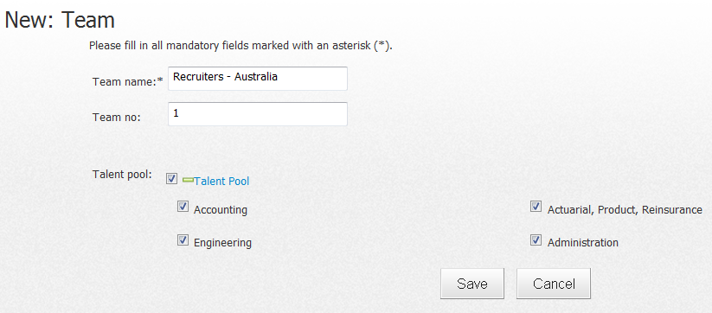

**NOTE:** For clients who have the **Talent Search module,** functionality exists to set access to talent pools per team. Please refer to the Talent Search configuration guide for more information.

**Step 2: Creating permission groups  
How to determine what permissions a client needs created:**Permissions are created to set the access levels of users. At a minimum, a client’s system will general have 3 recommended permission groups created

1. **SuperUser:** Access to all functionality and modules. These are the users that maintain the configuration of the system and contact support for assistance. The number of SuperUsers a client has will vary depending on the size of the organisation and how recruitment is managed but SuperUser access should be kept to a minimum where possible. This reduces the risk of users editing configuration content they should not be changes, adding duplication information because users are not discussing changes with one another, etc.
2. **Recruiters:** Access to most functionality except back end configuration items which is left to the SuperUser (e.g. system settings, manage forms, manage users, etc.). This permission group should provide the user with all functionality require to perform their role as a recruiter (e.g. creating a new job, advertising jobs, communicating with applicants, etc.)
3. **Hiring Managers:** Two possible scenarios depending on the client’s recruitment function.
4. Access for Hiring Managers – generally view Recruitment Centre (i.e. The Hiring Manager interface) where they can perform simple recruitment functions such as raising jobs, approving jobs, etc.
5. No access for Hiring Managers - managers do not log in BUT we still have hiring manager names in the system so that they can be attached to jobs and offers for reporting purposes. For instance, if you want to capture the reports to manager for a role, you will use a user look up field to add this person. They may not access the system but they are technically a user so that they can be available in look up fields.

The best way to create permission groups is start with a template. Instance 100 has the following pre-defined permission groups to get you started.

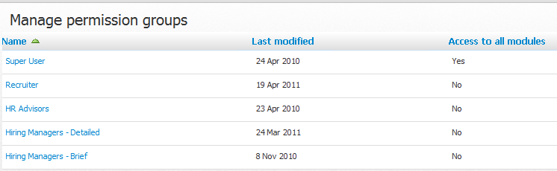

**For new clients:** These permission groups will be copied over into your instance when an instance 100 copy is completed at project start up. Update the Recruiter and Hiring manager permission groups as required based on your consultation with the client. You can then use these as a base to copy and create new permission groups if further groups are identified.

**For existing clients:** Unfortunately, these base permission groups will not be in your system. However, it is recommended that if you create a new permission group from scratch, to open instance 100 and copy the settings of the relevant permission group manually to get you started. This will be easier than trying to review all the permission settings from scratch and will save time in the long run.

To create a new permission go to manage users > manage permission groups > new

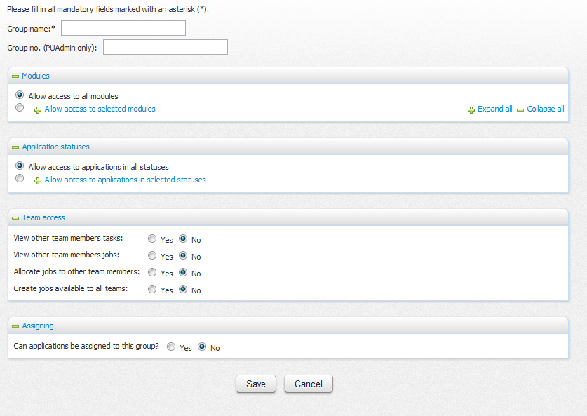

**Section 1: Group name and Group No.**Give your permission group a name and number. The number is for internal PageUp People administration purposes only. If you add a number against your permission, you will be able to bulk upload users via the **quick data importer** in feature manager and set the permission against the applicant in the process. Please note, permission number needs to be unique so ensure you don’t add the same number twice!

**Section 2: Modules -** Specifies what functionality the permission group should have access to.

|  |  |
| --- | --- |
| Allow access to all modules | Users in this permission will see **all** functionality activated in their system. This is a SuperUser permission. |
| Allow access to selected modules | Allows you to choose the functionality this particular permission group will have access to. If you expand all you will see every permission available in the system. Recommend that the best way to use this permission tree is to expand all and then use ctrl + F to search for specific words to find your permission  **NOTE:** The permissions tree is hierarchical. You generally need to tick the top permission before the permission below it will work. For example, if you do not have the top level permission applicant settingsticked, ticking permissions under this will be unlikely to work as the higher permission set to NO will override permission underneath. |

**Section 3: Application statuses -**. Specifies if users should be able to access all application statuses against a recruitment process. Becomes most relevant when used for Hiring manager permission groups who have access to recruitment centre. They may be asked to review applicants at certain points of the recruitment process BUT should not be able to move applicants into every step available, only those defined by the client.

|  |  |
| --- | --- |
| Allow access to applications in all statuses | The user will be able to see and change all application statues across all recruitment processes. This is generally the setting most permission groups across all clients have set |
| Allow access to applications in selected statuses | If this is chosen, a list of all available recruitment processes will be shown. Each process can be expanded to show the application statuses available.  **NOTE:** If you need to restrict application status visibility in 1 recruitment process, be sure to update ALL other recruitment processes by ticking ALL of the available statuses – otherwise users may have more restrictions than intended |

**Section 4: Team access –** Specifies the team access users will have to their own team and other teams

|  |  |
| --- | --- |
| View other team members tasks | **Dashboard visibility:** Adds the **Team and Users** column to the dashboard.   * If set to **YES**, users can view their primary team and ‘other teams’ they have access to (i.e. visibility of users along with their tasks and jobs). * If set to **NO,** the Teams and Users column is not displayed on the dashboard. |
| View other team members jobs | **Manage jobs visibility:**   * If set to **YES**, users will have access to jobs created by users in their primary team and users in ‘other teams’ they have access to via manage jobs. * If set to **NO,** users will only see jobs they have created when on manage jobs. |
| Allocate jobs to other team members | * If set to **YES**, allow visibility of **lTeamID** on the job card. This drop down will display all teams that the user has access to (i.e. Their primary team and other teams) so they can allocate jobs to other teams |
| Create jobs available to all teams | * If set to YES, adds the option “Available to all teams” to **lTeamID** on the job card. |

**Section 5: Assigning**

|  |  |
| --- | --- |
| Can applications be assigned to this group? | TBC – Old functionality that has been replaced with features |

**Step 3: Set a default team and permission group**Once your teams and permission groups are created, you should set a default team and default permission. There can only be 1 default per team and permission. This is important for a number of reasons.

* Clients with a user feed from a HRIS – when new users are sent to PUP via an integration and user feed, users will be placed in the default team and default permission group. Usually clients who have user feeds have large volumes of users being added into the system. Users should generally be added to the permission with the least amount of access. It is then up to a client SuperUser to update a user’s team and permission manually if necessary.
* Adding users ‘on the fly’ – if the feature bSearchDialogAddProvider is switched on which allows users to be created ‘on the fly’ from the user dialog box, these users are placed in the default team and permission group

**Step 4: Creating users**  
Once all of your teams and permissions are created, you are able to create users. To create a new user go to manage users > new users.

* **What is a BETA user?**Beta is a testing version of the LIVE environment. All users in LIVE are set to be beta or non-beta. Both users log into the same LIVE environment but users set as BETA will have access to functionality in the beta environment which has not yet be deployed to LIVE. Typically, SuperUsers are beta users.
* **What happens if I add a user to multiple permissions? What can they DO?**

If multiple permissions are set against a user, the permission settings are combined to create access for that user. So, if permission A does not access to system settings BUT permission B does and a user is added to both, that user WILL have access to system settings.

Product permissions

* **Product Permissions** – Ensure you select admin under the recruitment option. This will give the user access to recruitment related reporting dataviews if they have access to report builder.

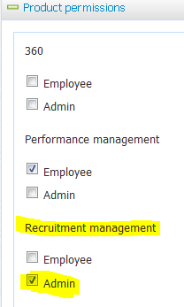

**Bulk importing users:**Feature manager provided the ability to bulk upload users into the system. Please refer to the Feature Manager – Importer guide for further information (guide in progress)

**Permissions**

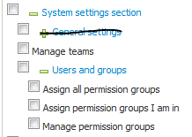

**NOTE:** The permission System settings section MUST be ticked in order for any other permission below it relating to this module to work.

|  |  |  |
| --- | --- | --- |
| Permission | Path | Description |
| Manage teams | System settings section >  Manage teams | Activates the **manage teams** link on the manage users page |
| Users and groups | System settings section >  Users and Groups | Activates the ‘Manage users’ page. If this is the only permission set, users can create new users (and the user will be placed into the default permission team) and can edit and delete existing users. |
| Assign all permission groups | System settings section >  Users and Groups >  Assign all permission groups | When creating a new user, the user signed in will be able to add the new user into any existing permission groups. This overrides the permission “assign permission groups I am in” |
| Assign permission groups I am in | System settings section >  Users and Groups >  Assign permission groups I am in | When creating a new user, the user signed in will be able to add the new user into permission groups they are actually assigned to (i.e. I can’t add anyone into the SuperUser permission group if I only belong to the Recruiter permission group) |
| Manage permission groups | System settings section >  Users and Groups >  Manager permission groups | Activates the **manage permissions** link on the manage users page |

**Configuration audit**

|  |  |  |  |
| --- | --- | --- | --- |
| # | Task to Complete | Owner | Status |
| 1 | Creation of teams complete |  |  |
| 2 | Creation of permission groups complete |  |  |
| 3 | All user accounts have been added into the system |  |  |
| 4 | User passwords have been provided to the client if they were not provided as accounts were set up |  |  |
| 5 | Dummy users created to test each permission group – were you able to perform the actions required of that group (e.g. can you create a job successfully, access Talent Search, etc.) |  |  |

**Frequently asked questions**

**Q: ADD  
*A:*** *ADD*

**Q: ADD  
*A:*** *ADD*

# Management Reports

**Description**

This module provides access to the full suite of PUP reports. Some reports are standard reports already pre-defined and identical for all clients (analysis, raw, cube, additional). Clients also have the ability to ‘build’ reports and specifically select the information they want to report on from the system. This is commonly referred to a ‘report builder’.

**Related documents**

|  |  |
| --- | --- |
| Document | File location |
|  |  |
|  |  |

**Acronyms, Terms and Definitions**

|  |  |
| --- | --- |
| Acronym/Term | Definition |
|  |  |
|  |  |

**Once-off features (mandatory)**

|  |  |  |
| --- | --- | --- |
| Feature | Value | Description |
| bManagementReports | True | Activates the management reports module |
| sReportVersion | Management | Ensure this feature is set to ‘management’ and not ‘standard’. Reports is now part of RPM but previously, clients who did not purchase management reports received basic (i.e. standard) reports. |
| **Setting up a hammer key | N/A | Please refer to instructions to follow – this **must** be completed in feature manager in order for Build your own reports to function |

**Optional Features**

|  |  |  |
| --- | --- | --- |
| Feature | Value | Description |
| N/A |  |  |

**System Scoping**

|  |  |
| --- | --- |
| Scoping question | Possible Outcomes |
| What information are you currently reporting on? | Client may need to replicate reports in PUP currently being generate from other systems – gather requirements and work with clients to build specific reports |
| What information would you like to report on? | This is a fairly big and open question. Some clients will have specific reports they may generate manually and wish to replicate in PUP. Some clients will not have any specific requirements and our standard reports may be a sufficient starting point. |
| Who will need to access reports in the system? Are there people who should receive reports via email and not need to log into the system? | Although many users may need to see reports, they may not all need to have direct access. Report schedules can be set up so that users receive tailored reports straight to their email. |
| Do you have active x installed on your computers? | This is required to view cube reports – it’s a good idea to check is the client has this available on their computers. Many clients do not and simply do not use these pivot reports |
| Does your organisation need to report on equity and diversity? | If yes, the client will need to ask applicants certain questions to capture this information. Review the section of this guide relating to **hidden answers** to learn about the functionality available (in the application form builder guide) |
|  |  |

**Configuration guide**

**Setting up a hammer key**

A unique ‘hammer key’ needs to be added to the client’s instance in order for build your own reports to work. This should be completed before proceeding with the rest of this guide. Instructions are as follows:

1. Log into Feature Manager
2. Go to Manage clients and find the client’s instance
3. Click the ITM link for the instance
4. Click the Create hammer key link, under the Common heading. There should be nothing next to the "Encrypted key:" text. If there is, do not go any further. The hammer key has been set and MUST NOT be overwritten.
5. If the field is blank, click Generate key. This will make a key.
6. Click Save key and you're done! This key will be saved into the feature **sDataEncryptionKey**. **DO NOT** manually enter a key into this field.

If this is not completed, you will receive the following error when you try and create a ‘build your own’ report”

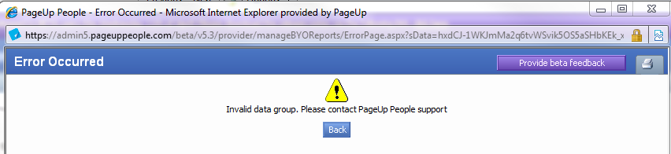

**How does the module work?**Once the module is activated, view reports will be enabled in the right side menu

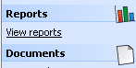

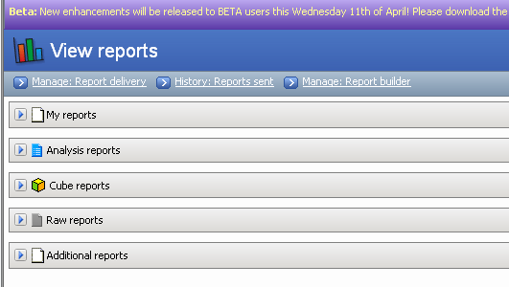

* Click the blue arrow to expand the list of reports avaialble. My Reports shows all ‘report builder’ reports a user has access to view or edit.
* **NOTE:** All reports will be visibile to clients, even if the report is related to a module that the client does not have implemented (e.g. alumni, employee referral). The report will simply pull blank data if the module is not relevant.

**Clients have access to the following reports:**

**1. Standard Reports**

* **Report types –** Analysis, Cube, Raw, Additional report
* **Pros** – these reports are already built and are shared amongst all of our clients. They report on key information within the system.
* **Cons** – limited configuration. Columns cannot be added/removed. Labels cannot be changed. This is because the reports are shared across all client instances.

**2. Report Builder**

* **Report types –** Different reports can be built based on the ‘dataview’ chosen (e.g. to report on job data you would choose the job (including time-to-fill) data view.
* **Pros** – Highly configurable. Data items can be dragged/dropped into reports. Graphs, sporting and filtering can also be added.
* **Cons** – Requires time to build reports. Sometimes dataviews do not contain all of the information required so additional work is needed to add more report filters to the data view. Once a report is built though, it is easy to make copies of the report as a base and tweak as required.

To configure the Management Reports module, you will need to consult with the client to understand the information they want to report on in the system. Some commonly reported on information you may wish to discuss with your client includes:

* **Job Costs** – Will the client be looking to report on cost of recruitment? If so, they need to remember to record all job costs against all jobs in order for the job cost report to be accurate. Job costs are added via the dollar sign symbol in the system -  - *“Reports are only as good as the data you enter into the system – if you want to report on it, we need to capture it in some way”*
* **Job card / offer card data –** if the client does not capture information like cost centre, site, organisational structure, etc., this information cannot be reported on. When talking about the job or offer card, it’s good to remind clients that if information needs to be reported on, you need to ensure it’s being asked on the job or offer card.
* **Offers / Time to fill** – If the client does not record the accepting of job offers and filling/closing of jobs accurately, the suite of offer and job filled related reports will not be accurate. It’s very important that users close jobs correctly so that date reporting is accurate.

**How do I create a ‘build your own’ report?**

Click **View reports** from the right side menu and click  **Manage: Report Builder.** From here, click **New** to create a new report.

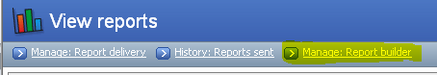

A pop up will display. Give your report a title and select a dataview to report on. The system contains a lot of data to report on and the system manager this by sorting the information into dataviews.

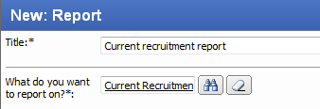

**What are dataviews?**

Dataviews are a way to group different types of data for reporting. We have 2 different types of data views.

* 1. LIVE data views - Data is updated instantly. If you create a job, it will appear in reports immediately.
  2. MASHER data views - Data needs to be processed through the ‘masher’ overnight so there is up to a 24 hour delay on this information appearing in reports.

There is no easy way to determine which reports use which data views in the system (you need to go into Feature Manager) but as a rule, advise clients that reports will have data available within 24 hours, some faster if using a LIVE data view

**What do I do if a client needs to report on something that is NOT available in any of the data views?**

Sometimes clients might capture data in the system (e.g. on the job card, on the offer card, etc.) that is not shown as an available column in any of the data views. These items should be raised as a TD to have additional columns added to a particular data view.

**Setting permissions on your report**

All ‘build your own’ reports can be set to restrict viewing and editing by other users. If there are no restrictions on this report, tick the following boxes.

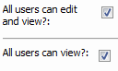

If you want to restrict the report, you can do this on a user by user basis OR on a permission by permission basis.

**Build your own report features:**

* 1. **Sorting –** drag and drop criteria to add sorting to the data (e.g. sort by Business Unit 1 displayed in ascending alphabetical order)

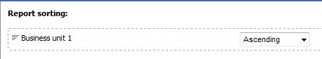

* 1. **Filters** – drag and drop criteria to add filters to the data (e.g. Only show jobs where Business Unit 1 = Head office)

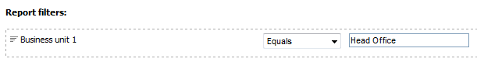

* 1. **Grouping/Charts** – drag and drop criteria to group data and create graphs/charts based on this grouping (e.g. Group data by Business unit 1 and create a pie graph).

When you add a graph, a picture will display in the report columns section (depending on the graph type) – examples below

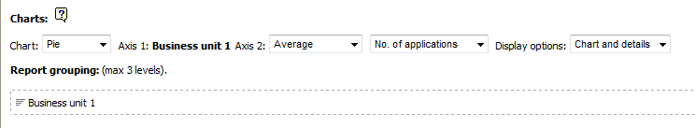

**Pie graph Bar Graph Column Graph (etc.)**

  

**Report Templates (information taken from release notes)**

**NOTE:** PageUp People provide the technology to allow use of report templates. It is the responsibility of the client to create macro excel sheets based on the look and feel that require

Clients have the ability to create report templates to produce custom formatted reports. The report template must be an Excel file, and can include macros to format the information that is output by Report builder.

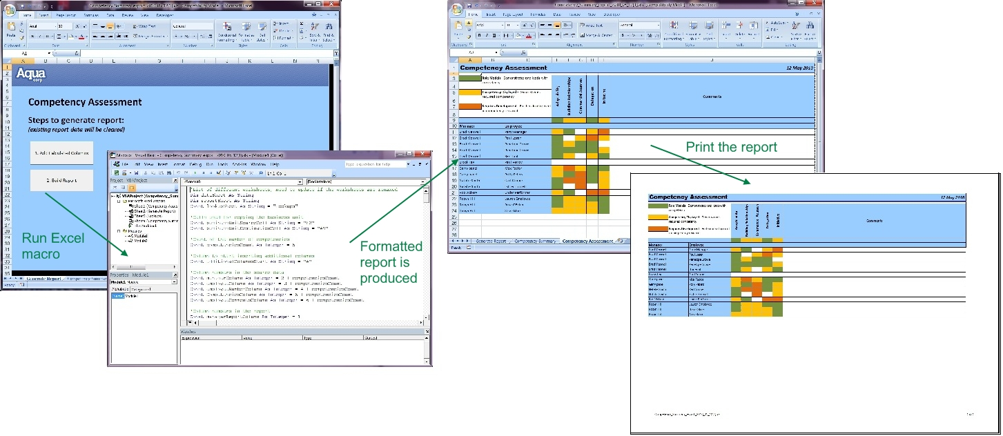

**Uploading report templates for use in Report builder**

If you want to use a report template, you must upload the template to allow it to be used by a Report builder report. In **Manage documents**, when you upload a new document, you now have the option to select a Document category of “Report builder template”:

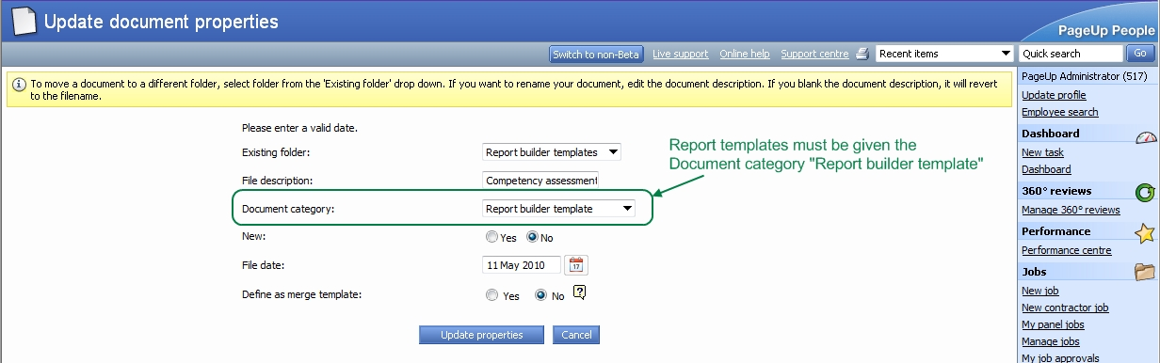

**Attaching a template to a Report builder report**

After you upload a report template, you can assign it as a template for any Report builder report. When editing a Report builder report, you can select the report template to use:

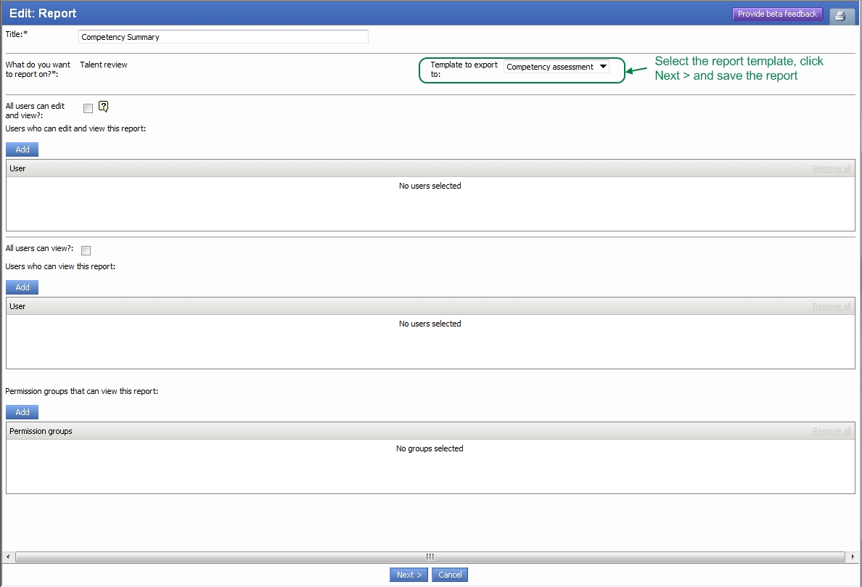

When exporting to Excel, if the report has a template to export to, the resulting Excel file will be based on the template. If no template is assigned, the report will export to a plain Excel file.

**Setting up a custom report using a report template**

To use a template to format your report builder reports:

1. In **View reports > Manage: Report builder**, build a report that contains a worksheet with the source information for your formatted report
2. Export the report to Excel
3. Save the Excel file
4. Add macro(s)/formatting to the Excel file
   * Do not apply any formatting to the worksheet containing the source information for the report, as you must delete this worksheet before uploading it. You must add a new worksheet to contain the formatted report, and apply formatting to this new worksheet.
   * When the report is exported using the template, the source data worksheet will be created as the second worksheet in the Excel file, named as the title of the Report builder report.
5. Run your macro(s) to verify the formatted report is correct based on the sample source information
   * You can assign a button or hotkey to macro(s) in Excel to make it easy to run them
6. Clean up the template to ready it for upload
   * Delete the worksheet containing the sample source information from the Excel file
   * Remove all information added by your macro from the worksheet that contains the formatted report output
7. Upload the Excel file using **Manage documents**. Set the document category as “Report builder template”.
8. In **View reports > Manage: Report builder**, edit the report you created initially, and attach the new report template to the report. Save the report.
9. Test your report by exporting the Report builder report to Excel and running the macro(s) to verify the formatted report output is correct

**How does My Reports work?**

My reports is the area on the ‘view reports’ page that shows build your own reports. Reports will be displayed here for a user if they have been given (1) Viewing or (2) Editing rights for a report.

**NOTE:** Users in recruitment centre will have access to any reports that they have been given permission to view or edit, even if the permission settings have reports switched OFF. If you create a report that is available to all users, the reports link will display in the recruitment centre right side menu so be careful of how permissions are set up for report.

**How do I create report schedules?**

Click **View reports** from the right side menu and click  **Manage: Report Delivery.** From here, click **New** to create a new report delivery schedule. **NOTE:** Analysis, raw and build your own reports can be sent via a report delivery schedule. Cube reports are not supported to be emailed to users.

If you click on **View reports** from the right side menu and click  **Manage: Reports sent** you can see a summary of previous reports sent and download a copy (very handy if you have reports with timeframe filters –i.e. show me all new jobs created last week). This report will be updated every week but you can see the actual data sent in previous weeks though the ‘reports sent’ link.

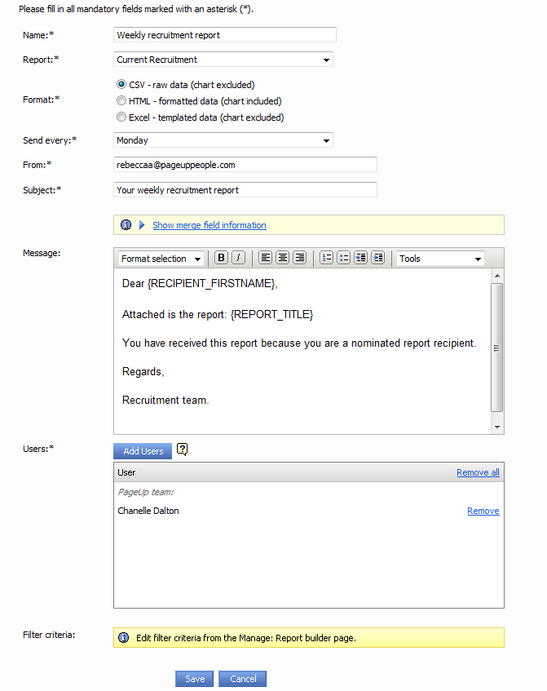

**Permissions**

|  |  |  |
| --- | --- | --- |
| Permission | Path | Description |
|  | Reports section | Provides access to the reports link in the right side menu – if all items are ticked you have full access to all reports. This is a typical setup 99% of the time for users that should have report access (rare to restrict the types or reports |
|  | Reports section | Manager report delivery - if unticked, this will remove the ability to access ‘Manager: Report delivery’ and ‘History: Reports sent’ |
|  | Reports section | Manage reports – if unticked, this will remove the ability to access ‘Manage: Report builder’ (i.e. Build your own reports) |
|  | Reports section | Statistical reports – if unticked, this will remove the ability to access analysis, cube, raw and additional reports (i.e. all the standard reports) |

**Configuration audit**

|  |  |  |  |
| --- | --- | --- | --- |
| # | Task to Complete | Owner | Status |
| 1 | Has a hammer key been setup? Build your own reports will not work until this is complete |  |  |
| 2 | Once features are activated, ensure that you can open each type of report (analysis, raw, cube, additional) |  |  |
| 3 | Create a ‘build your own report’ – ensure you can create and save the report |  |  |
| 4 | Once you create a report, ensure you can export it out to excel, csv etc. |  |  |
| 5 | Gather client’s reporting requirements – build reports with the client to ensure they are confident in building reports in the future |  |  |
| 6 | Submit TD’s for any ‘additional columns’ |  |  |

**Frequently asked question**

**Q: ADD  
*A:*** *ADD*

**Q: ADD  
*A:*** *ADD*

# Source Management

**Description**

The Source Management Module provides the ability to post jobs to multiple job boards or other advertising locations. Some job boards have a direct integration with PageUp People (e.g. Seek, MyCareer, CareerOne) and others have RSS feeds setup (e.g. UniJobs).

**Related documents**

|  |  |
| --- | --- |
| Document | File location |
|  |  |
|  |  |

**Acronyms, Terms and Definitions**

|  |  |
| --- | --- |
| Acronym/Term | Definition |
|  |  |
|  |  |

**Once-off features (mandatory)**

|  |  |  |
| --- | --- | --- |
| Feature | Value | Description |
| bJobSources | True | Activates the sourcing module – also activates the sourcing tab from the job card |
| sJobPreviewURL | <http://clientsCNAME/jobDetails.asp?sJobIDs>=  OR  http://clientsdns.clients.pageup.com.au/jobDetails.asp?sJobIDs= | Allows used to hit this symbol  from the manage jobs page and other areas of the system to preview the job advertisement |

**Optional Features**

|  |  |  |
| --- | --- | --- |
| Feature | Value | Description |
| bJobSourceMultipleLocations | True | Allows the sourcing of jobs to multiple locations from the website or intranet sourcing channel |
| bJobLink | True | Activates ‘link builder’ from the actions drop down for your sourcing channels on the sourcing page. If activated, users can copy the link directly to the apply page for that particular job |
| bJobSourceNotes | True | Adds ‘notes’ to the sourcing tab. These notes can be emailed to users. |

**System Scoping**

|  |  |
| --- | --- |
| Scoping question | Possible Outcomes |
| Which jobs boards do you currently use for advertising that you would like to continue using through PageUp People | Job boards identified – ask for account manager name and email address |
| If the client is not currently using the integration job boards (i.e. Seek, MyCareer, CareerOne) – Your source management imp fee covers integration with all job boards. If you wish to integrate with these job boards after go LIVE, there may be a charge involved for the time it will take your System Consultant to set this up. | Recommend that if you want to use these in the near future to contact each job board and see if they will set up an account free of charge that we can add into the system and deactivate temporarily. When ready to use, your System Consultant just needs to activate the feed – no configuration required. |
| You have job boards that we do not directly integrate with BUT we can set up an RSS feed as they have an existing relationship with PUP | If the client wants to source ads to a job board were we have an existing RSS, set this up as per the instructions in this document |
| You have job boards that we do not directly integrate with AND do not have an existing relationship with PUP | Advise the client that sourcing to this provide is out of scope of what the module covers and additional charges will apply – if they want to proceed, contact Product Marketing to determine if a partnership is possible |
| Do we need to restrict the visibility of sourcing channels to particular users? | Using permissions, you can show users the sourcing tab on the job card but show/hide individual sourcing channels |

**Configuration guide**

**How does the module work?**PageUp People allows users to source (i.e. advertise) jobs to multiple sourcing channels. The channels you set up will be dependent on which job boards and websites the client uses. This module allows our clients to integrate directly with Seek, CareerOne and MyCareer. Setting up another other feeds may incur and additional cost outside of the implementation fee for Source management. Verify with Sales or CPM before proceeding.

**Which job boards have direct integrations with PUP?**PUP has direct integrations with the following job boards

|  |  |  |
| --- | --- | --- |
| Seek | CareerOne | MyCareer |
| Monster |  |  |

**Which job boards have RSS feeds with PUP?**This list is constantly changing so the best way to see the most up to date list of RSS providers is to go to system settings > source management > sourcing channels > new sourcing channel and view the Type drop down. You will see a list of job boards with the majority being RSS setups.

**How do I set up the integrations?**

**Step 1: Obtain job board account details for the client’s account manager**  
To set these integrations up, your first step is to contact the account manager for each job board. Your client should provide you with these details per job board.

Email templates for contacting each job board / RSS provider can be found here: ..\2. Email templates

For the integrated job boards, each has slightly different terminology and requirements but in general, you will need the clients (1) Account name and number and (2) Template names and numbers. Please note, we can support multiple accounts per job board. Templates are linked to accounts - selecting a design template when sourcing will identify to the job board which account to charge.

**Step 2:** **Add new sourcing channels per job board**  
To add Seek (for example) as a sourcing channel, go into *System Settings 🡪 Source Management 🡪 Sourcing Channels 🡪 New Scouring Channel*

***Sourcing channel setup***

* ***Name:*** Name of the sourcing channel. Can be called anything that makes sense to the client as this is the name that appears on the sourcing page.
* ***Order****:* The order this sourcing channel should appear in on the sourcing page, 1 being the top and default selection
* ***Source pointer:*** This is the pointer of the PUP website or intranet you are creating a channel for. Website is typically **aw** and Intranet is **ai**. Integrated Job boards do not required source pointer (this will be pointed out to you when you select a type)
* ***Application form prefix:*** Sets the applicant services portal this source should point to. Again, website is typically **aw** and intranet is typically **ai.** Job boards should point to the client’s website.
* ***Visible:*** Sets if the sourcing channel is available for selection on the sourcing page. E.g. CareerOne was set up but the client no longer uses them so we would make the source invisible.
* ***Type:*** Defines the sourcing channel you are setting up – select from a drop down list.
* ***Sub-type:*** Will only display if the TYPE you have selected supports a subtype – e.g. Website type could be (1) Website (2) Intranet (3) Alumni, etc.
* ***Enable link builder:*** Determines if the ‘link builder’ link will display in the actions drop down on the sourcing page summary for that particular sourcing channel
* ***Guidance information:*** Adds a yellow information panel with the content of this field on the specified sourcing channel. Very helpful if clients want to provide users information on approximate costs for advertisements (refer to second screenshot below)

*Website setup example*

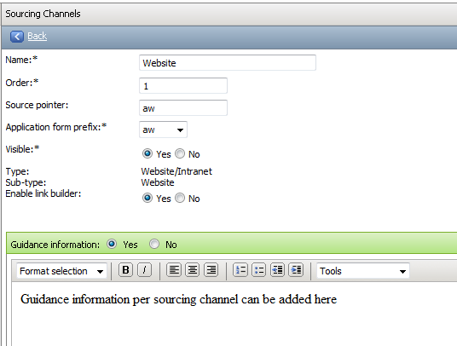

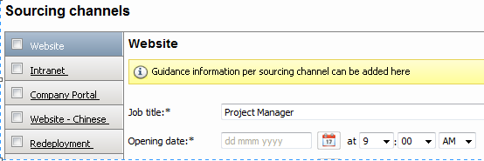

*Seek setup example*

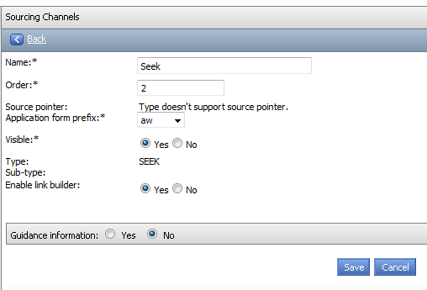

On the sourcing tab of a job card, you will see a list of all visible sourcing channels when you click 

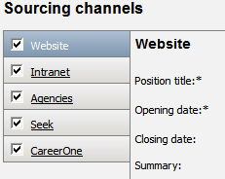

**Step 3: Configure job board account and design template details**To add job board account details provided by your client’s account manager, go into *System Settings 🡪 Source Management 🡪 Job boards.* **NOTE:** Job boards will automatically appear in this list once the sourcing channels for each job board have been created as per step 2.

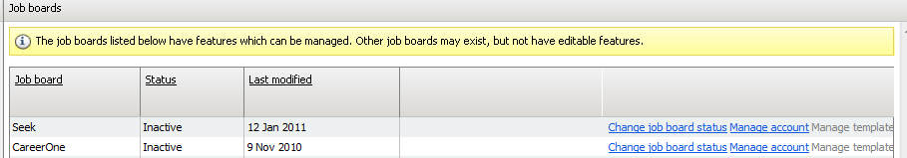

* ***Change job board status:*** This should be set to inactive if the client is not LIVE. Clicking this link will change the status to active and open the feed between job boards.
* ***Manage account:*** This is where you add the job boards account details. Click New Job Board account to add your account details (multiple accounts are supported)

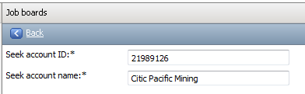

* ***Manage templates:*** This field is not available when a job board is set to inactive. To set up template information prior to go LIVE, set the job board to active temporarily. **NOTE:** Most job boards have the same template information required except that Seek also has the ability to source ‘stand out’ ads (this is optional). This is what the LOGO ID is for in the image below. The target source for SEEK is not a mandatory field and can be left blank.

|  |  |  |
| --- | --- | --- |
| Seek example template | CareerOne example template | MyCareer example template |
|  |  |  |

*Example of what a Stand Out ad looks like on Seek (i.e. client logo on the search results page):*

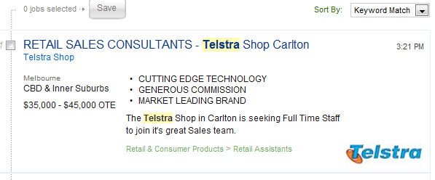

**Step 4: Activate job boards on go LIVE.**A few days before go LIVE, contact your job board contacts and confirm the go LIVE date is proceeding as planned to ensure a resource is available on the day. On go LIVE, activate the sourcing channel as explained in step 3. Open each job board website and ensure that the next feed includes jobs from your client. Click the ‘apply’ link and this should take you to the ‘applicant services’ page hosted by PageUp People. If this is occurring, the feed is working as expected.

**How often do feeds get sent from each job board:**

|  |  |  |
| --- | --- | --- |
| Seek | CareerOne | MyCareer |
| Every hour | Every 2 hours | Every 3 hours |

**Why use LinkBuilder?**Link Builder is great when a client wants to post to a job board we do not have a relationship with or when they want to post to a job board they use only on rare occasions. When on the sourcing tab, you can access a link directly to the application form for that job. Clients can provide this link to non-integrated job boards so that when applicants apply they are still directed to the PageUp People application process.

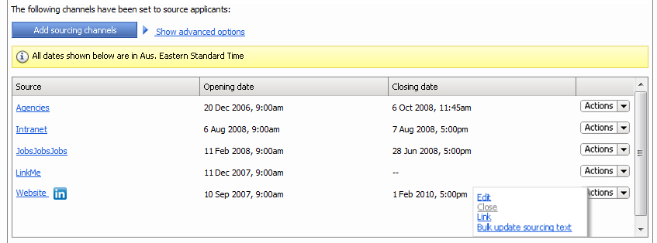

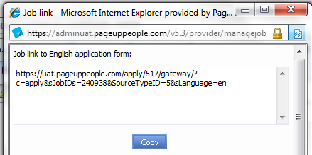

**What are blind/hidden jobs?  
NOTE:** This is only support for non-cloud clients.  
Clients can have a ‘Blind Job/Hidden Job’ sourcing channel created. When you source to this channel, the job will be posted to the client’s website BUT it will not come up in any searches. The only way to locate the job is by seraching for the job number. This is very handy when you want a applicant to view the job before anyone else (e.g. Internal applicant may be made aware of a job and asked to apply if interested before opening the job up to external advertising).

**To set this up**

1. Go to *system settings > source management > sourcing channels > new sourcing channel* and complete the following (please note that the NAME can be anything you like as long as it makes sense for the client)

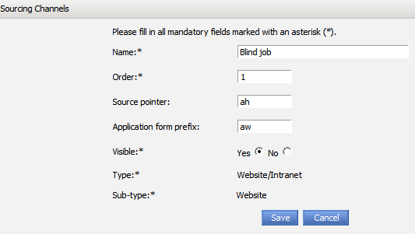

1. An update to **website – site properties** is also required to make this work. Log into **websites** for your client in feature manager. Click edit against the main website source (i.e. aw). Search for JobListing > AdditionalSources and add the source you created (ah) to the field

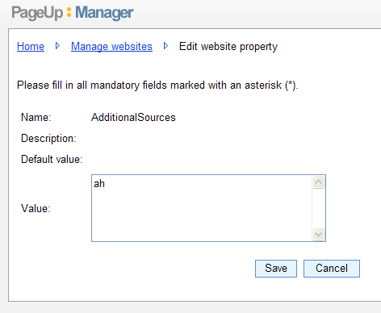

**How do I set up an RSS feed?**If PageUp People already have an RSS set up with a particular job board and you want to add this to another client’s instance, complete the following steps. **NOTE:** Setting up RSS feeds are charged per feed.

**Step 1: Add new sourcing channels per job board**  
To add UniJobs (an RSS job board for example) as a sourcing channel, go into *System Settings 🡪 Source Management 🡪 Sourcing Channels 🡪 New Scouring Channel.* Follow Step 2 above as if you were creating an integrated job board sourcing channel.

**Step 2: Contact the job board and advise of RSS link**All RSS feed follow the same format. Create the link and provide this to your job board so they know where to pick up jobs from. When choosing a source pointer, use the name of the job board (e.g. unijobs, linkme, etc.).

http:// CLIENT CAREERS WEBSITE/jobsrss.ashx?stp=SOURCE POINTER

Below are a few example of how this link might appear:

* <http://careers.kmart.com.au/jobsrss.ashx?stp=hippo>
* <http://aqua.pageuppeople.com/jobsRSS.ashx?stp=jobportals>
* <http://aqua.clients.pageup.com.au/jobsrss.ashx?stp=linkme>

**Step 3: Test the feed**  
Source a test job to the job board to ensure they are receiving it correctly in the RSS link.

**What if we have never created an RSS feed for this job board?**Discuss with Product Management. PageUp People will need to establish if the job board can support an RSS feed first before going any further.

**Permissions**

|  |  |  |
| --- | --- | --- |
| Permission | Path | Description |
|  | Job section >  Job Management >  Edit jobs >  Edit sourcing channels | Gives users access to the sourcing tab on the job card |
|  | Job section >  Job Management >  Edit jobs >  Edit sourcing channels | If the applicant has Talent Search, you can activate this feature so that suitable applicants in your database are presented as potential applicants for the job. The system will read the PD attached to the job (if no PD it will read the ad description on the position info tab). |
|  | Job section >  Job Management >  Edit jobs >  Edit sourcing channels >  Sourcing channels | Determines which sourcing channels should appear for users who have the sourcing tab. This list will be populated with whatever sourcing channels you have created for the client. |

**Configuration audit**

|  |  |  |  |
| --- | --- | --- | --- |
| # | Task to Complete | Owner | Status |
| 1 | Have you obtained and configured all job board accounts based on the clients sourcing requirements? |  |  |
| 2 | Has the client requested RSS feed setups? Have the job boards been contacted with the RSS link they require to scrap jobs for the client’s website? |  |  |
| 3 | On go LIVE, have you set the status of each job board to ACTIVE and checked that a job has sourced successfully (i.e. apply button links to the PUP application form) |  |  |

**Frequently asked question**

**Q: How do Seek stand out ads work?  
*A:*** *A stand out log can be attached per template. When a user sources to seek and picks the template, it will add the stand out logo IF they choose the ad to be stand out. Stand out logos can be attached to multiple templates. If the client wants the same template to have different stand out logos, you can create the template ID twice with the different logos. Example: Template 1234 – Stand out logo 1, Template 1234 -= Stand out logo 2.*

# Google Analytics

**Description**

Although this is not a module, all clients are set up with a free Google analytics account to track activity on their website and applicant services. This is owned and managed by Google but we set this up in order for our clients to use the statistics if they wish.

**Related documents**

|  |  |
| --- | --- |
| Document | File location |
| Google Anlaytics doc – for clients | This is a good summary document that you can provider to clients wanting to know more about how to use Google Analytics  *P:\Implementation\_Project In A Box\04. GO LIVE preparation\Google Analytics setup* |

**Set up guide**

**Step 1:** Setup up a Gmail account

* Go to [www.gmail.com](http://www.gmail.com) and click **create an account**
* Enter client information (example below)
  + **Firstname:** Aami
  + **Surname:** Aami
  + **Choose your username:** pageupaami
  + **Create a password:** page@up1
  + **Other email address**: [aami@pageuppeople.com](mailto:aami@pageuppeople.com)
  + **Location:** Australia

Agree to the terms and hit ‘next’

**NOTE:** Original passwords were set up as page@up but there is now a 8 character minimum

**Step 2:** Setup a Google Analytics Account – Add the website for tracking

* Go to <http://www.google.com/analytics/> and click **sign Up now**
* Sign in using the gmail account you just created
* Insert Account information
  + **Website URL:** Insert Client Careers Page – e.g. careers.aami.com.au
  + **Account name:** e.g. careers.aami.com.au
  + **Timezone country:** Australia
  + **Timezone:** GMT + 10
  + Continue
* Insert Account information
  + **Lastname:** Aami
  + **Firstname**: Aami
  + **Phone Number:** Leave blank
  + **Country or Territory:** Australia
  + Continue
  + Agree to the terms and click **Create new account**

Once you create your account, you will be presented with some code as follow. Copy the ID (underlined and bold) from the below piece of code – this needs to be added to feature manager (Step 4)

**Example:**

<script src="http://www.google-analytics.com/urchin.js" type="text/javascript">

</script>

<script type="text/javascript">

_uacct = "**UA-2302854-1**";

urchinTracker();

</script>

**Step 3:** Creating another profile for applicant services

* Insert the ‘Existing Applicant Login’ link for your new profile to track
* Remember to switch to https in the drop down (not http)
* The ID will be the same as that in step 2 expect the last digit will be a 2 (i.e. the second profile created against the account)

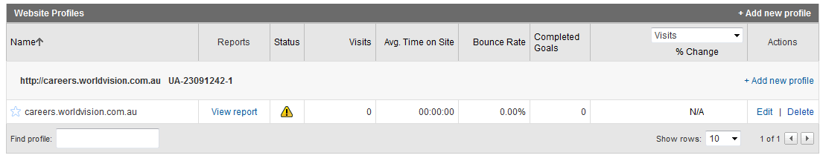

**Step 4:** Update feature manager

Two features need to be updated:

1. sGoogleAnalyticsID: website tracking – add the first ID you received
2. sAppFormGoogleAnalyticsID Applicant services tracking – add the second ID you received

# Audit

|  |  |  |  |
| --- | --- | --- | --- |
| Module | Date last reviewed | Reviewed by | For client.. |
| Base |  |  |  |
| Application Form Builder |  |  |  |
| Job Templates |  |  |  |
| Job Search and Mail |  |  |  |
| Source Management |  |  |  |
| Bulk Activities |  |  |  |
| Management Reporting |  |  |  |
| Permissions |  |  |  |
| Internal Form Builder |  |  |  |
| Google Analytics |  |  |  |