I.T Project Manager
Directorate: | Department:
Customer & Performance | Chief Information Office

Position Number: | Band/EA Classification:
BIT44, BIT48 | Band 7

Reports To: | Direct Reports:
Head of I.T Delivery | Nil

What we trust you to deliver
As an I.T Project Manager, you will be central to the delivery of priority I.T and digital initiatives which enable and support Council’s IT and business strategies. You will partner with business teams, community stakeholders and vendor partners to scope, build and implement technical change initiatives, which deliver impact and value.

The I.T Project Manager will utilise expertise in project management methodology (i.e. Lean, Agile and Waterfall methodologies), stakeholder and organisational change management and procurement of IT solutions to meet business specifications.
What you will need to thrive
- Demonstrated end to end project management experience across a multi-functional business.
- Exceptional verbal and report writing skills, including procedures documentation and presentation experience.
- Proven ability to motivate and influence an environment that fosters the use of technological advancement to meet business value and customer needs.
- Demonstrated understanding of financial and strategic planning.
- As a valued member of the team, you will contribute to a culture of continuous improvement and collaboration with a united teamwork approach to service development, problem solving and project delivery.
- Demonstrated ability in driving customer focused excellence by working in collaboration with clients and taking responsibility to meet client’s needs.
What success looks like
- Work closely with Business Analysts and project stakeholders to ensure projects match scope and strategy alignment.
- Optimise project schedule to gain efficiencies and deliver value as early as possible.
- Effectively manage project resources including budget, physical and people resources to maintain delivery to plan.
- Ability to estimate the effort and finances to deliver on high level requirements, and manage budget within defined tolerances.
- Manage the change and implementation planning in consultation with the business and technical subject matter experts.
- Prioritise components in consideration of risk, dependencies business need to inform a roadmap of change.
- Articulate the expected return on investment, in consultation with the benefit owners.
- Align outcomes of project to strategic intent of the organisation and directorate.
- Establish and maintain effective relationships with project stakeholders, including maintaining a customer focus with regards to community users of our technical solutions.
- Partner with business teams to deliver change and to sustain change post transition of project
- Meet the needs of digital users including staff and community
- Adheres to agreed methodologies, legislation and internal policies/ procedures.
- Manage and report on all aspects of project health, including schedule, financial, scope, change, risk and dependencies.
- Actively participate in Council’s approach to performance, development and review process ROADmap. Your ROADmap is the opportunity to bring your whole self to work through celebrating your talents and strengths and supporting your performance and development.
- This role may also be required to carry out other such duties as are within the limits of the employee’s skills competence and training.

The expertise you bring (including qualifications and experience)
- Qualification or certification in a relevant Project Management IT discipline is desired, alternatively Project Management training is required.
- 4+ years’ experience in practical Project Management experience in an IT environment.

Key capabilities
Ensures Accountability | Customer Focus | Balances Stakeholders | Plans and Aligns
Situational Adaptability | Drives Results | Collaborates | Communicates Effectively

OHS, Risk Management, Equal Opportunity, Child Safe Standards and Charter of Human Rights
- Adhere to Council’s Health and Safety, equal opportunity and risk management policies, plans and procedures as well as act in accordance with the Charter of Human Rights.
- Demonstrate and promote workplace behaviours that does not discriminate, bully or harass.
- Cooperate with any reasonable, lawful instruction to comply with relevant legal requirements.
- Adhere to policies and procedures to prevent injuries to people and damage to assets and property including reporting of these matter.
- Take reasonable care for your safety and the safety of others who may be affected by your actions or omissions.
- Promote positive mental health and wellbeing within your team and work towards the prevention of mental health injuries and illness in workplace.
- Ensure a child safe environment and contribute to a culture of child safety by fulfilling the requirements and responsibilities outlined in legislation, including the Child Safe Standards, Reportable Conduct Scheme and Council’s Child Safe Policy and Procedures.

Who you will work with:
Internal: | External:
- Head of IT Delivery | - External Service Providers/ Industry experts
- Chief Information Officer  - Executive Management  - All Council Staff  - ICT Committees | - Vendors and suppliers  - Other Councils and Government agencies  - Community members

Accountability and extent of authority
- Responsible for the management and delivery of projects to agreed baselines.
- Freedom to act set by policies, objectives and budgets; actions taken may have a significant effect on programs or projects, or on public perception of the wider organisation
- Provide regular project status reporting in line with IT Project Methodology framework and management requirements.
- Provide specialist advice to relevant stakeholders in relation to project methodology and risk identification.
- Management and maintenance of core business systems data integrity, confidentiality and security in accordance with Council policy.
- Accountable for the provision of effective and efficient services to the organisation and the quality, integrity and reliability of advice provided.
- Have an input into policy development

Judgement and decision making
- This role involves complex problem solving which may require creativity and innovation to satisfy business requirements and keep project within time and budget constraints.
- A strong emphasis on the ability to use initiative and successfully prioritise tasks to achieve required outcomes and benefits.
- A strong emphasis is placed on quality documentation against mandatory and non-mandatory deliverables. Ability to clearly and concisely articulate approach to project delivery and the value which the project will deliver, is key.
- Work is specialised and complex as a result of changing technology and statutory obligations, some requiring considered judgement and consultation with Executive Management.
- Apply sound judgement and financial acumen in complex decision making.
- Guidance is not always available within the organisation.

Specialist Skills and Knowledge
  - Well-developed project management and analytical skills with demonstrated experience and understanding of business process mapping in a digital environment.
  - Sound knowledge and understanding of relevant project methodologies and highly developed scheduling, time management and relationship building skills.
  - Demonstrated experience in understanding business requirements and development of systems to optimise their potential usage.
  - A level of proficiency/understanding and experience in designing and administration of relational database systems.
  - Well-developed skills in the implementation and coordination of business systems updates and management of process and test plans.
- Understanding of organisational values, and the legal and political context.
  - Knowledge and familiarity of principles and practices of budgeting and accounting/financial procedures.

Management skills
  - Ability to understand and apply standards, practices, policies and procedures relating to the use of computerised information systems within the business environment.
  - Ability to improve the effectiveness and efficiency of existing processes and to find better ways of doing things.
  - Demonstrated in multi-tasking, teamwork and prioritisation with a confident, positive and professional manner.
  - Ability to project timelines and exercise excellent time management skills and delivering on set priorities, and plans within a set timeframe despite conflicting priorities.
  - Provide guidance and advice to staff/team members and stakeholders where required on routine technical/procedural or administrative matters (including basic training).
  - Demonstrated ability to discuss, negotiate and resolve problems within the area of expertise.
- Able to implement personnel policies and practices including awards, EEO and OH&S policies, recruitment and selection procedures and techniques, position descriptions and staff development schemes.
- Expected to contribute to long term staffing strategies.

Interpersonal Skills
  - Well-developed communication and interpersonal skills to collaborate effectively with customers to anticipate understand and meet customer’s needs.
  - Demonstrated ability to gain co-operation and assistance from the team members, members of the public and other staff across Council.
  - The ability to establish and maintain a network of contacts both within Knox and externally to discuss specialist matters related to the position requirements.
  - Clarify and consider the needs and expectations of stakeholders through effective engagement.
- Ability to liaise with counterparts in other organisations to discuss and resolve specialist problems.
  - Ability to motivate and develop employees.

Inherent Requirements
The inherent requirements of the role are provided in the job advertisement as well as on Council’s Recruiting and Selecting for Excellence page.
Within reason, and subject to Council's obligations under legislation, it is expected that a person conducting this type of work will have the capacity to perform the genuine, reasonable and inherent tasks of the role.

Conditions of Employment
Conditions of employment are in accordance with the Knox City Council Enterprise Agreement and the Knox City Council Code of Conduct. Applicants will require the following:

Satisfactory Police Check | ID Verification Check | Reference Check
AU Entitlement to Work | Current Victorian Drivers Licence

About Knox
Making a difference to others and our community is at the heart of everything we do at Knox. Future Ready Knox connects our vision, aligns our purpose with values, strategy and people experience. We all have an important role to play, in working together we will achieve all we aim for and more.
 | Our Values  Our values are the foundations to our success and culture at Knox. They represent what we stand for, inspire us to bring our whole selves to work and create a shared understanding to align the way we work with our vision and purpose.  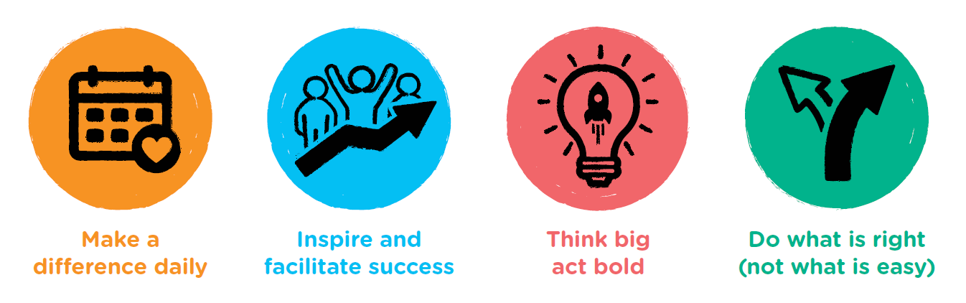
THRIVE: Our Future Ready Knox Strategy  The world we live in is changing, placing ever more focus on people and what it means to be human.  It is time we reimagine the future of work and adapt how we lead our changing business, so we evolve and remain purposeful for our residents, our community and our City. We all have capacity to adapt and evolve. It is through harnessing our changing skillsets and mindsets, and working and learning together that we will bring out the best in each other and create a future we can all feel good about.  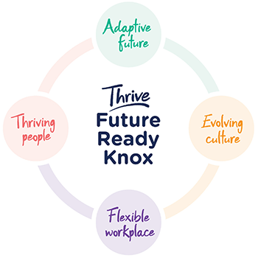 | Adaptive future  We will pursue the future with a clear strategy of excellence and service. We will never stop learning and growing. We will be a resilient, adaptable and sustainable workplace comprised of thriving people working together to fulfil our core purpose: empowering our diverse community to thrive and prosper.  Evolving culture  We strive to be an agile organisation built on a foundation of psychological safety and trust in our leaders, our teams and ourselves. We will be defined by our love of learning, innovation and growth. We will be led by wholehearted humans who bring out the best in our people and drive collective ownership of our vision, strategy and values. This will ensure we respond, adapt and thrive in a rapidly changing world.  Flexible workplace  We will thrive in our inclusive and connected workplace, defined by flexible practices and spaces, and enabled by new technologies and business intelligence. These will support our people to explore and adopt new ways of thinking, learning and working that ultimately deliver greater value to our community.  Thriving people  We will be defined by our resilient, diverse and capable people and will support them to keep growing and leveraging their passions, talents and skills. We will improve the ways we engage and communicate, embrace productive conflict and hold each other accountable for our commitments. We will harness our collective potential to make a difference and create a future we can all feel good about.
Please refer to our website www.knox.vic.gov.au for more information about Knox City Council.

